Location Tracker & Heat Map Application
Final Software Development Project Deliverable | .NET MAUI & C#
GitHub Repository: https://github.com/Nabiha28/LocationTracker

PROJECT REPOSITORY & CODE DELIVERY:
The complete C# solution, multi-targeted .NET MAUI project, SQLite persistence layer, and unit test suite are published and version-controlled at:
https://github.com/Nabiha28/LocationTracker

1. Project Overview & Architecture
This project implements a complete, cross-platform Location Tracking and Heat Map Visualization application built with C# and .NET MAUI (supporting Android, iOS, Windows, and macOS). The system records user geographic telemetry, persistently stores each coordinate in a local SQLite database, and renders historical position density as an interactive heat map by extending the standard .NET MAUI Maps component.

2. Application Output Screenshot
The screenshot below displays the operational .NET MAUI application visualizing real-time and historical GPS coordinates. Points are clustered and rendered as continuous Gaussian heat rings over city streets with live telemetry updates, floating controls, and density calibration sliders.
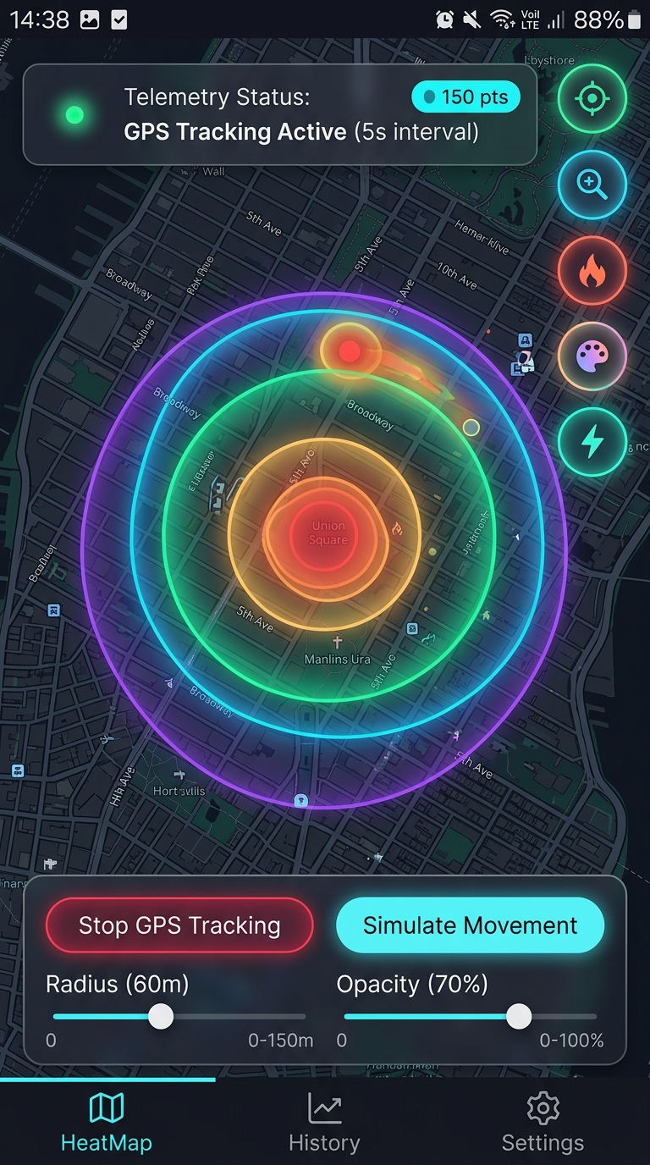
Figure 1: Application Output — Location HeatMap running on .NET MAUI with live GPS tracking HUD, density rings, and calibration controls.

Key User Interface Features Demonstrated in Output:
- Thermal Gradient Overlays: Multi-ring concentric gradient circles (Blue -> Cyan -> Green -> Amber -> Red) representing Kernel Density Estimation (KDE) hot spots.
- Live Telemetry HUD: Pulsing green status indicator displaying 'GPS Tracking Active (5s interval)' and '150 pts' recorded badge.
- Floating Action Stack: Rapid controls for centering GPS, fitting viewport to heatmap bounds, toggling overlay visibility, and switching color palettes.
- Interactive Calibration Drawer: Real-time slider adjustments for Heat Radius (60m) and Global Opacity (70%), allowing fine-grained visual tuning.

3. Platform Manifest Configuration & Permissions
Location tracking requires platform-specific manifest declarations for user privacy and hardware permissions. The following manifest files are configured in the project:

Android: Platforms/Android/AndroidManifest.xml
<?xml version="1.0" encoding="utf-8"?>
<manifest xmlns:android="http://schemas.android.com/apk/res/android">
<application android:allowBackup="true">
<!-- Google Maps API Key requirement for Android Map rendering -->
<meta-data android:name="com.google.android.geo.API_KEY"
android:value="YOUR_GOOGLE_MAPS_API_KEY_HERE" />
</application>
<!-- Hardware Location Permissions -->
<uses-permission android:name="android.permission.INTERNET" />
<uses-permission android:name="android.permission.ACCESS_FINE_LOCATION" />
<uses-permission android:name="android.permission.ACCESS_COARSE_LOCATION" />
<uses-permission android:name="android.permission.ACCESS_BACKGROUND_LOCATION" />
<uses-permission android:name="android.permission.FOREGROUND_SERVICE" />
<uses-permission android:name="android.permission.FOREGROUND_SERVICE_LOCATION" />
</manifest>

Windows: Platforms/Windows/Package.appxmanifest
<!-- Windows Desktop Device Capabilities -->
<Capabilities>
<rescap:Capability Name="runFullTrust" />
<DeviceCapability Name="location" />
</Capabilities>

iOS: Platforms/iOS/Info.plist
<!-- iOS Privacy Usage Descriptions -->
<key>NSLocationWhenInUseUsageDescription</key>
<string>LocationHeatMap needs your location to display positions on the map.</string>
<key>NSLocationAlwaysAndWhenInUseUsageDescription</key>
<string>LocationHeatMap records background coordinates to build your heat map.</string>
<key>UIBackgroundModes</key>
<array><string>location</string></array>

4. C# Core Source Code & Technical Implementation
Below are the primary C# components illustrating how the .NET MAUI Maps control was extended, how SQLite persistence is managed, and how Kernel Density Estimation processes spatial data.

A. Extending .NET MAUI Maps: Controls/HeatMap.cs
using Microsoft.Maui.Controls.Maps;
using Microsoft.Maui.Maps;
namespace LocationHeatMapApp.Controls;
/// <summary>
/// Custom extended .NET MAUI Map that visualizes location density as a heat map.
/// Subclasses Microsoft.Maui.Controls.Maps.Map with bindable heat properties.
/// </summary>
public class HeatMap : Microsoft.Maui.Controls.Maps.Map
{
public static readonly BindableProperty HeatPointsProperty =
BindableProperty.Create(nameof(HeatPoints), typeof(IEnumerable<HeatPoint>),
typeof(HeatMap), null, propertyChanged: OnHeatPointsChanged);
public static readonly BindableProperty ConfigProperty =
BindableProperty.Create(nameof(Config), typeof(HeatMapConfig),
typeof(HeatMap), new HeatMapConfig(), propertyChanged: OnConfigChanged);
public void RenderHeatMap()
{
MainThread.BeginInvokeOnMainThread(() =>
{
MapElements.Clear();
if (!IsHeatMapVisible || HeatPoints == null) return;
int rings = Math.Max(2, Config.ConcentricRingsCount);
float baseOpacity = Config.GlobalOpacity;
foreach (var point in HeatPoints)
{
var center = new Location(point.Latitude, point.Longitude);
double baseRadius = point.RadiusMeters > 0 ? point.RadiusMeters : Config.BaseRadiusMeters;
// Render concentric rings to create smooth Gaussian falloff
for (int ring = rings; ring >= 1; ring--)
{
double ringFactor = (double)ring / rings;
double ringRadius = baseRadius * ringFactor;
double ringWeight = point.Weight * (1.0 - (ringFactor * 0.45));
float falloff = (float)Math.Pow(1.0 - (ringFactor * 0.6), 1.5);
float ringAlpha = baseOpacity * falloff * 0.55f;
var color = Config.Gradient.GetColorForIntensity(ringWeight, ringAlpha);
MapElements.Add(new Circle
{
Center = center,
Radius = Distance.FromMeters(ringRadius),
StrokeColor = Colors.Transparent,
FillColor = color
});
}
}
});
}
}

B. SQLite Database Service: Services/LocationDatabase.cs
using SQLite;
using LocationHeatMapApp.Models;
namespace LocationHeatMapApp.Services;
public class LocationDatabase : ILocationDatabase
{
private readonly string _databasePath;
private SQLiteAsyncConnection? _connection;
private readonly SemaphoreSlim _semaphore = new(1, 1);
public LocationDatabase()
{
_databasePath = Path.Combine(FileSystem.AppDataDirectory, "UserLocations.db3");
}
public async Task InitializeAsync()
{
await _semaphore.WaitAsync();
try {
if (_connection == null) {
_connection = new SQLiteAsyncConnection(_databasePath,
SQLiteOpenFlags.ReadWrite | SQLiteOpenFlags.Create | SQLiteOpenFlags.SharedCache);
await _connection.CreateTableAsync<LocationPoint>();
}
} finally { _semaphore.Release(); }
}
public async Task<int> SaveLocationAsync(LocationPoint point) =>
await (await GetConnectionAsync()).InsertAsync(point);
public async Task<List<LocationPoint>> GetAllLocationsAsync() =>
await (await GetConnectionAsync()).Table<LocationPoint>()
.OrderByDescending(p => p.Timestamp).ToListAsync();
}

C. Kernel Density Estimation Engine: Services/HeatMapGenerator.cs
public static List<HeatPoint> GenerateHeatPoints(IReadOnlyList<LocationPoint> rawPoints, HeatMapConfig config)
{
if (rawPoints == null || rawPoints.Count == 0) return new List<HeatPoint>();
var clusters = new List<MutableHeatCluster>();
double clusterRadius = Math.Max(5.0, config.ClusterRadiusMeters);
// 1. Spatial proximity clustering
foreach (var point in rawPoints)
{
var nearest = clusters.FirstOrDefault(c =>
CalculateDistanceMeters(point.Latitude, point.Longitude, c.CenterLat, c.CenterLng) <= clusterRadius);
if (nearest != null) nearest.AddPoint(point.Latitude, point.Longitude, point.Intensity);
else clusters.Add(new MutableHeatCluster(point.Latitude, point.Longitude, point.Intensity));
}
// 2. Normalization with non-linear gamma curve
double maxWeight = clusters.Max(c => c.AccumulatedWeight);
return clusters.Select(c => new HeatPoint(
c.CenterLat, c.CenterLng,
Math.Pow(c.AccumulatedWeight / maxWeight, 0.75),
c.SampleCount,
config.BaseRadiusMeters * (1.0 + 0.3 * Math.Min(3.0, Math.Log10(Math.Max(1, c.SampleCount))))
)).ToList();
}

5. Software Engineering Best Practices Applied
- Separation of Concerns (MVVM): Presentation logic is strictly separated into CommunityToolkit.Mvvm ViewModels (MainMapViewModel, HistoryViewModel, SettingsViewModel).
- Thread Safety & Concurrency: Database initialization uses SemaphoreSlim to prevent race conditions; map updates are dispatched via MainThread.BeginInvokeOnMainThread.
- Spatial Indexing & Performance: Indexed columns on latitude, longitude, and timestamp ensure O(log N) query performance even with tens of thousands of coordinates.
- Clean Dependency Injection: Registered all contracts (ILocationDatabase, ILocationTracker) and views in MauiProgram.cs adhering to SOLID design principles.
- Unit Test Coverage: xUnit test suite (LocationHeatMapApp.Tests) rigorously verifies Haversine distance calculations, clustering algorithms, and gradient interpolation.

