- Check the server that in coming weekend for patching activity
- Raise the Change request for Activity
- Drop mail to respective server owners
- Take compliance report of server before patching
Link – https://skkrlprbgfix1.sskikt_nt.com:8083/webreports
ID – pslin
Pass - Nilsp@2019
Login and click on , Report list---->search “Schedulable Compliance by Content Template”

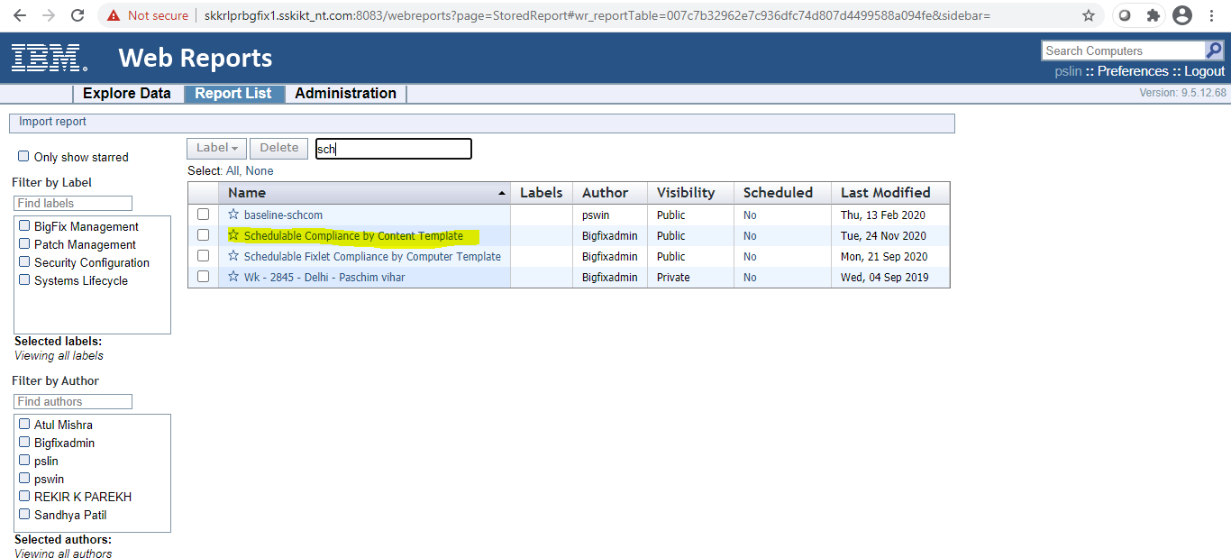
- Load the filter to take compliance report and select
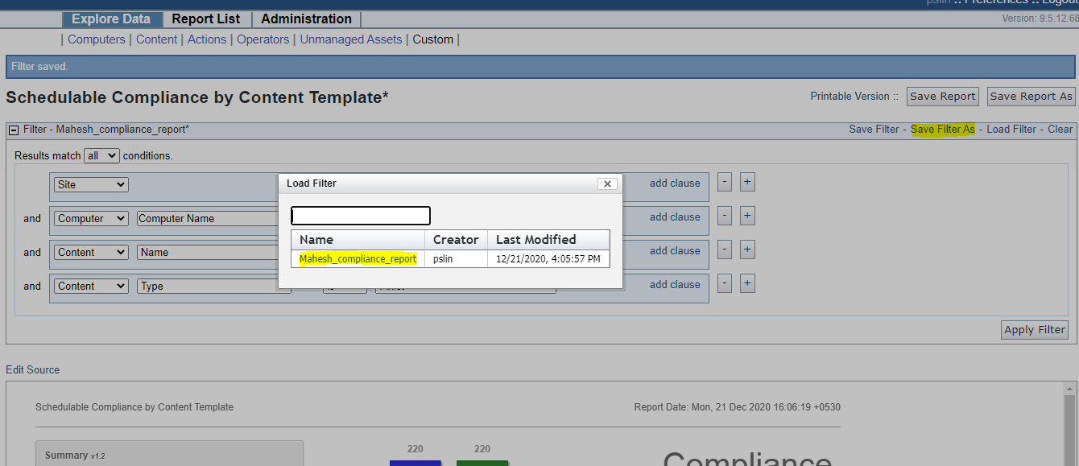
- Change the filter content as per OS and Server hostname
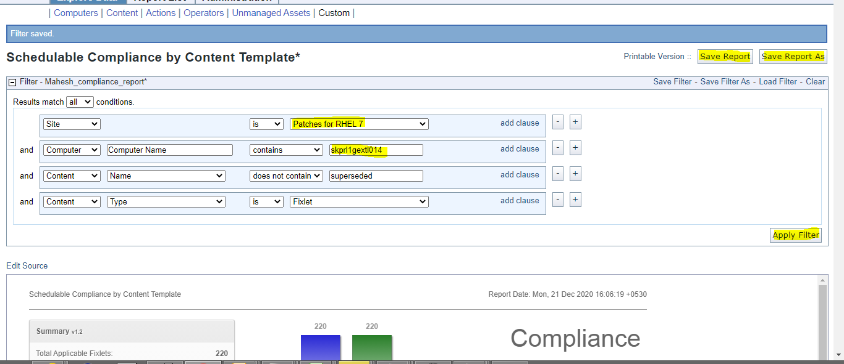
- Apply filter and save as PDF
- Open bigFIx Console

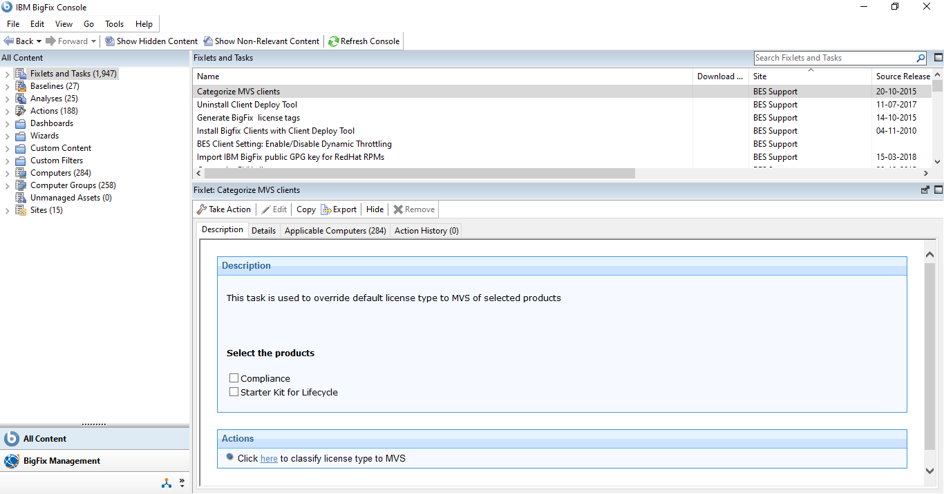
- Select the Fixlets and Tasks tab from left side
- Search the GPG key as per OS version

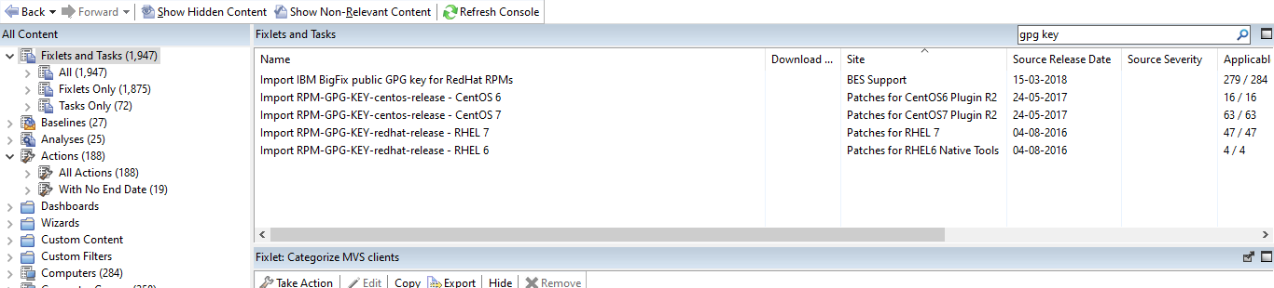
- We need to sync the baseline before apply for remove superseded patches
- select the tab as per screenshot, sync the baseline
- please check mail from bigfix vendor for more clarity.

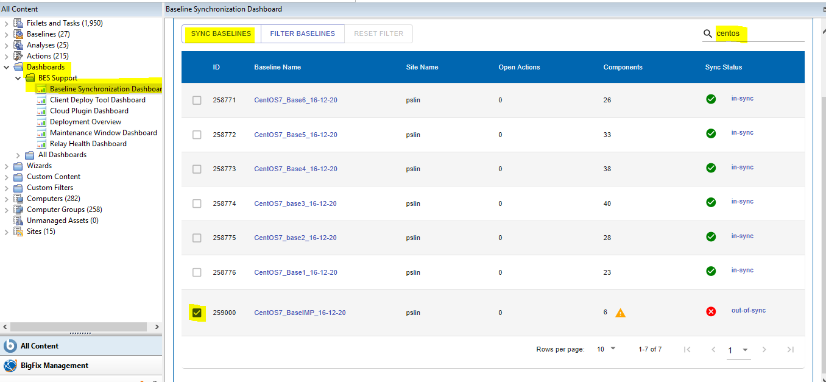

- Select and take action on server with entering the hostname

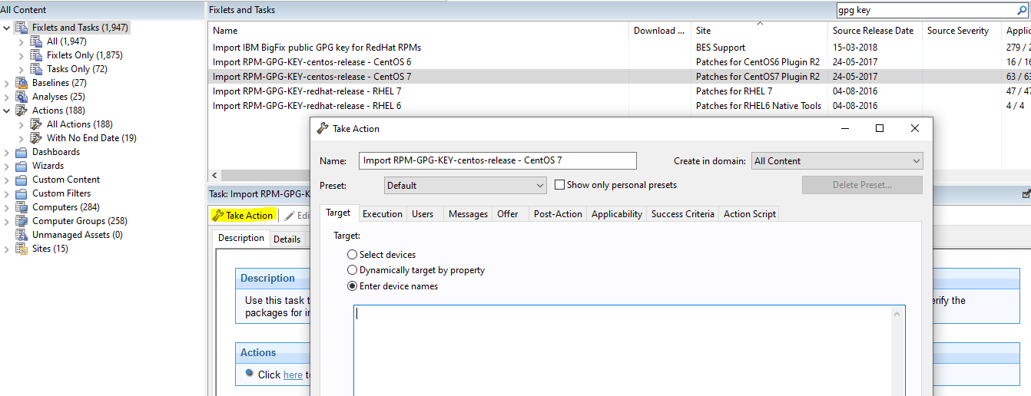
- Then check the tab of Baseline on left
- Select the baseline 1 to X as per OS and take action on server with entering the hostname same as GPG key
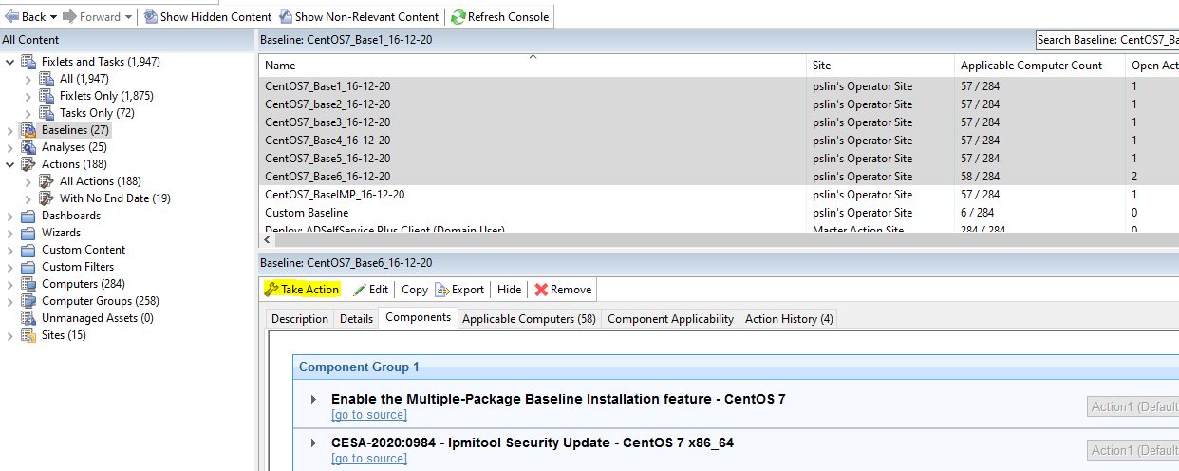
- Check the Status of action of deployed baseline in Action tab
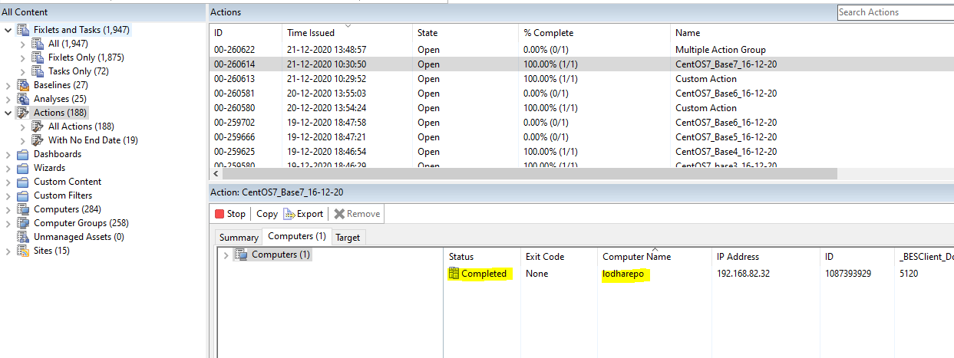
- When Baseline deployement complete. Then select last IMP baseline at last, that include Kernel and Imp patch. And take action on same server
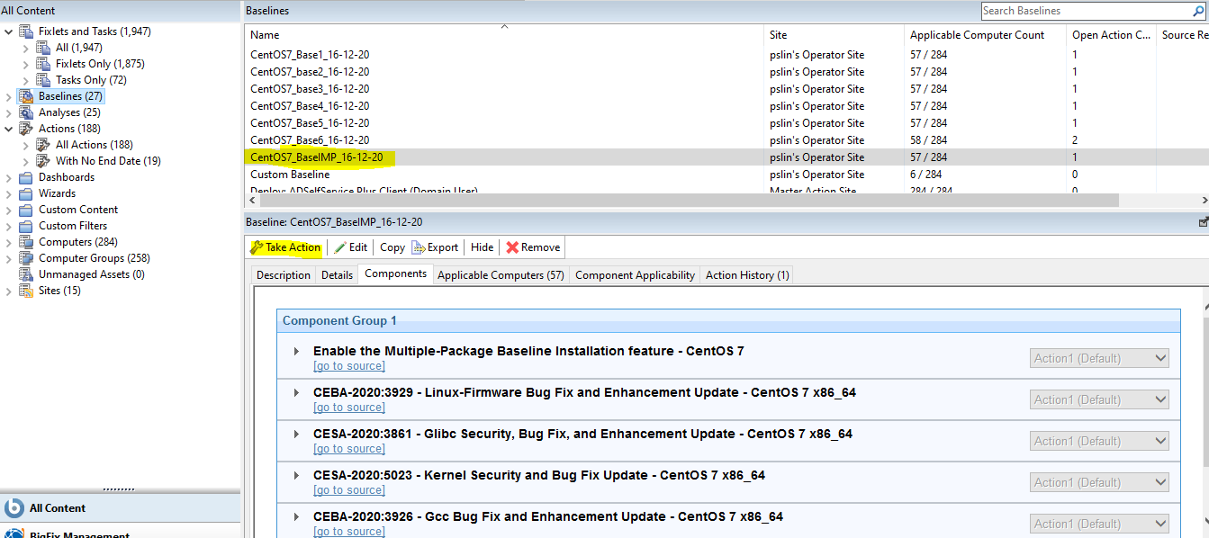
- Check the Status of action of deployed baseline in Action tab, after complete restart the server
- Take compliance report of server After patching
- Drop mail to respective server owners that activity is complete
- Also drop mail for VAPT

