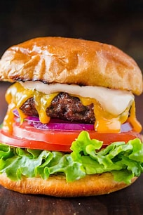

**HAMBURGER BODY PARAGRAPH**

TOP BUN - Topic Sentence

TOPPINGS – Set up to Integrate Quote (Who What When Where)

LEAN BURGER Quotation (Author’s last name page/link)

VEGGIES Analysis (Literary Technique)

BOTTOM BUN Prove Your Thesis Argument