Step B-1 — Created DynamoDB table Course_Registration with 6 RCU and 6 WCU
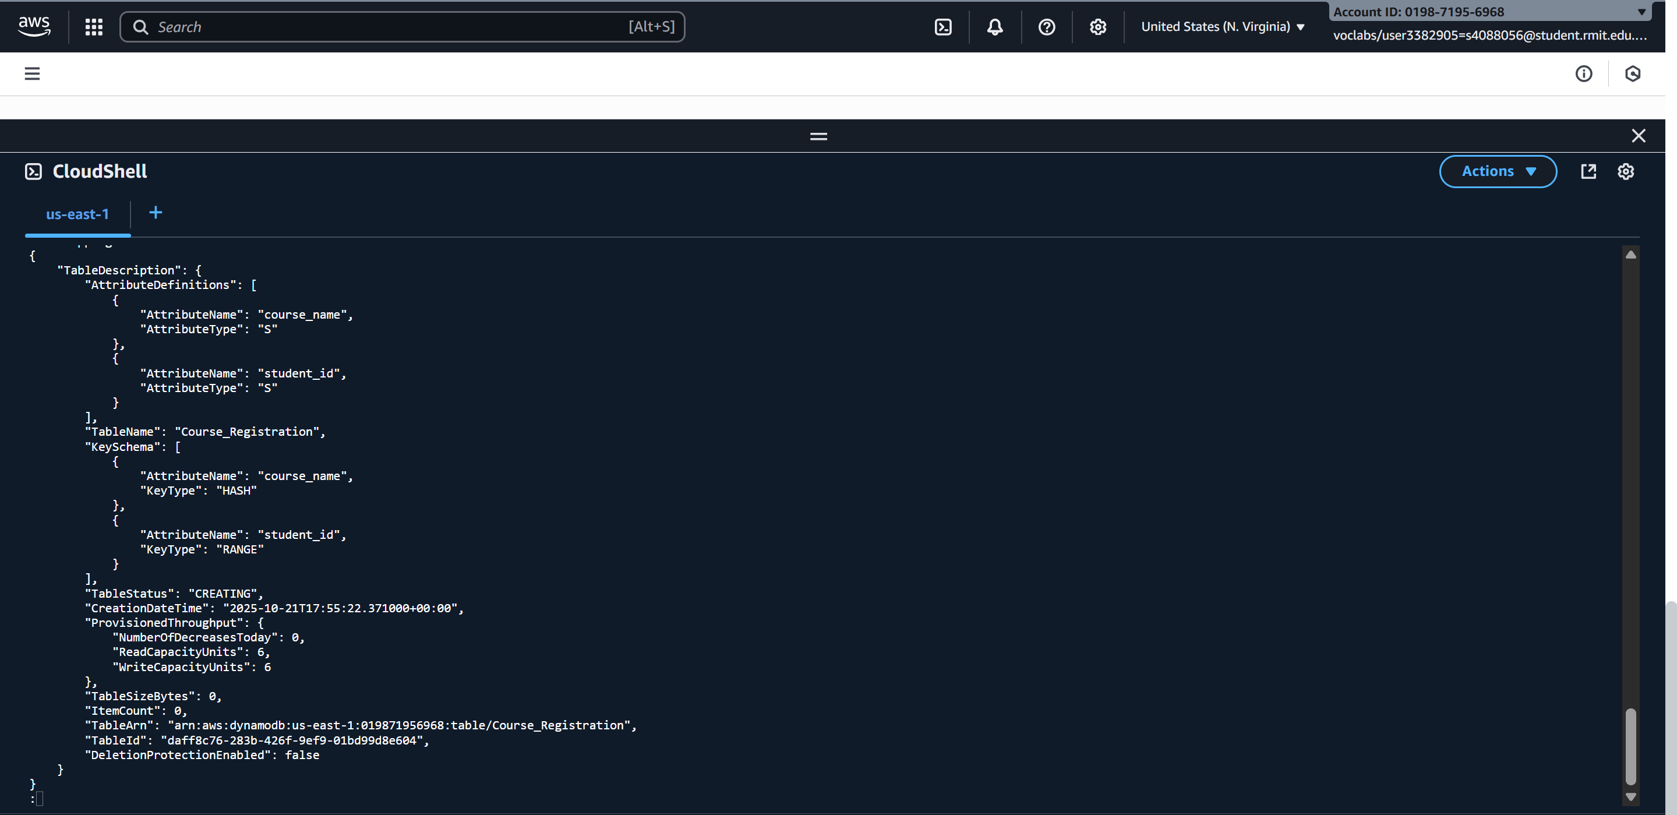

Step B-2 — Inserted first record (single item) and verified with scan command
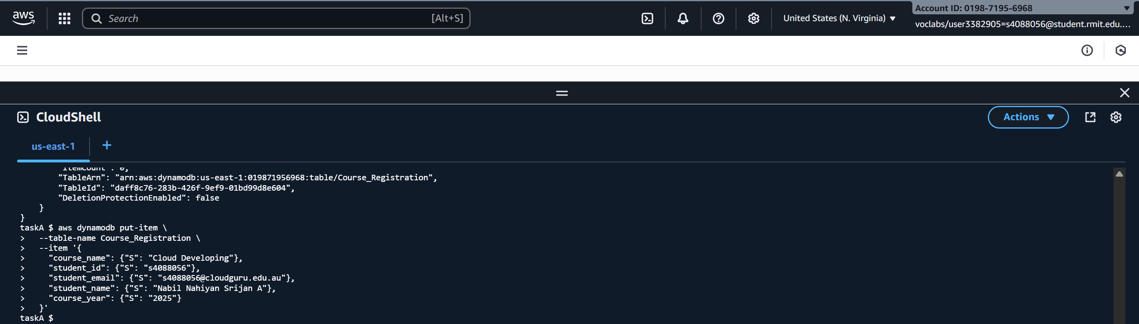
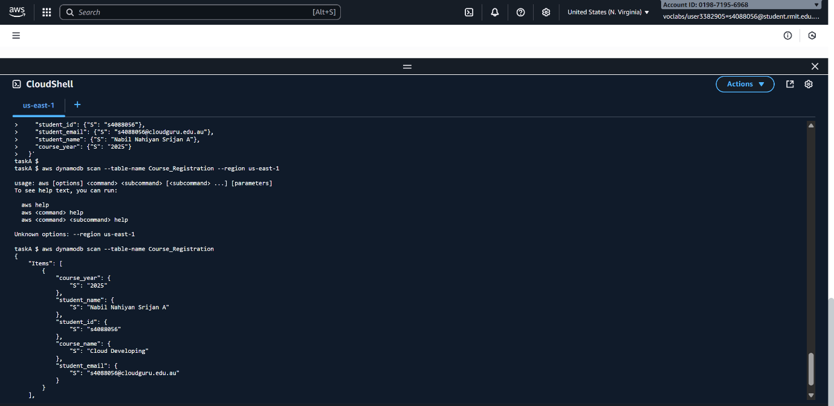

Step B-3 — Created records.json containing 7 student records for batch insertion.
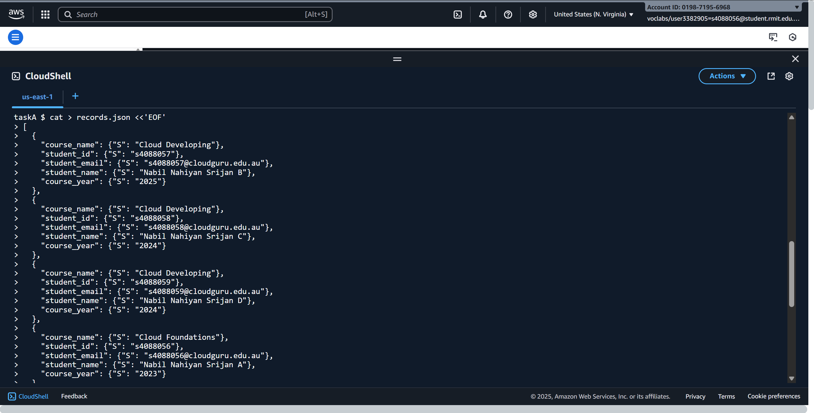
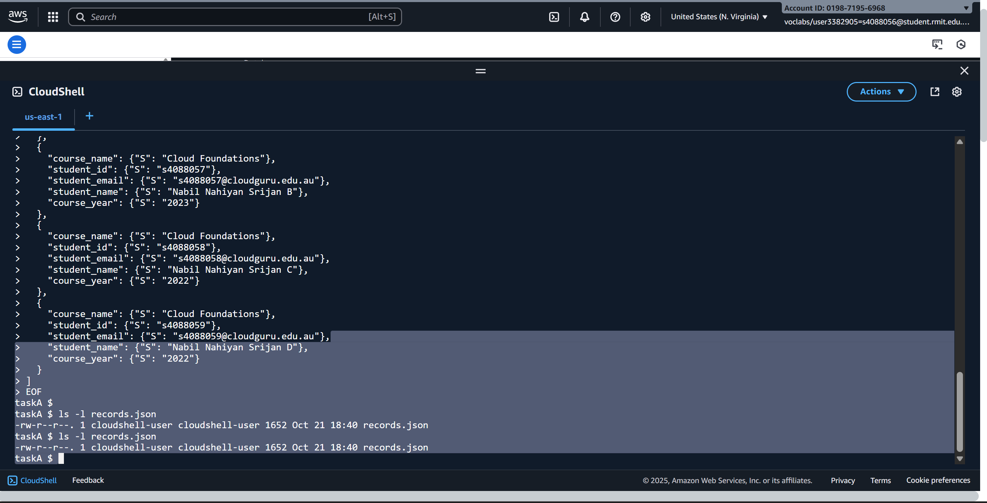

Step B-4 — Inserted remaining records via Python script using Boto3.
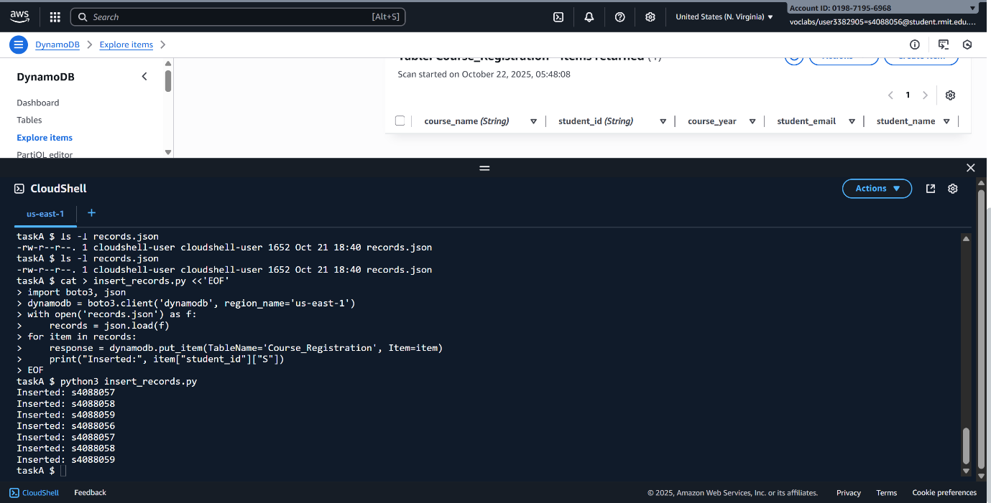

Step B-5 — Created Global Secondary Index studentname-year-index on Course_Registration table.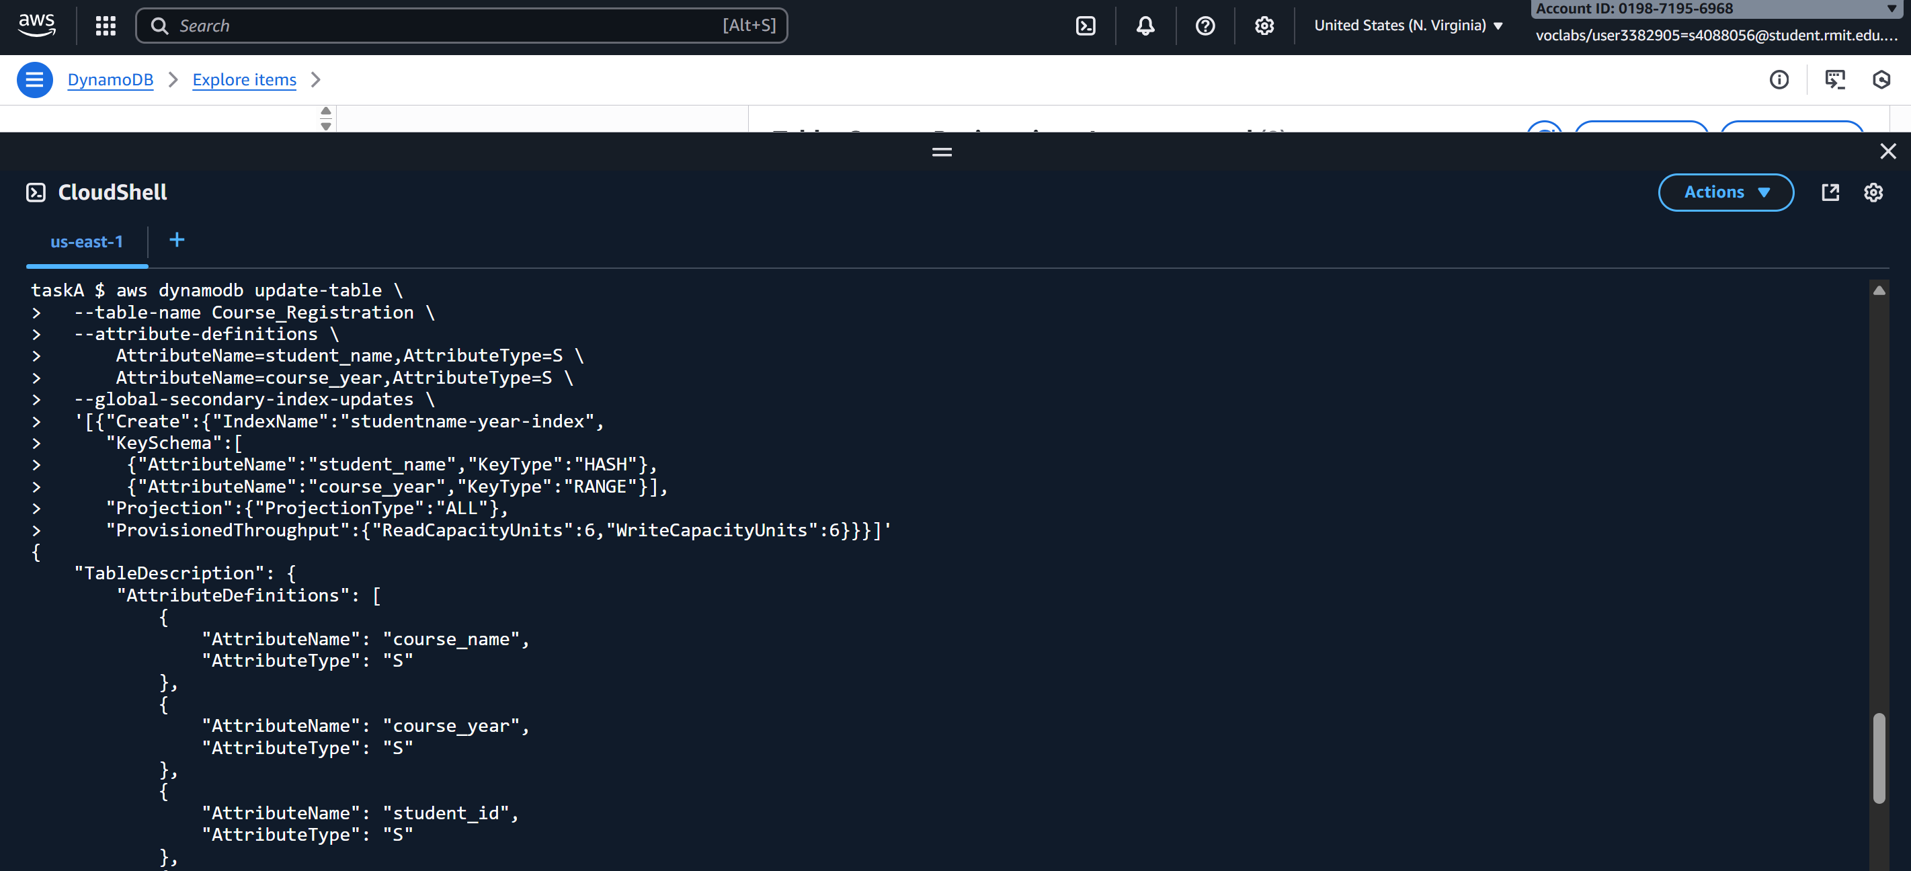
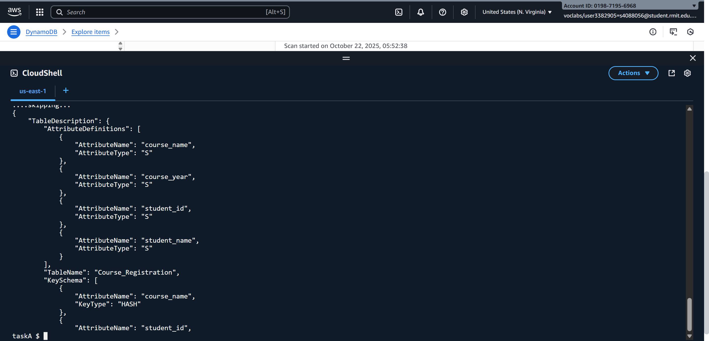

Step B-6 —Scanned all records in the Course_Registration table. Output confirms multiple records were retrieved successfully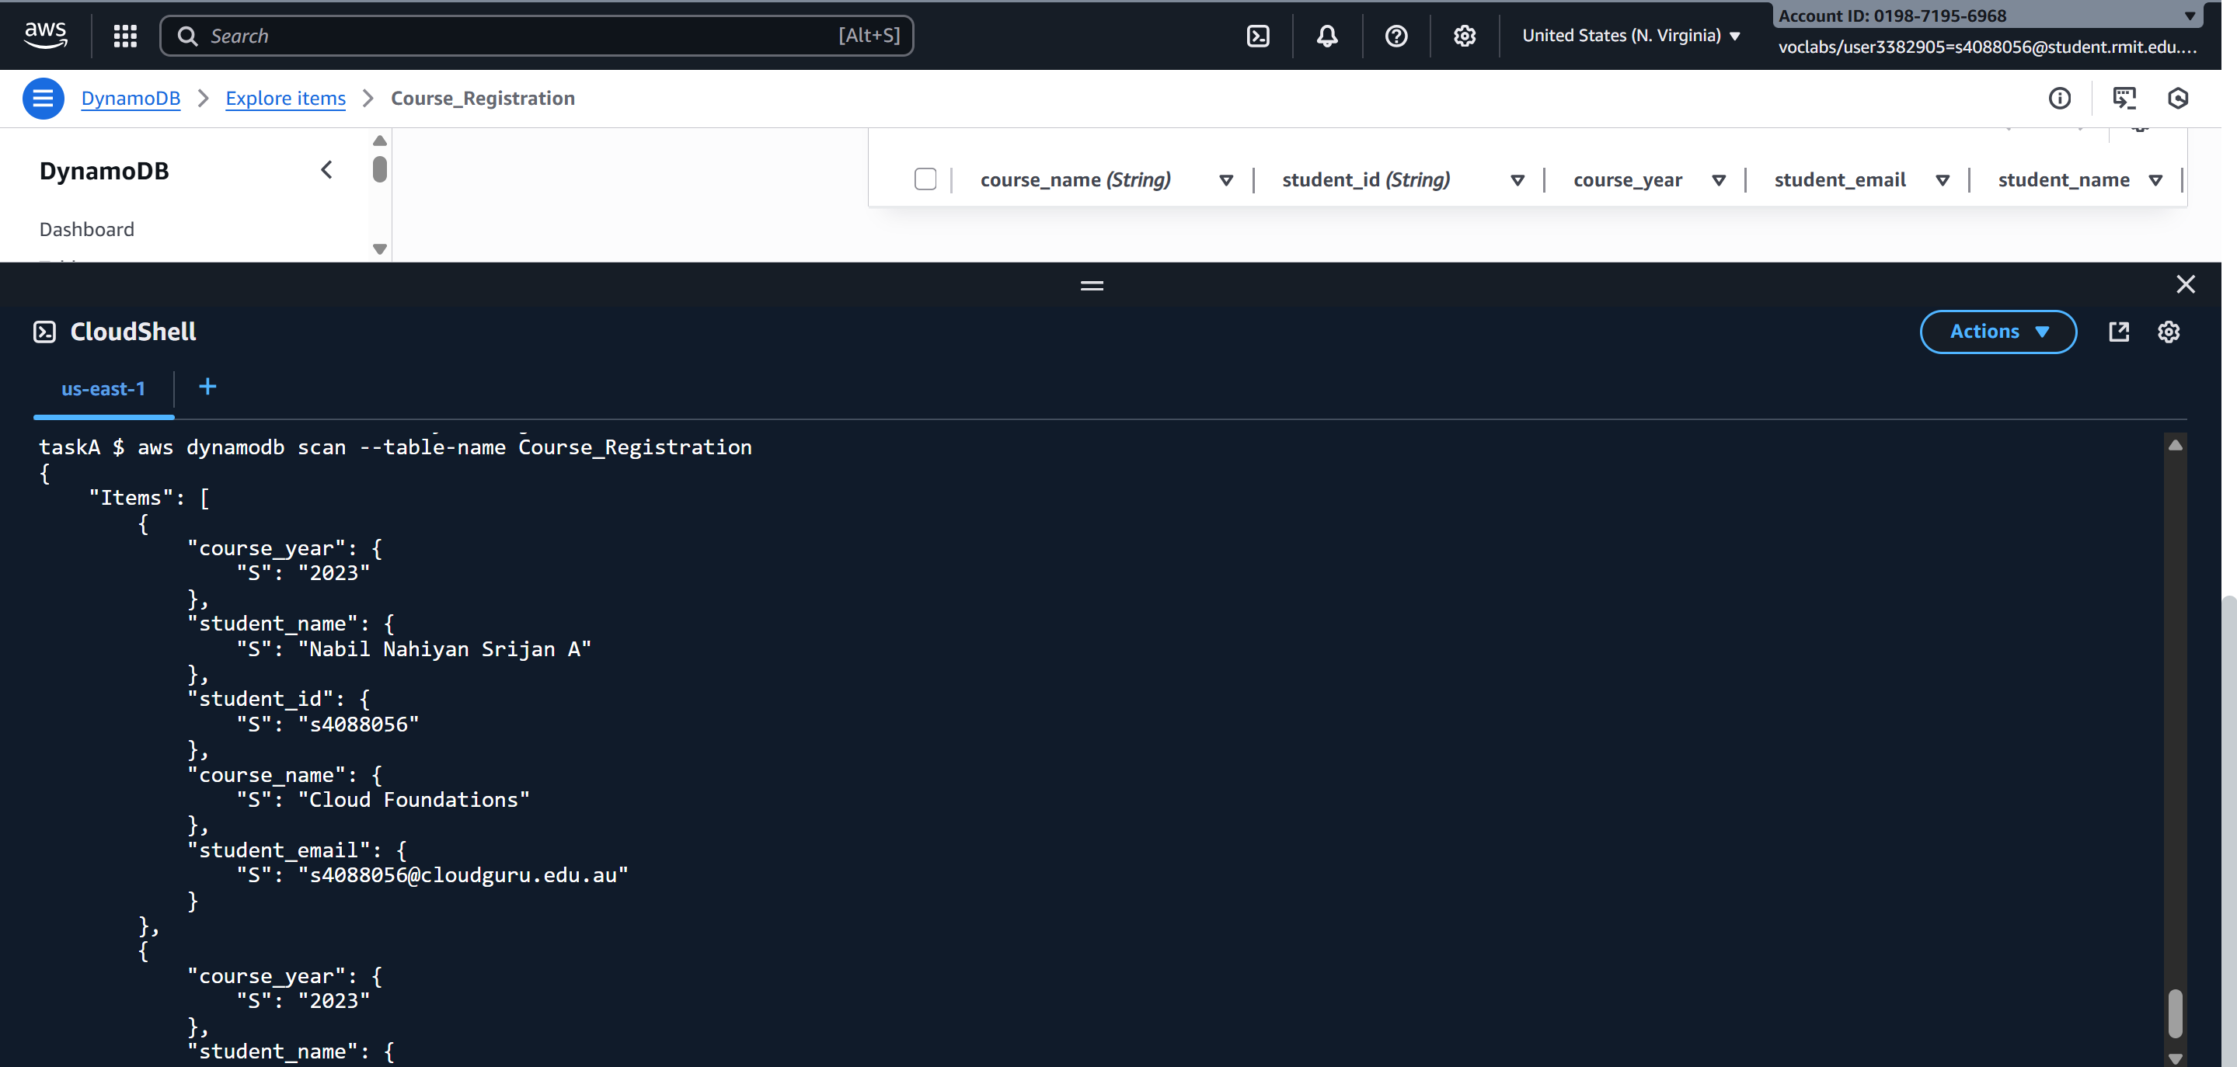

Step B-7 — Queried the Course_Registration table using the Global Secondary Index studentname-year-index