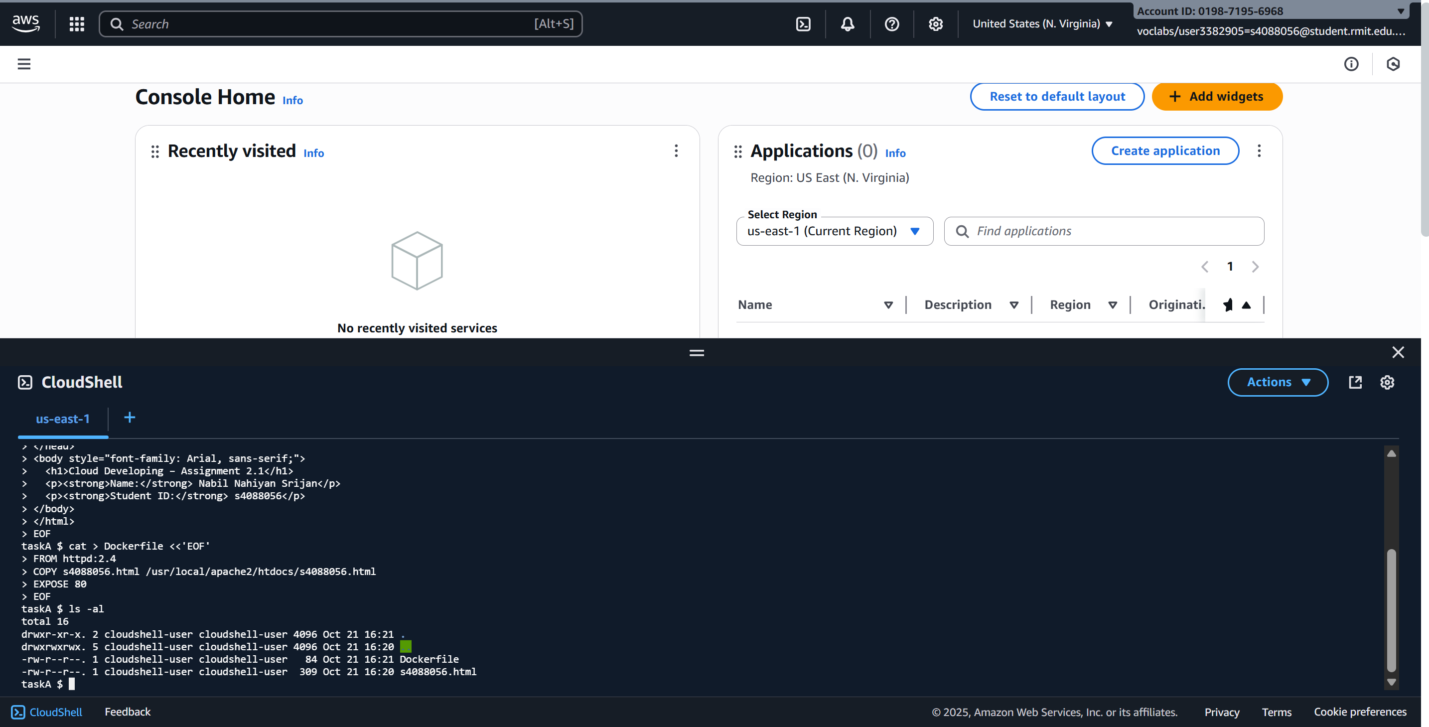
Step A-1 — Created Dockerfile and HTML file.
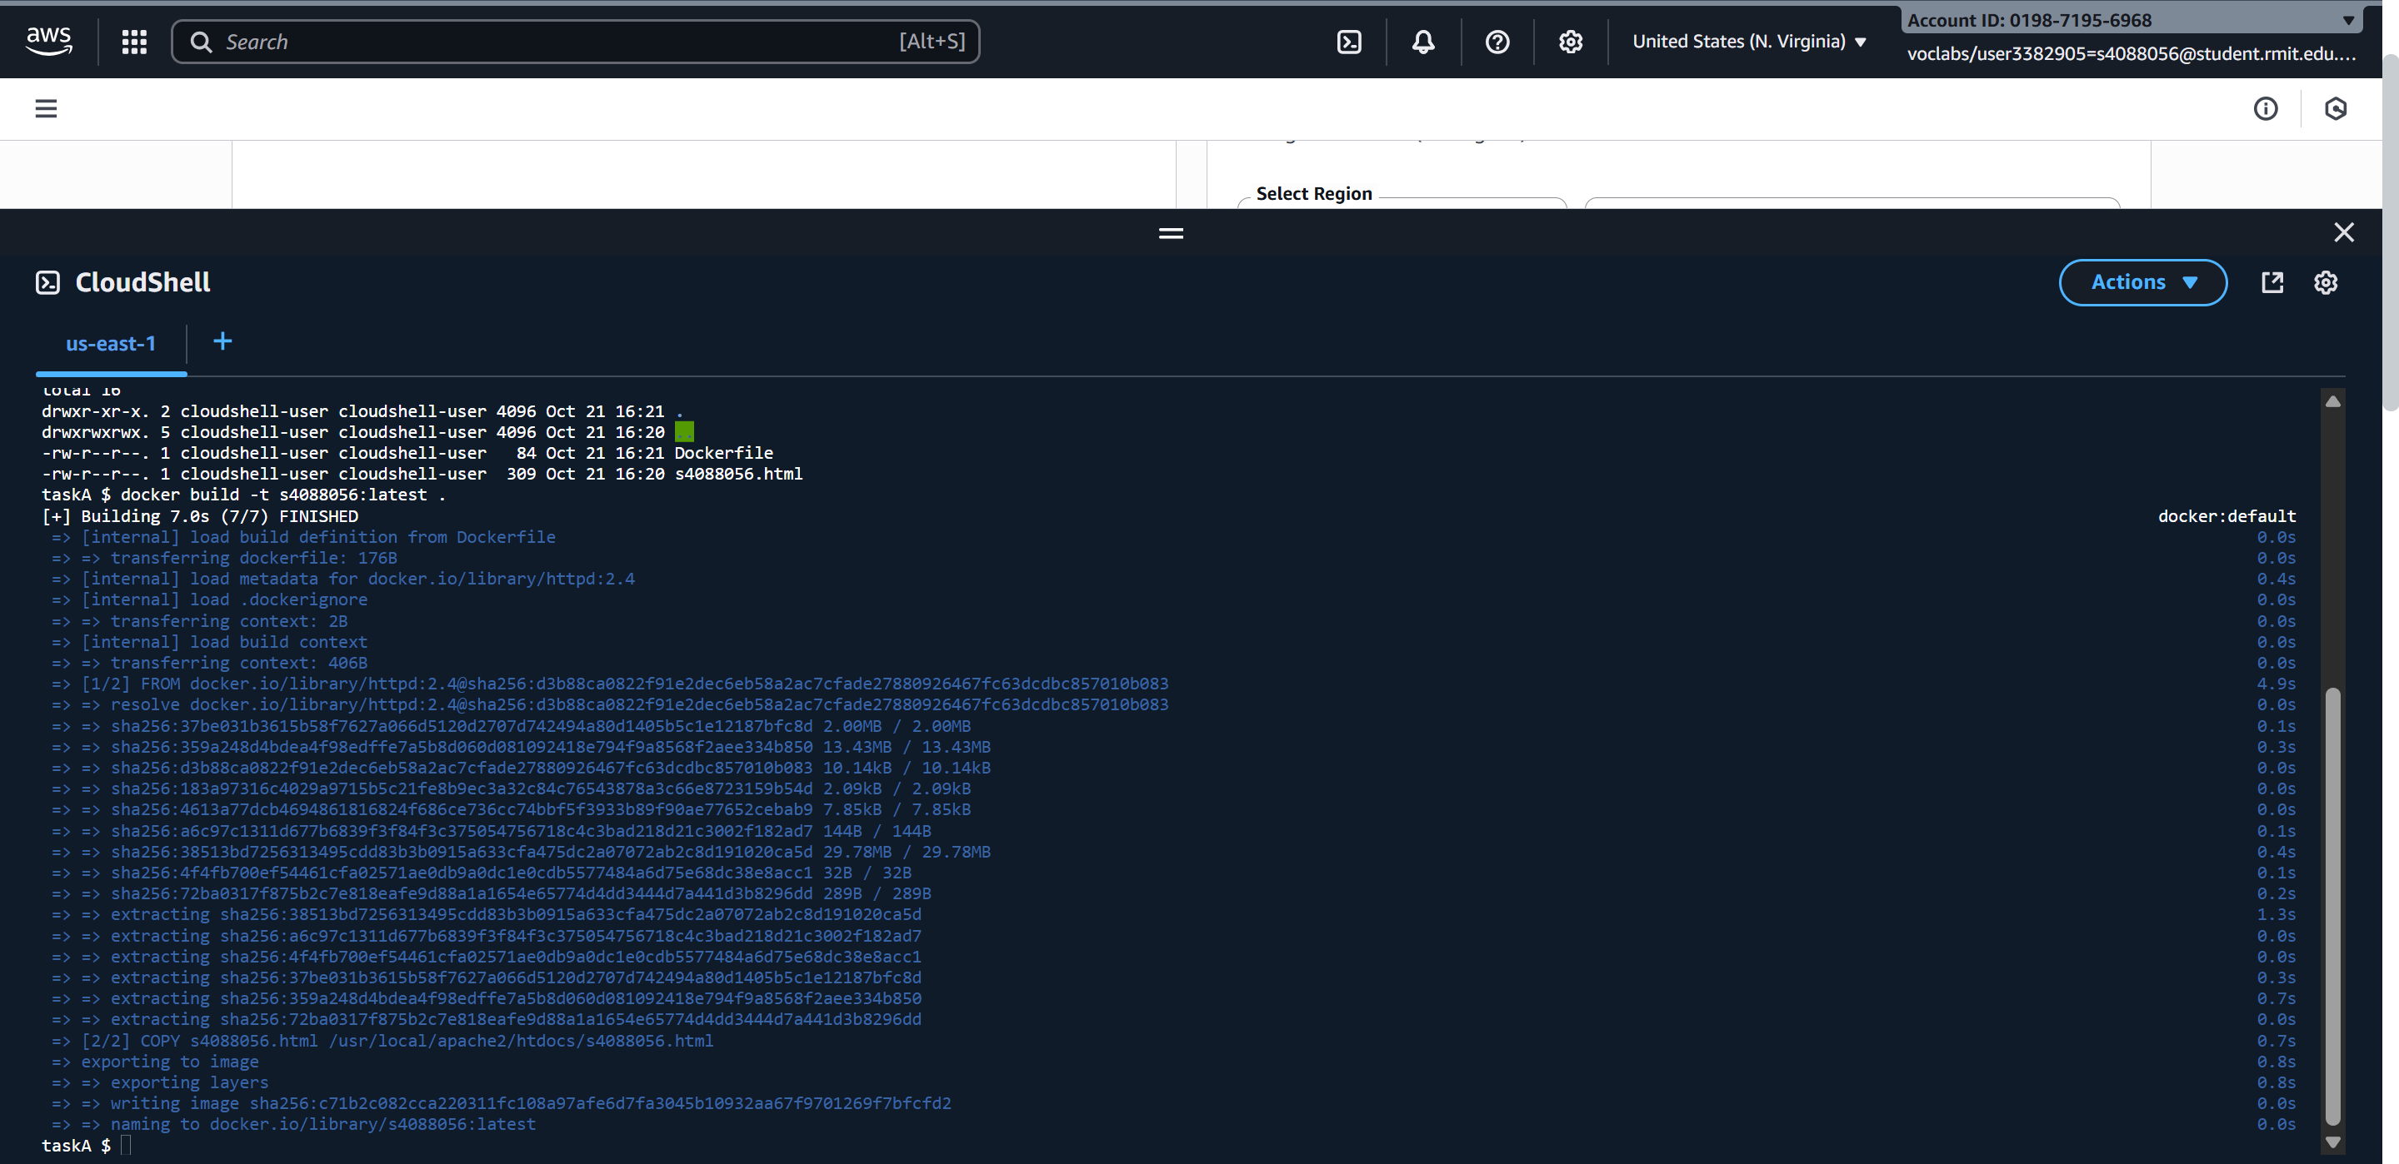
Step A-2 — Built Docker image and tagged as s4088056:latest
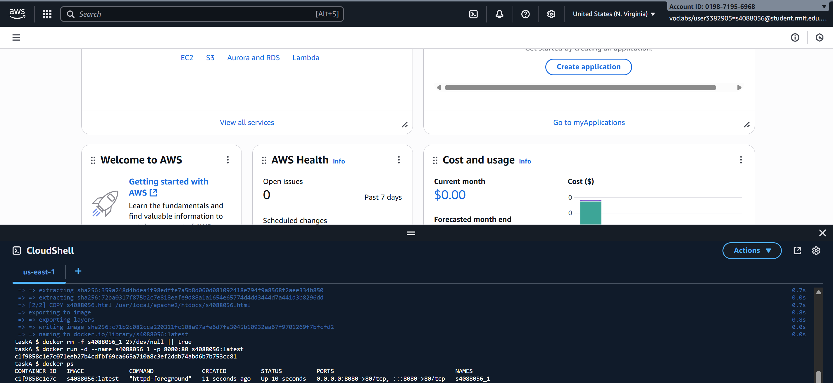
Step A-3 — Container s4088056_1 running, mapped host 8080 → container 80.

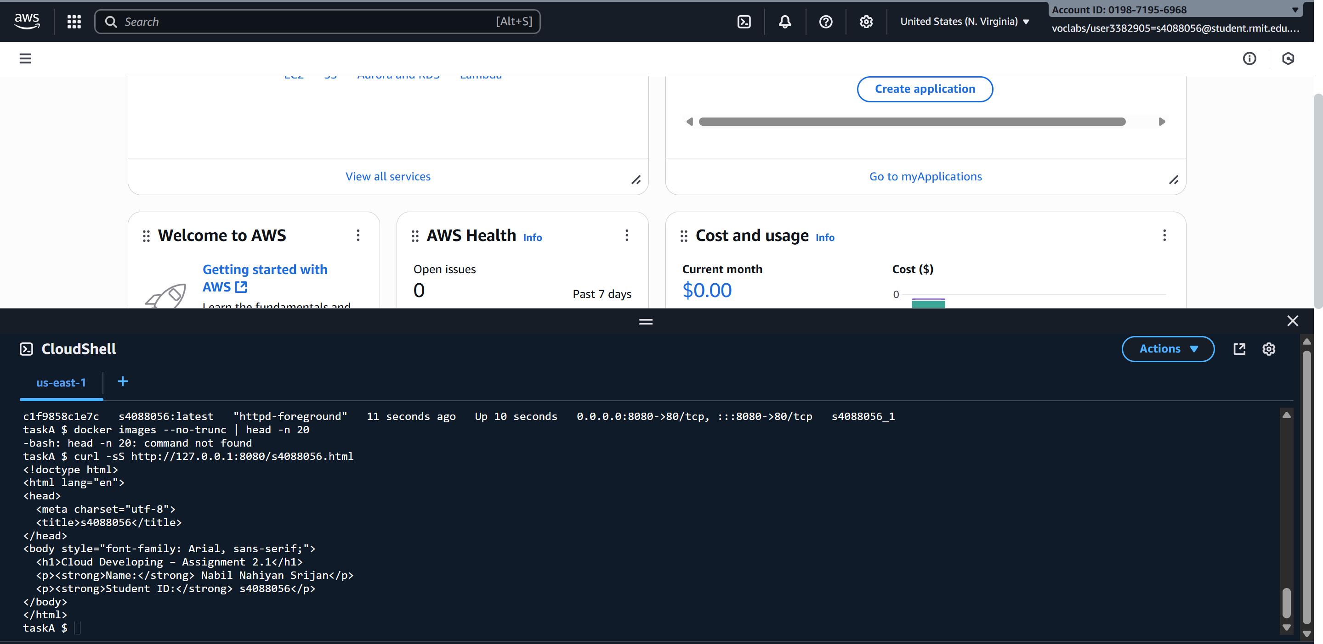
Step A-4 — Verified container output by curl; webpage displays student name and ID.
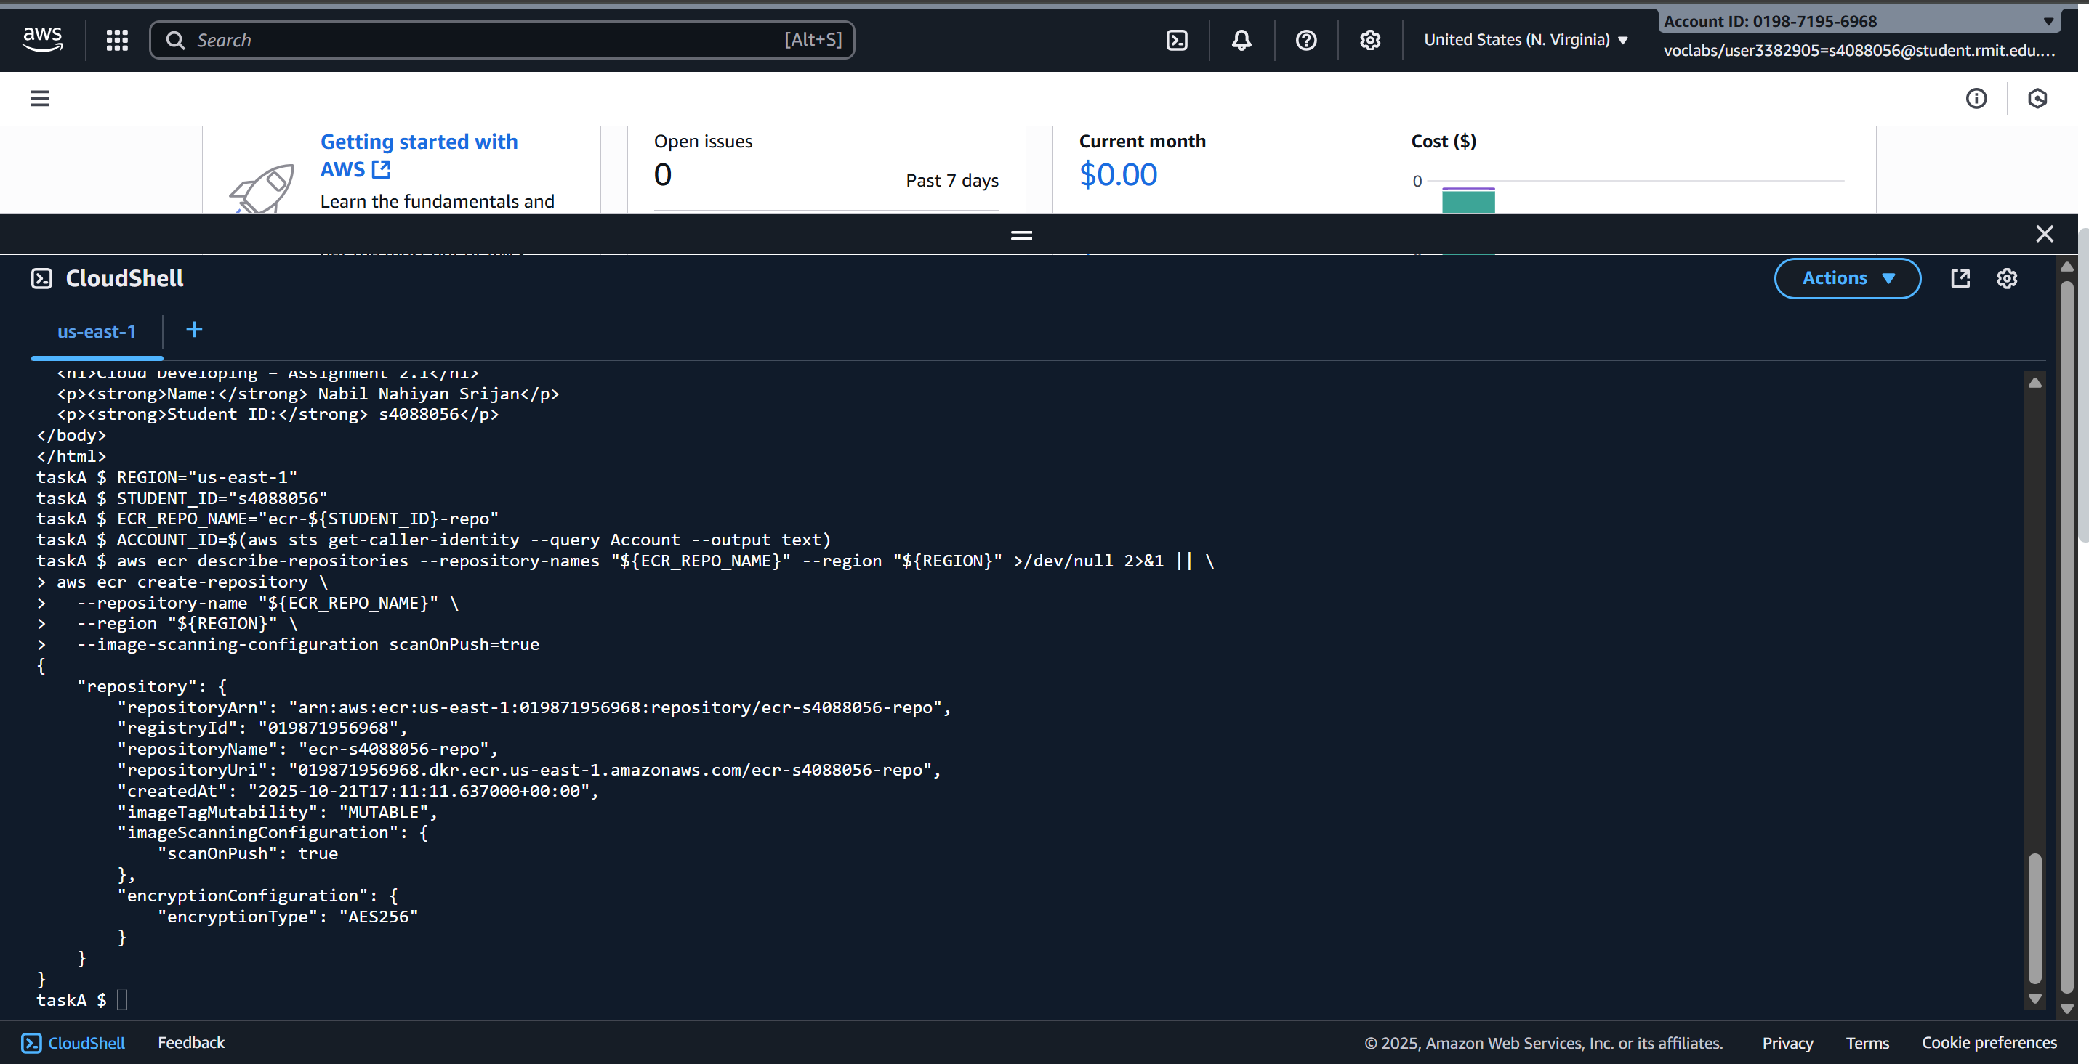
Step A-5 — Created ECR repository ecr-s4088056-repo successfully in region us-east-1

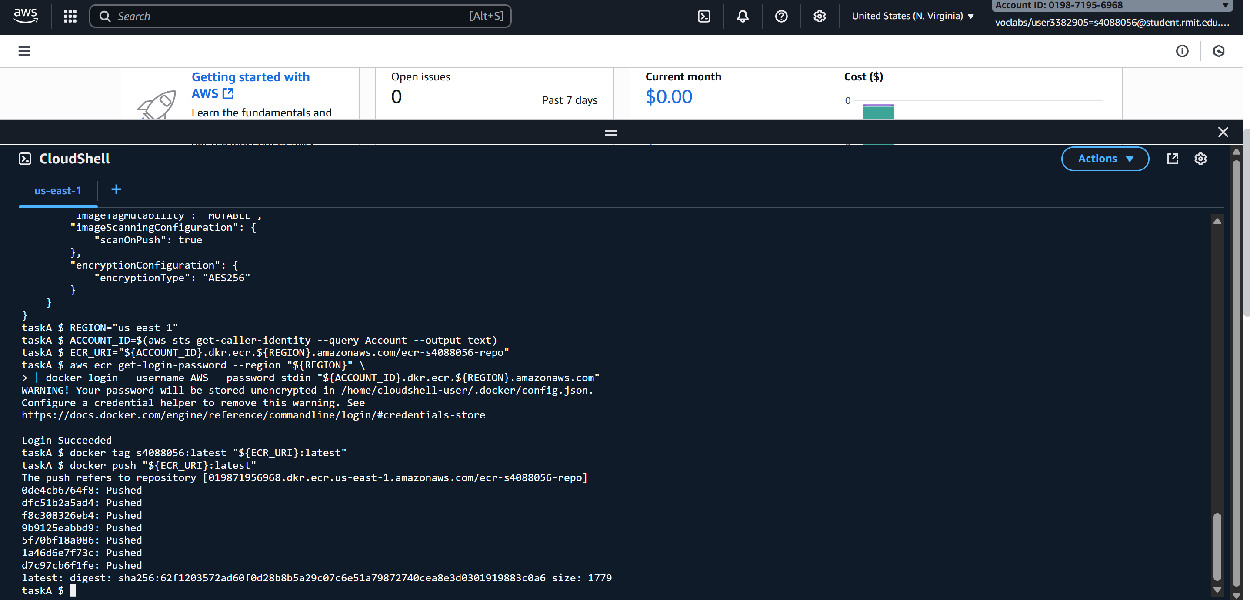
Step A-6 — Authenticated to ECR and successfully pushed image s4088056:latest to ecr-s4088056-repo.
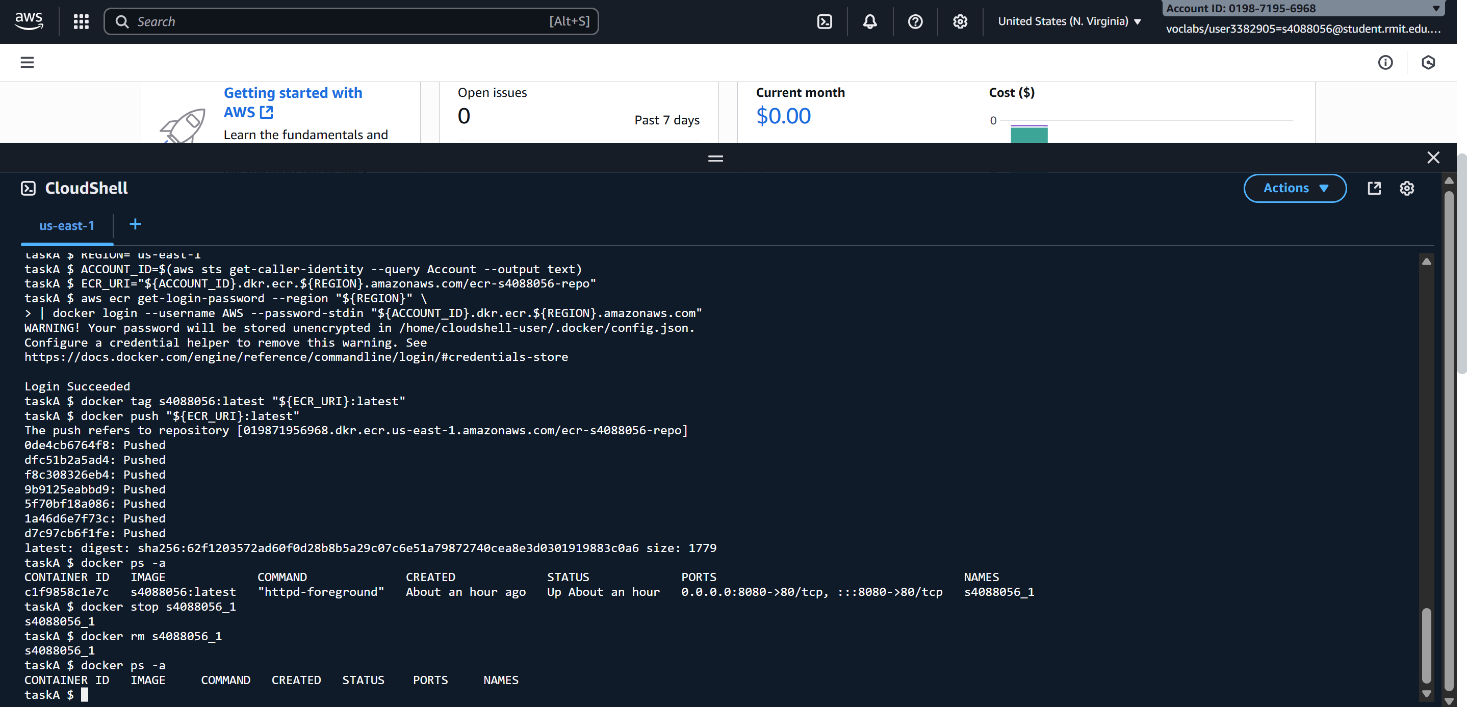
Step A-7 — Stopped and removed running container s4088056_1.

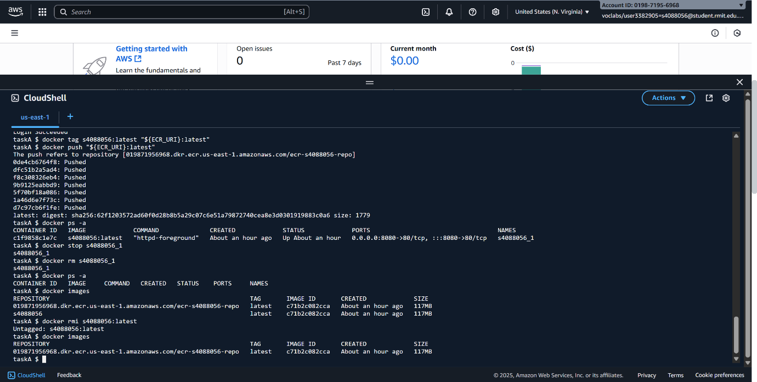
Step A-8 — Listed and removed local image s4088056:latest; verified cleanup complete.

