CSE440 Section-1 Project Group-8
ClueChain: A Bayesian Network-Based Mystery Solver Application
Md. Nazibul Islam Nabil  2222456042  Department of ECE  North South University  Dhaka, Bangladesh  nazibul.nabil@northsouth.edu | Tasnif Gaffar Pronoy  2222590042  Department of ECE  North South University  Dhaka, Bangladesh  tasnif.pronoy@northsouth.edu | Nazifa Tahsin  2132652642  Department of ECE  North South University  Dhaka, Bangladesh  nazifa.tahsin@northsouth.edu

Zinat Shaharin Mim  2111301042  Department of ECE  North South University  Dhaka, Bangladesh  zinat.mim@northsouth.edu | Jannat-a-habib-baishakhi  2131069642  Department of ECE  North South University  Dhaka, Bangladesh  jannat.baishakhi@northsouth.edu

Abstract—Making sound judgments under uncertainty is essential in complex domains that require combining evidence from several, often conflicting, sources. This paper presents ClueChain, an interactive application built to illustrate how probabilistic reasoning can be applied to a fictional crime scenario. The system is built around a Discrete Bayesian Network (DBN), implemented with the pgmpy library, which captures the relationships between the possible suspects and different categories of evidence, such as forced entry, alibis, and fingerprints. The graph structure reflects the assumed causal direction, running from Guilty Party to Evidence, while Conditional Probability Distributions (CPDs) quantify these relationships according to the logic of the scenario. A Streamlit-based graphical interface lets users enter observed clues dynamically. Once evidence is submitted, ClueChain runs the Variable Elimination algorithm to perform Bayesian inference and compute the posterior distribution P(GuiltyParty | Evidence), producing an updated, quantitative estimate of each suspect's likelihood of guilt. The application also uses graphviz to render the DBN structure, making the underlying conditional independence assumptions easier to see. Overall, ClueChain acts as a practical demonstration of how Bayesian Networks integrate evidence and update beliefs, offering an approachable way to understand probabilistic inference in decision-support contexts.
Index Terms—Bayesian networks, probabilistic inference, reasoning under uncertainty, conditional probability, variable elimination, decision support systems
I. INTRODUCTION
Reasoning under uncertainty sits at the core of artificial intelligence and decision-making, especially when incomplete or ambiguous evidence must be combined into a single judgment [1]. Deterministic approaches often struggle in these settings, whereas Bayesian Networks (BNs) provide a graphical framework that is well suited to modeling probabilistic relationships and carrying out inference [2], [3]. BNs capture conditional dependencies and, through Bayes' Theorem, offer a mechanism for updating beliefs as fresh evidence arrives, which makes them a natural fit for evidential reasoning problems. This paper presents ClueChain, an interactive application that demonstrates how BNs can be used to work through a fictional mystery scenario. Built with pgmpy [4] for the probabilistic model and Streamlit [5] for the interface, ClueChain represents the suspects and evidence variables as a Discrete Bayesian Network (DBN). The network's structure encodes the assumed causal influence of the Guilty Party on the various pieces of Evidence, and this influence is quantified through Conditional Probability Distributions (CPDs). As users enter clues, the system runs Bayesian inference through Variable Elimination [6], [7] to compute the posterior probability P(GuiltyParty | Evidence), and it visualizes the network structure with graphviz [8]. ClueChain is intended as a teaching tool that shows how an uncertain problem can be translated into a probabilistic model and how evidence integration unfolds through Bayesian inference. Although the case itself is fictional, the underlying principles carry over to real-world problems of evidence aggregation and assessment. The sections that follow describe the BN model, the implementation of the application, example usage, and our conclusions.
II. LITERATURE REVIEW
ClueChain draws on established work in probabilistic reasoning, particularly Bayesian Networks (BNs), and makes use of current software tools for building and visualizing the model. This section summarizes the relevant literature, with particular attention to conference contributions.
A. Probabilistic Reasoning and Bayesian Networks
Handling uncertainty has long been a central concern in Artificial Intelligence [1]. Early AI work was largely logic-based, but the need to represent probabilistic information drove significant progress in the field. Bayesian Networks, formalized through influential work often presented at venues such as Uncertainty in Artificial Intelligence (UAI) and the American Association for Artificial Intelligence (AAAI) [2], offer a graphical way to represent and reason about probabilistic dependencies. A BN consists of a Directed Acyclic Graph (DAG) in which nodes stand for random variables and edges denote direct influence, together with Conditional Probability Distributions (CPDs) that quantify those influences [3]. This structure allows the joint probability distribution to be represented compactly by encoding conditional independence assumptions [2], [3]. Pearl's foundational contributions established BNs as a principled approach to evidential reasoning [2]. The usefulness of BNs has since been shown across many application areas discussed at various conferences, from medical diagnosis systems presented at AMIA (American Medical Informatics Association) or AI in Medicine (AIME) [e.g., [9]] to system monitoring and diagnostics discussed at engineering or reliability conferences. These applications illustrate how BNs can combine multiple uncertain sources of evidence to support diagnostic or predictive judgments [10].
Building ClueChain depended on a handful of specialized software libraries. pgmpy, introduced at the Scientific Computing with Python (SciPy) conference [4], supplies the core tools for defining BN structures, specifying CPDs, and running inference algorithms such as VE within Python. Streamlit [5] was used for the interactive interface; it is a framework for quickly building data-centric web applications, though it is usually cited through its documentation rather than a conference paper. Finally, the BN structure is visualized with Graphviz, a graph-visualization toolset whose underlying ideas were introduced at software engineering venues [8]. ClueChain brings these theoretical foundations and software tools together into an interactive platform for exploring Bayesian evidence integration.
III. METHODOLOGY
A. Overview of Bayesian Networks and Probabilistic Inference
Bayesian networks (BNs) are probabilistic, directed, acyclic graphical (DAG) models [2], [3]. Nodes stand for random variables, arcs indicate direct dependencies between connected nodes, and conditional probability tables (CPTs) — referred to here as Conditional Probability Distributions (CPDs) for discrete variables — quantify those dependencies.
For n random variables X1, X2, …, Xn and a DAG G = (V, E) with n nodes, where node j corresponds to Xj, a BN represents the joint distribution of X1, X2, …, Xn as:
P(X1, X2, …, Xn) = ∏ⁿⱼ₌₁ P(Xj | Pa(Xj)) (1)
where Pa(Xj) is the set of parents of Xj in the graph G — that is, every variable Xi for which there is a directed edge (Xi, Xj) ∈ E.
1) Conditional Independence and Chain Rule:
The structure of a BN encodes conditional independence assumptions: a variable is conditionally independent of its non-descendants given its parents [2]. This lets the joint probability distribution over V = {X1, …, Xn} factor according to the graph's structure, as in Eq. 1 — a factorization commonly called the chain rule for Bayesian networks.
2) Marginalization:
Marginalization refers to computing the probability distribution of a subset of variables Q ⊆ V by summing (or, for continuous variables, integrating) the joint distribution over the remaining variables V \ Q:
P(Q) = Σ_{V\Q} P(X1, …, Xn) (2)
where the sum ranges over every possible configuration of the variables not in Q.
3) Probabilistic Inference:
Given a BN, probabilistic inference seeks the conditional probability distribution of a set of query variables Q ⊆ V, given that a set of evidence variables E ⊆ V has been observed to take specific values e.
Input:
• A Bayesian network representing P(X1, …, Xn).
• A set of evidence variables E ⊆ V together with their observed values e.
• A set of query variables Q ⊆ V, typically with Q ∩ E = ∅.
Output:
• The posterior probability distribution P(Q | E = e).
This posterior is obtained from the definition of conditional probability:
P(Q = q | E = e) = P(Q = q, E = e) / P(E = e) (3)
where the joint probabilities P(Q, E) needed in the numerator and denominator (for normalization) come from marginalizing the full joint distribution given by Eq. 1:
P(Q = q, E = e) = Σ_{V\(Q∪E)} P(X1, …, Xn) (4)
Algorithms such as Variable Elimination [6], [7] carry out this conditioning and marginalization efficiently by exploiting the structure of the factorization in Eq. 1.
B. Dataset Collection
A notable aspect of how ClueChain was built is that no traditional empirical dataset was collected or used. The goal was to build an illustrative application that demonstrates Bayesian Network reasoning within a controlled, narrative-driven setting, rather than to learn model parameters from real observations. As a result, we did not follow the usual steps of sourcing raw data, sampling, or compiling case records. Instead, the model was built entirely from the qualitative description of the fictional 'Case of the Missing Manuscript' scenario (described in Section III.D). This narrative served as a substitute for empirical data, forming the basis both for identifying the relevant variables and for the knowledge-engineering process used to derive the prior and conditional probabilities (CPDs) that parameterize the Bayesian Network (Section III.F). In this sense, the project's 'dataset' was the curated narrative itself, and 'data collection' meant translating the elements and relationships described in that narrative into the structure and parameters of the probabilistic model — a very different approach from data-driven modeling, where statistical patterns are extracted from large datasets to estimate parameters.
C. System Architecture
ClueChain is built as a modular Python application, with distinct libraries handling specific responsibilities across two main components. The probabilistic model and inference engine live in a dedicated backend module (e.g., mystery_solver.py). This module uses pgmpy [4] to define the Bayesian Network's structure (nodes and edges), specify the CPDs, and provide functions for validating the model and running inference. The frontend interface and interaction logic sit in the main application script (e.g., main.py), built with the Streamlit framework [5]. This script collects evidence from the user through interactive widgets, calls the backend inference engine's Variable Elimination routine from pgmpy [6], [7], and displays the prior and posterior probabilities using pandas DataFrames alongside Streamlit's charting tools. The network structure is visualized through the graphviz library [8], rendered conditionally when the library and its system dependencies are available. Splitting the probabilistic reasoning core from the presentation layer in this way keeps the codebase easier to maintain and extend.
D. Fictional Mystery Scenario Description
To give the Bayesian Network model and its inference a concrete setting, ClueChain is built around a specific fictional story: 'The Case of the Missing Manuscript.' In this scenario, a rare and valuable manuscript disappears overnight from a securely locked library room. Three suspects are considered, each with a different possible motive and opportunity. Suspect A, 'The Scholar,' had legitimate access to the library and a known professional rivalry with the manuscript's owner, giving a plausible motive. Suspect B, 'The Butler,' held keys to the room but says he heard nothing unusual overnight. Suspect C, 'The Cat Burglar,' is a known professional thief active in the area, presumably motivated by the manuscript's monetary value, though with no obvious prior connection to the premises. The scenario allows for several kinds of evidence: whether forced entry occurred, how well each suspect's alibi holds up, whether fingerprints matching a suspect were found, and whether security footage yields anything useful. This narrative, with its suspects, evidence types, and built-in uncertainty, forms the basis for the random variables, network structure, and conditional probabilities that make up the Bayesian Network described in the next section.
E. Data Representation
ClueChain represents data in several distinct forms, corresponding to the Bayesian Network's structure, its parameters, the evidence supplied by the user at runtime, and the resulting inferences. The core model structure — a Directed Acyclic Graph (DAG) — is represented internally through pgmpy's [4] DiscreteBayesianNetwork class. This object stores the network's nodes as string variables (e.g., 'GuiltyParty', 'ForcedEntry') and its directed edges as a list of dependency tuples (e.g., [('GuiltyParty', 'ForcedEntry'), ...]), matching the formal definition G = (V, E). For visualization, this structure is converted into a graphviz object [8] that draws the nodes and the dependencies between them.
The probabilistic parameters (Θ) that quantify the network's relationships are held in pgmpy's TabularCPD objects. Each TabularCPD represents the conditional probability distribution P(Xj | Pa(Xj)) for a single variable, storing the variable's name, its cardinality, information about its parent variables, and the probability values themselves in a multi-dimensional array. A key feature is the state_names dictionary, which maps numerical indices (0, 1, 2, …) to human-readable state labels (e.g., 0: 'Yes', 1: 'No'), keeping numerical computation consistent with conceptual understanding. Together, the full set of TabularCPD objects makes up the parameter set Θ for the Bayesian network B = (G, Θ).
At runtime, evidence supplied by the user is stored as a Python dictionary whose keys are variable names (e.g., 'ForcedEntry', 'Fingerprints') and whose values are the observed states (e.g., 'Yes', 'A'), matching the state_names defined in the corresponding CPDs. Variables the user leaves as 'Unknown' are deliberately left out of this dictionary, so the inference algorithm can marginalize properly over those unspecified states. This dictionary format feeds directly into pgmpy's inference methods through their evidence parameter.
The inference results — the posterior probability distribution over the GuiltyParty variable — are first produced as a pgmpy DiscreteFactor object. For display and interaction within the Streamlit interface [5], this is converted into a pandas DataFrame with two main columns: Suspect (holding the state names 'A', 'B', 'C' of the GuiltyParty variable) and Probability (the computed likelihood values). This tabular layout makes it easy to sort the results, format probabilities as percentages, and build comparative visualizations such as bar charts that show each suspect's relative likelihood.
F. Bayesian Network Design
Following the principles set out in Section III-A, we designed a Discrete Bayesian Network (DBN) to represent the 'Case of the Missing Manuscript.' The core random variables V consist of a hypothesis variable GuiltyParty (GP) with states {A, B, C}, standing for the three possible culprits (Scholar, Butler, and Cat Burglar respectively), together with six evidence variables: ForcedEntry (FE), AlibiA (AA), AlibiB (AB), AlibiC (AC), Fingerprints (FP), and SecurityFootage (SF), each with its own discrete states (e.g., FE: {Yes, No}; FP: {A, B, C, None}). The network structure G = (V, E) makes GuiltyParty the sole root node, with directed edges to every evidence variable, E = {(GP, Xj) | Xj ∈ {FE, AA, AB, AC, FP, SF}}. This encodes the assumption that, conditioned on GuiltyParty, all evidence variables are mutually independent. Fig. 1 shows this structure, drawn with Graphviz [8] for use in the application interface.
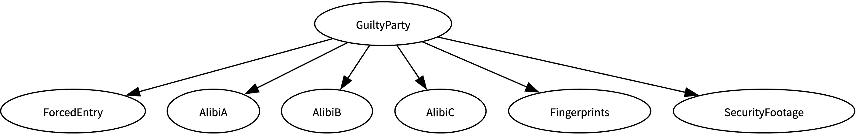
Fig. 1. Bayesian Network Model for ClueChain. 'GuiltyParty' is the root node, influencing all evidence variables.
The parameter set Θ was built up through careful probability assignments grounded in the narrative's logic. The root node was given a uniform prior, P(GP) = {P(GP = A) = 1/3, P(GP = B) = 1/3, P(GP = C) = 1/3}, reflecting unbiased initial beliefs about the three suspects. For every evidence node Xj, conditional probability distributions P(Xj | GuiltyParty) were defined through knowledge engineering, turning the scenario's description into concrete numbers. For example, to reflect the Cat Burglar's typical modus operandi, we set P(ForcedEntry = Yes | GuiltyParty = C) = 0.9, while the Scholar's legitimate access led us to set P(ForcedEntry = Yes | GuiltyParty = A) = 0.1. The same reasoning shaped the probabilities for alibis (e.g., P(AlibiA = No | GuiltyParty = A) = 0.8, capturing a higher chance that the guilty party lacks a solid alibi) and for fingerprints (e.g., P(Fingerprints = A | GuiltyParty = A) = 0.7). These distributions were worked out systematically for every relevant variable-state combination.
The implementation used pgmpy's [4] TabularCPD class to represent these probability distributions numerically. Each evidence variable's CPD was stored as a multidimensional array capturing how it depends on the different states of GuiltyParty. Together with the prior distribution for GuiltyParty, the full set of these CPDs forms the parameter set Θ of the ClueChain BN, B = (G, Θ). This design supports efficient probabilistic inference while remaining easy to interpret, since network parameters map clearly onto the mystery scenario's narrative.
G. Joint Distribution Representation & Marginalization Calculation
Together, the Bayesian Network structure and the CPDs designed in Section III-F implicitly define the full Joint Probability Distribution (JPD) over all variables V in the ClueChain model, following the factorization in Eq. 1. Importantly, the methodology never explicitly builds or stores the complete JPD table, which would be computationally impractical given how quickly the number of entries grows with the number of variables — in this case, 3 × 2 × 2 × 2 × 2 × 4 × 2 = 384 states, a manageable number here but still illustrative of the general problem. Instead, the JPD is represented implicitly through the collection of individual TabularCPD objects tied to each node in the pgmpy model [4]. This factorized representation keeps computation efficient while preserving probabilistic consistency.
Marginalization — summing out variables to obtain distributions over smaller subsets (Eq. 2) — is central to inference but is carried out computationally rather than by manipulating an explicit JPD. While prior marginal probabilities such as P(FE) could in principle be found by summing Eq. 1 over every other variable, marginalization mainly comes into play during inference, when computing posterior probabilities P(GP | E = e) via the Variable Elimination (VE) algorithm (Section III-H). VE eliminates the nuisance variables Z = V \ ({GP} ∪ E) one at a time by summing over intermediate factors built from the CPDs [6], [7]. This marginalization, embedded within VE, ensures that the resulting posterior for GuiltyParty properly accounts for the uncertainty in any evidence variables that were left unobserved. The pgmpy implementation optimizes these summation and multiplication steps by exploiting the network's structure to avoid redundant computation.
H. Probability Distribution Calculation Using Probabilistic Inference
The Bayesian Network built for ClueChain (Section III-F) implicitly defines the full Joint Probability Distribution (JPD) over V = {GP, FE, AA, AB, AC, FP, SF} through the chain-rule factorization in Eq. 1, given the network structure G and parameters Θ. This combines the prior distribution P(GP) for the root node with the CPDs P(Xj | GP) for each evidence variable Xj, stored as TabularCPD objects in pgmpy [4]. The main computational task is inference: finding the posterior distribution P(GP | E = e), which captures the updated belief about each suspect's guilt given the specific evidence e entered through the interface (Section III-I).
To perform exact inference, ClueChain implements the Variable Elimination (VE) algorithm [6], [7]. This choice follows from the network's structure: because it is a polytree — a DAG whose underlying undirected graph has no cycles — VE gives an efficient and exact method of inference [7]. We used pgmpy's [4] VariableElimination class. When the user requests a solution, inference proceeds through the following conceptual stages:
1) Evidence Instantiation: The algorithm folds the user's observations e into the model by restricting the factors derived from the CPDs to the rows or columns matching the observed states. Variables the user marked 'Unknown' are left without evidence and treated as unobserved.
2) Factor Multiplication and Summation (Elimination): VE works over the set of factors, made up of the initial CPDs and the prior. It picks an elimination order for the non-query, non-evidence variables Z = V \ ({GP} ∪ E). For each variable Zk being eliminated, VE multiplies together every factor involving Zk, then sums Zk out of the resulting product — this step is the marginalization process in action.
3) Result Computation: Once every variable in Z has been eliminated, the factors left involve only the query variable GP and, potentially, evidence variables that happened to be parents of GP (which does not occur here). Multiplying these remaining factors together yields the joint probability P(GP, E = e).
4) Normalization: The factor representing P(GP, E = e) is then normalized by dividing by P(E = e) = Σ_gp P(GP = gp, E = e), producing the final posterior distribution P(GP | E = e).
The algorithm's output is the posterior distribution P(GP | E = e), a discrete probability vector over {A, B, C} that reflects the system's updated belief about which suspect is guilty given the evidence. This distribution is then handed off to the user interface for display (Section III-I). Because VE is exact for this network topology, and because its complexity is exponential only in the graph's treewidth — which is small for polytrees [7] — it remains efficient enough for interactive use while guaranteeing exact results.
Choosing Variable Elimination (VE) as the inference algorithm followed from the size and structure of the ClueChain network. Since the network is fairly small (seven variables) and follows a simple polytree structure — specifically, a naive Bayes structure where evidence nodes depend only on the class node — VE offers an efficient way to compute exact posterior probabilities. Its computational cost is manageable for this topology, O(n · d²), where n is the number of variables and d is the largest domain size for a naive Bayes structure. This avoids the need for approximate techniques such as sampling, which would likely be necessary for larger, more densely connected networks but would also introduce approximation error. Using VE ensures the probabilities shown to the user are the exact results dictated by the model's structure, its CPDs, and the evidence provided — in keeping with the goal of clearly illustrating Bayesian inference without the complication of approximation error.
I. User Interaction and Interface
To let users work directly with the Bayesian Network model and its inference process, we built an interactive web-based interface with the Streamlit library [5]. The interface pursues two main goals: (1) offering an intuitive way to enter evidence and (2) clearly displaying the prior and posterior probability distributions over the suspects. The layout typically places a sidebar panel for user input and introductory or scenario text, while the main panel shows the Bayesian Network's structure (when available) and the inference results. Evidence is collected through a series of Streamlit st.selectbox widgets in the sidebar, one per evidence variable (e.g., ForcedEntry, AlibiA, Fingerprints, SecurityFootage). Each selectbox lets the user pick the observed state for that variable from a predefined list matching its domain (e.g., ['Yes', 'No', 'Unknown'] for ForcedEntry; ['A', 'B', 'C', 'None', 'Unknown'] for Fingerprints). Every selectbox consistently includes an 'Unknown' option; choosing it signals that no observation is available for that piece of evidence, and this choice is handled explicitly while preparing the evidence before inference.
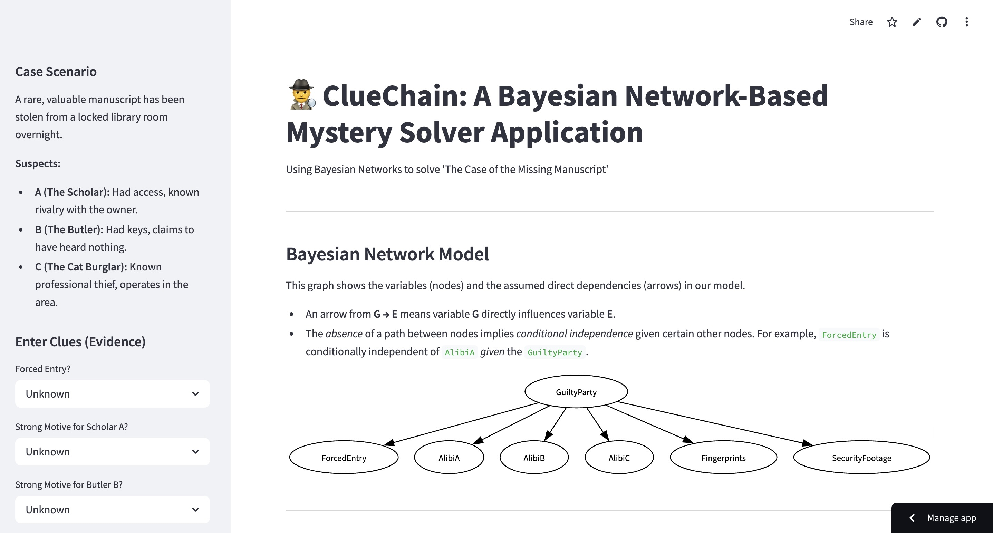
Fig. 2. ClueChain App UI Interface: Sidebar for Inputting Evidence ('Unknown' option allows omitting evidence).
When the user clicks the 'Solve Mystery' button (built with st.button), the application starts the inference process, which involves several steps inside the Streamlit script. First, it reads the current state of each evidence selectbox and builds a Python dictionary representing the evidence set E = e needed by the pgmpy inference engine (Section III-H). This dictionary maps variable names to their observed states, leaving out any variable the user set to 'Unknown' — only variables with a specific observed state make it into the evidence dictionary passed to the inference function. The system then calls the backend inference function, which runs the Variable Elimination algorithm (Section III-H) with this evidence dictionary. The resulting posterior distribution P(GP | E = e) comes back as a pgmpy factor or a pandas DataFrame. The results then appear in the main panel of the Streamlit app through several synchronized views: a formatted table (built with pandas and shown via st.dataframe or st.table) listing each suspect ('A', 'B', 'C') with their posterior probability of guilt, usually shown as a percentage; and, alongside it, a bar chart (built with Streamlit's native charting, e.g., st.bar_chart) comparing the suspects' relative likelihoods. If graphviz [8] and its system dependencies are available, the interface also draws the Bayesian Network's DAG (Fig. 1) using st.graphviz_chart, helping users see the underlying probabilistic dependencies.
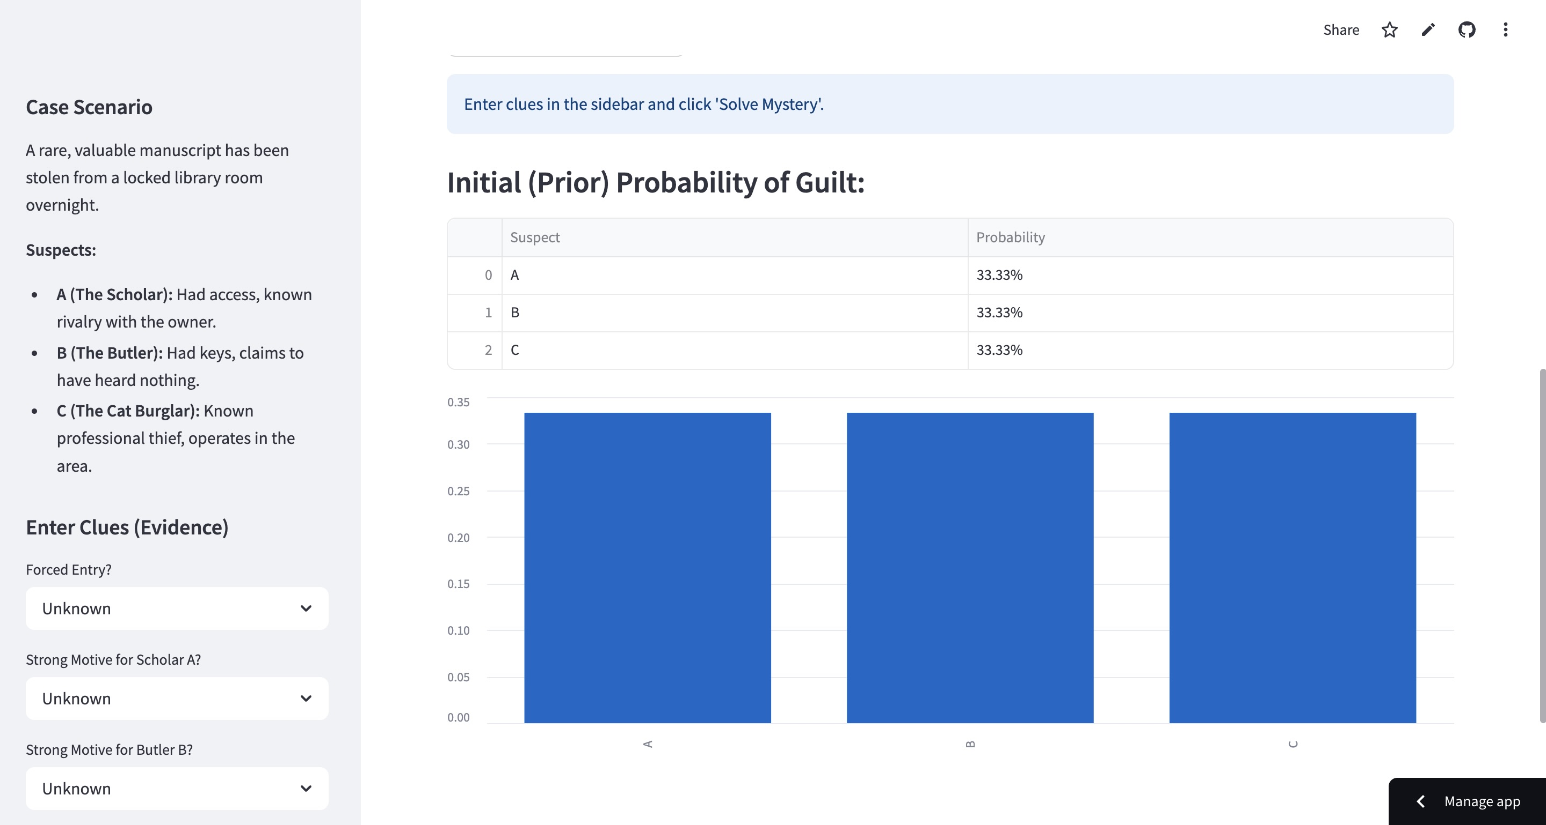
Fig. 3. ClueChain App UI Interface: Main Panel Displaying Posterior Probability of Guilt (Table and Bar Chart).
This interface design accomplishes several methodological goals. It keeps a clear correspondence between the theoretical Bayesian Network model (Sections III-F, III-H) and how the user interacts with it. It gives immediate, intuitive feedback on how new or changed evidence shifts the level of suspicion attached to each suspect, illustrating the idea of Bayesian belief updating. It also lets users freely explore different hypothetical scenarios by changing the evidence and watching how the probabilities shift, creating an interactive learning or investigative experience grounded in rigorous probabilistic reasoning. Because the implementation relies on Streamlit's [5] reactive programming model, the display automatically refreshes whenever an input widget changes or the inference button is pressed, keeping the experience seamless and responsive.
IV. RESULT
ClueChain successfully implements and demonstrates Bayesian inference for a fictional mystery scenario through its Streamlit-powered [5] web interface. When the application launches, it correctly initializes and displays the prior probability distribution for the GuiltyParty (GP) variable. With no evidence entered yet, each suspect (A: Scholar, B: Butler, C: Cat Burglar) is given an equal likelihood of guilt, P(GP) = {A: 0.333, B: 0.333, C: 0.333}. This uniform prior appears both numerically, in a pandas DataFrame table, and visually, in a bar chart in the main panel, establishing a clear baseline belief before any evidence comes in. If Graphviz [8] is configured, the interface simultaneously renders the Bayesian Network's DAG (as in Fig. 1), confirming visually that GuiltyParty is the parent node driving all six evidence variables (FE, AA, AB, AC, FP, SF). This starting state makes the model's initial assumptions and structure clear before any evidence is introduced.
The core functionality — driven by the sidebar evidence widgets in Fig. 2 — behaves as expected. When users pick specific states for one or more evidence variables (for example, ForcedEntry='Yes', AlibiC='No', Fingerprints='C') and click 'Solve Mystery' to trigger inference, the application correctly interfaces with the pgmpy [4] backend. The Variable Elimination algorithm (Section III-H) then computes the exact posterior probability distribution P(GP | E = e) based on the supplied evidence e. Evidence variables left as 'Unknown' are properly excluded from the evidence dictionary passed to the inference engine, ensuring the correct marginalization over unobserved variables as Bayesian principles require.
The main panel (Fig. 3) then updates dynamically to reflect the new posterior probabilities. Both the table and the bar chart refresh instantly, giving immediate feedback on how the entered evidence changes the belief about each suspect's guilt. Testing across a range of evidence combinations confirmed that the system produces results that stay logically consistent with the predefined CPDs:
A. Scenario Examples
To show how the system behaves under different evidence patterns, consider two scenarios drawn from the fictional 'Case of the Missing Manuscript':
Scenario 1: Strong Evidence Against the Cat Burglar (Suspect C). Suppose the user enters the following evidence:
• Forced Entry (FE): Yes
• Alibi A (AA): Yes
• Alibi B (AB): Yes
• Alibi C (AC): No
• Fingerprints (FP): C
• Security Footage (SF): Obscured (treated as 'Unknown', or a state indicating no useful information)
After clicking 'Solve Mystery,' ClueChain processes this evidence. Forced entry strongly points toward Suspect C (P(FE=Yes | GP=C) = 0.9). C's lack of an alibi (P(AC=No | GP=C) is high, e.g., 0.8) and the discovery of C's fingerprints (P(FP=C | GP=C) is high, e.g., 0.7) add further incrimination. Meanwhile, confirmed alibis for A and B substantially lower their likelihood (P(AA=Yes | GP=A) and P(AB=Yes | GP=B) are both low, e.g., 0.2). The inference algorithm combines all of this evidence through Bayes' theorem, and the resulting posterior would be heavily skewed toward Suspect C — likely P(GP=C | e) > 0.95 — while P(GP=A | e) and P(GP=B | e) would sit close to zero. The bar chart would clearly single out C as the dominant suspect.
Scenario 2: Ambiguous Evidence. Now consider a scenario with less clear-cut clues:
• Forced Entry (FE): No
• Alibi A (AA): No
• Alibi B (AB): Yes
• Alibi C (AC): Yes
• Fingerprints (FP): None
• Security Footage (SF): Unknown
Here the evidence is mixed. The absence of forced entry may slightly favor insiders A or B over C (since P(FE=No | GP=A/B) > P(FE=No | GP=C)). A's missing alibi raises suspicion toward A (P(AA=No | GP=A) is high), while B's and C's confirmed alibis lower suspicion toward them (P(AB=Yes | GP=B) and P(AC=Yes | GP=C) are both low). The absence of identifiable fingerprints ('None') offers little discriminating power, though depending on how P(FP=None | GP) is set in the CPDs, it might slightly favor whoever is less likely to leave prints, such as someone who wore gloves. When ClueChain processes this evidence, the posterior probabilities would likely come out more spread across the suspects than in Scenario 1. Suspect A's probability would rise from the prior because of the missing alibi, though the lack of forced entry might soften that rise or lean slightly toward B. Suspect B might hold onto some probability because of having keys, despite the confirmed alibi. Suspect C's probability would likely fall noticeably given the absence of forced entry and the confirmed alibi. A representative output might be P(GP=A | e) ≈ 0.60, P(GP=B | e) ≈ 0.30, P(GP=C | e) ≈ 0.10.
The visualization would capture this remaining uncertainty, showing A as the most likely suspect while still leaving B as a real possibility.
Together, these examples show the system's core capability: combining several, potentially conflicting pieces of evidence within the defined probabilistic model — its structure and CPDs — to produce a reasoned, quantitative estimate of likelihoods that updates dynamically from the prior based on the specific evidence pattern entered.
V. DISCUSSION
ClueChain shows how Bayesian Networks can work as an interactive reasoning tool, connecting abstract probabilistic ideas with a hands-on user experience. Its design turns theoretical building blocks — prior probabilities, conditional probability distributions (CPDs), evidence observation, and posterior probability calculation through inference (Eq. 4) — into an intuitive interface where users directly manipulate inputs and watch the belief state P(GP | E = e) update in real time. Built on pgmpy [4] for the probabilistic modeling and inference, Streamlit [5] for rapid web development, and, optionally, Graphviz [8] for visualizing the model, this implementation works both as a functional prototype and as a useful teaching tool. The network visualization (Fig. 1) is especially helpful for clarifying the model's underlying conditional independence assumptions — namely, that pieces of evidence are independent of one another given the guilty party. The immediate feedback loop between selecting evidence and seeing the resulting shift in posterior probabilities (Fig. 3) effectively demonstrates the core Bayesian idea of belief updating, making probabilistic reasoning more approachable even for users without a strong statistics or AI background.
That said, the model's outputs need to be read in light of its design choices and limitations. The posterior probabilities ClueChain produces depend not just on the observed evidence e but also, critically, on the predefined network structure G and the manually specified CPD parameters Θ. These parameters came from knowledge engineering based on the logic of the fictional narrative rather than from empirical data — a challenge common to many practical Bayesian Network applications, where reliably eliciting or estimating such probabilities can be difficult, especially in domains short on statistical data [10]. While the model correctly works out the mathematically sound consequences of its assumptions and the given evidence using exact inference (VE [6]), the resulting probabilities express beliefs conditional on the model itself rather than objective facts. The current model also makes a significant simplifying assumption: conditional independence between all evidence variables given the guilty party, i.e., a naive Bayes structure. Real investigations often involve more complex interdependencies between pieces of evidence that this model does not capture. Restricting the scope to three suspects and six evidence types in a single fixed scenario trades realism for pedagogical clarity on purpose. These limitations are acceptable given the project's goal as an educational demonstration, but they do mark a clear gap between this prototype and a system built for real-world forensic analysis.
A. Limitations
Even as a useful educational demonstration, ClueChain has several limitations that stem mainly from prioritizing pedagogical clarity over real-world complexity. The model uses a heavily simplified naive Bayes structure, assuming conditional independence between all evidence variables given the guilty party, and so ignores interdependencies that often matter in real investigations [10]. The CPDs and prior probabilities were also set through subjective knowledge engineering based on the fictional narrative rather than empirical data, which makes the model's outputs highly sensitive to these particular parameter choices and leaves them without objective grounding [10]. The scope is narrow — a single scenario with a small, fixed set of suspects and evidence types — which limits how broadly the results generalize and rules out validation against real case data. The reliance on discrete variable states also struggles to capture the nuance and uncertainty typical of real evidence, and the model itself is static, with no mechanism for learning or adapting beyond processing the predefined inputs. Taken together, these constraints mean ClueChain is best understood as a tool for illustrating Bayesian principles, not as a robust system for practical forensic analysis or complex decision support.
VI. FUTURE WORK
Several directions could make ClueChain more realistic and useful going forward. First, the model's structure could move beyond the naive Bayes assumption to capture dependencies between evidence variables, better reflecting real-world scenarios, though this would call for more sophisticated causal reasoning and likely more involved CPD elicitation [3]. Second, the reliance on subjective, manually defined parameters could be reduced by exploring data-driven approaches — if suitable data were available, techniques such as Maximum Likelihood or Bayesian parameter estimation could be applied using libraries like pgmpy [4], [7] to learn CPDs empirically, paired with sensitivity analysis to gauge how robust the model is to parameter uncertainty [10]. Third, to handle larger and more complex networks where exact inference via Variable Elimination [6] becomes computationally impractical, future versions could add approximate inference methods such as MCMC or variational techniques, which would also help users see the trade-off between computational cost and accuracy [7]. Finally, the interface could be expanded to visualize these richer models, show outputs from approximate inference (such as confidence intervals), and give users more direct interaction with the model's structure or parameters.
VII. CONCLUSION
This paper introduced ClueChain, an interactive web application built to demonstrate how Bayesian Networks can be applied to reasoning under uncertainty in the context of a fictional mystery-solving scenario. Using a Discrete Bayesian Network implemented with pgmpy [4], the system models the probabilistic relationships between the possible suspects (GuiltyParty) and various forms of evidence. Users can enter observed clues interactively through a Streamlit-based graphical interface [5]. Once evidence is submitted, the application runs the Variable Elimination algorithm [6], [7] to perform exact Bayesian inference, computing and displaying the updated posterior probability distribution over the suspects. Optional integration with Graphviz [8] further helps users understand the network's underlying structure and conditional independence assumptions.
ClueChain effectively demonstrates the core strengths of Bayesian methods: the ability to formally combine multiple, disparate pieces of evidence and to update beliefs quantitatively as new information comes in. While the current implementation carries limitations tied to its pedagogical focus — namely a simplified model structure and subjective, manually defined parameters — it works well as an accessible tool for teaching the fundamentals of probabilistic reasoning and belief updating. It also points to the broader potential of Bayesian Networks as a framework for building decision-support systems in domains marked by uncertainty and the need to synthesize evidence. Future work could focus on adding more realistic dependencies to the model, exploring data-driven parameter learning, investigating approximate inference methods for scalability, and enriching the interface to give users deeper insight into the reasoning process.
REFERENCES
[1] S. Russell and P. Norvig, Artificial Intelligence: A Modern Approach, 4th ed. Hoboken, NJ, USA: Pearson Education, Inc., 2020.
[2] J. Pearl, Probabilistic Reasoning in Intelligent Systems: Networks of Plausible Inference. San Mateo, CA, USA: Morgan Kaufmann Publishers Inc., 1988.
[3] F. V. Jensen and T. D. Nielsen, Bayesian Networks and Decision Graphs, 2nd ed. New York, NY, USA: Springer Science+Business Media, LLC, 2007.
[4] A. Ankan and A. Panda, "pgmpy: Probabilistic Graphical Models using Python," in Proceedings of the 14th Python in Science Conference (SciPy), Austin, TX, USA, Jul. 2015, pp. 91–96.
[5] Streamlit Inc., "Streamlit Documentation," 2023. [Online]. Available: https://streamlit.io/
[6] R. Dechter, "Bucket elimination: A unifying framework for probabilistic inference," in Proceedings of the Twelfth International Conference on Uncertainty in Artificial Intelligence (UAI'96), E. Horvitz and F. Jensen, Eds. San Francisco, CA, USA: Morgan Kaufmann Publishers Inc., 1996, pp. 211–219.
[7] D. Koller and N. Friedman, Probabilistic Graphical Models: Principles and Techniques. Cambridge, MA, USA: The MIT Press, 2009.
[8] E. R. Gansner and S. C. North, "An open graph visualization system and its applications to software engineering," Software: Practice and Experience, vol. 30, no. 11, pp. 1203–1233, Sep. 2000.
[9] L. C. van der Gaag, S. Renooij, C. L. M. Witteman, B. M. P. Aleman, and B. G. Taal, "Probabilities for a probabilistic network: a case study in oesophageal cancer," Artificial Intelligence in Medicine, vol. 25, no. 2, pp. 123–148, Jun. 2002.
[10] K. B. Korb and A. E. Nicholson, Bayesian Artificial Intelligence, 2nd ed. Boca Raton, FL, USA: CRC Press, Taylor & Francis Group, 2010.
[11] Stanford University, "Bayesian Networks 1 - Inference — Stanford CS221: AI (Autumn 2019)," YouTube, Oct. 2019. [Online]. Available: https://youtu.be/U23yuPEACG0. [Accessed: 24-Feb-2025].
[12] "Evidence in Context: Bayes' Theorem and Investigations," YouTube, [Online]. Available: https://youtu.be/EC6bf8JCpDQ. [Accessed: Feb. 24, 2025].

