Hardware implementation
Of the LUX algorithm

Dual Port RAM

Input
Message

Dual Port RAM

Output
Core C3
ramMt_we
ramMt_d
ramMt_addr

ramC3_we
ramC3_addr
ramC3_q
done
clk
rst
run
message_lenght

Lux controller

One Round
lux
Read
message
write
C3

ctr

Figure 1: Overall schema block
Main idea:

Message is transmitted to the LUX using the Dual RAM (Input Message), and gets the cripted message using the Dual RAM (output core C3). The message is first placed in to RAM via write operation using those pin: ramMt_we, ramMt_d, ramMt_addr, the message length is assigned to pin message_lenght. Next we launch the run of the LUX algorithm using the pin run; we wait for the end for the end execution of the LUX algorithm when the pin done go high. The result is stored on the Dual RAM (Output Core C3). Finally we recuperate the cripted message from this RAM via read operation using those pin: ramC3_we, ramC3_addr, ramC3_q.

LUX algorithm one round.
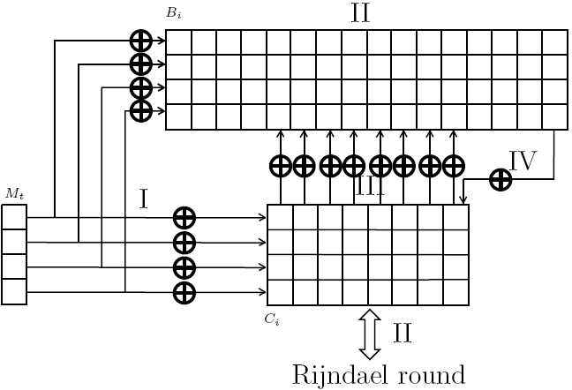

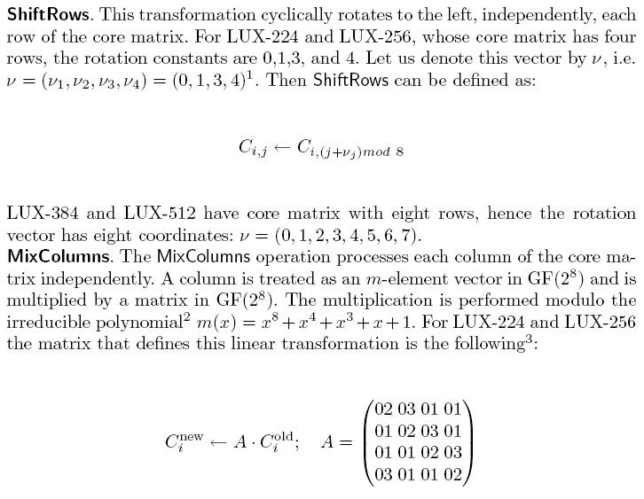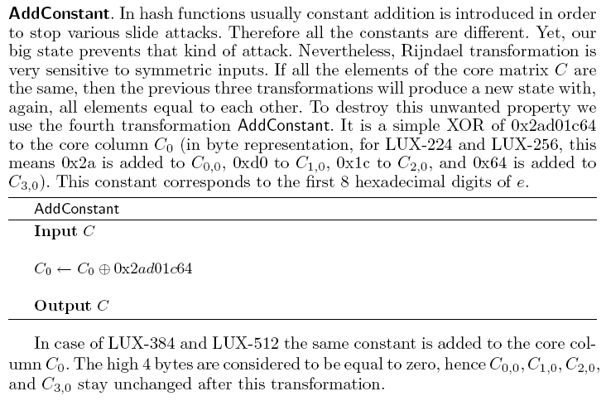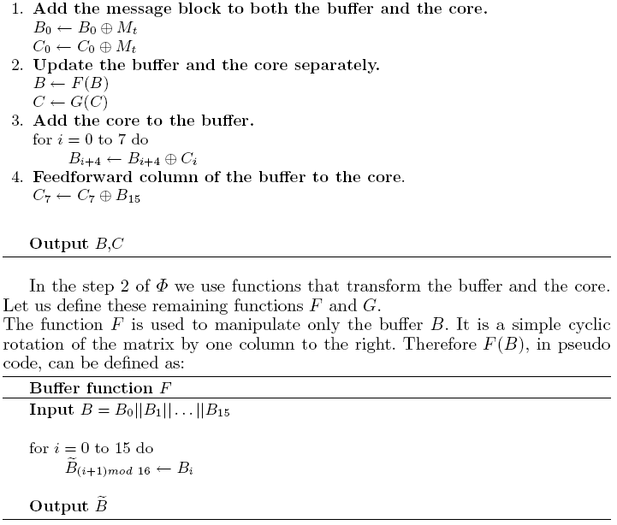
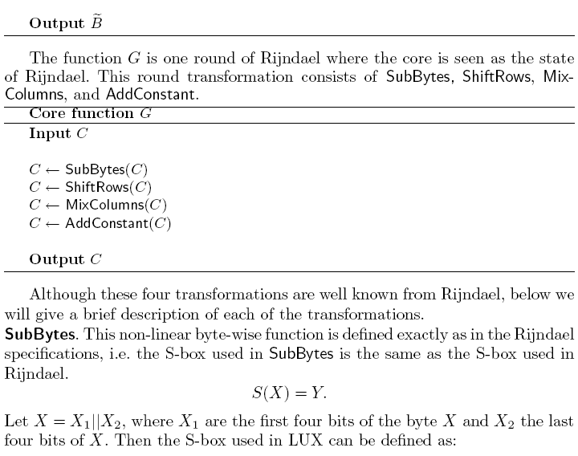

Rijndael round

LUX
clk
rst
start
Start_rst
Mt
Cout
done
Figure 2: One Round in/out pin

entity lux is
Port ( clk : in STD_LOGIC;
rst : in STD_LOGIC;
start : in STD_LOGIC;
start_rst : in STD_LOGIC;
done : out STD_LOGIC;
Mt : in STD_LOGIC_VECTOR (31 downto 0);
Cout : out STD_LOGIC_VECTOR (31 downto 0));
end lux;

One round is implemented using the state machine (figure 3), we first present the message in the pin Mt, next launch the algorithm using the pin start or pin start_rst to reset the Core and Buffer matrix.

The design perform those operation: addMessage, functionF, subBytes, shiftRows, mixcoluns, addconstant, Add_core_to_buffer, Feedfw_buffer_to_core.

All those function are performed in one clock period, except: mixcoluns and subBytes which are implemented on 32 clock period. We can count the preferment of the algorithm do make one round: 6 + 32*2 = 70 clock period.

idle
init_soft_rst
add_message
start_rst
start_rst
function_F
SubBytes
ShiftRows
count_reg = 31
MixColumns
AddConstant
count_reg = 31
Add_core_to_buffer
Feedfw_buffer_to_core

Figure 3: One Round state machine
Here is the code of how this is implemented for the Buffer matrix

combinatory_bmem_next : process( Bmem_reg, state_reg,Cmem_reg,Mt_reg )
begin
Bmem_next <= Bmem_reg;
case state_reg is
when idle =>
when init_soft_rst =>
Bmem_next <= (others=>(others=>'0')) ;
when add_message =>
Bmem_next (0) <= Bmem_reg (0) xor Mt_reg;
when function_F =>
Bmem_next (0) <= Bmem_reg (15);
for i in 0 to 14 loop
Bmem_next (i+1) <= Bmem_reg (i);
end loop;
when Add_core_to_buffer =>
for i in 0 to 7 loop
Bmem_next (i+4) <= Bmem_reg (i+4) xor Cmem_reg(i);
end loop;
when others =>
end case;
end process;

Here is the code of how this is implemented for the Core matrix

combinatory_Cmem_next : process( Cmem_reg, state_reg,Bmem_reg,Mt_reg,count_reg ,sub_index_row,mixcol)
begin
Cmem_next <= Cmem_reg;
case state_reg is
when idle =>
when init_soft_rst =>
Cmem_next <= (others=>(others=>'0')) ;
when add_message =>
Cmem_next (0) <= Cmem_reg (0) xor Mt_reg;
when ShiftRows =>

-- row 1
Cmem_next (7)(15 downto 8) <= Cmem_reg (0)(15 downto 8);
for i in 0 to 6 loop
Cmem_next (i)(15 downto 8) <= Cmem_reg (i+1)(15 downto 8);
end loop;

-- row 2
Cmem_next (5)(23 downto 16) <= Cmem_reg (0)(23 downto 16);
Cmem_next (6)(23 downto 16) <= Cmem_reg (1)(23 downto 16);
Cmem_next (7)(23 downto 16) <= Cmem_reg (2)(23 downto 16);
for i in 0 to 4 loop
Cmem_next (i)(23 downto 16) <= Cmem_reg (i+3)(23 downto 16);
end loop;

--row 3
for i in 0 to 3 loop
Cmem_next (i)(31 downto 24) <= Cmem_reg (i+4)(31 downto 24);
end loop;
for i in 4 to 7 loop
Cmem_next (i)(31 downto 24) <= Cmem_reg (i-4)(31 downto 24);
end loop;

when SubBytes =>
case count_reg(1 downto 0) is
when "00" =>
Cmem_next (conv_integer(count_reg( 4 downto 2))) (7 downto 0 ) <= LUC_SBOX (conv_integer(sub_index_row) );
when "01" =>
Cmem_next (conv_integer(count_reg( 4 downto 2))) (15 downto 8 ) <= LUC_SBOX (conv_integer(sub_index_row) );
when "10" =>
Cmem_next (conv_integer(count_reg( 4 downto 2))) (23 downto 16 ) <= LUC_SBOX (conv_integer(sub_index_row));
when "11" =>
Cmem_next (conv_integer(count_reg( 4 downto 2))) (31 downto 24 ) <= LUC_SBOX (conv_integer(sub_index_row));
when others =>
end case;

when MixColumns =>
case count_reg(1 downto 0) is
when "00" =>
Cmem_next (conv_integer(count_reg( 4 downto 2))) (7 downto 0 ) <= mixcol;
when "01" =>
Cmem_next (conv_integer(count_reg( 4 downto 2))) (15 downto 8 ) <= mixcol;
when "10" =>
Cmem_next (conv_integer(count_reg( 4 downto 2))) (23 downto 16 ) <= mixcol;
when "11" =>
Cmem_next (conv_integer(count_reg( 4 downto 2))) (31 downto 24 ) <= mixcol;
when others =>
end case;

when AddConstant =>
Cmem_next (0) <= Cmem_reg (0) xor X"641cd02a";

when Feedfw_buffer_to_core =>
Cmem_next (7) <= Cmem_reg (7) xor Bmem_reg (15);

when others =>
end case;
end process;

Cout <= Cmem_reg (3);

mix_matrix0 <= MC(conv_integer(count_reg( 1 downto 0)))(0);
mix_matrix1 <= MC(conv_integer(count_reg( 1 downto 0)))(1);
mix_matrix2 <= MC(conv_integer(count_reg( 1 downto 0)))(2);
mix_matrix3 <= MC(conv_integer(count_reg( 1 downto 0)))(3);

U_Rj_mul0 :Rijndael_mults port map( ain=> col_swap_sig (7 downto 0 ),
bin=> mix_matrix0,
pout=> mixcol0 );
U_Rj_mul1:Rijndael_mults port map( ain=> col_swap_sig (15 downto 8 ),
bin=> mix_matrix1,
pout=> mixcol1 );
U_Rj_mul2 : Rijndael_mults port map( ain=> col_swap_sig (23 downto 16),
bin=> mix_matrix2,
pout=> mixcol2 );
U_Rj_mul3:Rijndael_mults port map( ain=> col_swap_sig (31 downto 24),
bin=> mix_matrix3,
pout=> mixcol3 );

mixcol <= mixcol3 xor mixcol2 xor mixcol1 xor mixcol0;

sub_index_col <= Cmem_reg (conv_integer(count_reg( 4 downto 2)));

col_swap_next <= sub_index_col when count_reg(1 downto 0) = 0 else
col_swap_reg;
col_swap_sig <= sub_index_col when count_reg(1 downto 0) = 0 else
col_swap_reg;

row_indexGEN : process( count_reg,sub_index_col )
begin
sub_index_row <= (others=>'0');
case count_reg(1 downto 0) is
when "00" =>
sub_index_row <= sub_index_col (7 downto 0 );
when "01" =>
sub_index_row <= sub_index_col (15 downto 8 );
when "10" =>
sub_index_row <= sub_index_col (23 downto 16 );
when "11" =>
sub_index_row <= sub_index_col (31 downto 24);
when others =>
end case;
end process;

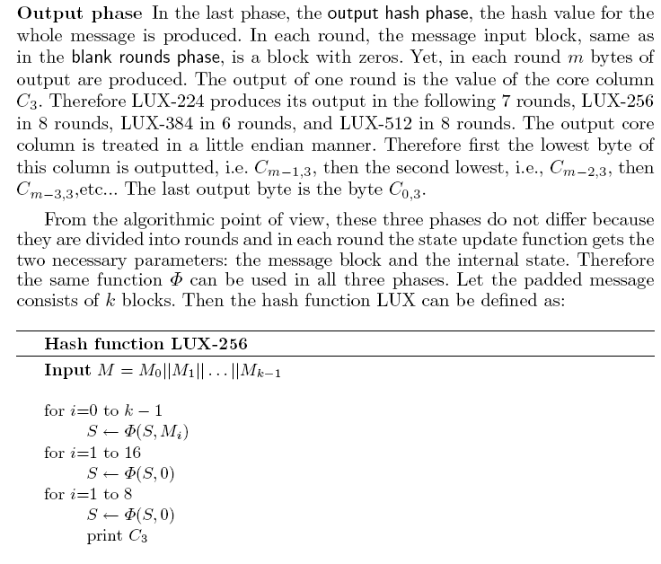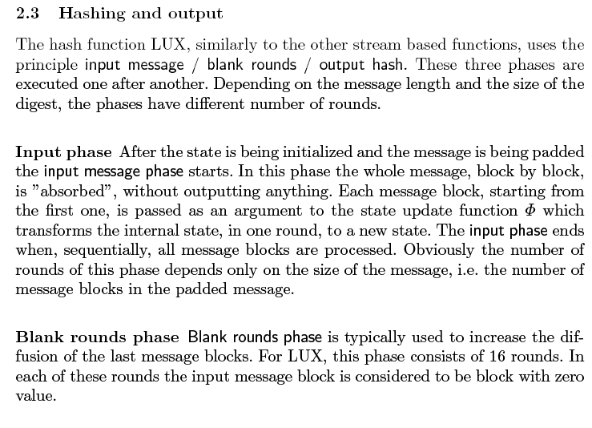

Lux algorithm implementation

clk
rst
run
message_lenght

ramMt_we
ramMt_d
ramMt_addr

ramC3_we
ramC3_addr
ramC3_q
done

luxcontroller

Figure 4: luxcontroller in/out pin

ENTITY luxcontroller IS
PORT ( clk : in std_logic ; -- System Clock
rst : in std_logic ; -- System Rese
run : in std_logic ; -- run lux algo
message_lenght : in STD_LOGIC_VECTOR (31 downto 0);
ramMt_we : in std_logic ;
ramMt_d : in STD_LOGIC_VECTOR (31 downto 0);
ramMt_addr : in STD_LOGIC_VECTOR( 9 downto 0);
ramC3_we : in std_logic ;
ramC3_addr: in STD_LOGIC_VECTOR( 2 downto 0);
ramC3_q : out STD_LOGIC_VECTOR (31 downto 0);
done : out std_logic
);
END luxcontroller;

The luxcontroller block execute several time the one round algorithm via the state machine figure 5, first he launch the algorithm on all message block one by one, throw state first_round, wait_R_first, Mt_round,wait_R_Mt. the luxcontroller controller must make special operation to the last message block as it is described in the previous section throw state: last_Mt, last_round32, last_round32n, wait_R_32, wait_R_32n.

Next he run the lux one round on the length of the message, this is done twice throw state: lenght_round0, wait_R_lenght0, lenght_round1, wait_R_lenght1.

Next we run 16x round using emply message throw state: empty_round, wait_R_empty.

Finally we run 8x lux round using emply message and extract the output C3, this output is stored in the Dual Ram memory throw state: c3_round, wait_R_C3, savelast_R_C3.

When all is done we put the done pin to high.

idle
first_round
wait_R_first
Mt_round
wait_R_Mt
last_Mt
last_round32
wait_R_32n
wait_R_32
lux_done
lux_done & message_lenght(31..5)) = ramMt_addr1_reg
lux_done
last_round32n
message_lenght(4 ..0)) = 0
message_lenght(4 ..0)) != 0
lux_done
wait_R_lenght0
lenght_round0
wait_R_lenght1
lenght_round1
wait_R_empty
empty_round
wait_R_C3
c3_round
savelast_R_C3
lux_done
lux_done
lux_done
count_round_reg = 16
message_lenght<= 32 & run
run
lux_done
lux_done
count_round_reg = 24
lux_done
Figure 5: lux controller state machine
combinatory_command : process( state_reg ,count_round_reg,ramMt_q1,ramMt_addr1_reg,ramC3_addr1_reg ,lux_Cout,message_lenght)
begin

lux_start <= '0';
lux_start_rst <= '0' ;
ramMt_we1 <= '0' ;
ramC3_we1 <= '0' ;
ramC3_d1 <= lux_Cout;
lux_Mt <= ramMt_q1;
done <= '0';
ramMt_addr1_next <= ramMt_addr1_reg;
ramC3_addr1_next <= ramC3_addr1_reg;
count_round_next <= count_round_reg;

case state_reg is

when idle =>
-- reset all state & register to Zero
done <= '1';
ramMt_addr1_next <= (others=>'0') ;
ramC3_addr1_next <= (others=>'0') ;
count_round_next <= (others=>'0') ;

when first_round =>
-- launch the lux algo & reset the lux (first run)
lux_start_rst <= '1';
lux_Mt <= ramMt_q1;
-- next message
ramMt_addr1_next <= ramMt_addr1_reg + 1;

when wait_R_first =>

when Mt_round =>
-- launch the lux algo
lux_start <= '1';
lux_Mt <= ramMt_q1;
-- next message
ramMt_addr1_next <= ramMt_addr1_reg + 1;

when wait_R_Mt =>

when last_Mt =>

when last_round32 =>
if unsigned(message_lenght) <= 32 then
-- launch the lux algo & reset the lux (first run)
lux_start_rst <= '1';
else
-- launch the lux algo
lux_start <= '1';
end if;
-- our message is x"80000000"
lux_Mt <= x"80000000";

when last_round32n =>
if unsigned(message_lenght) <= 32 then
-- launch the lux algo & reset the lux (first run)
lux_start_rst <= '1';
else
-- launch the lux algo
lux_start <= '1';
end if;
-- add 1 to the : bit (lenght message ) <= '1'
lux_Mt <= ramMt_q1 or mask(conv_integer(message_lenght(4 downto 0)));

when wait_R_32 =>

when wait_R_32n =>

when lenght_round0 =>
-- launch the lux algo
lux_start <= '1';
-- message is the lenght
lux_Mt <= message_lenght;

when wait_R_lenght0 =>

when lenght_round1 =>
-- launch the lux algo
lux_start <= '1';
-- message is the lenght
lux_Mt <= message_lenght;

when wait_R_lenght1 =>

when empty_round =>
-- launch the lux algo
lux_start <= '1';
-- emply message
lux_Mt <= (others=>'0') ;
-- this conter is used to detect that we have proceded 16x
count_round_next <= count_round_reg +1;

when wait_R_empty =>

when c3_round =>
-- launch the lux algo
lux_start <= '1';
-- emply message
lux_Mt <= (others=>'0') ;
-- save C(3,addr++)
if unsigned(count_round_reg) > 16 then
ramC3_addr1_next <= ramC3_addr1_reg + 1;
ramC3_we1 <= '1' ;
ramC3_d1 <= lux_Cout;
end if;
-- this conter is used to detect that we have proceded 8x
count_round_next <= count_round_reg +1;

when wait_R_C3 =>

--save last one C(3,7)
when savelast_R_C3 =>
ramC3_we1 <= '1' ;
ramC3_d1 <= lux_Cout;

when others =>

end case;
end process;

end RTL;

Test bench

The testbench is generated using the reference c code, we have add some printf to extract the input message and the output message
Here is an example :

-- message lenght 115 bit
message_lenght <= x"00000073";

-- transmit the message to the lux algo
-- store the message in the memory ramMt
ramMt_d <= x"55A4FA60";
ramMt_addr <= (others => '0') ;
ramMt_we <= '1';
wait for 100ns;

ramMt_d <= x"97E8753C";
ramMt_addr <= ramMt_addr + 1 ;
wait for 100ns;

ramMt_d <= x"CE38FB4E";
ramMt_addr <= ramMt_addr + 1 ;
wait for 100ns;

ramMt_d <= x"59d46000";
ramMt_addr <= ramMt_addr + 1 ;
wait for 100ns;

ramMt_we <= '0';
wait for 100ns;

run <= '1';
wait for 100ns;

-- launch the algorithm
run <= '0';
-- wait for the end of the LUX algorithm
wait until done = '1' ;

-- compare the expected value generated by the reference c code
-- and the vhdl found value this is stored in ramC3
ramC3_addr <= to_unsigned(0,3) ;
wait for 100ns;
expectedC3 <= x"9A59A828";
wait for 100ns;
assert (ramC3_q = expectedC3)
report "Error on addC3:(" & hstr(ramC3_addrc) &") expected " & hstr(expectedC3) &" found :" & hstr(ramC3_q)
severity Error;

ramC3_addr <= to_unsigned(1,3) ;
wait for 100ns;
expectedC3 <= x"7843375A";
assert (ramC3_q = expectedC3)
report "Error on addC3:(" & hstr(ramC3_addrc) &") expected " & hstr(expectedC3) &" found :" & hstr(ramC3_q)
severity Error;

ramC3_addr <= to_unsigned(2,3) ;
wait for 100ns;
expectedC3 <= x"7FB22F40";
assert (ramC3_q = expectedC3)
report "Error on addC3:(" & hstr(ramC3_addrc) &") expected " & hstr(expectedC3) &" found :" & hstr(ramC3_q)
severity Error;

ramC3_addr <= to_unsigned(3,3) ;
wait for 100ns;
expectedC3 <= x"40A26B7F";
assert (ramC3_q = expectedC3)
report "Error on addC3:(" & hstr(ramC3_addrc) &") expected " & hstr(expectedC3) &" found :" & hstr(ramC3_q)
severity Error;

ramC3_addr <= to_unsigned(4,3) ;
wait for 100ns;
expectedC3 <= x"D6B3E4D3";
assert (ramC3_q = expectedC3)
report "Error on addC3:(" & hstr(ramC3_addrc) &") expected " & hstr(expectedC3) &" found :" & hstr(ramC3_q)
severity Error;

ramC3_addr <= to_unsigned(5,3) ;
wait for 100ns;
expectedC3 <= x"E346D0BE";
assert (ramC3_q = expectedC3)
report "Error on addC3:(" & hstr(ramC3_addrc) &") expected " & hstr(expectedC3) &" found :" & hstr(ramC3_q)
severity Error;

ramC3_addr <= to_unsigned(6,3) ;
wait for 100ns;
expectedC3 <= x"9FB5FFCB";
assert (ramC3_q = expectedC3)
report "Error on addC3:(" & hstr(ramC3_addrc) &") expected " & hstr(expectedC3) &" found :" & hstr(ramC3_q)
severity Error;

ramC3_addr <= to_unsigned(7,3) ;
wait for 100ns;
expectedC3 <= x"290E85F6";
assert (ramC3_q = expectedC3)
report "Error on addC3:(" & hstr(ramC3_addrc) &") expected " & hstr(expectedC3) &" found :" & hstr(ramC3_q)
severity Error;

here is the do file that launch the simulation :

vlib work
vcom lux_ctr.vhd
vcom testbench.vhd
vsim testbench_vhd

view wave
add wave *
add wave sim:/testbench_vhd/uut/u_lux/state_reg
add wave sim:/testbench_vhd/uut/state_reg
add wave sim:/testbench_vhd/uut/u_ram_c3/mem(7)
add wave sim:/testbench_vhd/uut/u_ram_c3/mem(6)
add wave sim:/testbench_vhd/uut/u_ram_c3/mem(5)
add wave sim:/testbench_vhd/uut/u_ram_c3/mem(4)
add wave sim:/testbench_vhd/uut/u_ram_c3/mem(3)
add wave sim:/testbench_vhd/uut/u_ram_c3/mem(2)
add wave sim:/testbench_vhd/uut/u_ram_c3/mem(1)
add wave sim:/testbench_vhd/uut/u_ram_c3/mem(0)

run 2 ms
radix hex
wave zoomfull

We present in the next figure 6,7,8,9,10,11 the simulation result of :
Length of message is 455
Msg=55B1386C80FBECC7B54207EEAEF70069B1836378558309973FE2836322BEFD420AAAD73E399D1BCA063A590C3A82DF8708B1457B61A2C80352
MD = 74695F060B1181E7A1597C204A6A1B176520B05F0081D496C135C1EA

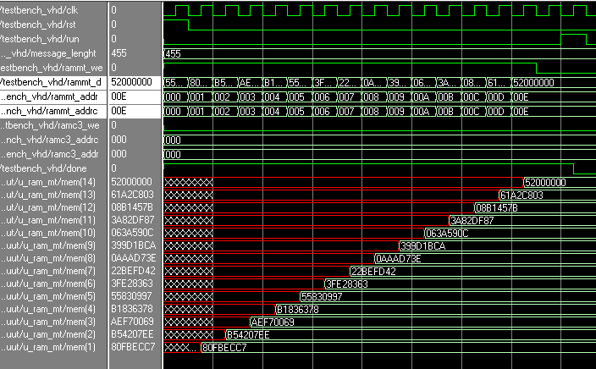
Figure 6: input message to the dual RAM

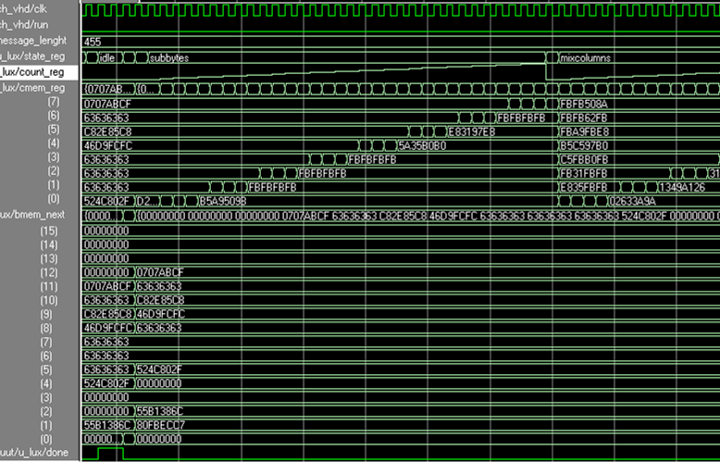
Figure 7: simulation of step: addMessage, functionF, subBytes, shiftRows, mixcoluns,
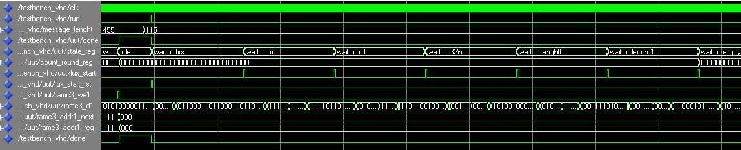
Figure 8: simulation of step: one round run of one block Mt

Figure 9: simulation of step: two round run on message lenght

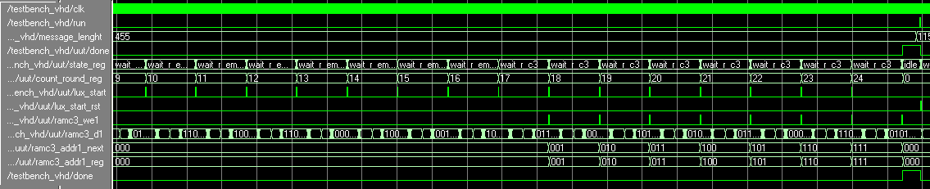
Figure 10: simulation of step: 16x round on empty message

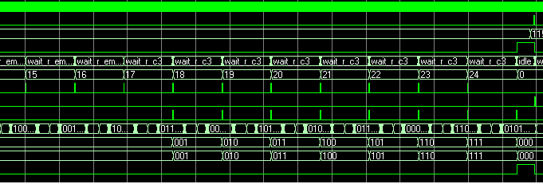
Figure 11: simulation of step: 8x round on empty message and save C3
Synthesis Summary Report: 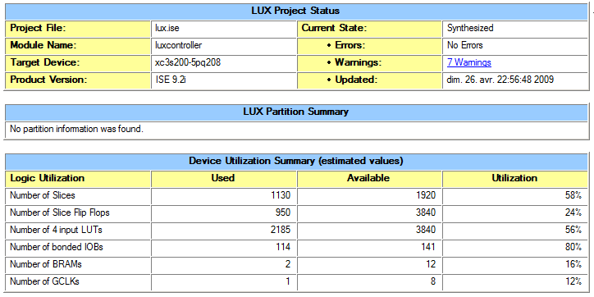

Advanced HDL Synthesis Report:

Macro Statistics
# FSMs : 2
# RAMs : 2
1024x32-bit dual-port block RAM : 1
8x32-bit dual-port distributed RAM : 1
# ROMs : 3
256x8-bit ROM : 1
32x32-bit ROM : 1
4x32-bit ROM : 1
# Adders/Subtractors : 3
10-bit adder : 1
3-bit adder : 1
33-bit adder : 1
# Counters : 1
5-bit up counter : 1
# Registers : 933
Flip-Flops : 933
# Comparators : 3
27-bit comparator equal : 1
33-bit comparator lessequal : 1
34-bit comparator greater : 1
# Multiplexers : 2
32-bit 8-to-1 multiplexer : 1
8-bit 4-to-1 multiplexer : 1
# Xors : 106
1-bit xor2 : 64
32-bit xor2 : 9
8-bit xor2 : 32
8-bit xor4 : 1
Timing Summary:

Speed Grade: -5

Minimum period: 11.654ns (Maximum Frequency: 85.808MHz)
Minimum input arrival time before clock: 7.809ns
Maximum output required time after clock: 7.193ns
Maximum combinational path delay: No path found

