Online Shopping Website

Software Engineer/

NABIL FAWZY HALEM

**Introduction**

Many people need to buy their clothes without moving from their home so our website created for any body to buy what he wants   
at anytime.

Main Idea

It is online shopping system for youth’s Clothes :   
T-shirts , Shirts, Trousers and Shorts.  
It is a very easy website for moving between All categories   
for choosing your item.   
Admin have availability to make new admins , remove users  
,add or remove products.

Pages Descriptions

* 1. Master Page
  2. Default Page
  3. Categories

1.3.1 T-shirts

1.3.2 Shirts

1.3.3 Trousers

1.3.4 Shorts

1.4 Admin  
 1.4.1 Admin or remove

1.4.2 Add new Product

1.4.3 Remove Product

1.5 Register

1.5.1)sign in

1.5.2)sign Up

1.6 Diagram

1.7 used tools and frameworks 1.8 references

1.1)Master Page 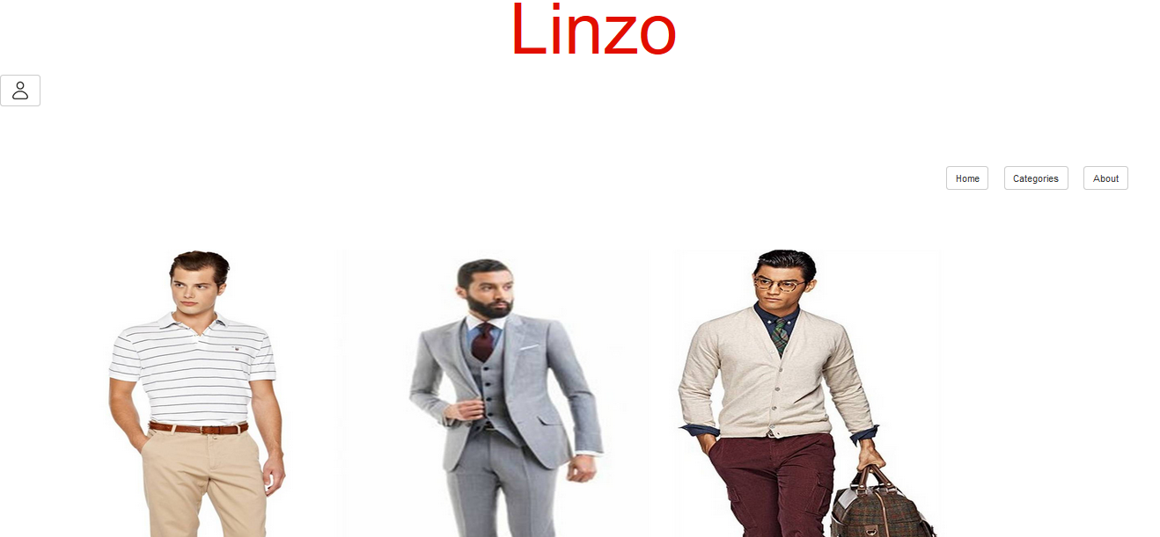

It is master page has a button for log in , menu for main website links and picture which change throughtime using viewstate .

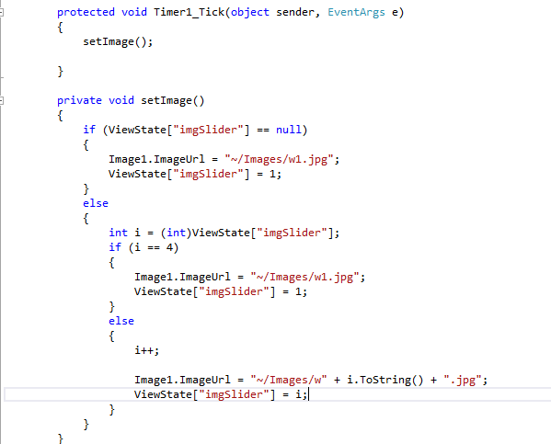

1.2)Default Page

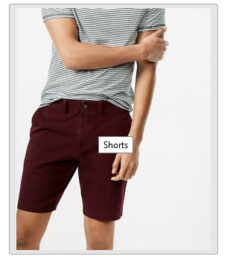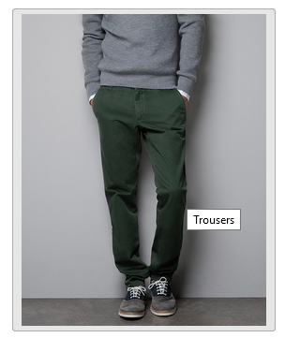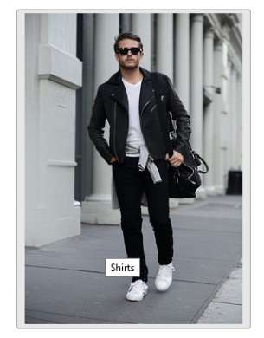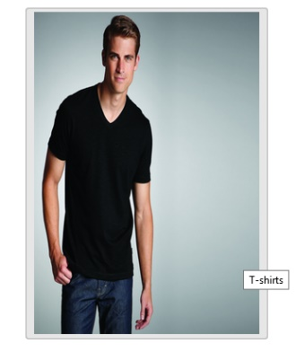

<asp:ImageButton ID="ImageButton1" CssClass="btn btn-default img-fluid" runat="server" ImageUrl="~/Images/cg1.png" Width="100%" Height="100%" PostBackUrl="~/CategA.aspx" ToolTip="T-shirts" />

<asp:ImageButton ID="ImageButton2" CssClass="btn btn-default img-fluid" runat="server" ImageUrl="~/Images/cg2.jpg" Width="100%" Height="100%" PostBackUrl="~/CategB.aspx" ToolTip="Shirts" />

<asp:ImageButton ID="ImageButton3" CssClass="btn btn-default" runat="server" ImageUrl="~/Images/cg3.jpg" Width="100%" Height="100%" PostBackUrl="~/CategC.aspx" ToolTip="Trousers" />

<asp:ImageButton ID="ImageButton4" CssClass="btn btn-default" runat="server" ImageUrl="~/Images/cg4.jpg" Width="100%" Height="100%" PostBackUrl="~/CategD.aspx" ToolTip="Shorts" />

Default page has 4 buttons each button links to category from 4 Categories :  
T-shirts, Shirts, Trousers and Shorts.

Using PostBackUrl move to specific form.

Using CssClass=” btn btn-default img-fluid” make the image responsive.

1.3.1)T-Shirts

T-shirts displayed using our database which stored in sql by linq using entity framework get all T-shirts then display it.

ShoppingDbEntities2 db = new ShoppingDbEntities2();

t.InnerHtml = "";

var Prod = from pro in db.Products select pro;

List<Product> prodc = Prod.ToList();

foreach (var r in prodc)

{

if (r.catID == 1)

{

t.InnerHtml += "<div class='join-button' style='float:left; width:200px;height:250px;margin-bottom:100px' runat='server '>";

t.InnerHtml += ("<asp:Button runat='server' Class='btn btn-default' id='tshirt" + r.productID + "'><img src=Images/" + r.imageName + " style='width:200px; height:200px' runat='server'> <br/>");

t.InnerHtml += r.description + "<br/>Price : " + r.price + "$</Button></div>";

}

}

By Change catID switching for 2,3,4 switch for categories Shirts, trousers and shorts.

1.4) Admin

1.4.1) Admin or remove

In this Page Admin can make user admin or remove him

First for make someone user when getting email   
 our project function change the idgroup to 1 (default zero)  
as being admin the user became admin and hasing all admin  
functionality.

Second button for remove user from database.

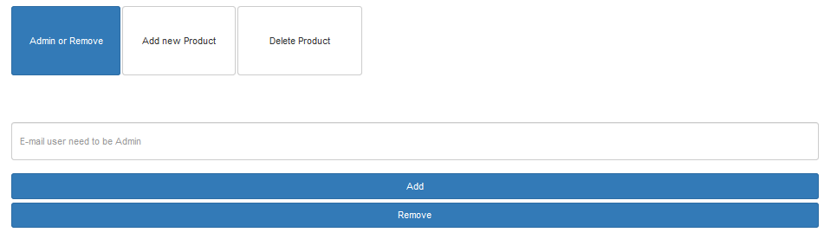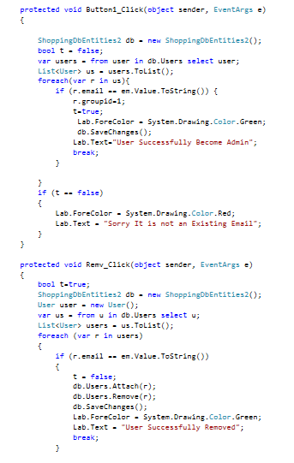

1.4.2) Add Product

It is function for add new product image added to image folder and all data added in sql database.

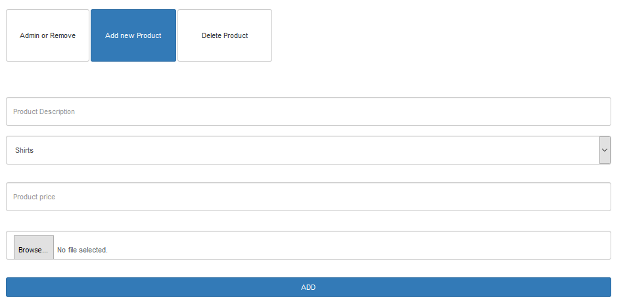

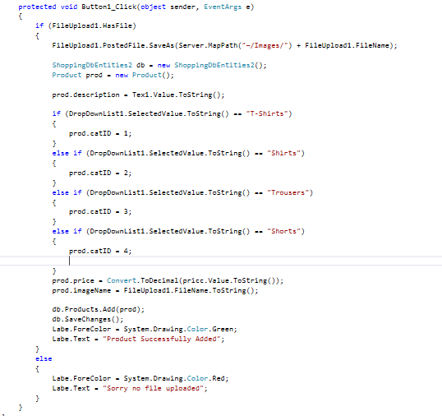

1.4.3)Delete Product

Using image name and it is price and selection category name  
delete product from db.

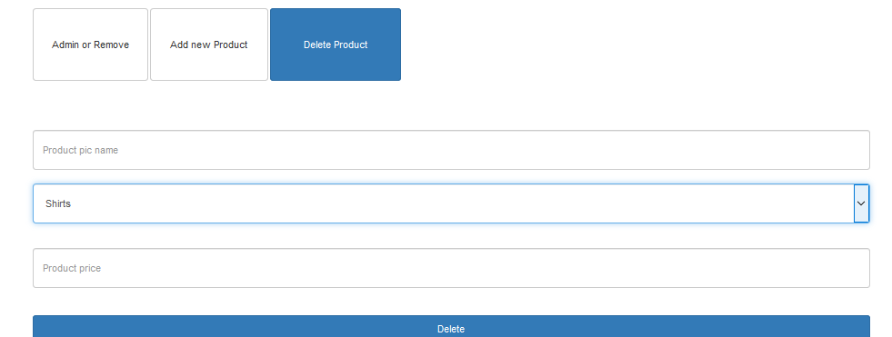

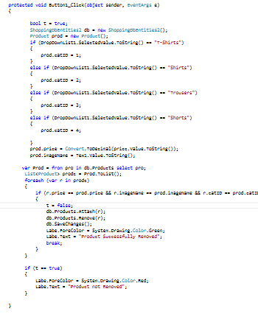

1.5.1)Sign In

Here it is page for log in and if user hasnot account can

Register.

By validate if user hase email and password in database

Can redirect to home page opening his account. 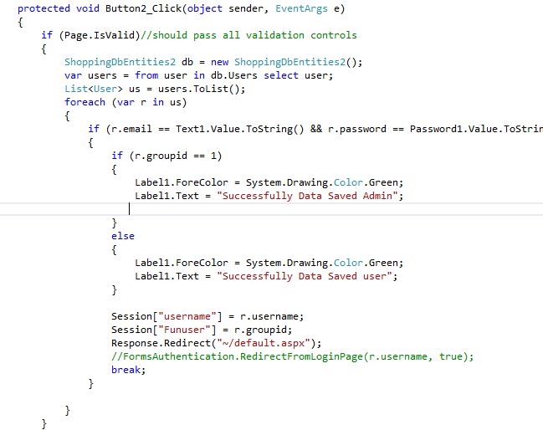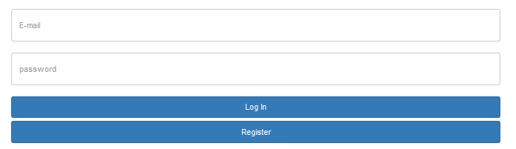

1.5.2)Sign Up

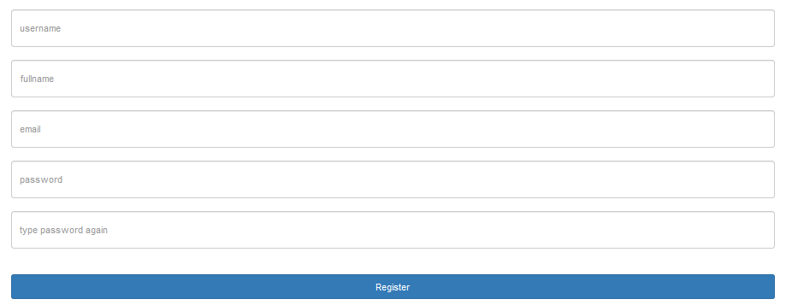

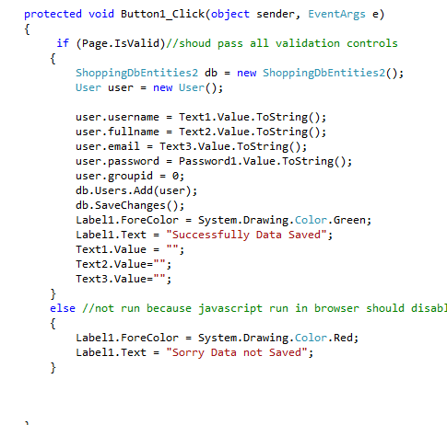

1.6)Diagram

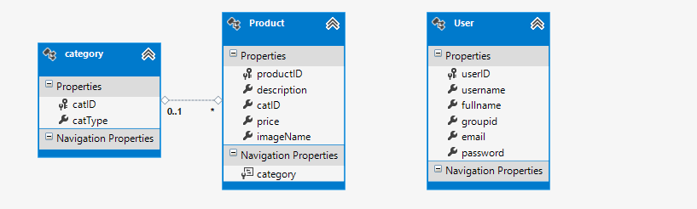

1.7)tools and frameworks

-Visual studio

- asp.net

-linq

-bootstrap

1.8)references

http://getbootstrap.com/docs/3.3/