UVM Verification Plan

AXI4 Full Burst Memory and FIFO Peripheral (axi4_peripheral)
Document Version: 1.0
Source RTL: axi4_peripheral.sv, axi_fifo.sv
TB shell: axi4_if.sv, top_example.sv
Status: Draft — for mentor review (open items flagged in Appendix A)

1. Specifications

1.1 Objective
Develop a complete, self-checking UVM environment for axi4_peripheral — a 32-bit AXI4-Full memory-mapped slave containing a 4 KiB RAM, an 8-register control/status bank, a 16×32-bit FIFO, and an interrupt controller, with configurable per-channel backpressure and support for multiple queued outstanding transactions.

1.2 DUT Interface
Signal Group | Fields | Width | Direction (Master→Slave unless noted)
Clock/Reset | ACLK, ARESETn | 1 / 1 | in (ARESETn active-low, async)
Write Address (AW) | AWID, AWADDR, AWLEN, AWSIZE, AWBURST, AWVALID / AWREADY | ID=4, ADDR=16, LEN=8, SIZE=3, BURST=2 | AWREADY is out
Write Data (W) | WDATA, WSTRB, WLAST, WVALID / WREADY | DATA=32, STRB=4 | WREADY is out
Write Response (B) | BID, BRESP, BVALID / BREADY | ID=4, RESP=2 | BID/BRESP/BVALID are out
Read Address (AR) | ARID, ARADDR, ARLEN, ARSIZE, ARBURST, ARVALID / ARREADY | same as AW | ARREADY is out
Read Data (R) | RID, RDATA, RRESP, RLAST, RVALID / RREADY | ID=4, DATA=32 | RID/RDATA/RRESP/RLAST/RVALID are out
Interrupt | IRQ | 1 | out

Parameters: ADDR_W=16, DATA_W=32, ID_W=4, QDEPTH=4 (outstanding-request queue depth per channel — this is an RTL parameter, not called out in the spec doc, and is a key capacity limit to verify).

1.3 DUT Internal Functional Blocks
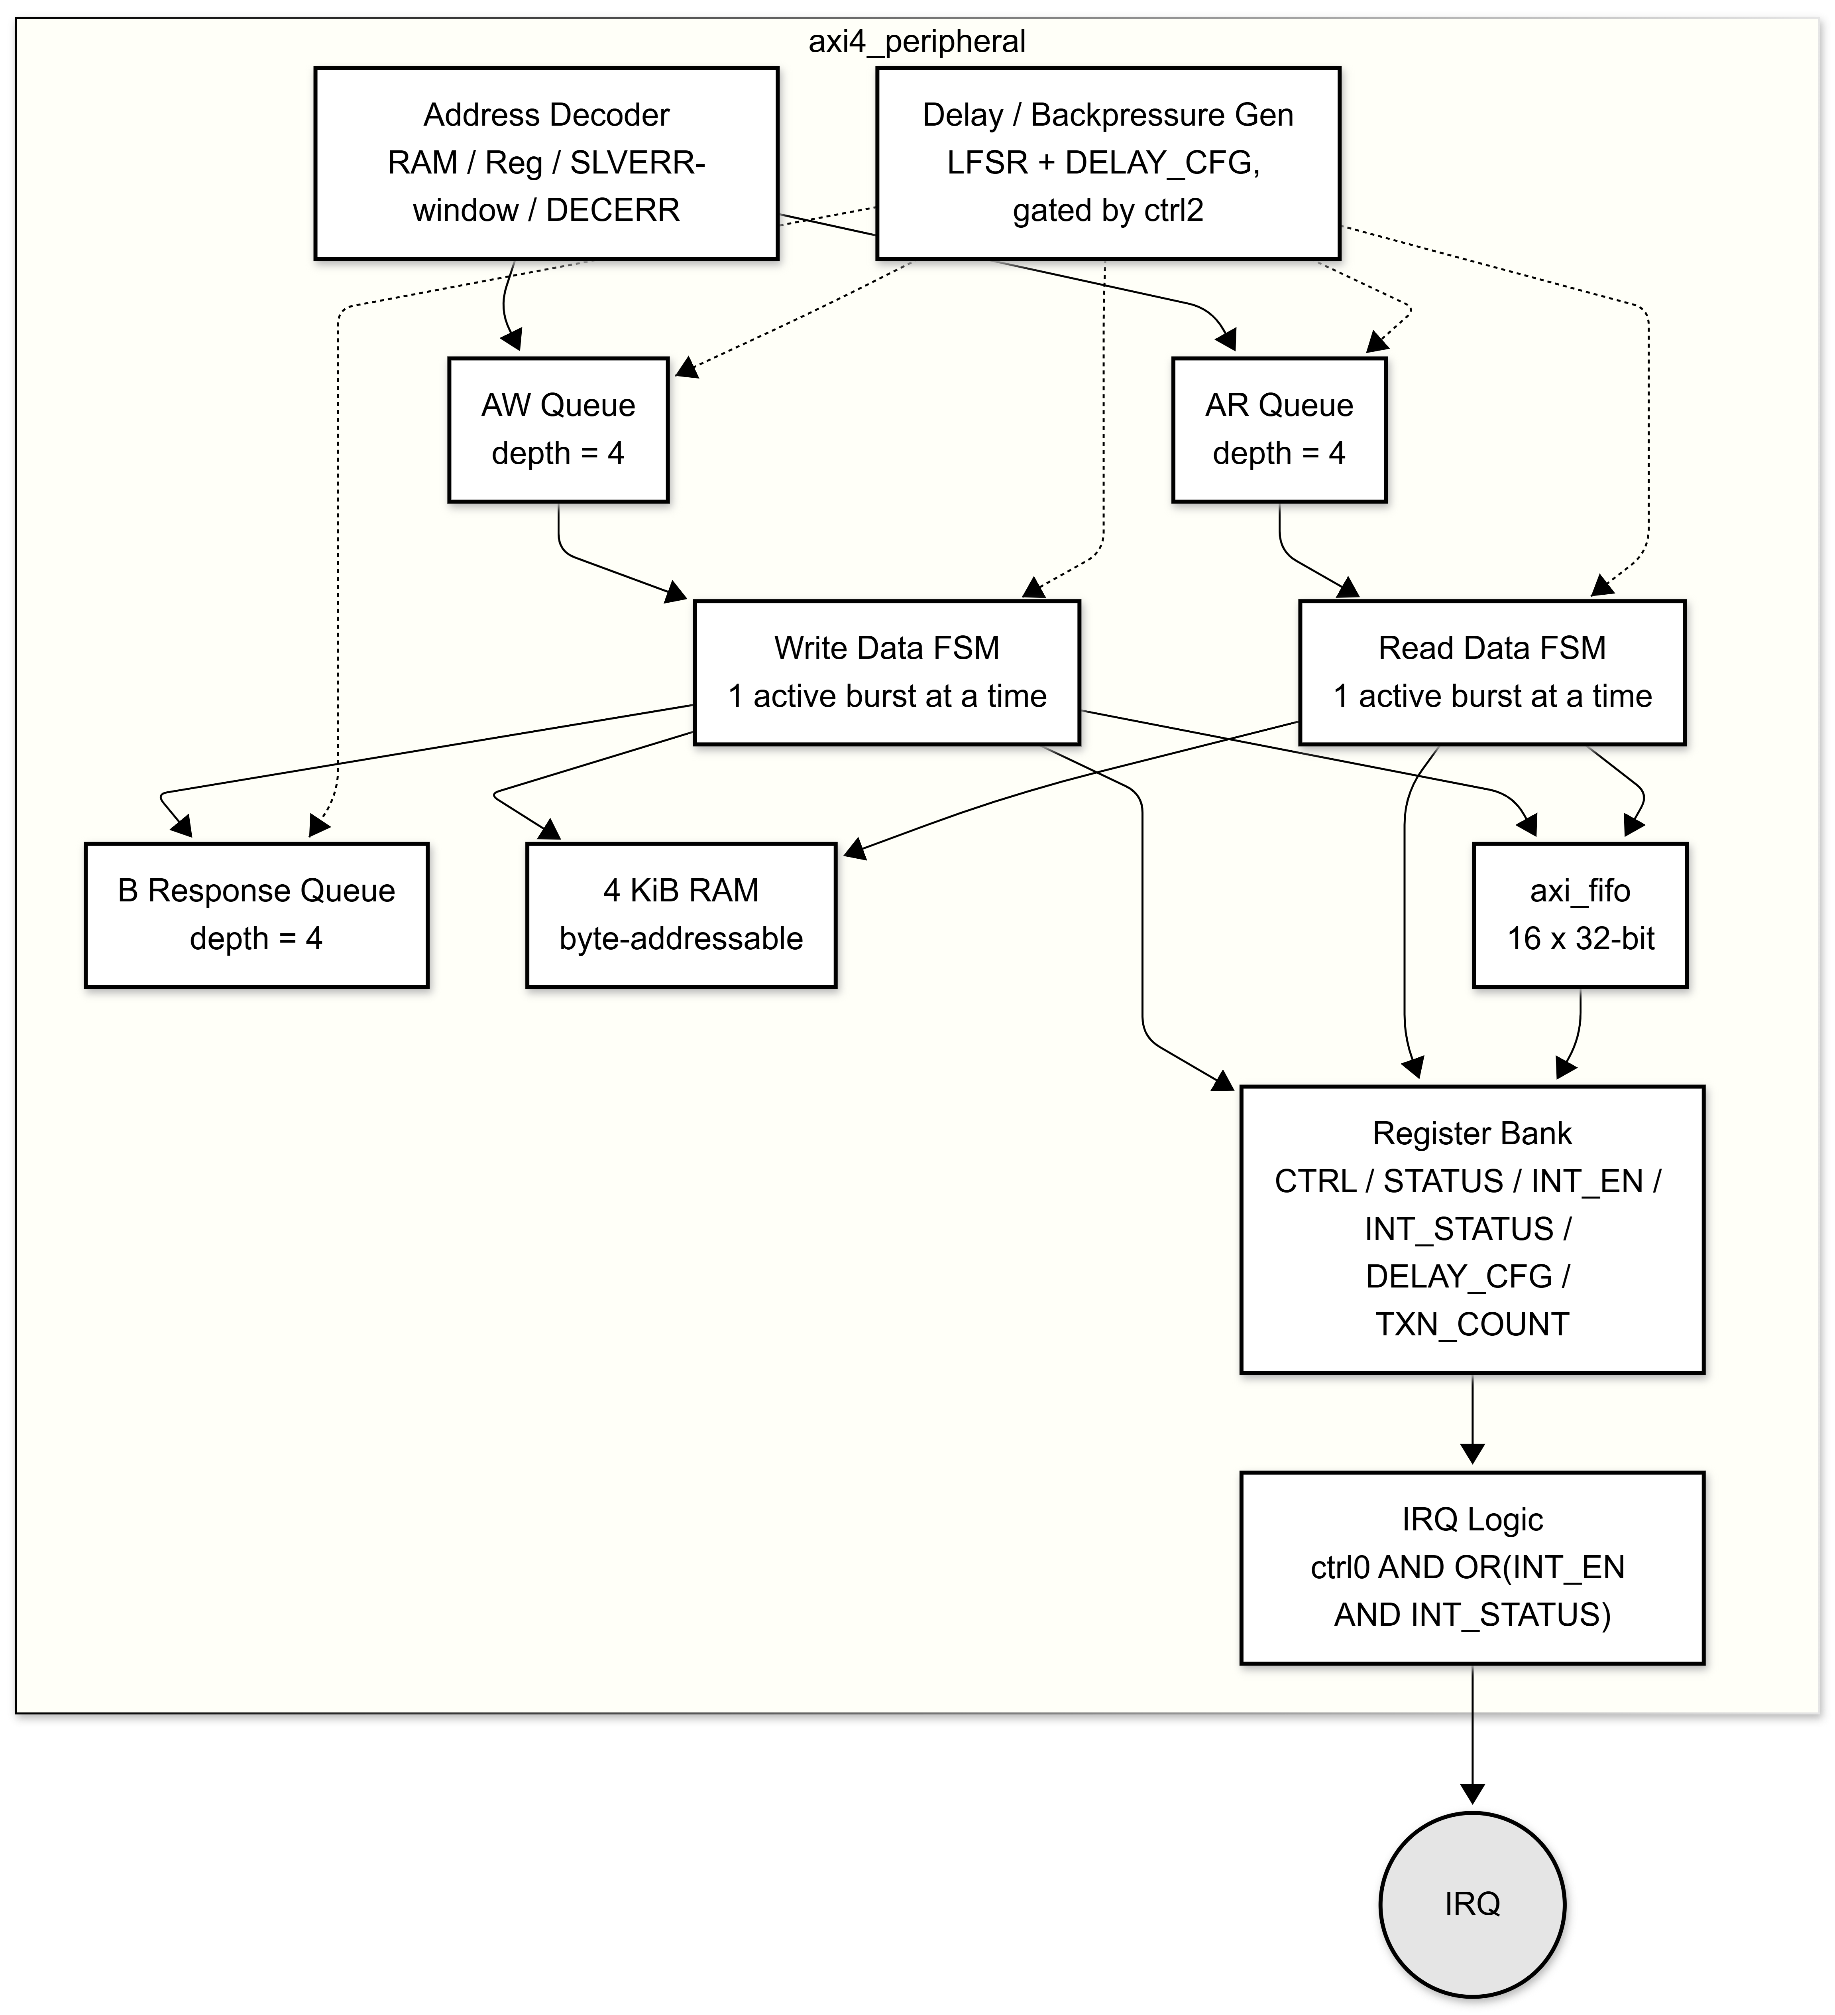

1.4 Address / Register Map
Address | Block/Register | Access | Notes
0x0000–0x0FFF | RAM | RW | 4 KiB, byte-addressable, WSTRB-controlled
0x1000 | CTRL | RW | bit0=irq_en, bit1=fifo_en, bit2=delay_en (bits [31:3] unused, RTL stores only [2:0])
0x1004 | STATUS | RO | bit0=write-busy, bit1=read-busy, bit2=fifo_empty, bit3=fifo_full, bit4=IRQ (derived from RTL, not detailed in spec doc)
0x1008 | INT_EN | RW | bits[2:0] mask for INT_STATUS bits 0/1/2
0x100C | INT_STATUS | W1C (RO on read) | bit0=fifo-full event, bit1=fifo-empty event, bit2=error event (illegal burst / bad address / RO-write / FIFO misuse)
0x1010 | FIFO_DATA | RW (push on write / pop on read) | full-word (WSTRB=0xF) only; gated by CTRL.fifo_en
0x1014 | FIFO_STATUS | RO | bit0=empty, bit1=full, bits[8:4]=level
0x1018 | DELAY_CFG | RW | bits[3:0]=max delay for AW/W/B (write side), bits[7:4]=max delay for AR/R (read side); active only when CTRL.delay_en=1
0x101C | TXN_COUNT | RO | increments once per completed write burst and once per completed read burst
0x2000–0x2FFF | Error window | — | any access here returns SLVERR
Other | Unmapped | — | any access here returns DECERR

1.5 Minimum DUT Behavior (from spec + confirmed in RTL)
- 32-bit AXI4-Full slave; 16-bit address, 4-bit ID.
- Burst types supported: FIXED (AWBURST/ARBURST=00) and INCR (=01). WRAP (=10) and reserved (=11) are illegal → SLVERR.
- Max burst length = 16 beats (AWLEN/ARLEN up to 15, i.e., len>15 is illegal).
- Transfer sizes: 1, 2, 4 bytes only (AWSIZE/ARSIZE 0–2); size>2 is illegal.
- INCR bursts crossing a 4 KiB boundary are illegal.
- AW, W, B, AR, R channels operate independently (separate valid/ready handshakes, separate queues).
- Backpressure/response delay is configurable and pseudo-random (LFSR-driven), only active when CTRL.delay_en=1.
- WSTRB controls per-byte write updates into RAM.
- WLAST/RLAST must mark the final beat of a burst.
- Responses return the ID of the matching request.
- Up to 4 outstanding AW, AR, and B entries may be queued (QDEPTH=4); a 5th request stalls via de-asserted READY.
- FIFO overflow (push while full) and disallowed FIFO access (partial-strobe write, or access while fifo_en=0) are error conditions (SLVERR + INT_STATUS[2]).
- INT_STATUS is write-1-to-clear.

1.6 Reset Behavior
- Asynchronous, active-low (ARESETn).
- On reset: all queues empty, all registers cleared to 0, entire 4 KiB RAM cleared to 0, FIFO cleared, wr_active/rd_active cleared, LFSR reseeded to a fixed non-zero value, IRQ=0.

2. Features (to be Verified)
# | Feature | Description | Priority
F1 | Reset State | All regs/RAM/FIFO/queues clear correctly; IRQ=0; no channel asserts VALID out of reset | High
F2 | AW/AR Handshake & Queuing | AWREADY/ARREADY correctly reflect queue occupancy (<QDEPTH) and delay counters; queue holds up to 4 outstanding entries | High
F3 | Outstanding-Depth Stall | 5th queued AW/AR request stalls until an entry is dequeued (drained by data-phase progress) | High
F4 | W Data Phase & WSTRB | Byte-lane writes to RAM honor WSTRB; unstrobed bytes unmodified | High
F5 | WLAST / Beat-Count Consistency | Burst completes on WLAST OR internal beat count reaching AWLEN; mismatch between the two is a DUT ambiguity to test explicitly (see Appendix A) | High
F6 | B Response Generation & ID Echo | BID matches the originating AWID; BRESP reflects worst response across all beats of that burst | High
F7 | R Data Phase & RLAST | RLAST asserted exactly on the final beat (rd_beat==ARLEN); ID echoed on RID | High
F8 | FIXED Burst Addressing | Address does not increment across beats | Medium
F9 | INCR Burst Addressing | Address increments by (1<<AWSIZE/ARSIZE) per beat | High
F10 | WRAP / Reserved Burst Rejection | AWBURST/ARBURST = 2'b10 or 2'b11 → SLVERR on all beats of that burst | High
F11 | Burst Length Limit | AWLEN/ARLEN > 15 → SLVERR | High
F12 | Transfer Size Limit | AWSIZE/ARSIZE > 2 (i.e., >4 bytes) → SLVERR | High
F13 | 4 KiB Boundary Crossing | INCR burst whose last beat address crosses into a different 4 KiB page than the start → SLVERR | High
F14 | Address Decode — RAM Region | 0x0000–0x0FFF reads/writes hit RAM, response OKAY | High
F15 | Address Decode — Register Region | Defined register offsets respond OKAY; unused offsets in 0x1000–0x1FFF band (e.g. 0x1020) respond DECERR | High
F16 | Address Decode — SLVERR Window | 0x2000–0x2FFF always returns SLVERR, regardless of read/write | High
F17 | Address Decode — DECERR | Any other unmapped address → DECERR | High
F18 | RO Register Write Protection | Writes to STATUS, FIFO_STATUS, TXN_COUNT → SLVERR + INT_STATUS[2] set, register value unchanged | High
F19 | CTRL — irq_en (bit0) | IRQ output is force-0 when irq_en=0 regardless of INT_EN/INT_STATUS | High
F20 | CTRL — fifo_en (bit1) | FIFO push/pop only occur when fifo_en=1; fifo_en=0 also clears FIFO contents immediately (RTL ties axi_fifo.clear to !fifo_en) | High
F21 | CTRL — delay_en (bit2) | When 0, all per-channel delays forced to 0 regardless of DELAY_CFG | Medium
F22 | INT_EN Masking | IRQ only reflects INT_STATUS bits whose corresponding INT_EN bit is set | High
F23 | INT_STATUS W1C Behavior | Writing 1 to a bit clears it (if not re-set same cycle); writing 0 has no effect | High
F24 | INT_STATUS Level-Set Bits | Bits 0/1 are set every cycle fifo_full/fifo_empty is true (not edge-detected) — includes immediately after reset since FIFO starts empty | High
F25 | INT_STATUS Error Bit | Bit 2 sets on: illegal burst, non-OKAY address decode, RO register write, or disallowed FIFO access | High
F26 | FIFO Push via FIFO_DATA Write | Only succeeds with WSTRB==4'hF, fifo_en=1, FIFO not full, and address legal; otherwise SLVERR | High
F27 | FIFO Pop via FIFO_DATA Read | Read of FIFO_DATA triggers a pop when the beat completes; pop request while empty is silently absorbed by the FIFO with no error flagged — verify against spec's "underflow is an error condition" (Appendix A) | High
F28 | FIFO_STATUS Accuracy | level/empty/full fields track actual FIFO occupancy at all times | Medium
F29 | DELAY_CFG Split Control | Field [3:0] affects only AW/W/B delay; field [7:4] affects only AR/R delay | Medium
F30 | TXN_COUNT Accuracy | Increments exactly once per completed write burst and once per completed read burst (not per beat) | Medium
F31 | Channel Independence | Concurrent read and write bursts (interleaved on the bus) do not corrupt each other's data/response/ID | High
F32 | Multiple Outstanding IDs / Ordering | Multiple queued requests with different IDs are serviced in issue order (single-engine, not reordered per ID — worth confirming against AXI4 out-of-order allowance, Appendix A) | High
F33 | Same-ID Back-to-Back | Two bursts with the same ID complete in issue order with correct, distinct responses | Medium
F34 | Reset Mid-Transaction | Assertion of ARESETn while a burst is in flight cleanly aborts all channels and clears state | High
F35 | Illegal-Burst Response Precedence | When both burst-legality and address-decode would produce an error, illegal-burst check takes precedence (per RTL order) | Medium
F36 | Backpressure Stress (Slave→Master) | DUT correctly stretches AWREADY/WREADY/ARREADY and BVALID/RVALID timing under max DELAY_CFG | Medium
F37 | Backpressure Stress (Master→Slave) | DUT correctly stalls on WVALID, BREADY, RREADY deassertion from the master side (TB-driven, independent of DUT's own delay) | Medium
F38 | Maximum Burst Stress | 16-beat INCR burst at each of the 3 sizes, sweeping full RAM address range including boundary-adjacent regions | Medium

3. UVM Block Diagram with DUT

3.1 High-Level Data Flow (start here if the detailed diagram is a lot to take in)
This is the simplified version — just the path one piece of stimulus takes, start to finish, with no channel-splitting or class names to worry about yet.
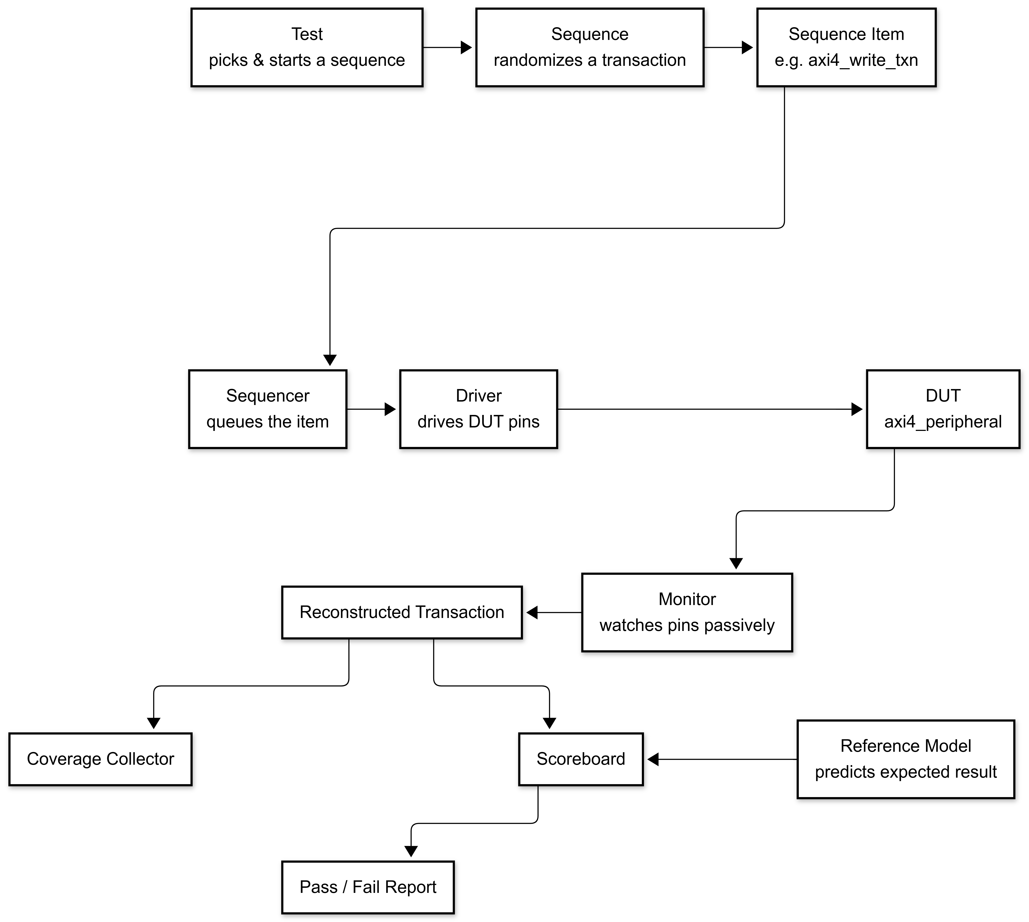
Reading it left to right: the only thing the driver ever sees is a sequence item; the only thing the scoreboard ever sees is a reconstructed transaction from the monitor plus a prediction from the reference model — the driver and scoreboard never talk to each other directly. That separation is what makes the checking "independent of the driver."

3.2 Time-Ordered Flow for One Write Transaction
Same idea, but showing the actual order of calls/events over time for a single write burst — useful when you're wiring up the UVM phases and TLM connections and need to know who calls whom.
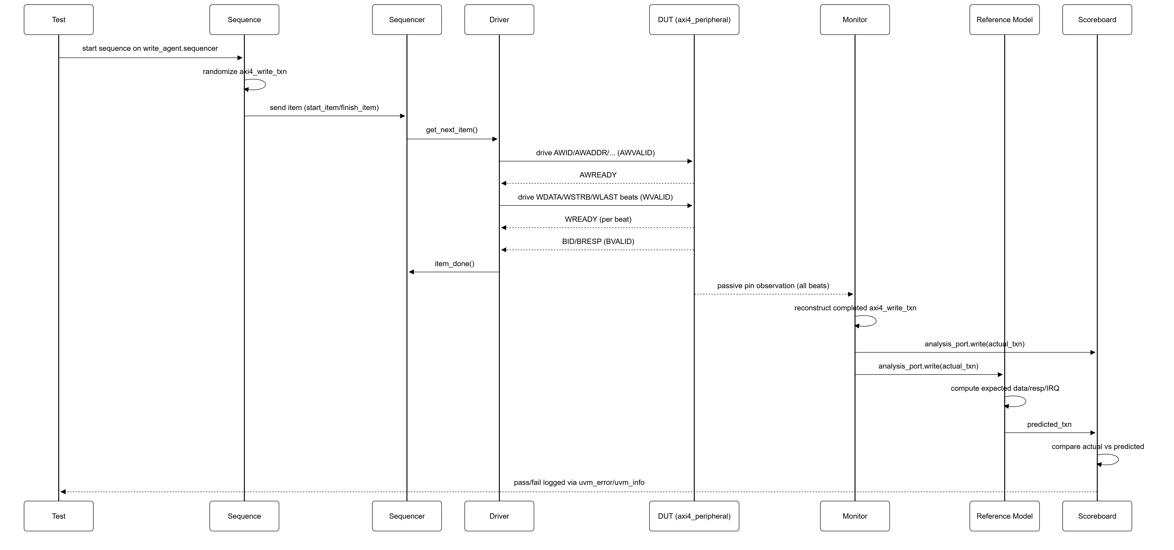
Note the two separate arrows out of the Monitor — it broadcasts the same observed transaction to both the scoreboard and the reference model via independent analysis-port connections (standard UVM TLM broadcast). The reference model doesn't watch the driver or the sequencer at all; it only reacts to what the monitor actually saw happen on the bus, which is what lets it also be used to catch monitor-reconstruction bugs, not just DUT bugs.

3.3 Hierarchical tb_top Block Diagram — With RAL (Phase 3 / Final Environment)
This mirrors the classic "box-in-a-box" testbench diagram style — tb_top at the outermost level, containing Test → Env → agents/checking components, with Interface and DUT sitting alongside at the top level.
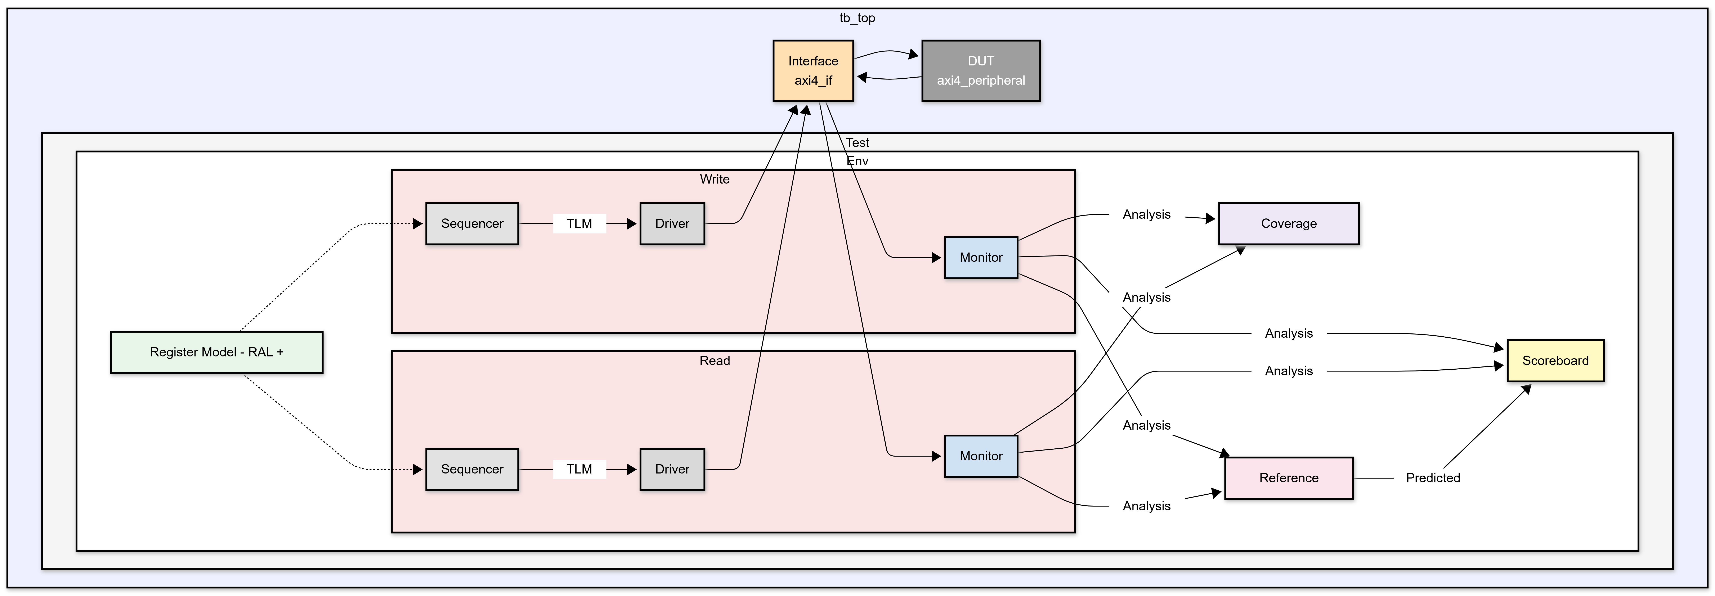
How to read it: tb_top is the outermost simulation shell — it instantiates Test, the Interface, and the DUT, and connects them by binding the virtual interface into Env via uvm_config_db. Test builds Env. Env builds the two agents plus the passive/checking components (Scoreboard, Coverage Collector, Reference Model, RAL). Only the agents' drivers/monitors ever touch the Interface directly — everything else inside Env talks to the agents only through TLM analysis ports, never through the interface directly. RAL connects into each agent's sequencer (dotted line) rather than the interface, since register accesses are just regular axi4_write_txn/axi4_read_txn items dispatched the normal way.

3.4 Hierarchical tb_top Block Diagram — Without RAL (Phase 1 / 2 Bring-up)
This is the same environment, minus the RAL block — matching Section 4.0's recommended build order, where RAL is deliberately left out until the core pipe is proven with hand-written sequences. Everything else (agents, scoreboard, reference model, coverage collector) is identical; only RAL and its dotted connections are removed.
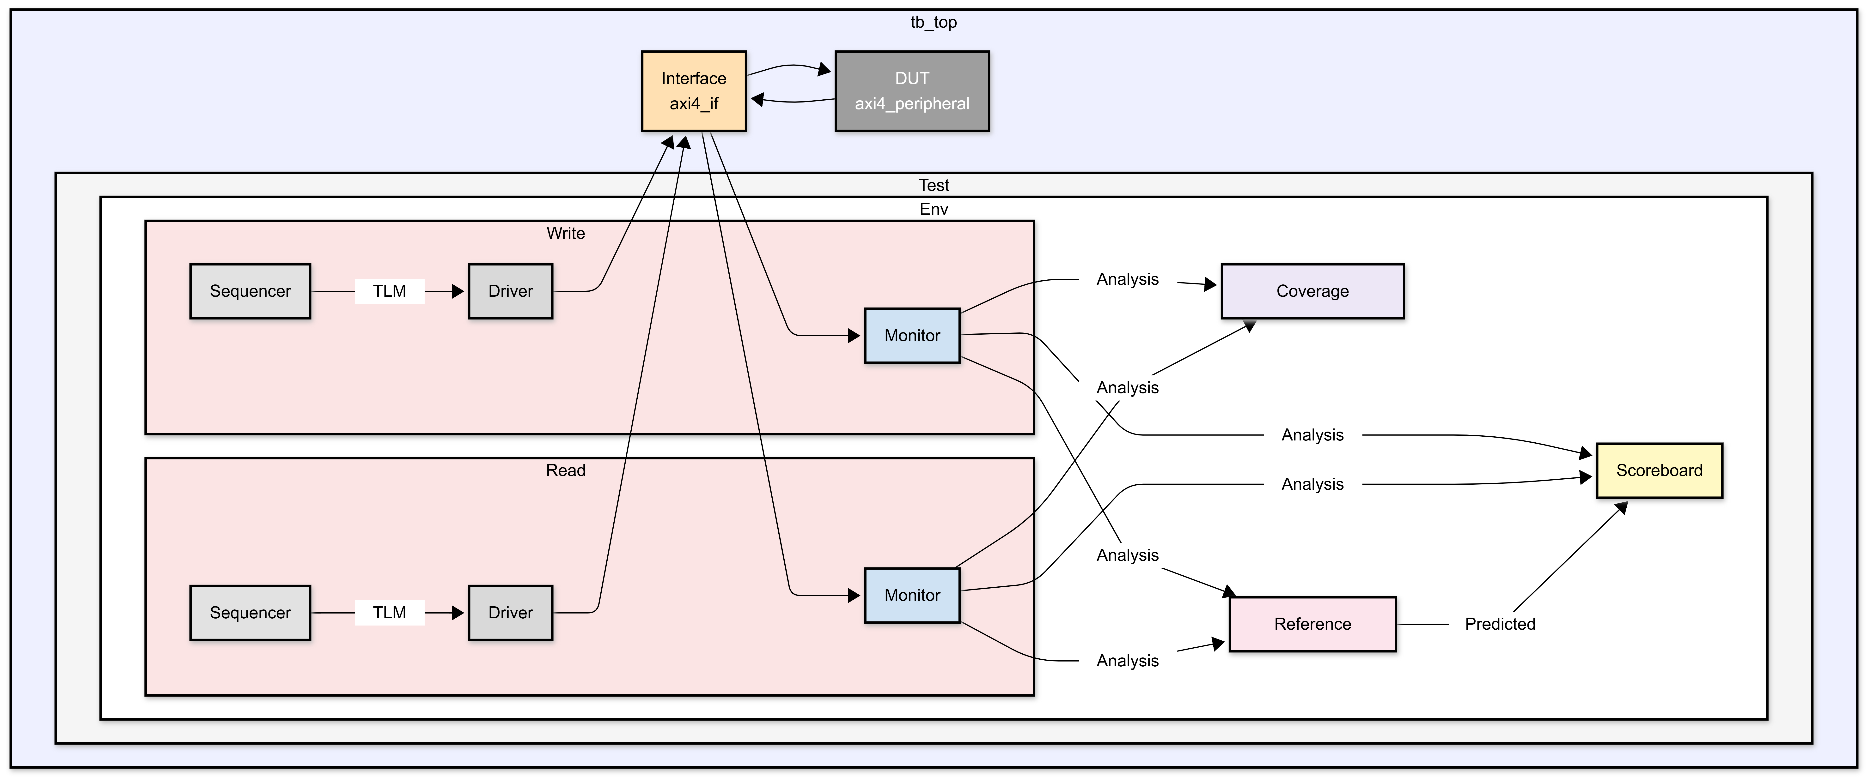
How to read it: identical structure to 3.3, but every stimulus item — including register accesses like "write CTRL, read it back" — is built directly as a hand-written axi4_write_txn/axi4_read_txn and sent straight to a sequencer, with no RAL layer translating it. This is the diagram that matches what you'll actually be running during Phase 1/2 of bring-up (Section 4.0); once it's stable, RAL gets bolted on to produce the 3.3 diagram without changing anything else in the environment.

3.5 Full Environment Block Diagram (detailed)
Key architectural points:
- Two agents, split by traffic direction, not by individual channel: axi4_write_agent owns AW+W+B, axi4_read_agent owns AR+R. This is the minimum split that still lets you prove "channels operate independently" (per the spec) by running reads and writes concurrently — that's the actual independence requirement, not AW-vs-W independence within one direction.
- Each driver internally forks parallel threads for its sub-channels: the write driver's AW-issue thread can queue address requests ahead of the W-issue thread finishing a previous burst's data (matching the DUT's real QDEPTH=4 queuing behavior), while a separate always-on thread drives BREADY per a configurable ready policy. Same pattern on the read side with AR and RREADY.
- Monitors are fully passive and feed the scoreboard/coverage independently of the driver — satisfying the "checking must be independent of the driver" requirement.
- No virtual sequencer is needed here since there's no cross-agent coordination required beyond "start a write sequence" and "start a read sequence" concurrently from the test, which fork/fork_join_none in the test's run_phase handles directly.
- If a future need arises to torture-test AW independently of W (not required by this spec), the write agent can be split further later — the 2-agent structure doesn't block that, it just doesn't build it before it's needed.

4. Env (Environment Architecture)

4.0 Recommended Build Order (Bring-up Phasing)
Build the environment in this order rather than all at once:
- Phase 1 — Core pipe, no RAL: write/read agents, monitors, reference model, scoreboard. Validate with hand-written directed sequences that build axi4_write_txn/axi4_read_txn items directly (e.g., "write 0x1 to CTRL, read it back") rather than through RAL. This proves the whole driver→DUT→monitor→scoreboard pipe using something simple enough to debug by hand if it fails.
- Phase 2 — Everything that doesn't need RAL: burst-legality negative tests, address-decode sweep, FIFO tests, IRQ tests, backpressure/outstanding-depth stress — all of these just need the same raw transaction items with different field values, so they can be written and passing before RAL exists at all.
- Phase 3 — Add RAL: once Phase 1 is trusted, layer axi4_reg_block + axi4_reg_adapter on top of the same sequencers. At this point uvm_reg_bit_bash_seq/uvm_reg_hw_reset_seq/uvm_reg_access_seq become nearly free register coverage, and any failure in them is far more likely to be a real bug than a plumbing bug, since plumbing was already proven in Phase 1.
Rationale: RAL only adds value once you trust what's underneath it. Building it first means every RAL sequence failure could be the DUT, the adapter, or an unproven driver — three unknowns instead of one.

4.1 Class Hierarchy (top-down)
axi4_test (extends uvm_test)
└─ axi4_env (extends uvm_env)
├─ axi4_write_agent (uvm_agent: sequencer + driver + monitor, owns AW/W/B)
├─ axi4_read_agent (uvm_agent: sequencer + driver + monitor, owns AR/R)
├─ axi4_reg_block (RAL model) + axi4_reg_adapter
├─ axi4_ref_model (reference/golden model)
├─ axi4_scoreboard
└─ axi4_coverage (subscriber)
No virtual sequencer is needed for this scope — the test's run_phase simply forks a write sequence on write_agent.sequencer and a read sequence on read_agent.sequencer concurrently when it wants concurrent read/write traffic (F31), and runs them sequentially otherwise.

4.2 Transaction / Sequence-Item Classes
Class | Fields | Used By
axi4_write_txn | id, addr, len, size, burst, data[], strb[] (driver input); per-beat resp, final resp (monitor output) | write_agent sequencer (as stimulus) and monitor (as reconstructed output)
axi4_read_txn | id, addr, len, size, burst (driver input); data[], per-beat resp, final resp (monitor output) | read_agent sequencer (as stimulus) and monitor (as reconstructed output)

Using one rich item per logical burst (rather than one item per channel beat) is what lets a single sequencer per direction work — the driver is responsible for unpacking the item into per-cycle pin wiggles across AW+W(+B) or AR+R.

4.3 Agents
- axi4_write_agent: sequencer produces axi4_write_txn items. The driver, on receiving an item, forks three concurrent processes:
  - AW-issue thread — drives AWID/AWADDR/AWLEN/AWSIZE/AWBURST/AWVALID, waits for AWREADY. Can start the next item's AW phase before the current item's W/B phase finishes, matching the DUT's real queuing (F2/F3).
  - W-issue thread — drives WDATA/WSTRB/WLAST/WVALID beat-by-beat for the item, waits for WREADY each beat.
  - B-ready thread — runs continuously (not per-item), driving BREADY per a configurable policy (always-ready / random / slow-drain), independent of items being processed.
- axi4_read_agent: mirrors the same pattern — AR-issue thread, and a continuously-running R-ready thread.
- Monitors are passive: the write monitor watches AW+W+B and reconstructs a completed axi4_write_txn (matching WLAST/beat-count and the corresponding B); the read monitor reconstructs axi4_read_txn on RLAST. Neither monitor's output path touches the driver.
- Config knobs (via uvm_config_db): max outstanding count to drive, ready-delay distribution, error-injection weight (e.g., % of bursts intentionally illegal), ID reuse policy.

4.4 Sequence Library — 50 Sequences
Implementation strategy — don't write 50 sequences from scratch. Build a handful of base sequence classes, each with configurable knobs (constraints, class properties) that control what it drives. Every one of the 50 named sequences below is a thin subclass that just sets those knobs in pre_body() (or via its constructor) and calls super.body(). This is standard UVM practice for exactly this situation — it gives you 50 individually-nameable, individually-callable sequences (so your mentor sees 50 distinct, purposeful scenarios) without 50 copies of the same handshake-driving code.
Base classes to build first: | Base Class | Drives | Used by categories below | |---|---|---| | axi4_write_base_seq | one write burst (id/addr/len/size/burst/data/strb configurable) | C, D, E, F, G | | axi4_read_base_seq | one read burst (id/addr/len/size/burst configurable) | C, D, E, F, G | | axi4_reg_base_seq | single-beat register access (via RAL adapter once built, or raw item pre-RAL) | B, F, H | | axi4_vseq_base (virtual) | coordinates a write-side and read-side child sequence concurrently | I |
Each named sequence below extends one of these and only overrides the relevant fields/constraints — e.g., seq_illegal_len_gt15_write is axi4_write_base_seq with len constrained > 15 and everything else left to randomize normally.

A. Reset & Sanity (3)
# | Sequence | Feature(s)
1 | seq_reset_basic | F1
2 | seq_reset_readback_zero | F1
3 | seq_reset_midtxn | F34

B. Directed Register Access — one per register + RAL reuse (10)
# | Sequence | Feature(s)
4 | seq_reg_ctrl_rw | F19–F21
5 | seq_reg_status_ro_check | F18
6 | seq_reg_int_en_rw | F22
7 | seq_reg_int_status_w1c | F23,F25
8 | seq_reg_fifo_data_access | F26,F27
9 | seq_reg_fifo_status_ro_check | F18,F28
10 | seq_reg_delay_cfg_rw | F29
11 | seq_reg_txn_count_ro_check | F18,F30
12 | seq_reg_bit_bash_all (RAL uvm_reg_bit_bash_seq reuse) | F18,F22,F29
13 | seq_reg_hw_reset_check (RAL uvm_reg_hw_reset_seq reuse) | F1

C. Negative — Burst Legality (10)
# | Sequence | Feature(s)
14 | seq_illegal_wrap_burst_write | F10
15 | seq_illegal_wrap_burst_read | F10
16 | seq_illegal_reserved_burst_write | F10
17 | seq_illegal_reserved_burst_read | F10
18 | seq_illegal_len_gt15_write | F11
19 | seq_illegal_len_gt15_read | F11
20 | seq_illegal_size_gt2_write | F12
21 | seq_illegal_size_gt2_read | F12
22 | seq_illegal_4k_boundary_write | F13
23 | seq_illegal_4k_boundary_read | F13

D. Positive — Legal Burst Variants (9)
# | Sequence | Feature(s)
24 | seq_legal_fixed_burst_write | F6,F8
25 | seq_legal_fixed_burst_read | F7,F8
26 | seq_legal_incr_burst_write | F6,F9
27 | seq_legal_incr_burst_read | F7,F9
28 | seq_max_length_burst_write (16 beats) | F11,F38
29 | seq_max_length_burst_read (16 beats) | F11,F38
30 | seq_single_beat_write (len=0) | F4,F6
31 | seq_single_beat_read (len=0) | F7
32 | seq_wstrb_sweep_write (full-strobe, single-byte, sparse patterns) | F4

E. Address Decode (5)
# | Sequence | Feature(s)
33 | seq_addr_ram_region_rw | F14
34 | seq_addr_reg_region_rw | F15
35 | seq_addr_unmapped_decerr | F17
36 | seq_addr_error_window_slverr | F16
37 | seq_addr_reg_gap_decerr (e.g. offset 0x1020) | F15

F. FIFO Scenarios (5)
# | Sequence | Feature(s)
38 | seq_fifo_push_pop_basic | F26–F28
39 | seq_fifo_overflow_push_while_full | F26
40 | seq_fifo_underflow_pop_while_empty | F27 (Appendix A #1)
41 | seq_fifo_disable_clears_contents | F20
42 | seq_fifo_partial_strobe_reject | F26

G. Interrupt Scenarios (5)
# | Sequence | Feature(s)
43 | seq_irq_basic_assert_deassert | F19,F22
44 | seq_irq_mask_sweep | F22
45 | seq_irq_en_gate | F19
46 | seq_irq_w1c_clear | F23
47 | seq_irq_level_set_fifo_flags (post-reset FIFO-empty check) | F24 (Appendix A #4)

H. Outstanding / Backpressure / Ordering — virtual sequences (3)
# | Sequence | Feature(s)
48 | seq_outstanding_depth_stress | F2,F3,F32,F33
49 | seq_backpressure_sweep | F21,F29,F36,F37
50 | seq_concurrent_read_write (virtual, axi4_vseq_base) | F31

Traceability check: all 38 features from Section 2 are covered by at least one sequence above; several (e.g., F18, F22, F26) are deliberately exercised from more than one angle (directed register test + negative/stress test) since that's exactly the kind of redundancy a mentor is usually looking for at 50 sequences — not 50 unique features, but multiple independent angles of attack on the important ones.

4.5 Reference / Golden Model
A behavioral model (axi4_ref_model) re-implementing, independently of the RTL's coding style, the intended address decode, burst-legality checks, RAM/register/FIFO state, and IRQ equation. It:
- Maintains a shadow RAM, shadow register file, and shadow FIFO (queue of 32-bit words).
- Predicts BRESP/RRESP per beat and the final accumulated BRESP.
- Predicts RDATA for RAM/register/FIFO reads.
- Predicts IRQ and INT_STATUS evolution, including the level-set fifo_full/fifo_empty behavior (F24) and W1C clearing.
- Tracks per-channel outstanding queue occupancy to predict READY stalls at QDEPTH.
Being written independently (not copy-pasted from RTL) is what gives this model actual bug-finding value — it should be built from Section 1 of this plan and the AXI4 spec, not from reading the RTL beat-by-beat.

4.6 Scoreboard
- In-order, transaction-level comparison: for each completed axi4_write_txn/axi4_read_txn from the monitors, compare against axi4_ref_model's prediction for the same ID/address/type — using a FIFO-per-nothing (single global order) matching policy, since this DUT processes bursts strictly in issue order (see F32).
- Checks: BRESP/RRESP correctness (per beat and final), RDATA correctness, BID/RID echo correctness, RLAST/WLAST timing, post-transaction register/RAM/FIFO state via periodic register-model mirror() reads.
- Separately tracks IRQ as a continuously-sampled signal compared every cycle against the reference model's live prediction (not just at transaction boundaries), since IRQ and INT_STATUS bit 0/1 change asynchronously to any single transaction (F24).
- Reports mismatches with full transaction context (ID, address, expected vs. actual) to ease debug.

4.7 Functional Coverage
Covergroup | Coverpoints | Key Crosses
cg_burst | burst type (FIXED/INCR/WRAP/rsvd), size (1/2/4/illegal), len (0,1,mid,15,>15) | burst × size × len
cg_addr_region | RAM / each register / error-window / unmapped, per channel | region × (read/write)
cg_wstrb | strobe patterns (all-1, single-byte, sparse, none) | strobe × region
cg_id | ID value bins, same-ID-back-to-back, distinct-ID-outstanding | id × outstanding-count
cg_outstanding | 0,1,2,3,4 outstanding AW/AR entries; stall-hit vs. not | aw_outstanding × ar_outstanding
cg_ctrl | irq_en, fifo_en, delay_en individually and combined | irq_en × fifo_en × delay_en
cg_irq | INT_EN bins (none/one/all), INT_STATUS bins, resulting IRQ value | int_en × int_status × irq
cg_fifo | empty, full, mid-level, push-while-full, pop-while-empty | fifo_state × push/pop attempt
cg_delay | DELAY_CFG read-side/write-side bins (0, low, high, max) | delay_en × delay_bin
cg_resp | OKAY/SLVERR/DECERR per channel, cause of error | resp × cause

Goal: 100% functional coverage (or documented waiver) + ≥95% code coverage (line/branch/toggle/FSM) prior to sign-off.

4.8 Register Model (RAL)
- axi4_reg_block models the 8 defined registers (CTRL, STATUS, INT_EN, INT_STATUS, FIFO_DATA, FIFO_STATUS, DELAY_CFG, TXN_COUNT) with correct access policies (RW, RO, W1C — UVM's built-in W1C field policy fits INT_STATUS directly).
- FIFO_DATA is special (each read/write has a side effect on FIFO state rather than storing a value) — modeled either as a WO/RO-hybrid pseudo-register with NO_REG_ACCESS_CHECK or driven purely through raw sequences rather than RAL read()/write(), to avoid RAL's automatic mirror logic fighting the FIFO's stateful semantics. Decide and document this choice explicitly in the plan before coding (Appendix A item).
- axi4_reg_adapter (extends uvm_reg_adapter) converts uvm_reg_bus_op into a single-beat (len=0) axi4_write_txn or axi4_read_txn. The RAL map is configured with write_agent.sequencer as its write bus and read_agent.sequencer as its read bus (uvm_reg_map::set_sequencer takes a bus write and bus read sequencer separately, so this maps cleanly onto the 2-agent split with no extra glue). This lets uvm_reg_hw_reset_seq, uvm_reg_bit_bash_seq, and uvm_reg_access_seq be reused for cheap coverage of F15/F18/F22/F23/F29/F30.

4.9 Assertions (SVA) — bound to axi4_if
Assertion | Checks
a_valid_stable_until_ready | Once any *VALID asserts, it (and its associated data/control) must remain stable until the paired *READY (AXI4 handshake rule)
a_no_x_on_active_signals | No unknowns on VALID/READY/control fields once out of reset
a_wlast_count | WLAST asserted exactly on beat count == AWLEN for the corresponding accepted AW
a_rlast_count | RLAST asserted exactly on beat count == ARLEN
a_resp_id_match | Every BVALID/RVALID handshake carries the ID of some previously-accepted, not-yet-responded AW/AR
a_reset_deasserts_channels | All *VALID deasserted for at least 1 cycle immediately following reset deassertion until legally driven
a_irq_formula | IRQ == (CTRL[0] && |(INT_EN & INT_STATUS)), continuously checked (independent of scoreboard, catches combinational bugs immediately)

4.10 Test List
Test | Sequences Used | Intent
test_reset | 1–3 | Sanity + F1, F34
test_directed_regs | 4–13 | Directed per-register access, RO/W1C checks, RAL reuse
test_directed_burst_basic | 24–32 (fixed seeds) | Basic FIXED/INCR/single-beat/WSTRB sanity
test_negative_burst | 14–23 | F10–F13
test_addr_decode | 33–37 | F14–F17
test_fifo | 38–42 | F20,F26–F28
test_irq | 43–47 | F19,F22–F25
test_outstanding_stress | 48 | F2,F3,F32,F33
test_concurrent_rw | 50 | F31
test_backpressure | 49 | F21,F29,F36,F37
test_random_regression | random mix of 1–50, randomized seed | full regression / coverage closure

4.11 Regression, Coverage Closure & Exit Criteria
- Directed tests pass first (bring-up).
- Constrained-random regression run nightly across all tests with rotating seeds (target: hundreds of seeds per test for test_random_regression).
- Functional + code coverage merged and reviewed weekly; unhit bins triaged as either missing stimulus or genuinely unreachable (waived with justification).
- All SVA assertions enabled and passing across every regression run (not just dedicated protocol tests).
- Sign-off requires: 0 open P1/P2 bugs, 100% functional coverage (or waived), ≥95% code coverage (or waived), full regression clean on final RTL, and all Appendix A ambiguities resolved/documented.

Appendix A — Design Ambiguities / Items for Mentor Review
These surfaced from reading the RTL against the written spec and should be raised, per the project's own instruction that "technical ambiguities are to be discussed during mentor reviews":
- FIFO underflow: The spec doc lists FIFO underflow as an error condition, but the RTL silently absorbs a pop request on an empty FIFO (no SLVERR, no INT_STATUS bit set) — a read of FIFO_DATA while empty just returns stale/zero data with OKAY. Confirm whether this is intended, or whether F27 should be written as a negative test expecting an error that the current RTL does not produce (i.e., a candidate DUT bug).
- WLAST vs. beat-count mismatch: the write FSM terminates a burst on WLAST or internal beat-count reaching AWLEN, whichever occurs first — driving WLAST early or late relative to AWLEN is untested territory in the spec. Recommend an explicit negative sequence and a decision on expected behavior.
- Transaction ordering / ID reordering: the DUT services AW/AR requests strictly in FIFO issue order regardless of ID (single active write engine, single active read engine) rather than allowing genuine out-of-order completion across different IDs, which AXI4 permits but does not require. Confirm this in-order behavior is the intended DUT capability (not a bug), since some test benches assume ID-based reordering is exercised.
- INT_STATUS[0]/[1] are level-set, not edge-detected — they get re-asserted every cycle the FIFO is full/empty, including immediately after reset (FIFO starts empty). This means IRQ can assert right after reset if irq_en, INT_EN[1], and default INT_STATUS conditions line up before software ever touches the FIFO. Confirm this is intended interrupt semantics.
- RAL modeling of FIFO_DATA: since it has push/pop side effects rather than a stored value, the team should agree up front whether to model it as a plain RAL register with disabled mirroring/checking, or bypass RAL entirely for this address and drive it via raw sequences.

