Create an App on Git

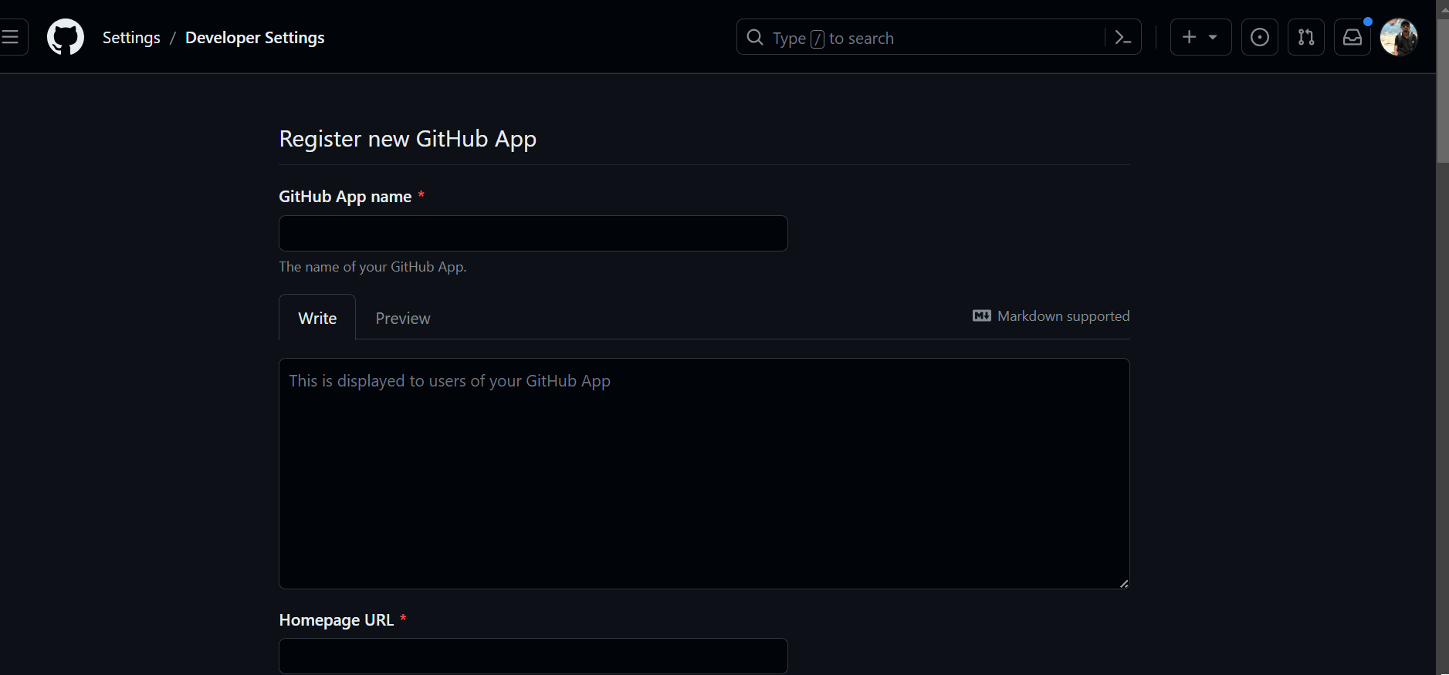

Obtain Client and Secret Key

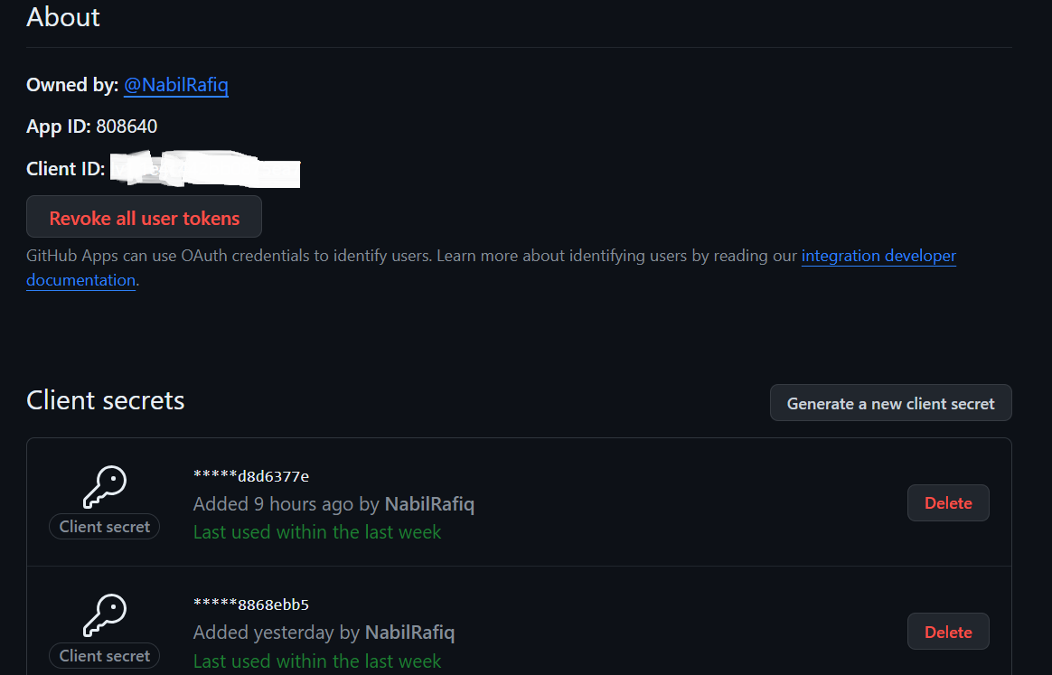

Import necessary libraries and create essential information variables in flask app

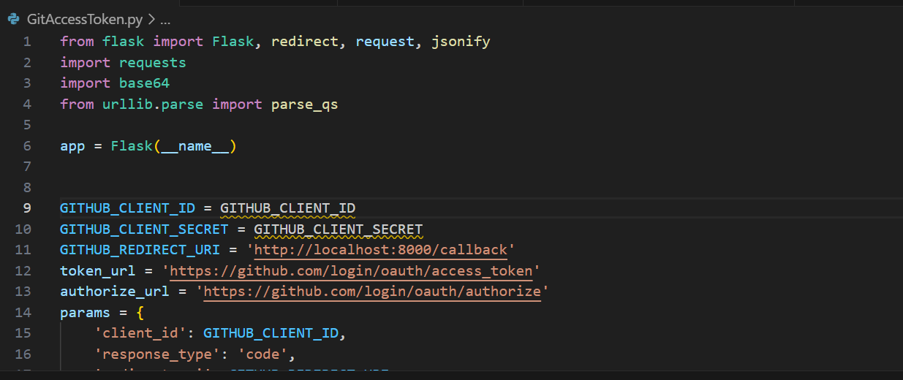

Run and Authorize the App

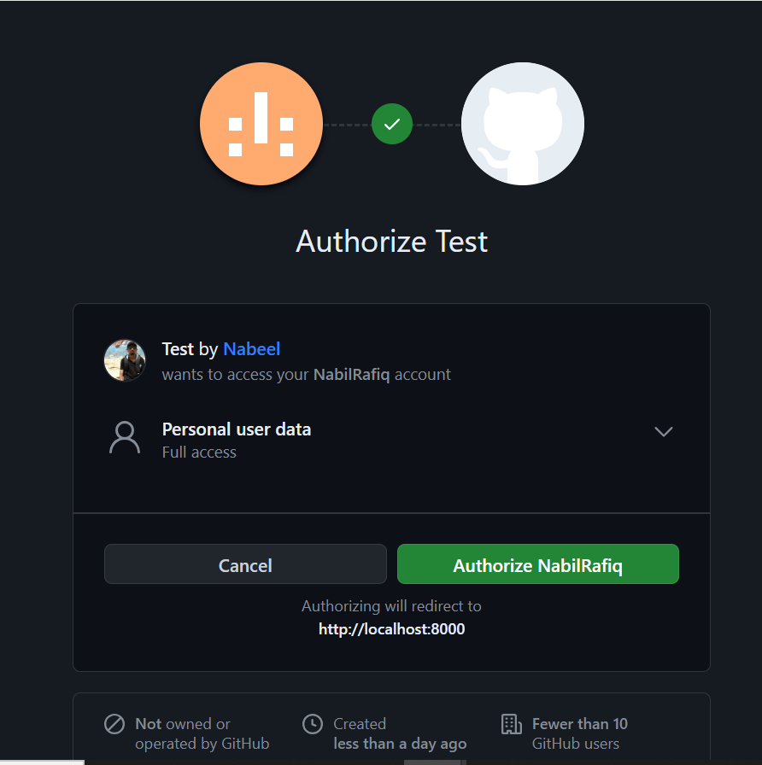

Now Git Hub Don’t return in URL Encoded String so we have to make some changes in the code

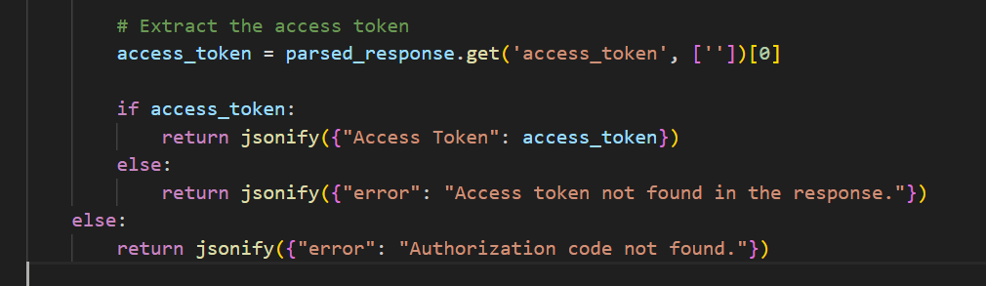

With this it will access token on Local Host which now we will use for endpoints

Now we are going use endpoints:

1. Return All Repos of a Person:

For this we don’t need flask app so will create a new file. Here we will use username of person whose repos we want from git hub account and access token that we got from flask app.

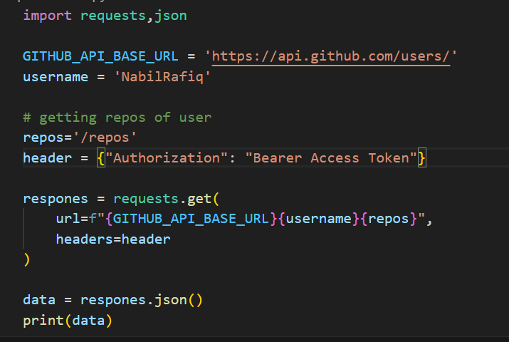

Result:

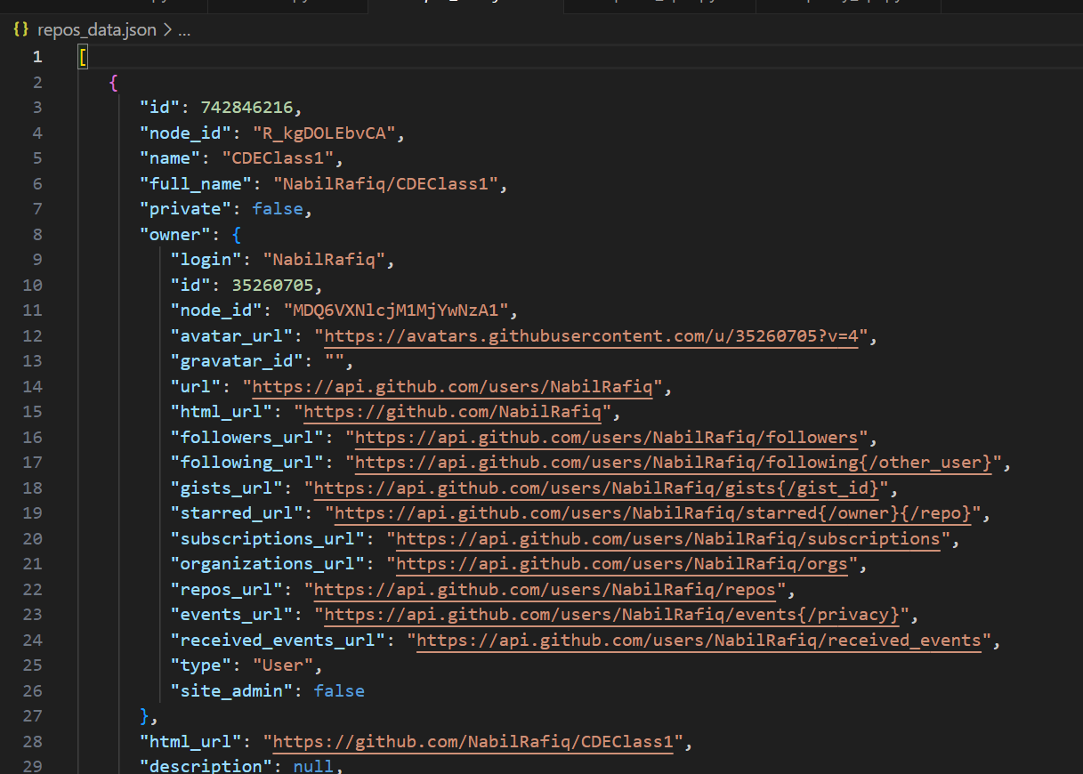

(We have stored data returning in a JSON File)

1. Create a repo

Now we will use this api to create a repo. We will continue to work on that python file it has our accesstoken stored already

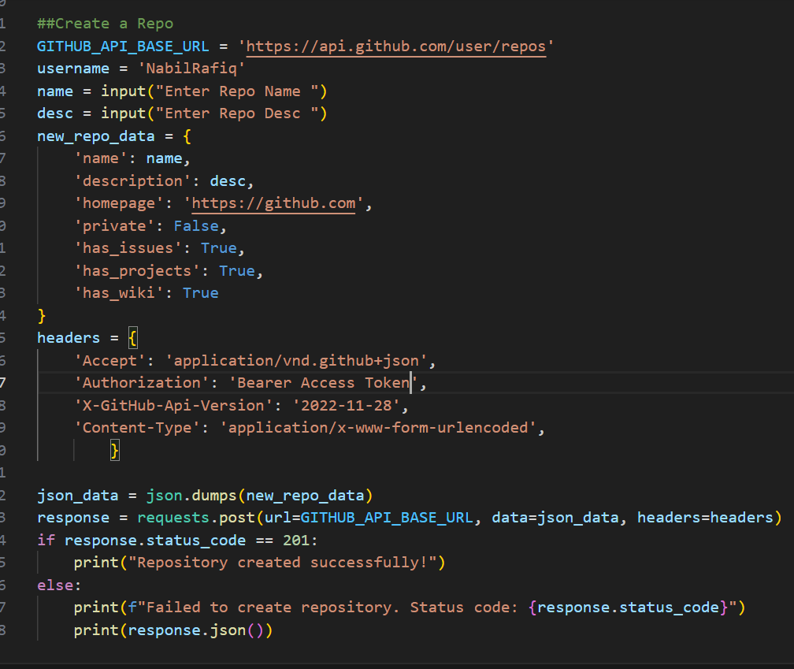

Note for update we may use .put however git api docs to use patch plus it also passes additional headers

Result:

