**OUTPUT**

Main page

Option 1 (before reservation)

Option 2 (default)

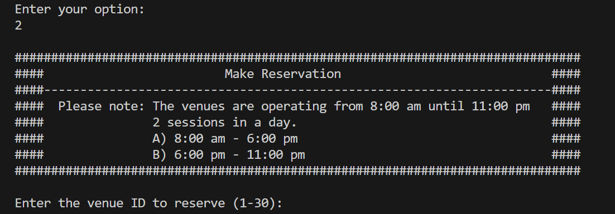

Option 2: Make reservation

Option 2: Invalid date

Option 2: Same venue, date, time //error

Option 2 (cancel) //it will display the main page once cancelled

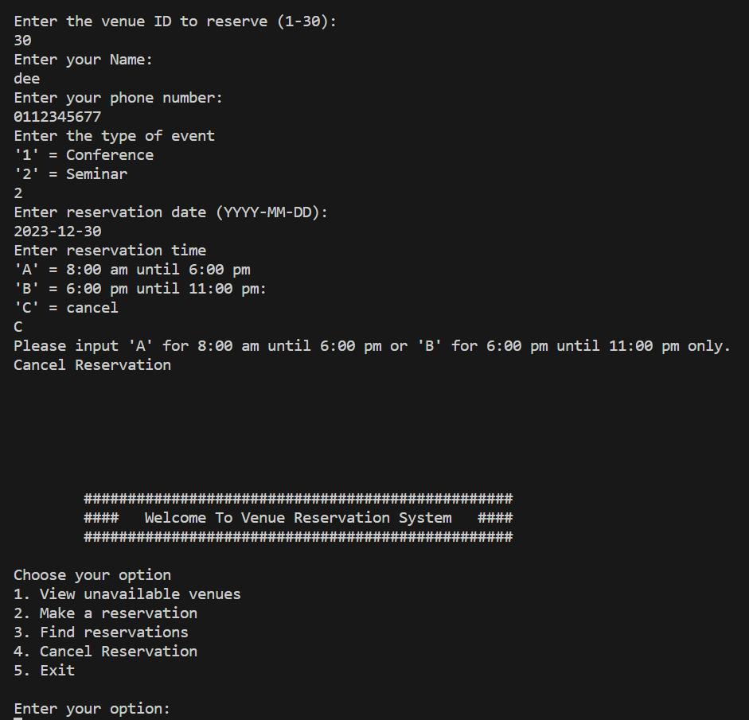

Option 1 (after reservations)

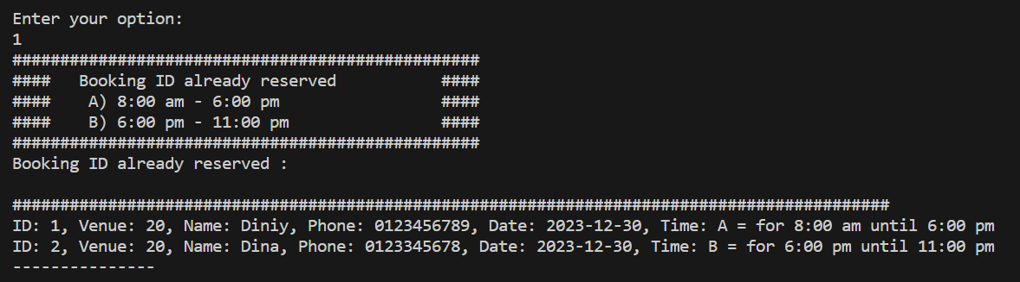

Option 3: Find reservations //Display the reservations for matching IDs

Option 4: Cancel reservation (using ID)

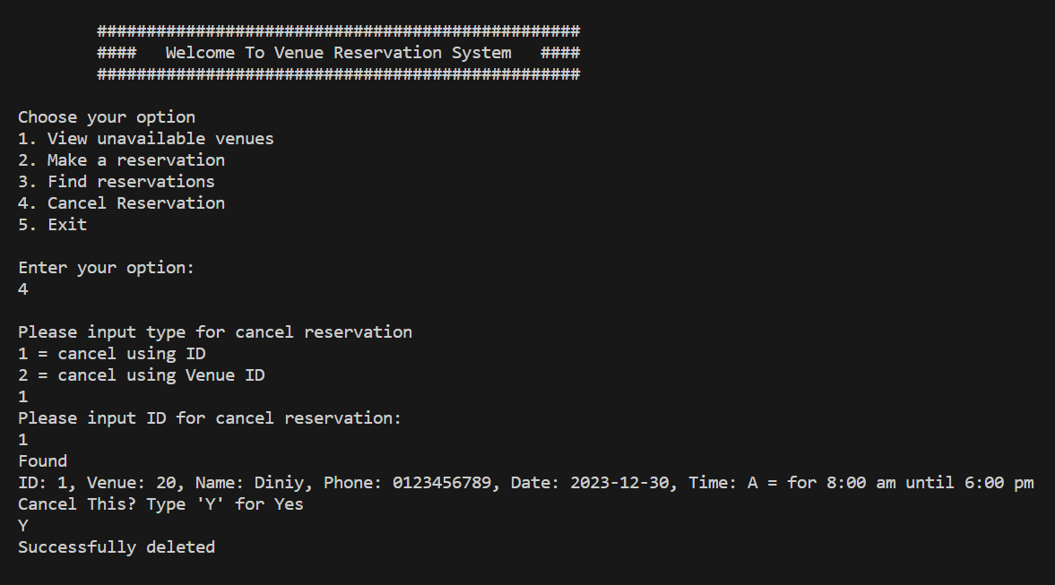

Option 4: Cancel reservation (using venue ID) //Cancels all reservation that matches the ID

Check effectiveness after cancellations by choosing option 1 //Cancellation Successful

