**Micro Project 3**

**Line Follower Robot**

**CYBERNETICS ROBO ACADEMY, SYLHET.**

This is a line follower robot that can move following 3 cm black line on a white surface.

**REQUIRED COMPONENTS:**

|  |  |  |
| --- | --- | --- |
| Components | Quantity | Photo |
| 1. [Arduino UNO](https://www.facebook.com/commerce/products/2144395295679800/) | 1 |  |
| 2. [Jumper Wire](https://www.facebook.com/commerce/products/2524411487570684/) | 20 |  |
| 3. [L298N Motor Driver](https://www.facebook.com/commerce/products/2326493327361305/) | 1 |  |
| 4. Motor And Wheel | 2 |  |
| 5. Ball Causter | 1 |  |
| 6. [Battery and Case](https://www.facebook.com/commerce/products/1442820612509548/) | 1 set |  |
| 7. [TCRT-5000](https://www.facebook.com/commerce/products/2267154666679394/) | 6 |  |
| 8. [220 ohm Resistor](https://www.facebook.com/commerce/products/2667126680024933/) | 6 |  |
| 9. [20K Resistor](https://www.facebook.com/commerce/products/2667126680024933/) | 6 |  |
| 10. [Angel Male Header](https://www.facebook.com/commerce/products/2179405898805402/) | 8 |  |
| 11. [Vero board](https://www.facebook.com/commerce/products/2644329068970699/) | 1 |  |
| 12. [Chassis](https://www.facebook.com/commerce/products/2426149377437933/) |  |  |

**Step 1**

Take the chassis and assemble it following the instruction in this video

<https://www.youtube.com/watch?v=3a-bE1VlaU8>

**Step 2**

Now put the Arduino, Motor Driver and battery case on the chassis like this

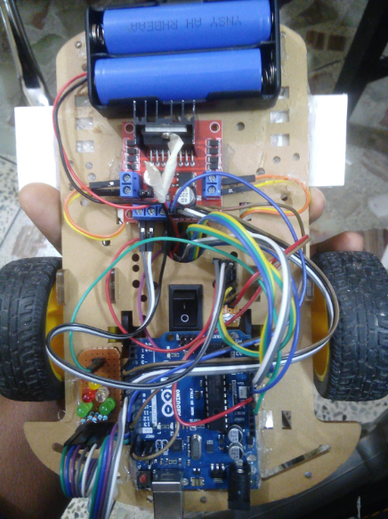

**Step 3**

Now take the Vero board, TCRT-5000, resistors, male angle header and solder them on the Vero board following the circuit diagram

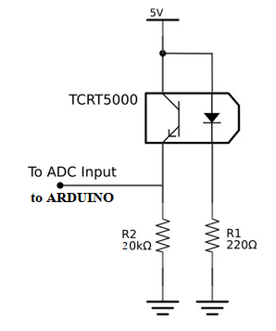

Connections of the circuit in words:

1. 5V >> IR LED Positive terminal and Photo transistors Collector

2. IR LED negative Tarminal >> 220 ohm Resistor’s one end

3. Photo Transistors Emitter >> 20 k ohm Resistor’s one end  
4. Both resistor’s another end >> Ground

5. Analog output will be taken from the Emitter.

After the circuit is completed it will look like this:

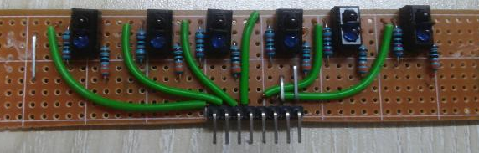

Connect Male angle headers as shown in the picture to power up the circuit and to take away the outputs.

**Step 4**

Now assemble the IR array under the robot just lie the picture. Make sure that the height of the sensors are not more than 1 cm from the surface.

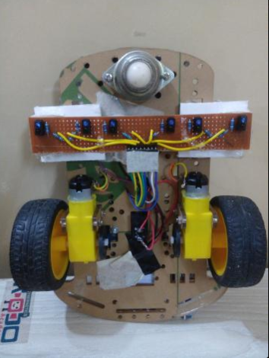

**Step 5**

Now using jumper wires, Set the following connections:

1. Switch:

* One end >> Batter Positive Terminal
* Second end >> 12V input of motor driver.

2. Motor Driver:

* Gnd >> Battery Ground
* 12 V>> Switch
* En A >> Arduino 9
* En B >> Arduino 10
* IN 1 >> Arduino 5
* IN 2 >> Arduino 4
* IN 3 >> Arduino 3
* IN 4 >> Arduino 2
* OUT A & B >> Left Motor
* OUT C & D >> Right Motor

3. Sensor Array :

* Positive >> Motor driver 5 V
* Negative >> Bttery Ground
* Sensor 1 output (Left most motor) >> Ardudino A0
* Sensor 2 output >> Ardudino A1
* Sensor 3 output >> Ardudino A2
* Sensor 4 output >> Ardudino A3
* Sensor 5 output >> Ardudino A4
* Sensor 6 output (Right most sensor) >> Ardudino A5

4. Arduino:

* Vin >> Motor driver 5V output
* Gnd >> Battery Ground

**Step 6**

Finally it’s time to run the code:

//////////////////////

//// CONNECTIONS ////

//////////////////////

// 1. Switch:

// • One end >> Batter Positive Terminal

// • Second end >> 12V input of motor driver.

// 2. Motor Driver:

// • Gnd >> Battery Ground

// • 12 V>> Switch

// • En A >> Arduino 9

// • En B >> Arduino 10

// • IN 1 >> Arduino 5

// • IN 2 >> Arduino 4

// • IN 3 >> Arduino 3

// • IN 4 >> Arduino 2

// • OUT A & B >> Left Motor

// • OUT C & D >> Right Motor

// 3. Sensor Array :

// • Positive >> Motor driver 5 V

// • Negative >> Bttery Ground

// • Sensor 1 output (Left most motor) >> Ardudino A0

// • Sensor 2 output >> Ardudino A1

// • Sensor 3 output >> Ardudino A2

// • Sensor 4 output >> Ardudino A3

// • Sensor 5 output >> Ardudino A4

// • Sensor 6 output (Right most sensor) >> Ardudino A5

// 4. Arduino:

// • Vin >> Motor driver 5V output

// • Gnd >> Battery Ground

int sensor[]={A0,A1,A2,A3,A4,A5};//left to right that means sensor[0] indicates the left one and sensor[5] is the right one

int sv[]={0,0,0,0,0,0};// sensor value

//int tv[]={490+50,620+50,560+50,490+50,740+50,680+50};//threshold value

int tv[]={850,850,850,850,850,850};

int enL=9, enR=10; //enable of left motor and right motor

int motorPin[]={2,3,4,5,9,10};// last two is enable pin anr 1st four is control pin

int led[]={12,11,8,7,6};

int i;

int rs=150, ls=150; // enable value of right and left motor for going forward

void setup() {

Serial.begin(9600);

for(i=2;i<=12;i++){

//pinMode(motorPin[i],OUTPUT);

pinMode(i,OUTPUT);

}

}

void loop(){

sense(0); sense(5);

if (sv[0]<tv[0] || sv[5]<tv[5]){

hbreak();

follow(-100,-100);

for(;;){

sense(0);sense(5);

if(sv[0]<tv[0] || sv[5]<tv[5]){

Stop(10);

break;

}

}

sense(0); sense(5);

if(sv[0]<tv[0] && sv[5]<tv[5]){

follow(rs,ls);

for(;;){

sense(0);sense(5);

if(sv[0]>tv[0] && sv[5]>tv[5]){

Stop(100);

break;

}

}

}

else if(sv[0]<tv[0] && sv[5]>tv[5]){

int ang=scanangle(0);

if (ang==1){

follow(rs,ls);

for(;;){

sense(0);sense(1);

if(sv[0]>tv[0] && sv[1]>tv[1]){

Stop(100);

break;

}

}

follow(rs,-20);

for(;;){

sense(0);

if(sv[0]<tv[0]){

Stop(100);

break;

}

}

follow(20,-ls);

for(;;){

sense(2);

if(sv[2]<tv[2]){

Stop(100);

break;

}

}

}

else{

follow(rs,-ls);

for(;;){

sense(2);

if(sv[2]<tv[2])

break;

}

ledoff();

}

}

else if(sv[0]>tv[0] && sv[5]<tv[5]){

int ang=scanangle(5);

if (ang==1){

follow(rs,ls);

for(;;){

sense(4);sense(5);

if(sv[4]>tv[4] && sv[5]>tv[5]){

Stop(100);

break;

}

}

follow(-20,ls);

for(;;){

sense(5);

if(sv[5]<tv[5]){

Stop(100);

break;

}

}

follow(-rs,20);

for(;;){

sense(3);

if(sv[3]<tv[3]){

Stop(100);

break;

}

}

}

else{

ledF(0);

follow(-rs,ls);

for(;;){

sense(3);

if(sv[3]<tv[3]){

Stop(10);

break;

}

}

}

}

}

else{

sense(1);sense(4);

if (sv[1]<tv[1] || sv[4]<tv[4]){

if(sv[1]>sv[4]){

follow(-20,ls);

}

else if(sv[1]<sv[4]){

follow(rs,-20);

}

}

else{

sense(2);sense(3);

if (sv[2]>sv[3]+10){

follow(rs-60,ls+105); //delay(500);

}

else if (sv[2]+10<sv[3]){

follow(rs+100,ls-50);

}

else{

follow(rs,ls);

}

}

}

}

void testMotors(){

for(;;){forward(255,255);}

for(int i=255;i>=-255;i--){

follow(i,i);

delay(10);

}

for(int i=-255;i<=255;i++){

follow(i,i);

delay(10);

}

}

void follow(int r, int l){

if (r>=0){

rwf(r);

}

else{

r=-r;

rwb(r);

}

if (l>=0){

lwf(l);

}

else{

l=-l;

lwb(l);

}

}

void backward(int bw){

rwb(bw);

lwb(bw);

}

void left(int lr, int ll){

rwf(lr);

lwb(ll);

}

void right(int rr, int rl){

rwb(rr);

lwf(rl);

}

void Stop(int s){

//follow(-rs,-ls);

//delay(10);

for(i=0;i<=5;i++)

digitalWrite(motorPin[i],0);

delay(s);

}

void hbreak(){

follow(-rs,-ls);

delay(70);

Stop(10);

}

void lwb(int a){ // right wheel forward

analogWrite(enL,a);

digitalWrite(motorPin[2],1);

digitalWrite(motorPin[3],0);

}

void lwf(int b){ // right wheel bacward

analogWrite(enL,b);

digitalWrite(motorPin[2],0);

digitalWrite(motorPin[3],1);

}

void rwf(int c){ // left wheel bacward

analogWrite(enR,c);

digitalWrite(motorPin[0],1);

digitalWrite(motorPin[1],0);

}

void rwb(int d){ // left wheel forwrd

analogWrite(enR,d);

digitalWrite(motorPin[0],0);

digitalWrite(motorPin[1],1);

}

void forward(int fr, int fl){

rwf(fr);

lwf(fl);

}

void checksensors(){

for(int i=0;i<6;i++){

sv[i]=analogRead(sensor[i]);

Serial.print(sv[i]);

Serial.print(" ");

}

Serial.println("");

}

int sense(int x){

sv[x]=analogRead(sensor[x]);

}

int scanangle(int x){

int val=0;

for(int i=0;i<6;i++){

if (i==x)

continue;

sv[i]=analogRead(sensor[i]);

if (sv[i]<tv[i]){

val=1;

break;

}

}

if (val==0){

sv[x]=analogRead(sensor[x]);

if (sv[x]>tv[x]){

val=1;

}

}

return val;

}

**Step 7**

That’s all. The robot is ready to follow over the line.

