Nabin Karki
Section-C
24071149

Program Descriptions (Week 5-6)
1. Count the number of lines, words, and characters in a text file..
This application processes a text file line by line while it is open in read mode. It employs a loop to determine the total number of lines, divides each line into words, and counts characters using the len() function. The final number of lines, words, and characters is shown.
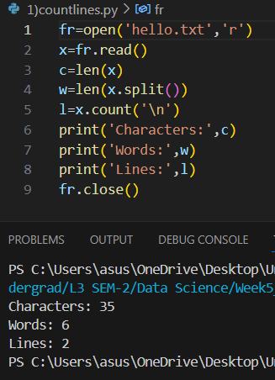

2. Copy contents from one file to another.
The application opens a destination file in write mode and a source file in read mode. The source file's contents are read and written into the destination file. This is helpful for making file duplicates or backups.
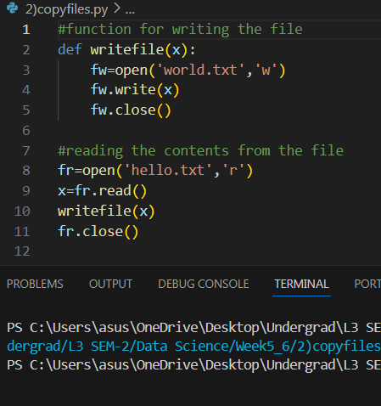

3. Find and replace a specific word in a file
This application reads a file, changes a word in the text with another word, and then writes the updated text back into the original file or another one. It illustrates simple file I/O and string manipulation using the replace() method to make substitutions.
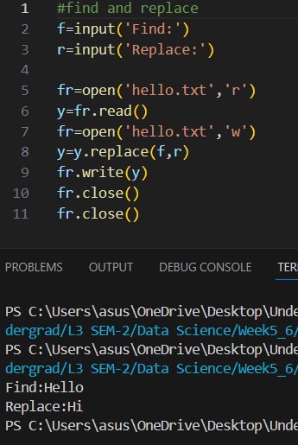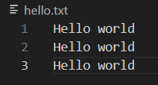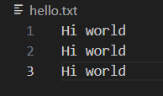

4. Read a CSV file and display its contents in tabular format.
The application reads a CSV file using the pandas library or CSV module. After that, the data is printed on the console in an orderly table format. This application facilitates the visual organization of CSV data for viewing or analysis.
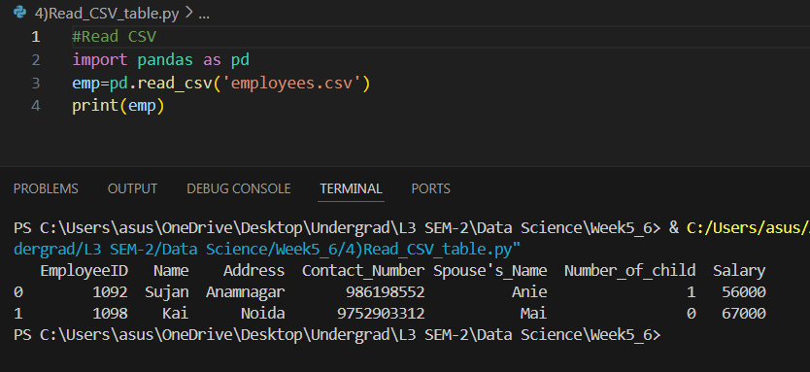

5. Count the occurrence of each word in a file.
This application reads a text file, breaks it up into words, and then counts the number of times each word appears using a dictionary. It gives information about word usage in the file by showing the frequency of each word.
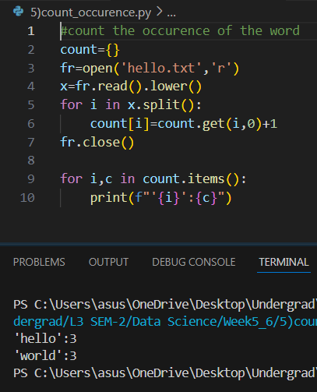

6. Class Student with attributes and display
A class The following characteristics define a student: name, address, level, section, admission year, and ID. To take input for these attributes, an object is made. After that, the application shows the full profile of the student, showcasing the usage of constructors and object instantiation.
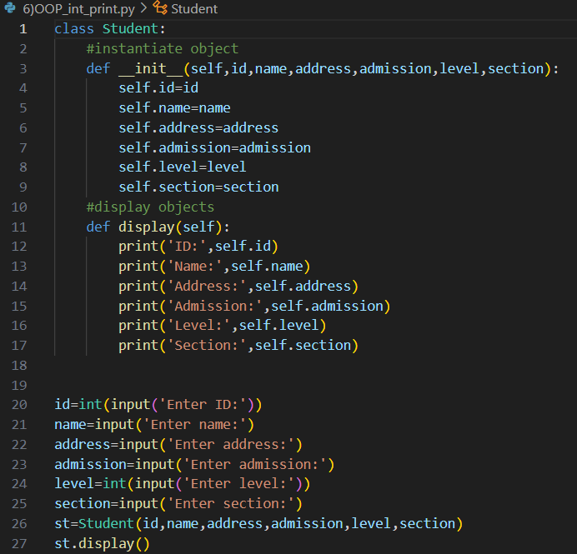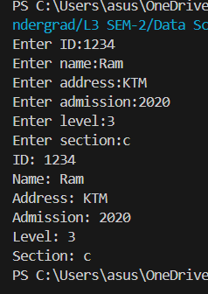

7. Class Employee with CSV file writing.
In order to gather data for numerous employees and write it to an employees.csv file, this program defines an Employee class with attributes. Additionally, the program uses try/except blocks to handle possible errors like invalid input or file access problems, and it offers the option to view all employees.
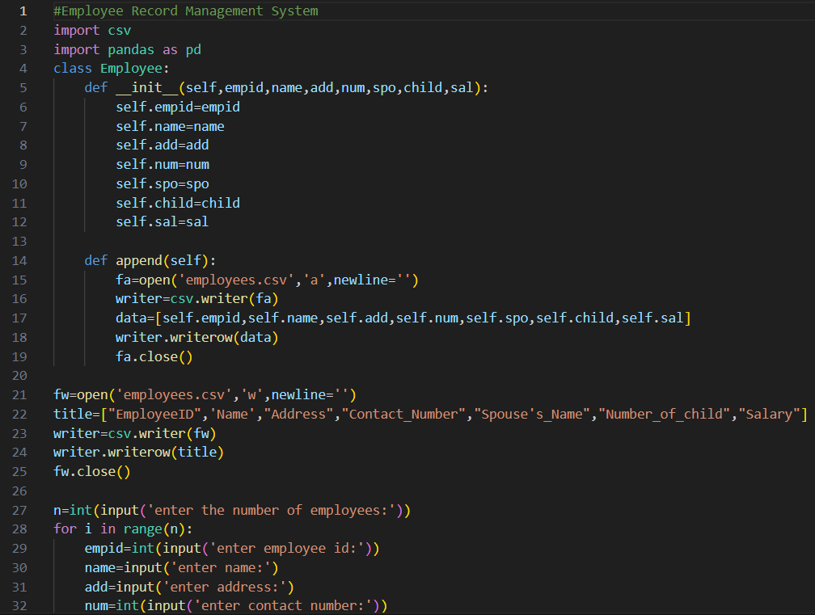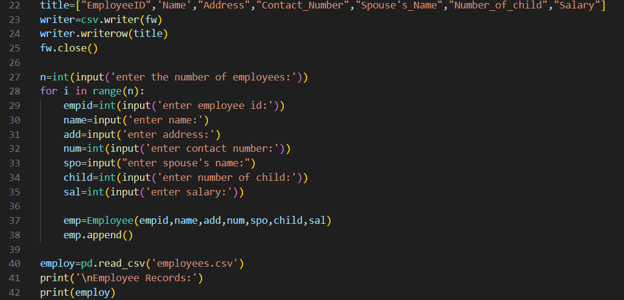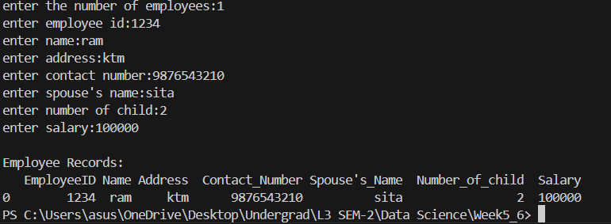

8. Basic Library Book Management System
The application uses OOP to implement a basic library management system. It has classes like Book and Library that can be used to search for books by title or author, issue books, and return books. Book data is stored in files to maintain state, and exception handling is used to manage errors lie unavailable books or missing files. 