Nabin Karki
Section-C
24071149

Program Descriptions (Week 1-2)

1. Perimeter of a Rectangle
Expression: 2 * (l + b)
Description: Calculates the perimeter using the formula 2(l + b).
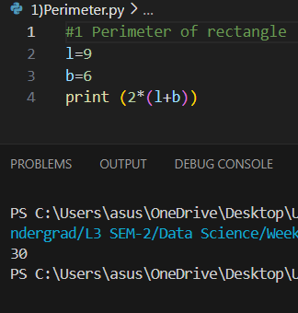

2. Print a Statement: “Python is great, it’s wild!”
Expression: print("Python is great, it’s wild!")
Description: Uses double quotes to handle the apostrophe safely. Displays the string as expected.
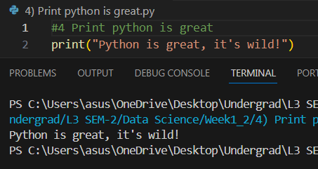

3. 2 Raised to the Power of 10
Expression: 2 ** 10
Description: Exponentiation operator. Returns 1024.
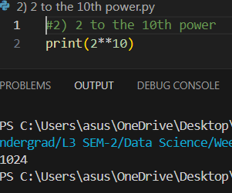

4. 7!, 5! subtracted
Expression: import math; math.factorial(7) - math.factorial(5)
Description: Uses math for factorials. Finds 5040-120=4920.
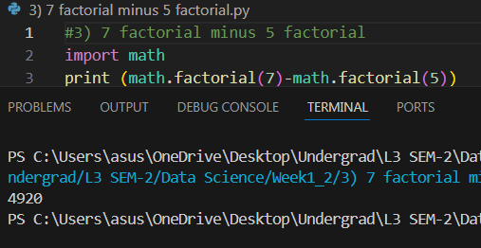

5. Multiply Your Forename by 5
Expression: "Pratyush" * 5
Description: The name "Pratyush" is repeated five times. Ideal for string repetition.
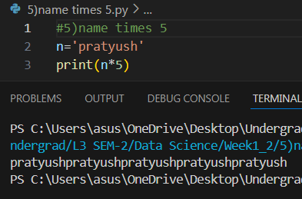

6. Left Justify Name to 15 Characters
Expression: "John".ljust(15)
Description: Completes the name with adequate space - to fill 15.
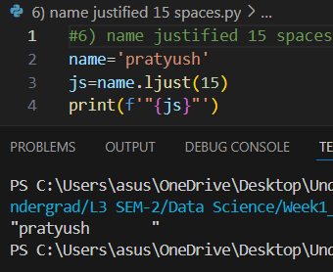

7. PI to 5 Decimal Places
Expression: format(22/7,’.5f’)
Description: Rounds PI by 3.14159 using the math module.
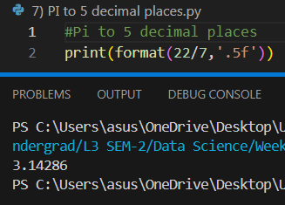

8. Modulus of 200 and 12
Expression: 200 % 12
Description: Returns a remainder after a division. Result is 8.
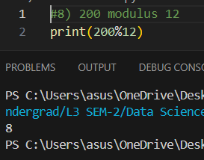

9. Convert 7.2 to Integer
Expression: int(7.2)
Description: Truncation. Result is 7.
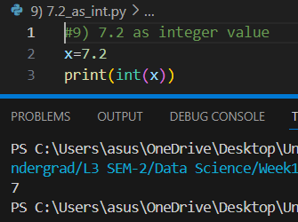

10. Unicode for Each Letter in Your Name
Expression: [ord(c) for c in "Pratyush"]
Description: Each character in the name converted to unicode value.
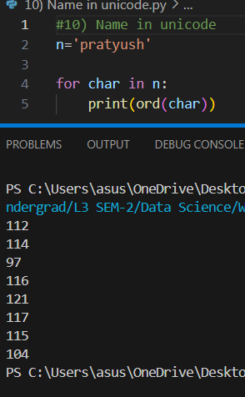

PART 2:
1. Even or Odd Number
Description: Reads an integer and computes whether it is divisible by 2 using %. Prints whether it is even or odd.
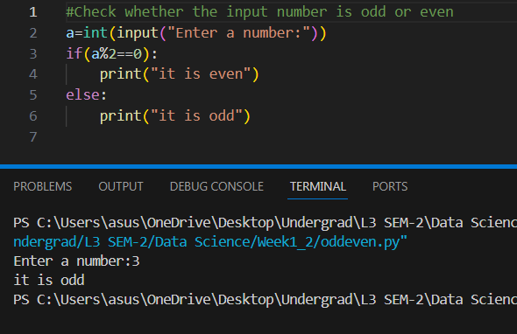

2. Divide Two Integers with Two Decimal Precision
Description: Accepts two integers, divides them, and gives the output in "{:.2f}".format(result) or round().
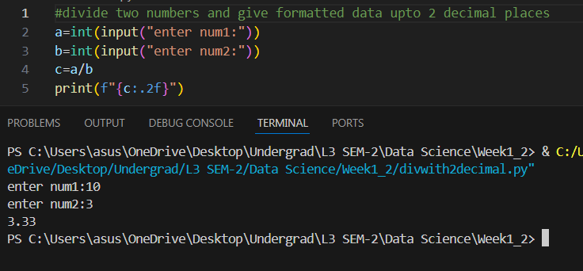
3. Convert Celsius to Fahrenheit
Formula: F = (C * 9/5) + 32
Description: Prompts user for input in Celsius and computes the output in the Fahrenheit approximation.
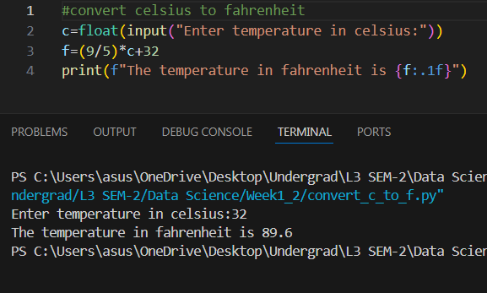

4. Euclidean Distance Between Two Coordinates Formula: (x2-x1)2+(y2-y1)2
Description: Find the distance that exists between two points provided by a user.
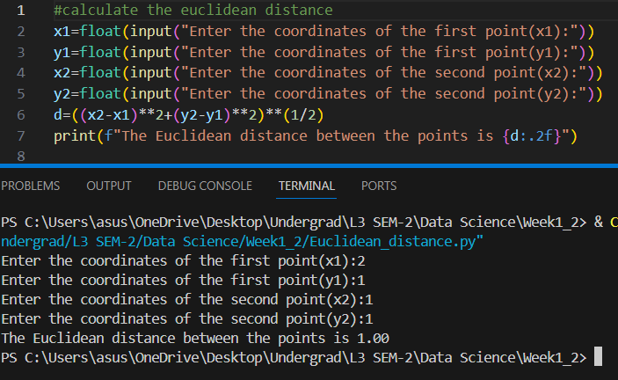

5. Simple Interest Calculator
Formula: SI = (P * R * T) / 100
Description: Ask for principal, rate, and time as input parameters and calculate simple interest.
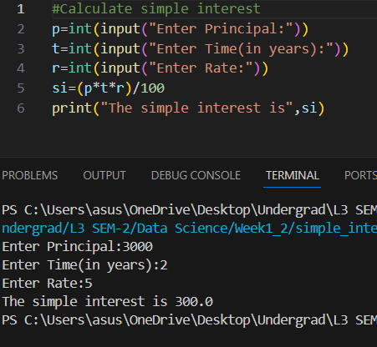

6. Find Numbers from 1500-2000, that are divisible by 7 and a multiple of 5
Describes: Uses a looping statement with if conditional to sort out numbers that are divisible by both 7 and 5.
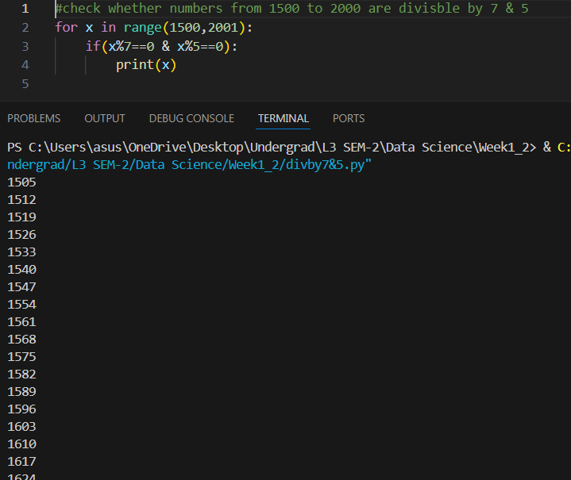

7. Count Digits and Letters in a String
Description: Iterate through each character and count letters separately by using combination of isalpha() and isdigit().
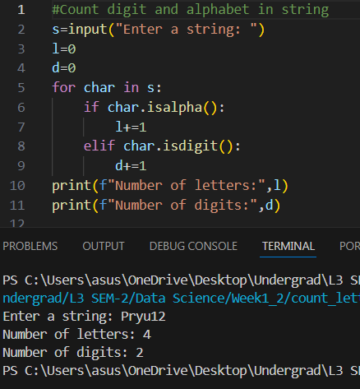

8. Number Guessing Game

I. Generate a Random Number:
Uses random.randint() for generation of the number.

II. Prompt for User Input:
Asks the user to guess a number.

III. Feedback After Each Guess:
It compares the guess to the answer and gives feedback: "Too high," "Too low," "Correct."

IV. Max Attempts 5:
It uses a loop to have up to 5 guesses.

V. Game Over Message:
Prints 'Game Over' if the user doesn't guess correctly in 5 attempts.

