Nabin Karki
Section-C
24071149

Program Descriptions (Week 3-4)

1. Count Upper and Lower Case Letters in a String
This function takes a string input and processes it to determine the number of uppercase letters and the number of lowercase letters in the string. It utilizes the string methods isupper() and islower() to check every character and maintain count.
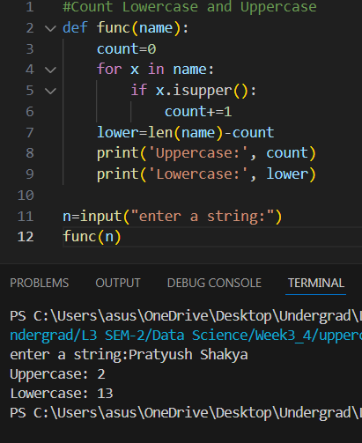

2. Prime Number Checker
This function checks whether a number is prime or not. A prime number is a number that is greater than 1 and has no divisors other than itself and 1. The function checks till the square root of the number for any existing divisibility.
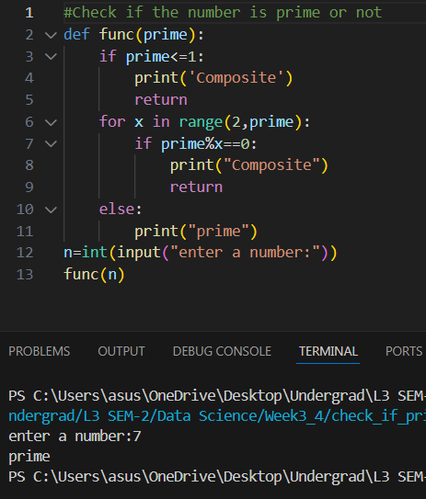

3. Armstrong Number Checker
This function checks whether the number is an Armstrong number. An Armstrong number for a number having 'n' digits will be when the sum of all its digits raised to 'n' equals the number itself.
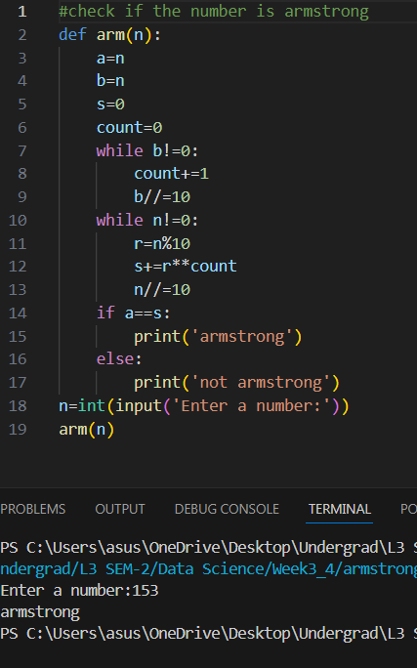

4. Sort List of Names
This function takes in a list of names and returns them sorted in alphabetical order using Python's built-in sort() function.
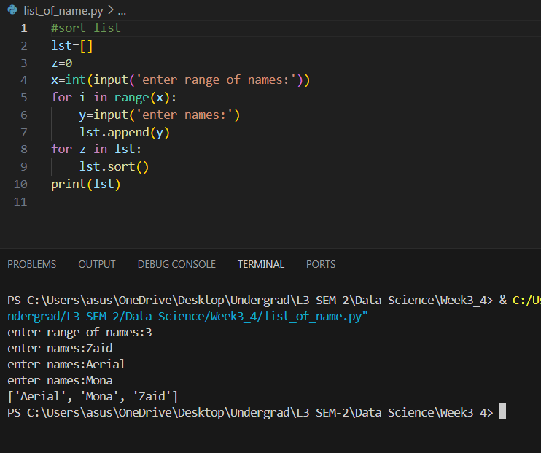

5. Calculator Program
This program lays out seven independent functions to facilitate basic arithmetic operations between two decimal numbers.
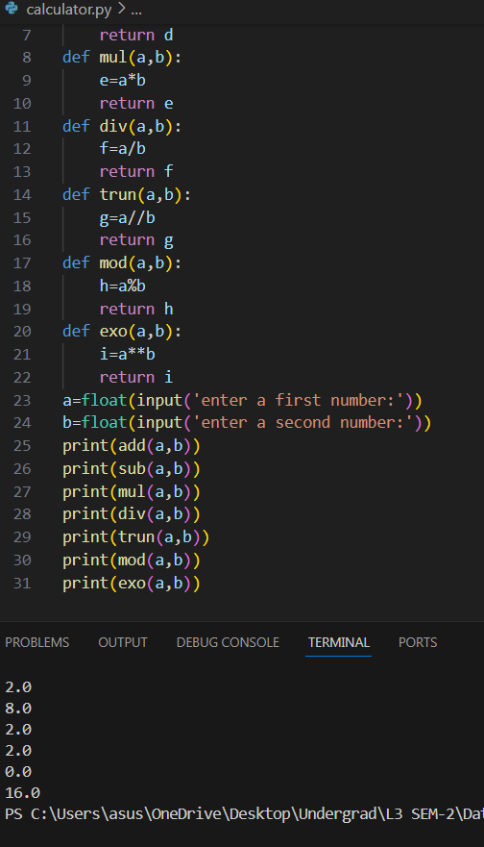

6. Filter List Between 1-100
The program prompts the user to enter a series of integers and saves only those between 1 and 100 in a new list, printing out the resulting list.
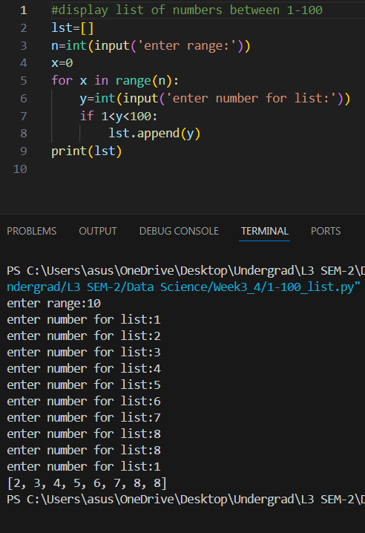

7. Count 'a' in List of Names
The program prompts the user to enter names in a list, counts how many times 'a appeared in all the names together, and stores all names in a list.
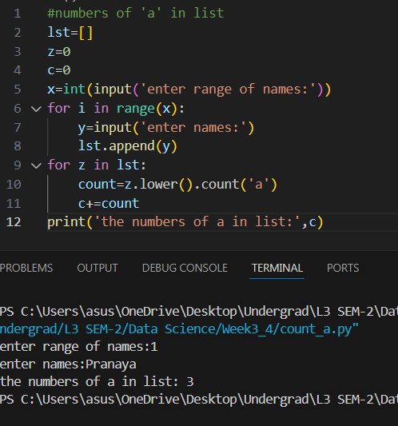

8. Compare Two Lists
The program allows the user to create two lists of integers and does the following to compare them:
- Checks if both lists are of the same length.
- Compares the sum of both lists' elements.
- Identifies whether any values occur in both lists.
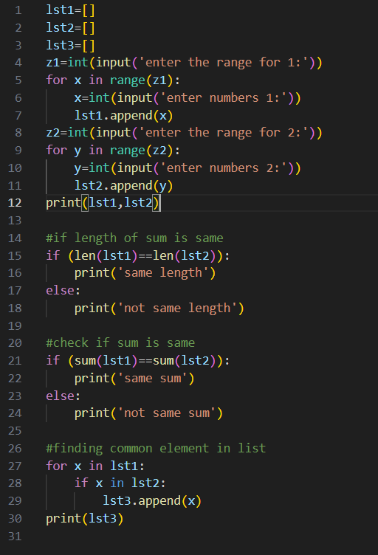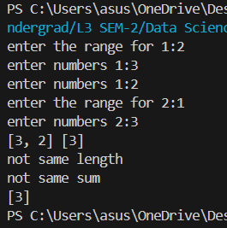

9. Add Daily Temperature
This function takes in a dictionary, a temperature, and a weekday. It adds the temperature to the dictionary if there is no value for that day; if that day already has a value in the dictionary, it does not change the dictionary but returns it.
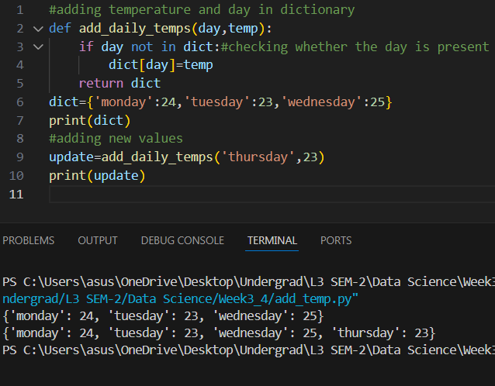

10. Get Daily Temperatures from User
This function asks the user to give input for the average temperature for every day of the week and returns a dictionary with that information. The keys will be the weekdays, and the corresponding averages will be the values.
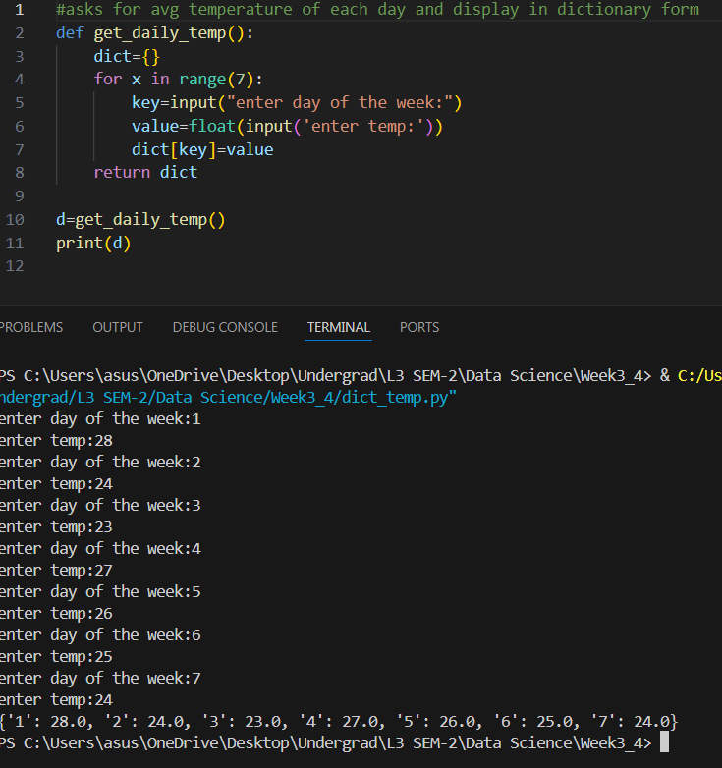

11. Dictionary Operations
With three dictionaries (dic1, dic2, dic3), the program:
- Merges them into one dictionary called nums.
- Adds in a new key/value pair (7, 70).
- Changes the value of key 3 to 80.
- Deletes the third item from the dictionary.
- Calculates the sum of all values.
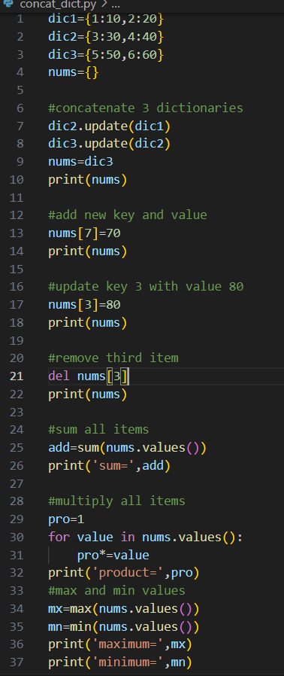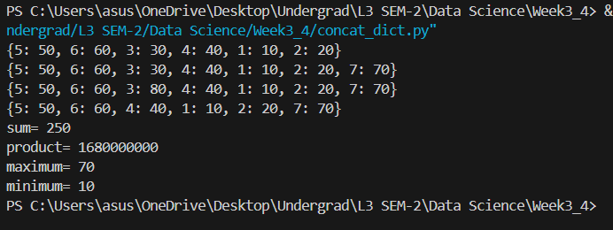

12. Set Operations
With two sets, set1 and set2, this program:
- Performs a union and prints the length of the result.
- Finds the intersection.
- Computes the symmetric difference.
- Adds 40 to set1 and checks if it changes.
- Removes 20 from set2.
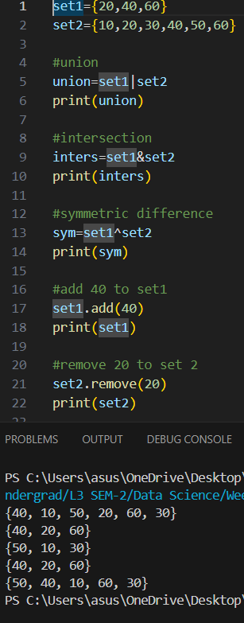
13. Word Intersection
This function, word_intersection, asks the user for two words and then determines which letters are common between the two. It displays the set of shared characters.
