Nabin Karki
Section-C
24071149
Program Descriptions (Week 7-8)

1. Create a Null Vector of Size 10 with the Fifth Value as 1
This program initializes a NumPy array of size 10 with zeros using np.zeros(). The fifth element (4th index) is manually set to one.
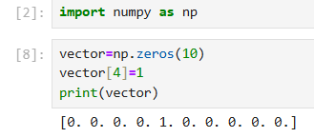

2. Random Array and Average Computation
The program asks the user for two integers between a and b. It then generates a NumPy array of random numbers of shape (a, b) with np.random.randint(). The array is printed, and the average is calculated using np.mean().
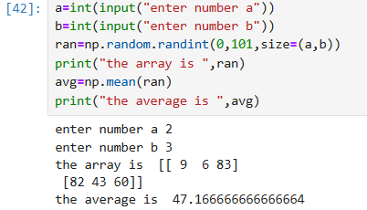
3. Vector of Size 10 with Values in Range 0 to 1
This program generates random values and excludes exact values of 0 and 1 by using a filter.
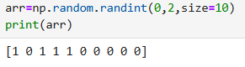

4. Identity Matrix of Shape (3, 3)
An identity matrix is, by definition, one that has the same number of rows as columns and is square.
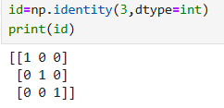

5. Create a 5x5 Matrix where Row Values Range from 0 to 4
The program creates a 0 to 4 matrix using broadcasting or np.tile().
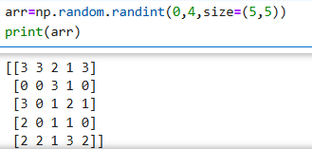

6. Accept Array Input, Sort the Array, and Slice
The user is prompted to input at least 10 numbers; the list is converted to a NumPy array and sorted using np.sort(). The elements are then sliced and displayed for indices 2-5, 5-8, and 2-9, respectively.
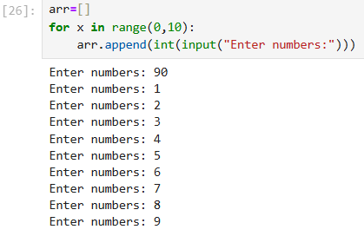
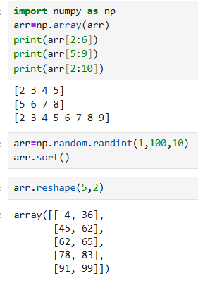

7. Array Random Integer, Sorting, and Reshaping
Random integers are generated to form a NumPy array. After sorting, it should be reshaped using np.reshape() into feasible dimensions of a matrix (2x5 or 5x2) by ensuring the integrity of the total number of elements.


8. Operations on Two Pandas Series
The program creates two Pandas Series containing numerical values and performs:
• Addition
• Subtraction
• Multiplication
• Division
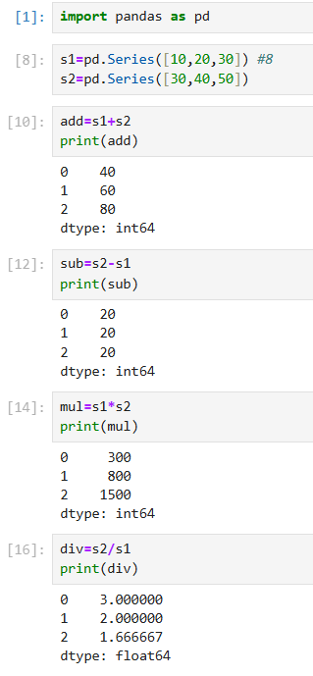

9. Employee DataFrame Operations
a. Name and Salary Columns Selected
b. Filter Employees in "IT" Department
c. Select Employees Older than 30 and Calculate Average Salary Per Department
d. Count Employees per Department
e. Add Bonus Column (10% of Salary)
f. Change "HR" to "Human Resources"
g. Employee with Longest Tenure (Earliest Join Date)
