# Online Food Delivery System

1. **Introduction**

An online food ordering system is software that lets restaurants, coffee shops, or bars accept orders online. It typically allows customers to choose and pay for food, then alerts the kitchen when an order is made. This happens without contact between staff and customers. Despite the lack of personal interaction, the software provides online customers with the same features someone visiting the restaurant or ordering on the phone would have. This includes access to the entire menu with full customization and varied payment methods such as card, PayPal, or cash on pickup or delivery.

1. **Objectives**

* It tracks all the information of item category, Delivery address, customer, etc.
* Manage the information of item category.
* Shows the information and description of the Food, Shopping cart.
* To increase efficiency of managing the food item category.
* It deals with monitoring the information and transactions of customer.

1. **Features of online delivery System**

* Product and Component based
* Creating and changing issues at ease
* Query issue list to any depth
* Reporting and charting in more comprehensive way
* Multi-level priorities & severities

1. **Implementation Methodology**

The project is done in markup language like HTML, CSS is used to style the HTML documents and scripting languages like Javascript is used for animations and for adding dynamic behaviors to the web pages.

1. **User Interface Design and code:**
2. **Navbar**

For Navigation bar we have use nav, div, img, li, ul, span, input,etc. The navigation-bar consists of Home, Services, About us, Conact Us, Login, Logo and search bar. For Css display properties, font size, padding, height, width, cursor, position, etc.

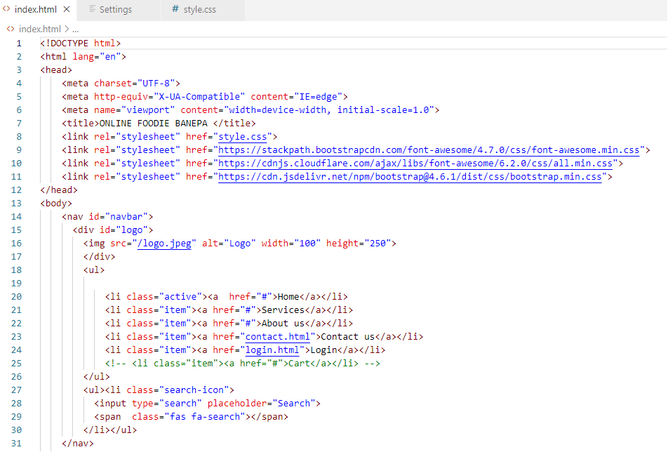

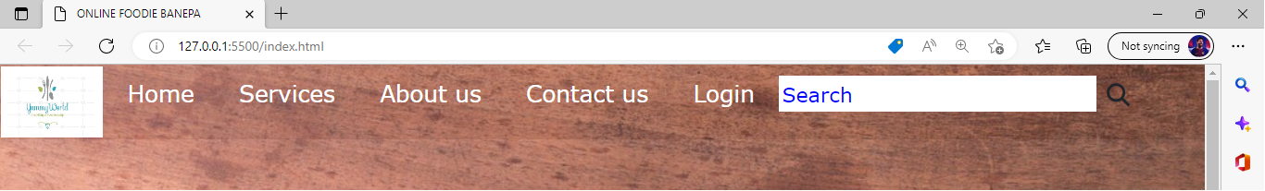

1. **Home section**

For Home section we have use section,h1, p and button tag. The home section consists of image, motto and order button for ordering. For Css display properties, font size, padding, height, width, cursor, position, z-index, justify-content, etc.

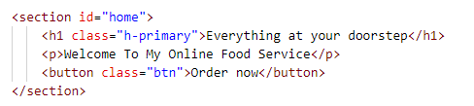

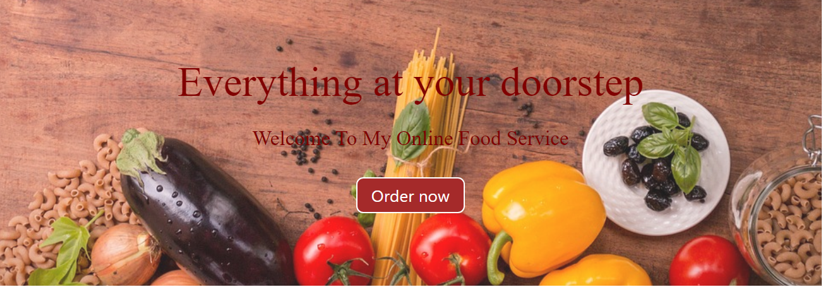

1. **Services**

For Service section we have use section, division, heading,paragraph and image tag. The services consists of service provided like food ordering, catering, training. For Css display properties, font size, padding, height, width, cursor, position, margin, border, etc.

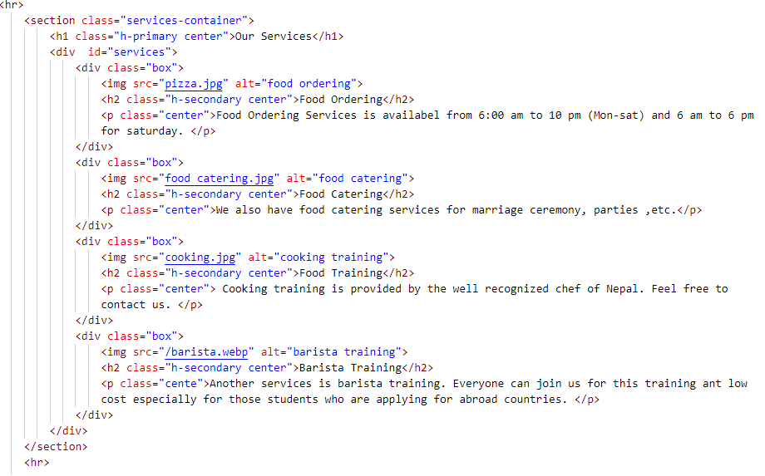

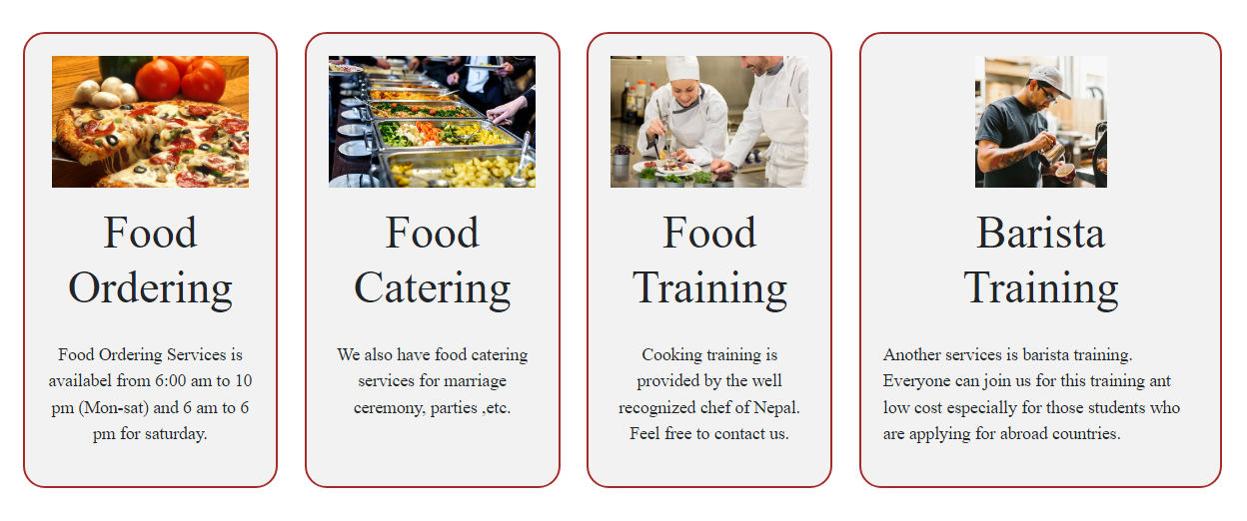

1. **Customer Review**

For Customer Review we have use nav, div, img, paragraph,etc. It consists of comments of customer whether they are statisfied by the service provided or not and things to improve for the betterment. For Css display properties, font size, padding, height, width, cursor, position, etc.

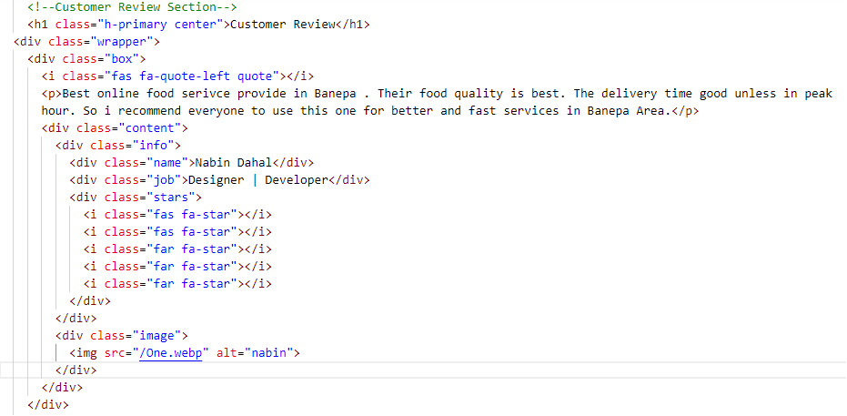

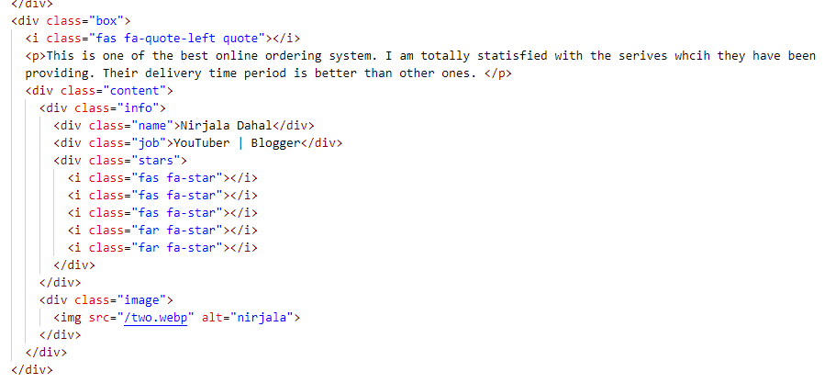

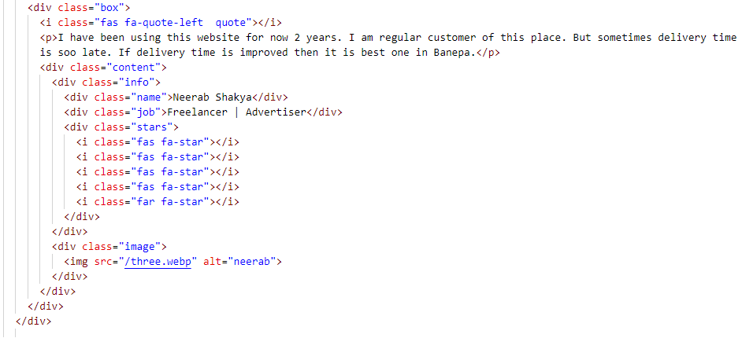

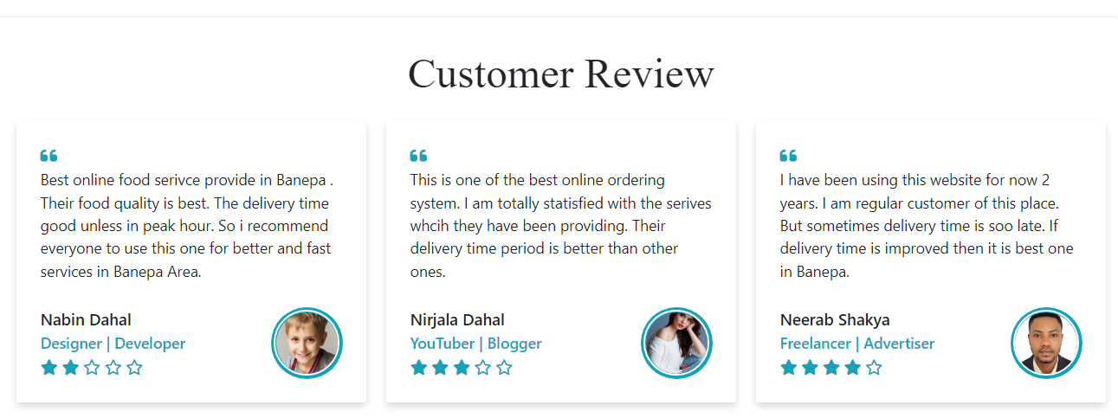

1. **Footer**

For footer we have use div, footer, heading, paragraph,etc. The footer section includes details of contact information about the cafe. For Css display properties, font size, padding, height, width, cursor, position, background, box-sizing, text-transform, etc.

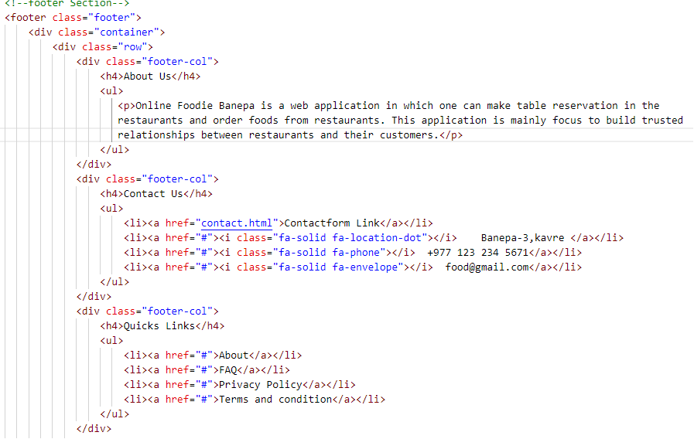

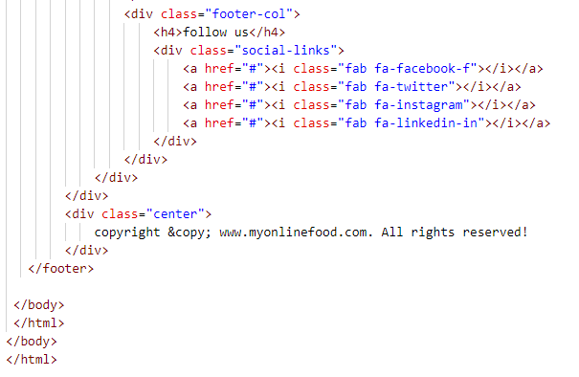

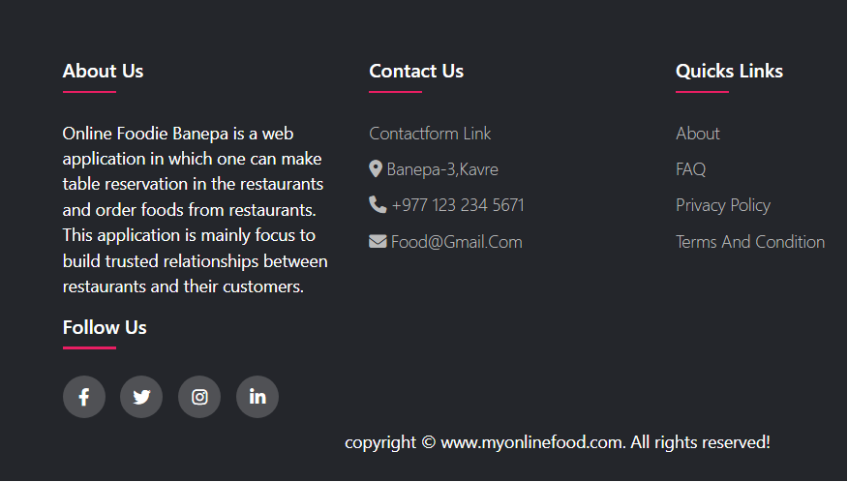

1. **Login and Regiser**

For login and register section we have use div, form, input. Login and register section help user or admin to sign up or sign in into the website for ordering and other purposes. For Css display properties, font size, padding, height, width, cursor, position, border, margin, text-decoration, transition, etc.

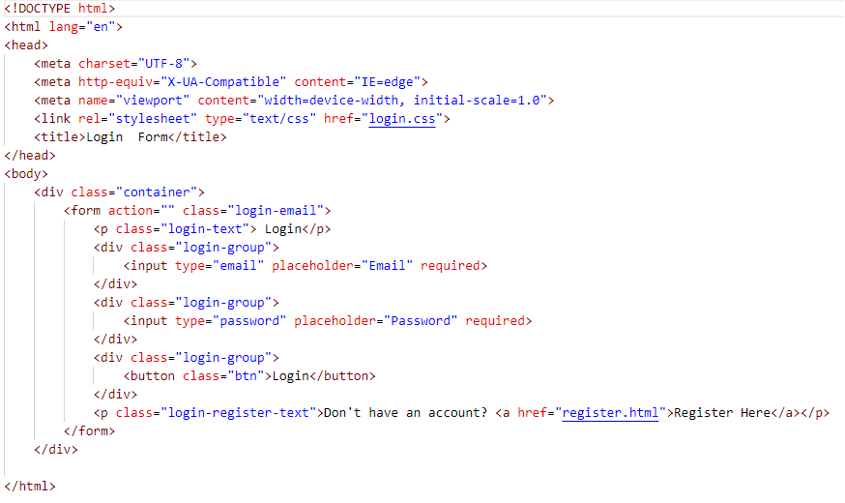

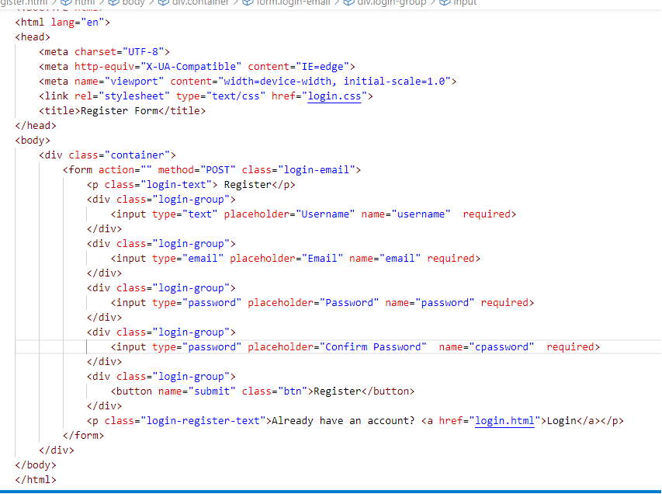

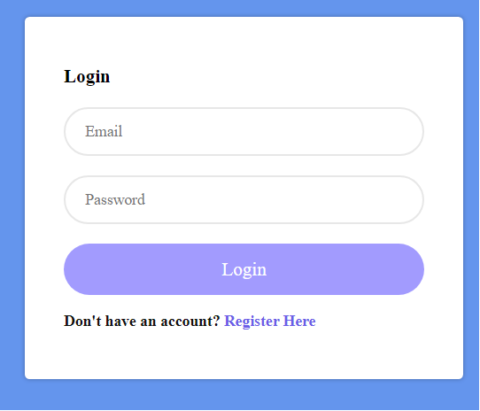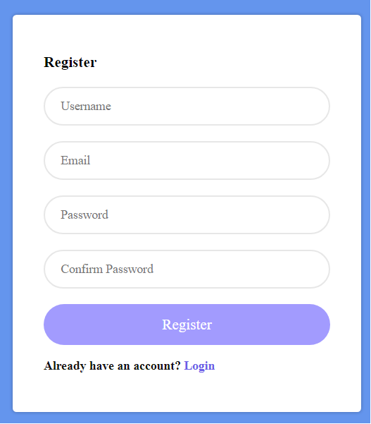

1. **Contact Us**

For contact section we have use div, form, input. Contact Us section main purpose is to message the respective person if they have any complain or want to apply for job or thinking of joining the courses. For Css display properties, font size, padding, height, width, cursor, position, border, margin, text-decoration, transition, etc.

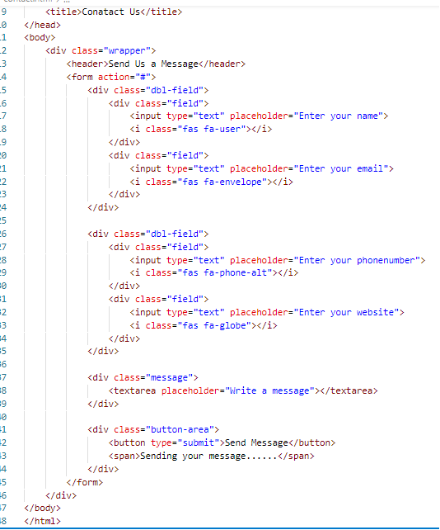

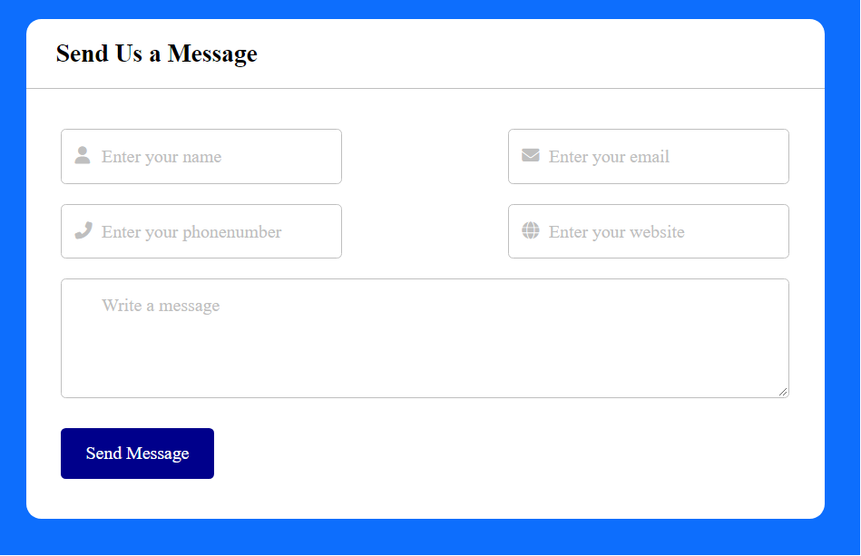

1. **Limitations**

* Food can get cold.
* Late and incorrect Orders
* Limited and irregular menu

1. **Conclusion**

Therefore, conclusion of the proposed system is based on considering

1. user’s need and is user centered. The system is developed in

all issues related to all user which are included in this system. Wide range of people can use this if they know how to operate android smart phone or windows or macbook. Various issues related to Mess/Tiffin Service will be solved by providing them a full- Ordering system is done to help and solve one of the important problems of people. Based on the result of this research, it can be concluded: It helps customer in making order easily; It gives information needed in making order to customer. The Food website application made for restaurant and mess can help restaurant and mess in receiving orders and modifying its data and it is also made for admin so that it helps admin in controlling all the Food system.

1. ﬂedged system. Thus, implementation of Online Food

notiﬁcation from provider end if any. On the other end