# Introduction to HTML

HTML stands for Hyper Text Markup Language. It is the standard markup language for web pages. HTML consists of a series of elements and tells the browser how to display the content. HTML elements are represented by tags. Browsers do not display the HTML tags, but use them to render the content of the page. With the help of HTML we can create the structure of our website. HTML is like skeleton of human body for any website, which gives base to the structure.

# Structure of HTML

<!DOCTYPE html>

<html>

<head>

<title> Page title</title>

</head>

<body>

</body>

</html>

# Elements of HTML

HTML element is defined by a start tag, some content and an end tag. The HTML element is everything from the start tag to the end tag.

<tagname> content</tagname>

Example: <h1> Welcome to Bsc.CSIT </h1>

<p> I am studying in bachelor</p>

# HTML attributes

All html elements can have attributes. Attributes provide additional information about elements. Attributes are always specified in start tag. Attributes usually come in name/value pairs like name=”value”. Following are some of the html attributes:

1. **The href attribute**

The <a> tag defines a hyperlink. The href attribute specifies a URL of the page the link goes to. Example: <a href=<https://www.google.com>> Visit Google</a>

1. **The src attribute**

The <img> tag is used to embed an image in html page. The src attribute specifies the path to the image to be displayed. Example: <img src=”nabin.jpg”>

1. **Width and height attribute**

The <img> tag also contain the width and height attributes, which specifies the height and width of the image. Example: <img src=”nabin.jpg” height=”400” wdith=”500”>

1. **The alt attribute**

The alt attribute for the <img> tag specifies and alternate text for an image, if the image for some reason cannot display. Example: <img src=”nabin.jpg” alt=”photo”>

# HTML tags

1. **Heading Tag**

HTML Headings are titles or subtitles that we want to display on a webpage. HTML headings are defined with the <h1> to<h6> tags. <h1> defines the most important heading and has the largest font size while <h6> defines the least important heading and has the smallest font size. It is important to use headings to show the document structure.

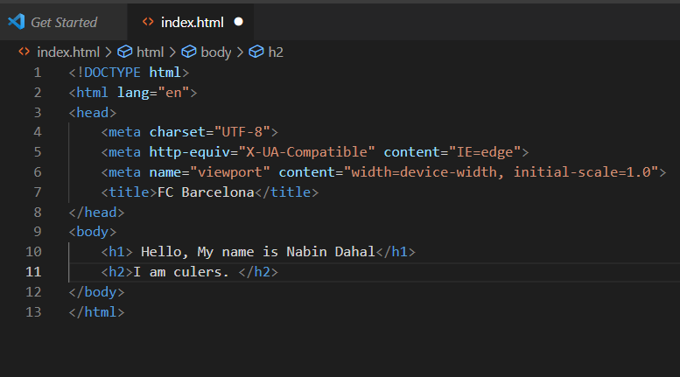

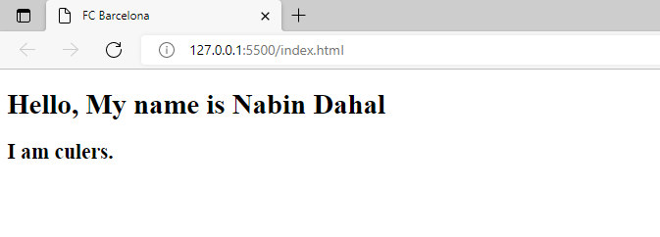

1. **Paragraph Tag**

The paragraph always starts on a new line, and is usually a block of text. The html<p> element defines a paragraph. It also adds some white space(margin) before and after a paragraph.

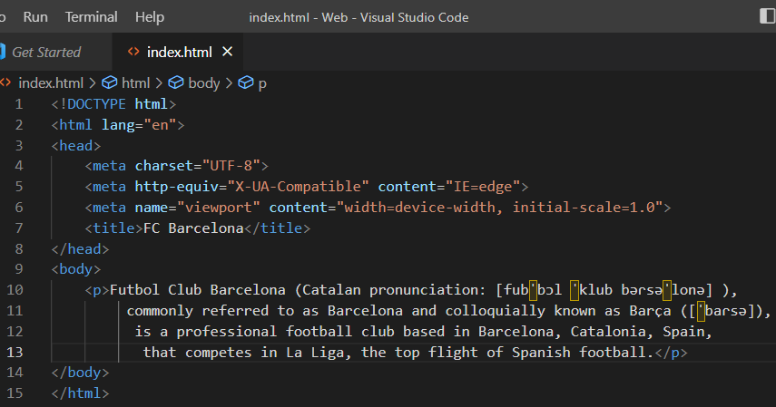

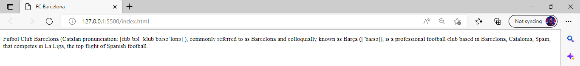

1. **Anchor Tag**

An anchor tag in HTML can be defined as a means to create a hyperlink that can link our current page on which the text is being converted to hypertext via<a> (anchor tag) to another page.

1. **Spacing Tag**
2. **Image Tag**
3. **Division Tag**
4. **Span Tag**
5. **List Tag**
6. **Table Tag**
7. **Form Tag**