**Implementation Methology**

In order to create these website, firstly we learned about basic html tags and CSS.

In this website we have used html tags like <div>, <h>, <p>, <link>, <li>, <a href> , <section>, <span>, <img> etc.

In order to display html elements on screen, paper, or in other media styling like background color, background size, width, height, padding, margin, border, font size, font family, display, align items, justify contents, list style, transition, text decoration, outline, animation, word spacing with help of CSS are done as it can control the layout of multiple web pages all at once.

Above tags and CSS styling uses and functions are described above.

User Interface Design and code:

**Home section:**

For home section, we use section, header, paragraph and button tag. The home section consists of travel packages and a navigation bar.

For CSS display properties, font size , padding, height, width, justify-content etc are used.

**Navbar:**

For navigation bar, we have used nav, div, img, li, ul, span, input etc. The navigation bar consists of about, gallery, maps, login page and contact, logo and search bar.

For CSS displays properties, font size, padding, height, cursor etc are used.

**For travel packages :**

For travel packages we have use section,division,heading,paragraph and image. This service consists of different tourism destination packages at affordable rates.

For CSS display properties, font size ,color,position etc are used.

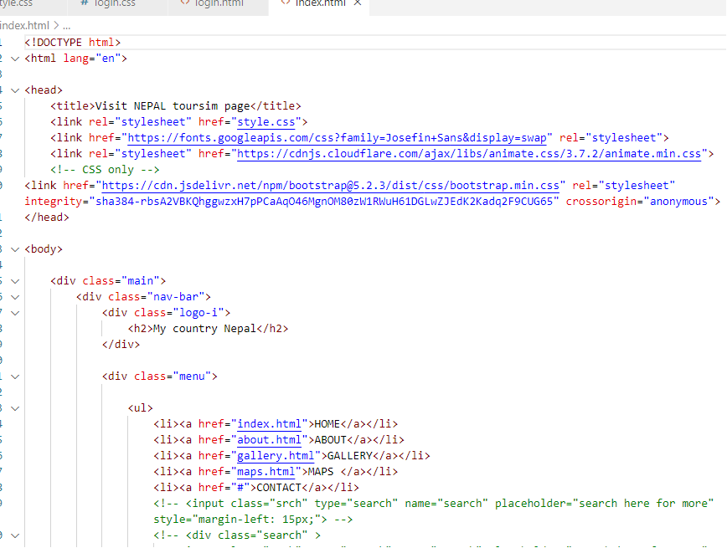

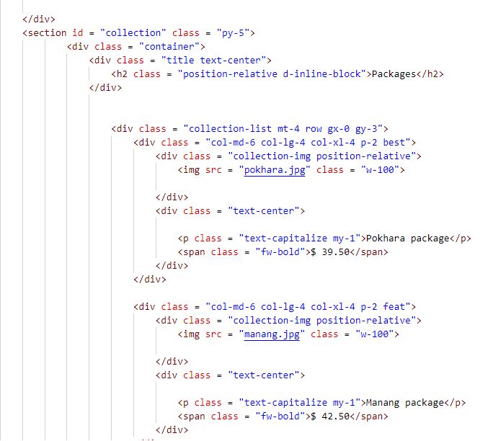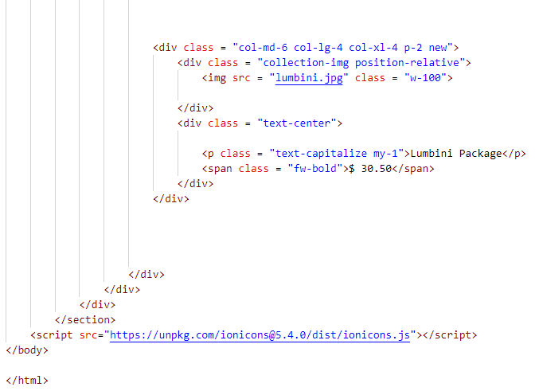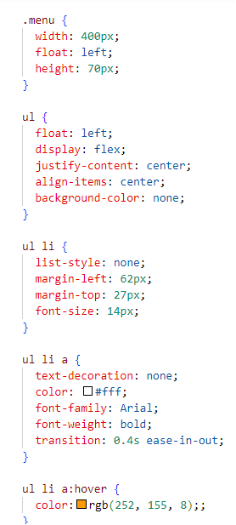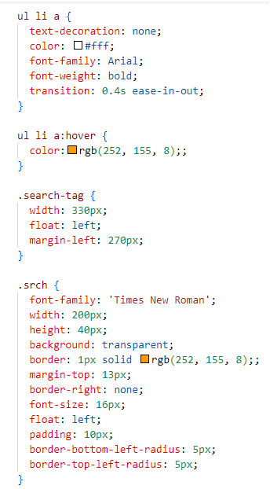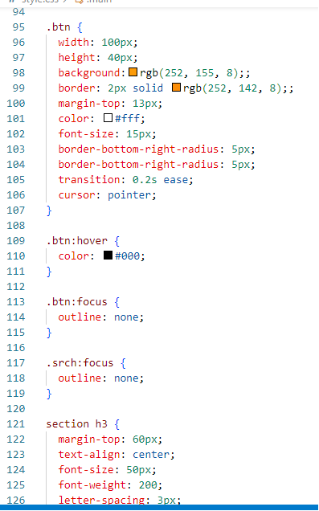

**Login and Register :**

For login and register section we have use div, form, input. Login and register section helps user or admin to sign up or sin in into the website for booking travel packages. For CSS display properties, font size, color, margin, padding, width, cursor, transition etc are used.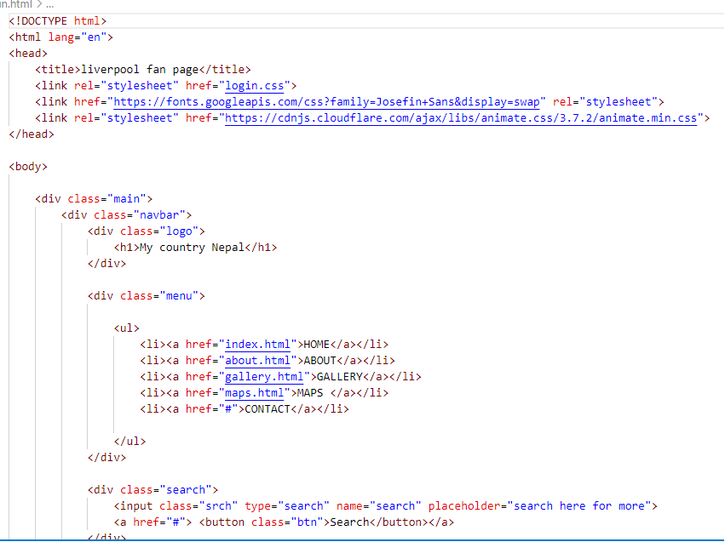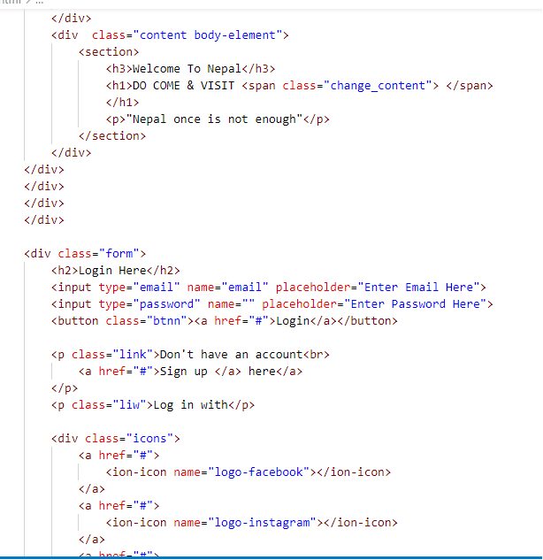

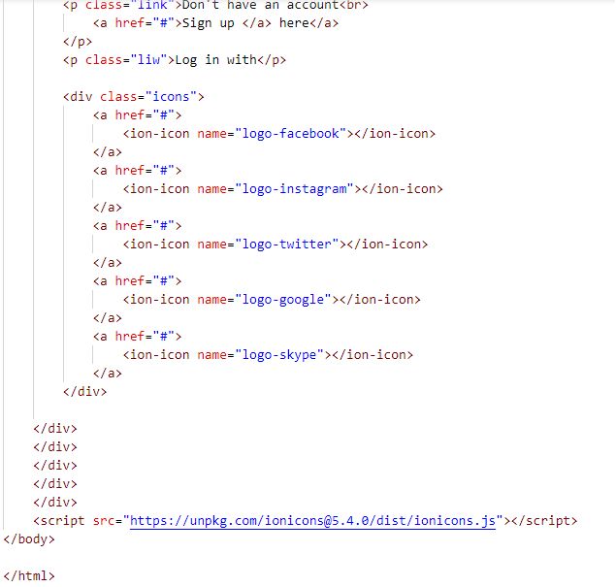

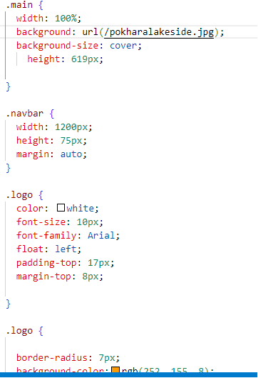

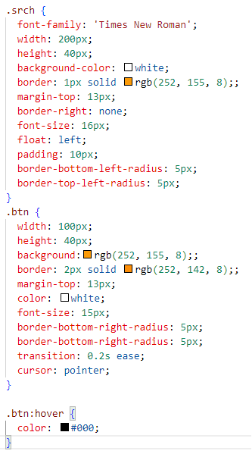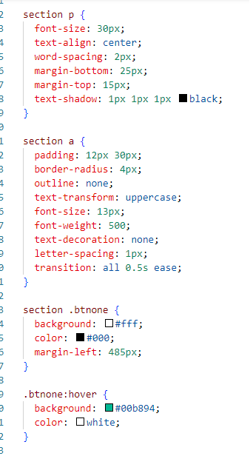

**About:**

For about, we have used head,title,link,body,division,list etc. The about is the description of our website. For CSS display,font size ,colors,position,etc are used.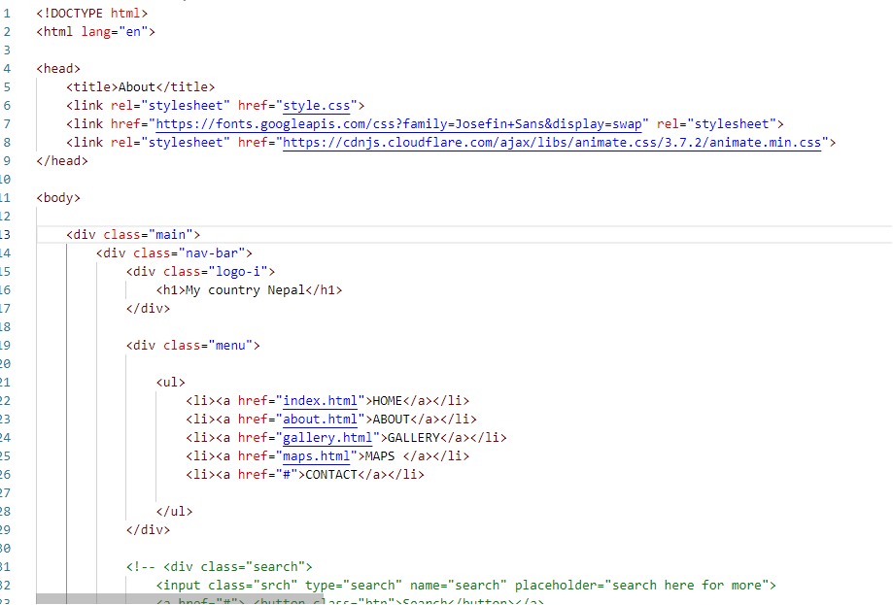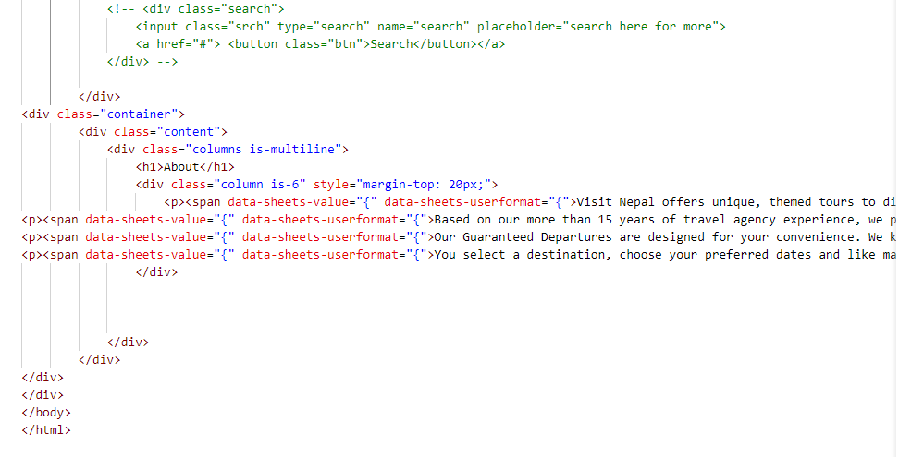

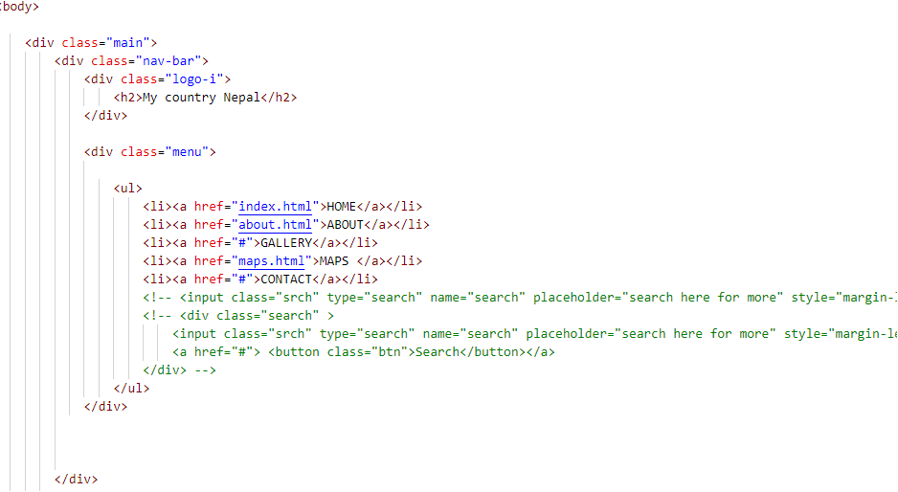

**Gallery**:

For gallery, we have used head,title,link,body,division,list etc. It consists of different images of sceneries of our country Nepal. For CSS, We haven’t use any properties.

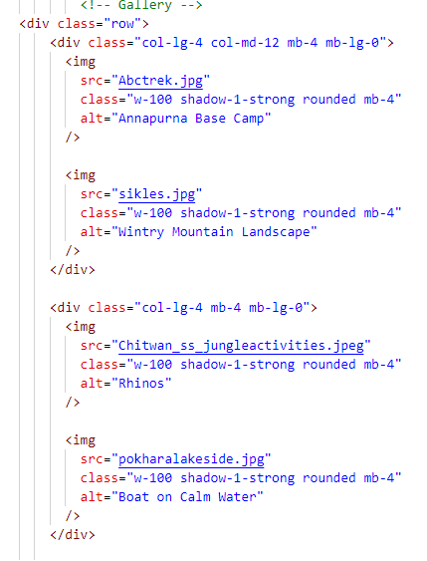

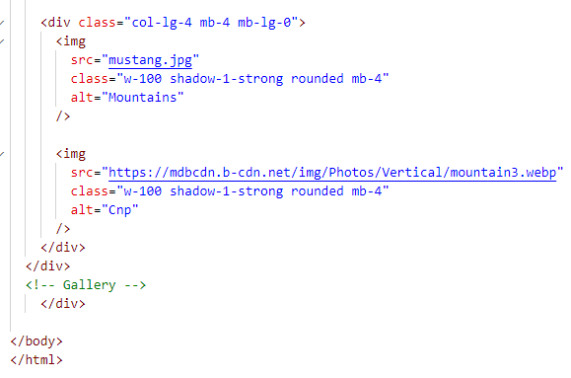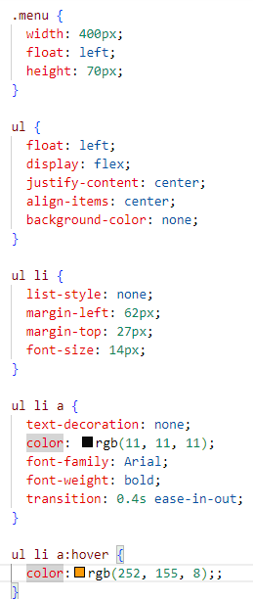

**Maps:**

For maps, we have used head, title, body, iframe etc. It consists of different maps of famous places of Nepal. For CSS, we have used margin,size etc.

