**Wildfly installation via script:**

**NOTE:**  Run the Script via root user.

**Workflow:**

* Check if internet connection is fine or not and response is stored in variable ‘rc’
  + If connection is fine then proceeding for basic installation
    - Update repository *(Fig 1.0)*
      * ***yum update -y;***
    - Install dependencies *(Fig 1.1)*
      * ***yum install java-1.8.0-openjdk-devel wget -y;***
    - group check function is created which checks if wildfly user is created previously or not
      * If wildfly user and group is created previously then proceed with the same user
      * If not then create group and user ‘wildfly’ and make its home directory /opt/wildfly without shell
      * ***groupadd -r wildfly***
      * ***useradd -r -g wildfly -d /opt/wildfly -s /sbin/nologin wildfly***
    - Used if loop to check if .tar.gz file is present in the directory *(Fig 1.3)*
      * If present then use that file to install wildfly
      * If not then download from the url using wget and put it in /tmp directory
      * Also check if the file is downloaded correctly or not using MD5sum
      * ***wget https://download.jboss.org/wildfly/19.0.0.Final/wildfly-19.0.0.Final.tar.gz -P /tmp***
    - Extract the tarfile to the /opt/ directory
    - ***tar xf /tmp/wildfly-19.0.0.Final.tar.gz -C /opt/***
    - Create symbolic link of wildlfy that will point to the /opt/wildfly directory *(Fig 1.6)*
    - Changed ownership of the directory to wildfly
    - ***chown -RH wildfly: /opt/wildfly***
    - Created directory named as wildlfy in /etc/ directory to store conf file of wildfly which is copied from /opt/wildfly/docs/contrib/scripts/system/wildlfy.conf *(Fig 1.5)*
    - **mkdir -p /etc/wildfly**
    - ***cp /opt/wildfly/docs/contrib/scripts/systemd/wildfly.conf /etc/wildfly/***
    - ***cp /opt/wildfly/docs/contrib/scripts/systemd/launch.sh /opt/wildfly/bin/***
    - ***cp /opt/wildfly/docs/contrib/scripts/systemd/wildfly.service etc/systemd/system***
    - Also provided executable permission to all scripts present in /opt/wildfly/ dir.
    - For the systemd services wildfly.service is transferred to /etc/systemd/system/ to enable restarting using system daemon *(Fig 1.4)*
      * Reloaded systemd daemon for applying this configuration.
    - Changed configuration to allow administrative users to access the website console from the network
    - Heap memory input is taken from user and added in line number 53,54 and 55 *(Fig: 1.11)*
* *standalone.conf.bat* 
  + - Restarted wildfly to apply the configuration
    - To access wildlfy we need to open ports 8080 and 9990 (administrative console)
      * After allowing port 8080 and 9990 firewall was reloaded. *(Fig 1.10)*
    - Now comes time to add user to wildfly. *(Fig 1.7)*
      * For this we used the script provided by wildfly to add user in /opt/wildlfy/bin/add-user.sh
      * At first we have to define the type of user
        + Created management user named: tms
        + And added the user to the wildlfy group
    - Installation of wildfly completed. *(Fig 1.12)*
  + If connection is down then scripts exists.

**Snapshot of successful installation of wildfly via script:**

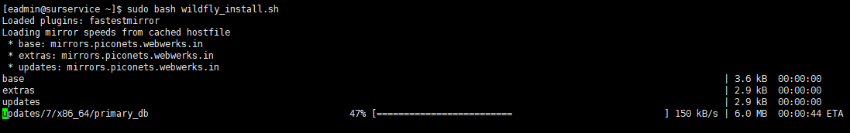

Fig: 1.0 Updating the repository

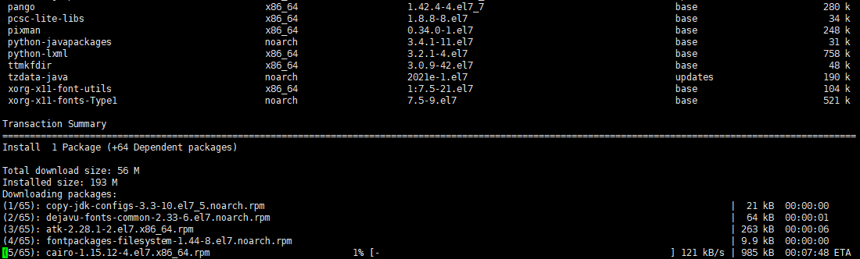

Fig 1.2 Installing necessary packages.

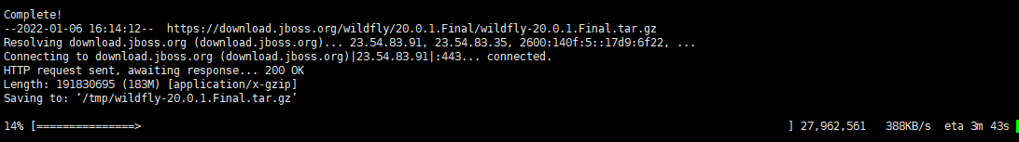

Fig 1.3: Confirming and downloading the tar file from the directory

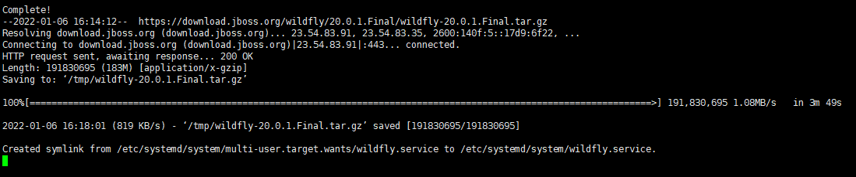

Fig 1.4: Symbolic link creation of wildfly service

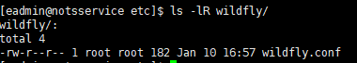

Fig 1.5: wildfly configuration in /etc wildfly directory

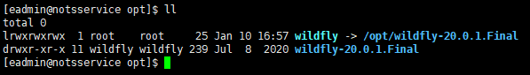

Fig 1.6: Symbolic Link of wildlfy file confirmation

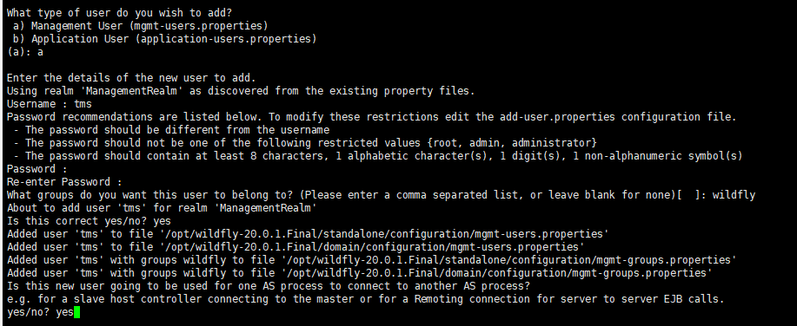

Fig 1.7: User creation and Addition into wildlfy group

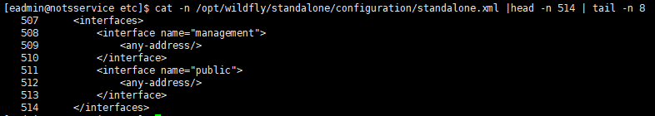

Fig 1.8: Management console configuration

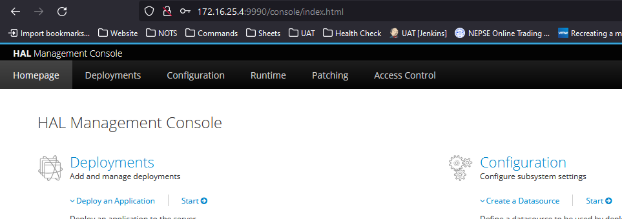

Fig 1.9: Management console web

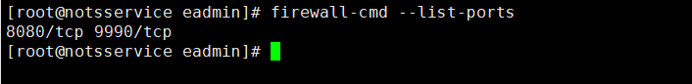

Fig 1.10: Firewall open ports

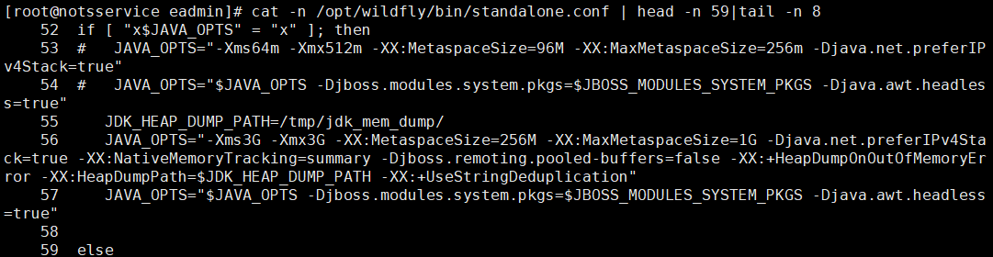

Fig 1.11: Configuration of heap memory

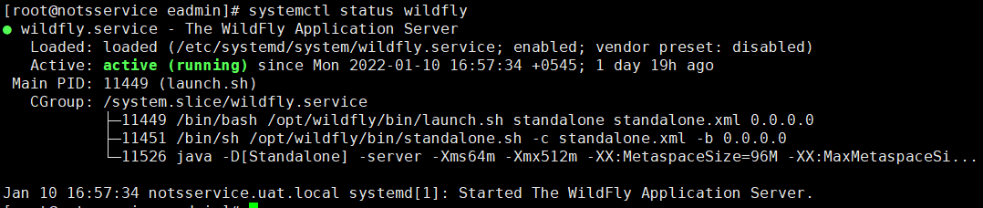

Fig 1.12: Confirmation