> library(forecast)

> library(fUnitRoots)

> data <- woolyrnq

> #looking the data

> tail(data)

Qtr1 Qtr2 Qtr3 Qtr4

1993 4588 5309 4732

1994 4837 6135 6396

> #plotting the data to see if there is trend

> plot(data)

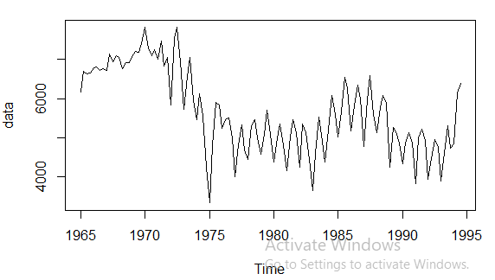

> #checking if the data is stationary or non stationary by ADF test

> #if p-value > 0.05, data is non-stationary else stationary.

> #if data is non-stationary, change to stationary

> adfTest(data)

Title:

Augmented Dickey-Fuller Test

Test Results:

PARAMETER:

Lag Order: 1

STATISTIC:

Dickey-Fuller: -0.6318

P VALUE:

0.4122

Description:

Sat Jul 04 10:27:42 2020 by user: Nabin

> #changing data to stationary

> #differencing the data

> plot(diff(data))

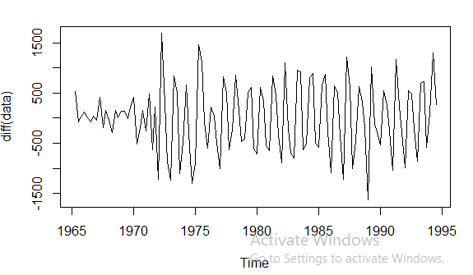

> #checking again the p-value

> adfTest(diff(data))

Title:

Augmented Dickey-Fuller Test

Test Results:

PARAMETER:

Lag Order: 1

STATISTIC:

Dickey-Fuller: -16.2194

P VALUE:

0.01

Description:

Sat Jul 04 10:29:01 2020 by user: Nabin

Warning message:

In adfTest(diff(data)) : p-value smaller than printed p-value

> #running AR - I - MA test

> ARIMAfit <- auto.arima(log10(data), approximation = TRUE, trace=TRUE)

Fitting models using approximations to speed things up...

ARIMA(2,0,2)(1,1,1)[4] with drift : -410.5355

ARIMA(0,0,0)(0,1,0)[4] with drift : -322.0106

ARIMA(1,0,0)(1,1,0)[4] with drift : -411.3009

ARIMA(0,0,1)(0,1,1)[4] with drift : -389.2564

ARIMA(0,0,0)(0,1,0)[4] : -323.7864

ARIMA(1,0,0)(0,1,0)[4] with drift : -380.2894

ARIMA(1,0,0)(2,1,0)[4] with drift : -410.7036

ARIMA(1,0,0)(1,1,1)[4] with drift : -417.7051

ARIMA(1,0,0)(0,1,1)[4] with drift : -422.4829

ARIMA(1,0,0)(0,1,2)[4] with drift : -420.8894

ARIMA(1,0,0)(1,1,2)[4] with drift : Inf

ARIMA(0,0,0)(0,1,1)[4] with drift : -332.1381

ARIMA(2,0,0)(0,1,1)[4] with drift : -419.7084

ARIMA(1,0,1)(0,1,1)[4] with drift : -420.8851

ARIMA(2,0,1)(0,1,1)[4] with drift : -417.5702

ARIMA(1,0,0)(0,1,1)[4] : -423.5253

ARIMA(1,0,0)(0,1,0)[4] : -382.3469

ARIMA(1,0,0)(1,1,1)[4] : -419.3679

ARIMA(1,0,0)(0,1,2)[4] : -422.2431

ARIMA(1,0,0)(1,1,0)[4] : -413.331

ARIMA(1,0,0)(1,1,2)[4] : Inf

ARIMA(0,0,0)(0,1,1)[4] : -332.8927

ARIMA(2,0,0)(0,1,1)[4] : -421.0103

ARIMA(1,0,1)(0,1,1)[4] : -421.8316

ARIMA(0,0,1)(0,1,1)[4] : -390.3976

ARIMA(2,0,1)(0,1,1)[4] : -418.8719

Now re-fitting the best model(s) without approximations...

ARIMA(1,0,0)(0,1,1)[4] : -445.1343

Best model: ARIMA(1,0,0)(0,1,1)[4]

> summary(ARIMAfit)

Series: log10(data)

ARIMA(1,0,0)(0,1,1)[4]

Coefficients:

ar1 sma1

0.8025 -0.6814

s.e. 0.0607 0.0786

sigma^2 estimated as 0.001148: log likelihood=225.68

AIC=-445.35 AICc=-445.13 BIC=-437.12

Training set error measures:

ME RMSE MAE MPE MAPE MASE

Training set -0.001747696 0.03301938 0.02408803 -0.05290803 0.6461015 0.6509808

ACF1

Training set 0.04013439

> #predicting the future values for three years i.e 36

> pred <- predict(ARIMAfit, n.ahead = 36)

> pred

$pred

Qtr1 Qtr2 Qtr3 Qtr4

1994 3.757152

1995 3.686770 3.759429 3.784220 3.739747

1996 3.672801 3.748219 3.775224 3.732527

1997 3.667008 3.743569 3.771493 3.729533

1998 3.664604 3.741641 3.769945 3.728291

1999 3.663608 3.740841 3.769303 3.727775

2000 3.663194 3.740509 3.769036 3.727562

2001 3.663023 3.740371 3.768926 3.727473

2002 3.662951 3.740314 3.768880 3.727436

2003 3.662922 3.740290 3.768861

$se

Qtr1 Qtr2 Qtr3 Qtr4

1994 0.03388466

1995 0.04344697 0.04861983 0.05167797 0.05734279

1996 0.06071198 0.06278623 0.06408661 0.06747208

1997 0.06956530 0.07088070 0.07171510 0.07433209

1998 0.07596982 0.07700616 0.07766628 0.07993412

1999 0.08136124 0.08226726 0.08284554 0.08491617

2000 0.08622343 0.08705496 0.08758632 0.08952438

2001 0.09075067 0.09153175 0.09203128 0.09386856

2002 0.09503303 0.09577551 0.09625066 0.09800528

2003 0.09911888 0.09982951 0.10028451

> #integral. showing the values

> 10^(pred$pred)

Qtr1 Qtr2 Qtr3 Qtr4

1994 5716.790

1995 4861.493 5746.836 6084.433 5492.207

1996 4707.621 5600.400 5959.694 5401.661

1997 4645.234 5540.760 5908.708 5364.543

1998 4619.600 5516.209 5887.687 5349.221

1999 4609.009 5506.057 5878.990 5342.879

2000 4604.623 5501.852 5875.386 5340.251

2001 4602.805 5500.108 5873.892 5339.161

2002 4602.051 5499.385 5873.273 5338.709

2003 4601.738 5499.086 5873.016

> plot(forecast(ARIMAfit, h=36))

