## STUDENT ID: S361102

## STUDENT NAME: Nabin Kumar Khatiwada

Table of Contents

Introduction 2

Objectives 2

Requirements 2

Test-Driven Development Approach 2

Process 3

Conclusion 4

# Introduction

A hand game called "Scissor-Paper-Rock" is often played by two players, who simultaneously make one of three shapes with their outstretched hands. A player who selects rock will defeat a player who picks scissors ("rock crushes scissors"), but will lose to a player who chooses paper ("paper covers rock"); a play of paper will lose to a play of scissors ("scissors cuts paper"). The game ties if both players select the same shape in which case a new round is usually played to break the tie.

## Objectives

The objective of this game is to simulate the hand game into a computer game where anyone can play "Scissor-Paper-Rock" with the computer. Scissors, Paper, or Rock is one of the alternatives available to the player. The winner is then determined by comparing this against the computer's choice.

## Requirements

The requirements of this game are:

1. The computer chooses one of the options of scissors, paper, or rock at random.
2. The player is then given the chance to choose one of the options of rock, paper, or scissors.
3. The winner receives one point.
4. The winner is the first player to score five points. The overall number of rounds played will also be shown.
5. The player is allowed to stop playing or start over when the winner is announced.
6. The player may also leave the game if they wish.

## Test-Driven Development Approach

This project is built using Test Driven Development approach in Python. The package called `*unittest`* is used to run the tests in the program. `*patch*` of the package is used to create dummy inputs for the game.

# Process

The game is created using Test Driven Development approach in Python. TDD and Unit-testing are used while writing most of the functions in this game. After writing a function, appropriate test cases were written to test the function if it is performing according to the requirement or not.

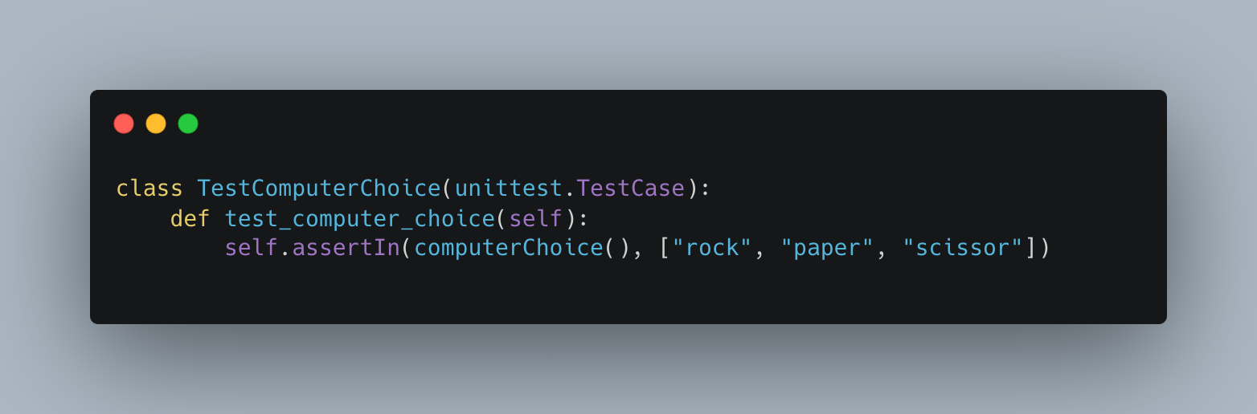

Above is the unit test to check the computer choice from either ‘rock’, ‘paper’, or ‘scissor’.

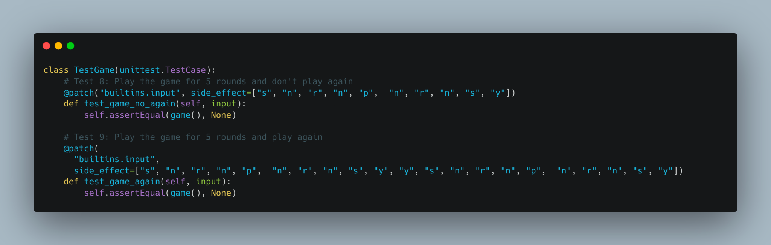

Above is the unit test to play the game with dummy inputs and either play again or don’t play again inputs.

# Conclusion

With this game, I have learned to implement a whole project using Test-Driven Development approach. I learned how test cases should be built for every functional unit and how the error on those tests can help us to optimize our function.

I have also learned to provide dummy inputs for unit testing.

GitHub Link: https://github.com/NabinKhatiwada/rock-paper-scissor