1. **Write a SELECT statement that joins the Categories table to the Products table and returns these columns: category_name, product_name, list_price.**

**Sort the result set by category_name and then by product_name in ascending sequence.**

SELECT

c.category_name,

p.product_name,

p.list_price

FROM

Categories c

JOIN

Products p

ON

c.category_id = p.category_id

ORDER BY

c.category_name ASC,

p.product_name ASC;

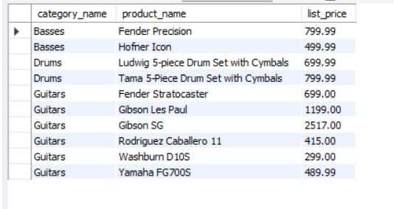

1. **Write a SELECT statement that joins the Customers table to the Addresses table and returns these columns: first_name, last_name, line1, city, state, zip_code.**

**Return one row for each address for the customer with an email address of** [**allan.sherwood@yahoo.com**](mailto:allan.sherwood@yahoo.com)**.**

SELECT

c.first_name,

c.last_name,

a.line1,

a.city,

a.state,

a.zip_code

FROM

Customers c

JOIN

Addresses a

ON

c.customer_id = a.customer_id

WHERE

c.email_address = 'allan.sherwood@yahoo.com';

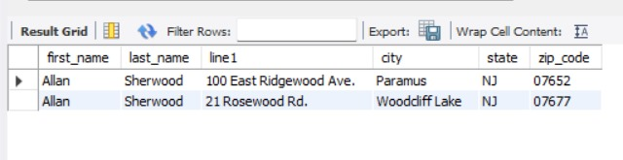

1. **Write a SELECT statement that joins the Customers table to the Addresses table and returns these columns: first_name, last_name, line1, city, state, zip_code.**

**Return one row for each customer, but only return addresses that are the shipping address for a customer.**

SELECT

c.first_name,

c.last_name,

a.line1,

a.city,

a.state,

a.zip_code

FROM

Customers c

JOIN

Addresses a

ON

c.shipping_address_id = a.address_id;

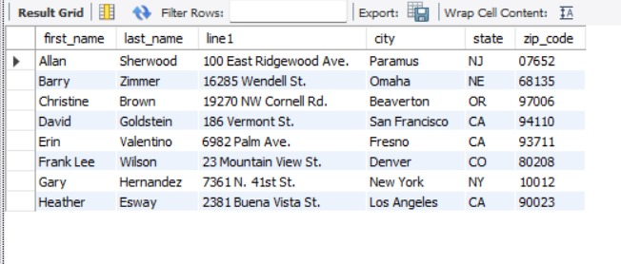

1. **Write a SELECT statement that joins the Customers, Orders, Order_Items, and Products tables. Thisstatement should return these columns: last_name, first_name, order_date, product_name, item_price, discount_amount, and quantity.**

**Use aliases for the tables. Sort the final result set by last_name, order_date, and product_name.**

|  |  |
| --- | --- |
| SELECT  c.last_name,  c.first_name,  o.order_date,  p.product_name,  oi.item_price,  oi.discount_amount,  oi.quantity  FROM  Customers AS c  JOIN  Orders AS o  ON  c.customer_id = o.customer_id  JOIN  Order_Items AS oi  ON o.order_id = oi.order_id  JOIN  Products AS p  ON  oi.product_id = p.product_id  ORDER BY  c.last_name,  o.order_date,  p.product_name; |  |

1. **Write a SELECT statement that returns the product_name and list_price columns from the Products table. Return one row for each product that has the same list price as another product.**

**Hint: Use a self-join to check that the product_id columns aren’t equal but the list_price columns are equal. Sort the result set by product_name**

SELECT

p1.product_name,

p1.list_price

FROM

Products AS p1

JOIN

Products AS p2

ON

p1.product_id <> p2.product_id

AND p1.list_price = p2.list_price

ORDER BY

p1.product_name;

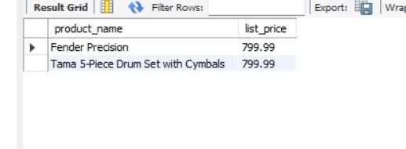

1. **Write a SELECT statement that returns these two columns:**

**category_name The category_name column from the Categories table product_id The product_id column from the Products table**

**Return one row for each category that has never been used.**

**Hint: Use an outer join and only return rows where the product_id column contains a null value.**

SELECT

c.category_name,

p.product_id

FROM

Categories AS c

LEFT JOIN

Products AS p

ON

c.category_id = p.category_id

WHERE

p.product_id IS NULL;

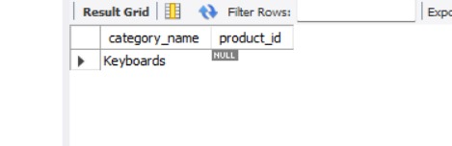

1. **Use the UNION operator to generate a result set consisting of three columns from the Orders table: ship_status A calculated column that contains a value of SHIPPED or NOT SHIPPED order_id The order_id column order_date The order_date column If the order has a value in the ship_date column, the ship_status column should contain a value of SHIPPED. Otherwise, it should contain a value of NOT SHIPPED. Sort the final result set by order_date.**

SELECT

'SHIPPED' AS ship_status,

order_id,

order_date

FROM

Orders

WHERE

ship_date IS NOT NULL

UNION

SELECT

'NOT SHIPPED' AS ship_status,

order_id,

order_date

FROM

Orders

WHERE

ship_date IS NULL

ORDER BY

order_date;

