**What is Forex?**

Simply it’s the global market that allows us to trade two different currencies each other.



Forex is the general term used for foreign exchange market. Forex is the largest financial market in the world. Forex is also known as FX for simpler use.

The FX market is a global decentralized market where the world’s different currencies change hands instantly which makes the constant fluctuations and oscillations in the exchange rates.

As we already know foreign global exchange is the largest financial market in the world, it’s daily trading volume is totally gigantic with 6.6 trillion Compared, to NYSE NEW YORK STOCK EXCHANGE whose trading volume is just a measly 22.4 billion per day.

There is a misleading hype “forex is a $6.6 trillion market”. This huge number sounds impressive, but it is a little exaggeration. It is because if we count the daily trading volume from retail traders (which is us), it’s small. It is estimated about 3-5% of overall daily FX trading volumes, or around $200-300 billion or even less.

You may be wondering where all those trillions of dollars are coming from. It is the bank and institutional organizations buying and selling for speculation.

The forex market is open 24 hours a day and 5 Day a week and closing during the weekends. In contrast of the stock or bond markets, forex market doesn’t close at the end of each business day. Instead, trading just changes to different time zones around the world.

Basically, there’s a 4 different time zone.

* Australian session
* Asian session
* London session
* New York session

Friday in UTC region forex market closes after New York session and again starts from Sunday from Australian session.

* **Trading sessions of forex**

1. **Sydney sessions**

In Sydney session AUD and NZD starts to make a major move.

1. **Tokyo sessions**

JPY make its initial move in this session.

Sydney and Tokyo session combined is an Asian session which have low liquidity and trading volume.

1. **London sessions**

It is the largest trading session of the world where it has a high volatility and high volume and a lot of traders are anticipating to make some profits.

EUR, GBPAND CHF are the major mover in this session.

1. **New York session**

This is the second largest session of the world in comparison of liquidity and trading volume.

CAD and USD are the major movers in this session.

**Retail forex**

* Only the big institutions and speculators could trade currencies in the past, but thanks to the computer geniuses and the booming growth of the internet (thanks to Mr. Al Gore) smart business minded individuals started a trading platform for individual traders unlike the trading platform banks created where the standard trade size is one million units, retail brokers allowed individuals to trade as little as 1000 units!
* Now without any hurdles, anybody can do forex trading in the comfort of their own home just by contacting a broker, opening an account and by depositing some money.

There are two types of broker:

1. **Market Makers**

Market makers as its name suggests they make their own bid and ask price themselves. We can say that the market makers are the fundamental building blocks of the foreign exchange market.

Retail market makers mainly provide liquidity by cutting up a large contract sizes from wholesaler into small size contracts.

1. **Electronic communications networks**

Electronic communications network (ECN) are the brokers who use the best bid and ask prices available to them from different banks and institutions.

Simply, it’s the name given to the trading platform which matches customers buy and sell orders at the given price automatically. These prices are assembled from different banks, market makers and other traders who use the ECN.

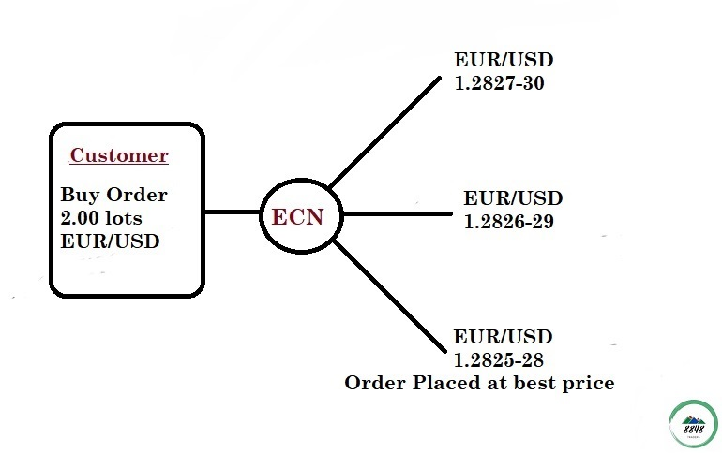

**What we trade in forex?**

Since we already know we trade different currency pairs from around the world, the simple answer is we trade **MONEY**.

Forex might be a little confusing since we are not buying and selling any physical entities. We are trading currencies of one country against the currencies of other.

Price of currency is normally direct reflection of the health and economy of the respective countries.

For the simpler term we can say buying a currency means a buying a share of a country, like buying a share of a company.

In forex when we say we are buying, US Dollar, we are basically buying a share of united states economy.

**Major Currencies**

Since we all know every country has their own currency, but as a new forex trader, you will be playing with a “major currency” for your trading.

* **CAD** (CANADIAN DOLLAR)
* **USD** (UNITED STATES DOLLAR)
* **GBP** (GREAT BRITAIN POUND)
* **EUR** (EUROPEAN EURO)
* **CHF** (SWISS FRANC)
* **JPY** (JAPANESE YEN)
* **AUD** (AUSTRALIAN DOLLAR)
* **NZD** (NEW ZEALAND DOLLAR)

They are called “major currencies” because they’re the most heavily traded currencies and represents the world’s largest economies.

Currency symbol always have three letters, the first two letters identify the name of country and the third letter identifies the name of the currency of their respective country.

For example,

**USD**

**US** =United states

**D**= Dollar

**How we trade forex?**

Forex trading is the simultaneous buying of one currency pair and selling another.

Currencies are traded in pairs. For example, the Australian dollar and the U.S. dollar (AUD/USD) OR the euro and the Japanese yen (GBP/JPY).

When we are trading in the forex market we are buying and selling in currency pairs as shown above.

An exchange rate is the relative price of two currencies from two different countries and the exchange rates of the currency pair fluctuates based on which currency is stronger at the moment between these two currencies.

For example, in USD/JPY pair

If USD is stronger than Japanese yen at the moment, we will be betting to buy USD/JPY pair and similarly if Japanese yen is stronger than USD at the moment, we will be selling the USD/JPY pair.

There are three categories of currency pairs:

1. The “**majors**”
2. The “**crosses**”
3. The “**exotics**”

The **major currency** pair always include the U.S. dollar.

Crosses that don’t involve U.S. dollar are called cross- currency pairs. Also, we can say that crosses that includes other major currency other than U.S. dollar are called **cross-currency** pairs also known as “**minors**”.

**Exotic currency** pairs only consist of one major currency and other currency from an emerging market (EM)

1. **Major currency pair**

As we know major currency pair consist of U.S. dollar, these are the major currency pair:

* EUR/USD “EURO DOLLAR”
* USD/JPY “DOLLAR YEN”
* GBP/USD “POUND DOLLAR”
* USD/CHF “DOLLAR SWISS”
* NZD/USD “KIWI DOLLAR”
* AUD/USD “AUSSIE DOLLAR”
* USD/CAD “DOLLAR LOONIE”

Major currency pairs have the most liquidity in the world.

1. **Minor or Crosses currency pairs**

Those pairs which don’t contain U.S. dollar (USD) are known as **minor or cross currency pairs**.

These crosses are not much traded as major currency pairs but still they have a pretty good liquidity in cross currency pair which provides us with a lot of trading opportunities.

The most traded cross currency are from three major currencies: **GBP, EUR** and **JPY**.

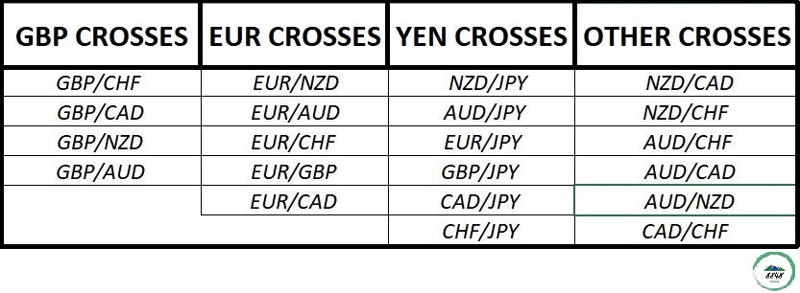

1. **EXOTIC CURERENCY PAIRS**

**Exotic currency** is made up of with one major currency pair and other from emerging markets like from Chile, brazil, Mexico etc.

These pairs are not so liquid so these pairs don’t create much trading opportunities. So, we don’t trade exotic pairs much. Some of the examples of exotic pairs are:

USD/THB “DOLLAR BAHT”

USD/SAR “DOLLAR RIYAL”

USD/BRL “DOLLAR REAL”

USD/MXN “DOLLAR MEX”

* **Advantages of trading forex**

There are many benefits of forex trading.

These are some of the examples or reasons for trading forex:

1. **No commission or low commission**

There’s no fees, no exchange fees, no government fees no brokerage fees. Almost all retail trading platforms compensate these fees through a “spread”. But some of the trading platforms charge you commission only for profit which doesn’t have a system of spread.

1. **Low transaction costs**

There’s low transaction costs which is charged through spread is less than 0.1% in normal market conditions. Transaction costs depends on the leverage and the size of your transaction.

1. **No barrier in lot size**

There’s not any limitation of lot size that you must use while trading. You can use as low as 0.01 to maximum of more than 1 lot size or as much as you want to.

1. **24-hour market**

There’s no waiting of opening and closing of the market. It is open 24 hour in weekdays. You can trade whenever you feel like in a weekday. Forex markets are closed only on weekends. (thank god we need some rest days too)

* **Leverage**

In forex trading you can deposit small amount and can trade more than what your account have through a system called leveraging. Leveraging means risking a small amount of money from your account to trade larger size which helps the trader to make nice profits through small fluctuations in the market.

All the retail trading platforms give the leveraging of as little as 50 to 1 and some of them up to 500 to 1.

For example, a forex broker may offer 100 to 1 leverage, which means that a $ 100-dollar margin deposit will allow a trader to buy or sell $10,000 worth of currencies.

While it looks so attractive and impressive, it comes with risks. Without proper risk management, you can loose your deposits or gain as quickly as you can imagine.

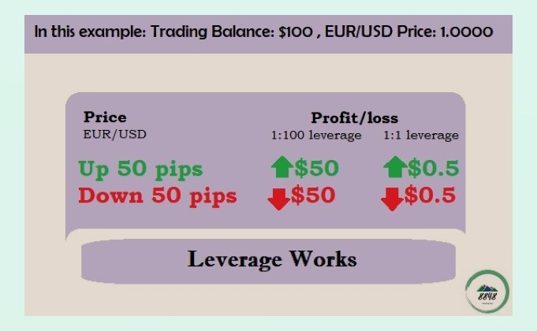

* **Introduction to pips**

When trading in the foreign exchange (forex) market, it's hard to underestimate the importance of pips. A pip, which stands for either "percentage in point" or "price interest point," represents the basic movement a currency pair can make in the market. For most currency pairs—including, for example, the British pound/U.S. dollar (GBP/USD)—a pip is equal to 1/100 of a percentage point, or one basis point, and pips are counted in the fourth place after the decimal in price quotes. For currency pairs involving the Japanese yen, a pip is one percentage point, and pips are counted in the second place after the decimal in price quotes.

Currencies must be exchanged to facilitate international trade and business. The forex market is where such transactions happen—along with bets made by speculators who hope to make money off of price moves in pairs of currencies. Pips are used in calculating the rates participants in the forex market pay when carrying out currency trades.

**Pips, Pipettes, and Spreads**

The value of the pips for your trade can vary depending on your [lot size](https://www.thebalance.com/choosing-a-lot-size-1345193) when you're trading. (A standard lot is 100,000 units of a currency, a mini lot is 10,000 units, and a micro lot is 1,000 units.)

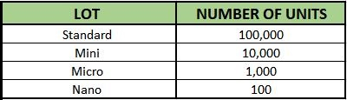

The difference in pips between the bid price (which is the price the seller receives) and the ask price (which is the price the buyer pays) is called the **spread**. The spread is basically how your broker makes money, because most [forex brokers](https://www.thebalance.com/how-to-find-a-forex-broker-1345138) do not collect commissions on individual trades.

When you're buying at the ask price (say, 0.9714)

and a seller is selling at the bid price (0.9711),

the broker keeps the spread (3 pips).

Many forex brokers quote prices to one decimal place after a pip. These divisions of pips are called pipettes and allow for greater flexibility on pricing and spreads.

**Pip Values for U.S. Dollar Accounts**

The currency you used to [open your forex trading account](https://www.thebalance.com/how-to-open-a-forex-trading-account-1344881) will determine the pip value of many currency pairs. If you opened a U.S. dollar-denominated account, then for currency pairs in which the U.S. dollar is the second, or quote, currency, the pip value will be $10 for a standard lot, $1 for a mini lot, and $0.10 for a micro lot. Those pip values would change only if the value of the U.S. dollar rose or fell significantly—by more than 10%.

If your account is funded with U.S. dollars and the dollar isn't the quote currency, you would divide the usual pip value by the exchange rate between the dollar and the quote currency. For example, if the U.S. dollar/Canadian dollar (USD/CAD) exchange rate is 1.33119, the pip value for a standard lot is $7.51 ($10 / 1.3319).

**Pip Values for Other Account Currencies**

If your account is funded with a currency other than the U.S. dollar, the same pip value amounts apply when that currency is the quote currency. For example, for a euro-denominated account, the pip value will be 10 euros for a standard lot, 1 euro for a mini lot, and 0.10 euro for a micro lot when the euro is the second currency in the pair. For pairs in which the euro isn't the quote currency, you would divide the usual pip value by the exchange rate between the euro and the quote currency.

**Pip Movements in Trades**

Let's say you're trading the euro/British pound (EUR/GBP), and the bid price is 0.8881 and the ask price is 0.8884. You expect the euro to rise against the pound, and so you buy a standard lot of euros at the ask price of 0.8884. Later in the trading day, the bid price is 0.8892 and the ask price is 0.8894. You sell at the bid price of 0.8892. You gained 8 pips. If your account is funded with pounds, you made 80 pounds on the trade.

**Forex Glossary**

**ASIAN SESSION**

23:00 – 08:00 GMT.

**LONDON SESSION**

08:00 – 17:00 (London).

**ASK (OFFER) PRICE**

The price at which the market is prepared to sell a product. Prices are quoted two-way as Bid/Ask. The Ask price is also known as the Offer.

In FX trading, the Ask represents the price at which a trader can buy the base currency, shown to the left in a currency pair. For example, in the quote USD/CHF 1.4527/32, the base currency is USD, and the Ask price is 1.4532, meaning you can buy one US dollar for 1.4532 Swiss francs.

In CFD trading, the Ask also represents the price at which a trader can buy the product. For example, in the quote for UK OIL 111.13/111.16, the product quoted is UK OIL and the Ask price is £111.16 for one unit of the underlying market.

**BID PRICE**

The price at which the market is prepared to buy a product. Prices are quoted two-way as Bid/Ask. In FX trading, the Bid represents the price at which a trader can sell the base currency, shown to the left in a currency pair. For example, in the quote USD/CHF 1.4527/32, the base currency is USD, and the Bid price is 1.4527, meaning you can sell one US Dollar for 1.4527 Swiss francs. In CFD trading, the Bid also represents the price at which a trader can sell the product. For example, in the quote for UK OIL 111.13/111.16, the Bid price is £111.13 for one unit of the underlying market.

Let’s look for the another example in figure:

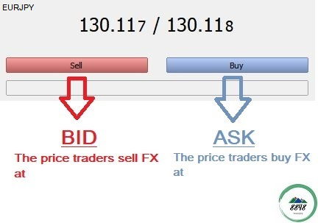

**BID/ASK (SPREAD)**

The difference between the bid and the ask (offer) price is called **spread**.

**BASE CURRENCY**

The first currency in a currency pair. It shows how much the base currency is worth as measured against the second currency. For example, if the USD/CHF (U.S. Dollar/Swiss Franc) rate equals 1.6215, then one USD is worth CHF 1.6215. In the forex market, the US dollar is normally considered the base currency for quotes, meaning that quotes are expressed as a unit of $1 USD per the other currency quoted in the pair. The primary exceptions to this rule are the British pound, the euro, and the Australian dollar.

* **What is Base currency and Quote currency?**

The first listed currency of a currency pair is called the **base currency**, and the second currency is called the **quote currency**. Currency pairs compare the value of one currency to another—the **base currency** (or the first one) versus the second or the **quote currency**.

**Quote currency** is also known as **Counter currency**.

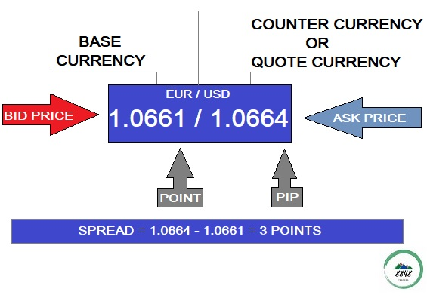

**bEARISH/BEAR MARKET**

Negative for price direction; favoring a declining market. For example, "We are bearish EUR/USD" means that we think the euro will weaken against the dollar.

**BEARS**

Traders who expect prices to decline and may be holding short positions.

**BULLISH/BULL MARKET**

Favoring a strengthening market and rising prices. For example, "We are bullish EUR/USD” means that we think the euro will strengthen against the dollar.

**BULLS**

Traders who expect prices to rise and who may be holding long positions.

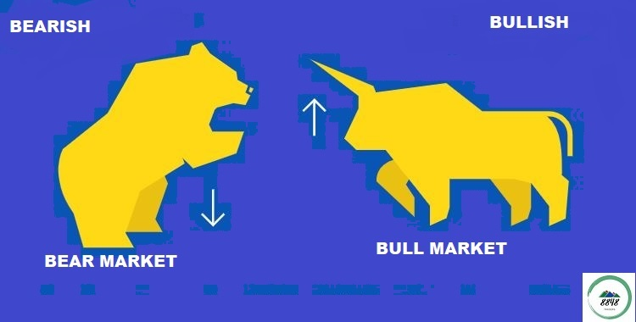

A good way to remember which a bear on its hind legs attacking **downward** and a bull with its horns down attacking by bucking its head **up**.

**BUY**

Taking a long position on a product.

**SELL**

Taking a short position in expectation that the market is going to go down.

**CANDLESTICK CHART**

A chart that indicates the trading range for the day as well as the opening and closing price. If the open price is higher than the close price, the rectangle between the open and close price is shaded. If the close price is higher than the open price, that area of the chart is not shaded.

**CLOSED POSITION**

Exposure to a financial contract, such as currency, that no longer exists. A position is closed by placing an equal and opposite deal to offset the open position. Once closed, a position is considered squared.

**CLOSING**

The process of stopping (closing) a live trade by executing a trade that is the exact opposite of the open trade.

**CLOSING PRICE**

The price at which a product was traded to close a position. It can also refer to the price of the last transaction in a day trading session.

**CONSOLIDATION**

A period of range-bound activity after an extended price move.

**DAY TRADER**

Speculators who take positions in commodities and then liquidate those positions prior to the close of the same trading day.

**DAY TRADING**

Making an open and close trade in the same product in one day.

**DOWNTREND**

Price action consisting of lower lows and lower highs.

**FUNDAMENTAL ANALYSIS**

The assessment of all information available on a tradable product to determine its outlook and therefore predict where the price is heading. Often non-measurable and subjective assessments, as well as quantifiable measurements, are made in fundamental analysis.

**GAP/GAPPING**

A quick market moves in which prices skip several levels without any trades occurring. Gaps usually follow economic data or news announcements.

**LEVERAGE**

Also known as margin, this is the percentage or fractional increase you can trade from the amount of capital you have available. It allows traders to trade notional values far higher than the capital they have. For example, leverage of 100:1 means you can trade a notional value 100 times greater than the capital in your trading account.

**LIMITS/LIMIT ORDER**

An order that seeks to buy at lower levels than the current market or sell at higher levels than the current market. A limit order sets restrictions on the maximum price to be paid or the minimum price to be received. As an example, if the current price of USD/JPY is 117.00/05, then a limit order to buy USD would be at a price below the current market, e.g. 116.50. A Limit Order that is attached to a currently existing open position (or a pending entry order) with the purpose of closing that position may also be referred to as a “Take Profit” order.

**LIQUID MARKET**

A market which has sufficient numbers of buyers and sellers for the price to move in a smooth manner.

**LIQUIDATION**

The closing of an existing position through the execution of an offsetting transaction.

**LONG POSITION**

A position that appreciates in value if market price increases. When the base currency in the pair is bought, the position is said to be long. This position is taken with the expectation that the market will rise.

**LONGS**

Traders who have bought a product.

**LOT**

A unit to measure the amount of the deal. The value of the deal always corresponds to an integer number of lots.



**MACRO**

The longest-term trader who bases their trade decisions on fundamental analysis. A macro trade’s holding period can last anywhere from around six months to multiple years.

**MARGIN CALL**

A request from a broker or dealer for additional funds or other collateral on a position that has moved against the customer.

**MARKET MAKER**

A dealer who regularly quotes both bid and ask prices and is ready to make a two-sided market for any financial product.

**MARKET ORDER**

An order to buy or sell at the current price.

**OFFER/ASK PRICE**

The price at which the market is prepared to sell a product. Prices are quoted two-way as Bid/Offer. The Offer price is also known as the Ask. The Ask represents the price at which a trader can buy the base currency, which is shown to the right in a currency pair. For example, in the quote USD/CHF 1.4527/32, the base currency is USD, and the ask price is 1.4532, meaning you can buy one US dollar for 1.4532 Swiss francs.

**PIPS**

The smallest unit of price for any foreign currency, pips refer to digits added to or subtracted from the fourth decimal place, i.e. 0.0001.

**POSITION**

The net total holdings of a given product.

**PULLBACK**

The tendency of a trending market to retrace a portion of the gains before continuing in the same direction.

**RANGE**

When a price is trading between a defined high and low, moving within these two boundaries without breaking out from them.

**RESISTENCE LEVEL**

A price that may act as a ceiling. The opposite of support.

**SUPPORT LEVELS**

A technique used in technical analysis that indicates a specific price ceiling and floor at which a given exchange rate will automatically correct itself. Opposite of resistance.

**SUPPORT**

A price that acts as a floor for past or future price movements.

**RETAIL INVESTOR**

An individual investor who trades with money from personal wealth, rather than on behalf of an institution.

**RISK**

Exposure to uncertain change, most often used with a negative connotation of adverse change.

**RISK MANAGEMENT**

The employment of financial analysis and trading techniques to reduce and/or control exposure to various types of risk.

**SHORT POSITION**

An investment position that benefits from a decline in market price. When the base currency in the pair is sold, the position is said to be short.

**SHORT SQUEEZE**

A situation in which traders are heavily positioned on the short side and a market catalyst causes them to cover (buy) in a hurry, causing a sharp price increase.

**SHORTS**

Traders who have sold, or shorted, a product, or those who are bearish on the market.

**SIDELINES, SIT ON HANDS**

Traders staying out of the markets due to directionless, choppy, or unclear market conditions are said to be on the sidelines or sitting on their hands.

**CHOPPY**

Short-lived price moves with limited follow-through that are not conducive to aggressive trading.

**SLOPPY**

Choppy trading conditions that lack any meaningful trend and/or follow-through.

**SPOT MARKET**

A market whereby products are traded at their market price for immediate exchange.

**SPOT PRICE**

The current market price. Settlement of spot transactions usually occurs within two business days.

**SPOT TRADE**

The purchase or sale of a product for immediate delivery (as opposed to a date in the future). Spot contracts are typically settled electronically.

**STOP ENTRY ORDER**

This is an order placed to buy above the current price, or to sell below the current price. These orders are useful if you believe the market is heading in one direction and you have a target entry price.

**STOP-LOSS HUNTING**

When a market seems to be reaching for a certain level that is believed to be heavy with stops. If stops are triggered, then the price will often jump through the level as a flood of stop-loss orders are triggered.

**STOP LOSS ORDER**

This is an order placed to sell below the current price (to close a long position), or to buy above the current price (to close a short position). Stop loss orders are an important risk management tool. By setting stop loss orders against open positions you can limit your potential downside should the market move against you. Remember that stop orders do not guarantee your execution price – a stop order is triggered once the stop level is reached, and will be executed at the next available price.

**STOP ORDER**

A stop order is an order to buy or sell once a pre-defined price is reached. When the price is reached, the stop order becomes a market order and is executed at the best available price. It is important to remember that stop orders can be affected by market gaps and slippage, and will not necessarily be executed at the stop level if the market does not trade at this price. A stop order will be filled at the next available price once the stop level has been reached. Placing contingent orders may not necessarily limit your losses.

**SUSPENDED TRADING**

A temporary halt in the trading of a product.

**TECHNICAL ANALYSIS**

The process by which charts of past price patterns are studied for clues as to the direction of future price movements.

**TICK (SIZE)**

A minimum change in price, up or down.

**TRADE SIZE**

The number of units of product in a contract or lot.

**TRADING BID**

A pair is acting strong and/or moving higher; bids keep entering the market and pushing prices up.

**TRADING HALT**

A postponement to trading that is not a suspension from trading.

**TRADING HEAVY**

A market that feels like it wants to move lower, usually associated with an offered market that will not rally despite buying attempts.

**TRAILING STOP**

A trailing stop allows a trade to continue to gain in value when the market price moves in a favorable direction, but automatically closes the trade if the market price suddenly moves in an unfavorable direction by a specified distance. Placing contingent orders may not necessarily limit your losses.

**TREND**

Price movement that produces a net change in value. An uptrend is identified by higher highs and higher lows. A downtrend is identified by lower highs and lower lows.

**VOLATILITY**

Referring to active markets that often present trade opportunities.

**WEDGE CHART PATTERN**

Chart formation that shows a narrowing price range over time, where price highs in an ascending wedge decrease incrementally, or in a descending wedge, price declines are incrementally smaller. Ascending wedges typically conclude with a downside breakout and descending wedges typically terminate with upside breakouts.

**Reference sources:** [**https://www.expertinvestor.net/forex/guides/glossary/**](https://www.expertinvestor.net/forex/guides/glossary/)

**Types of analysis**

Basically in trading there’s three types of analysis:

1. **Fundamental analysis**
2. **Technical analysis**
3. **Sentimental analysis**

While there’s a lot of debate going on about one analysis is better than other analysis among traders what we can assume is any kind of analysis done right can be profitable.

1. **Fundamental analysis**

Fundamental analysis is the most basic form of analysis for any asset, companies or even currencies. Fundamental analysis tries to determine the direction of a currency’s price based on supply and demand.

Fundamental analysis is also done by looking at the economic health of the countries and comparing with each other.

The few factors that fundamental analysis investigate are:

* Central bank policy
* Trade balance
* Unemployment reports
* Inflation reports.

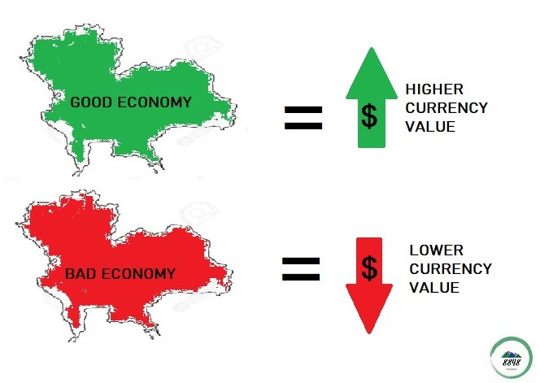

1. **Technical analysis**

Technical Analysis is the forecasting of future financial price movements based on an examination of past price movements. Like weather forecasting, technical analysis does not result in absolute predictions about the future. Instead, technical analysis can help investors anticipate what is “likely” to happen to prices over time.

Technical analysis is applicable to stocks, indices, commodities, futures, or any tradable instrument where the price is influenced by the forces of supply and demand. Price data (or as John Murphy calls it, “market action”) refers to any combination of the open, high, low, close, volume, or open interest for a given security over a specific timeframe. The timeframe can be based on intraday (1-minute, 5-minutes, 10-minutes, 15-minutes, 30-minutes or hourly), daily, weekly, or monthly price data and last a few hours or many years.

(source reference: <https://school.stockcharts.com/doku.php?id=overview:technical_analysis>)

1. **Sentiment analysis**

Sentiment analysis is a method for gauging opinions of individuals or groups, such as a segment of a brand’s audience or an individual customer in communication with a customer support representative. Based on a scoring mechanism, sentiment analysis monitors conversations and evaluates language and voice inflections to [quantify attitudes](https://lct-master.org/files/MullenSentimentCourseSlides.pdf), opinions, and emotions related to a business, product or service, or topic. Sentiment analysis is sometimes also referred to as opinion mining.

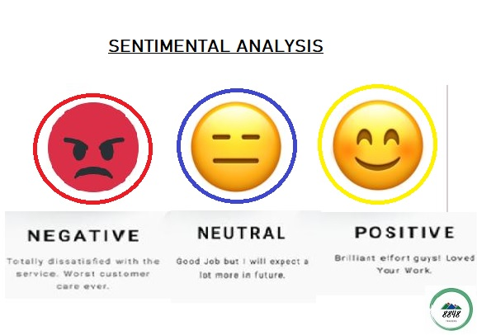

The most common use of Sentiment Analysis is this of classifying a text to a class. Depending on the dataset and the reason, Sentiment Classification can be binary (positive or negative) or multi-class (3 or more classes) problem.

In addition, among researchers and stakeholders, you can find either similar or completely different opinions concerning the relation between emotion detection and sentiment analysis, depending on their perspective. However, regardless the result or approach, they all adopt the same techniques.

**(**source reference: <https://callminer.com/blog/sentiment-analysis-examples-best-practices/> **)**

**Technical analysis for trading**

Technical analysis is the framework in which traders study price movement.

There’s a theory that a person can determine the present condition and potential price movement by looking at the historical price movements.

Someone who uses technical analysis is called a technical analyst. Traders who use technical analysis are known as technical traders.

The main evidence for using technical analysis is that, theoretically, all current market information is reflected in the price.

Technical traders generally ascribe to the belief that “It’s all in the charts!”

This simply means that all known fundamental information is priced into the current market price.

If price reflects all the information that is out there, then price action is all one would really need to make a trade.

Technical analysis looks at the rhythm, flow, and trends in price action.

Now, have you ever heard the old adage, “History tends to repeat itself “?

Well, that’s basically what [technical analysis](https://www.babypips.com/forexpedia/technical-analysis) is all about!

If a certain price held as a major support or resistance level in the past, [forex](https://www.babypips.com/forexpedia/forex) traders will keep an eye out for it and base their trades around that historical price level.

Technical analysts look for similar patterns that have formed in the past and will form trade ideas believing that price could possibly act the same way that it did before.

Technical analysis is NOT so much about prediction as it is about PROBABILITY.

Technical analysis is the study of historical price action in order to identify patterns and determine probabilities of the future direction of price.

So how the heck does one “study historical price action “?

In the world of trading, when someone says “technical analysis”, the first thing that comes to mind is a chart.

Technical analysts use charts because they are the easiest way to visualize historical data!

Technical analysts live, eat, and breathe charts which is why they are often called chartists.

You can look at past data to help you spot trends and patterns which could help you find some great trading opportunities.

What’s more is that with all the traders who rely on [technical analysis](https://www.babypips.com/forexpedia/technical-analysis) out there, these price patterns and indicator signals tend to become self-fulfilling.

As more and more [forex](https://www.babypips.com/forexpedia/forex) traders look for certain price levels and chart patterns, the more likely that these patterns will manifest themselves in the markets.

(SOURCE REFERENCE: <https://www.babypips.com/learn/forex/technical-analysis> )

**DEFINATION OF CHART**

In order to study how the price of a currency pair *moves*, you need some sort of way to look at its historical and current price behavior.

A **chart** is simply a **visual representation** of a currency pair’s price over a set period of time. A **chart**, or more specifically, a **price chart**, happens to be the first tool that every trader using technical analysis needs to learn. It visualizes the trading activity that takes place during a single trading period (whether it’s 10 minutes, 4 hours, one day, or one week).

**What does a price chart represent?**

A price chart represents **every buy and sell transaction** of that financial instrument (in our case, currency pairs) at any given moment. A price chart depicts changes in **supply and demand.**

**Types of Price Charts**

Let’s take a look at the three most popular types of price charts:

1. Line chart
2. Bar chart
3. Candlestick chart
4. **Line chart**

A simple line chart draws a line from one closing price to the next closing price.

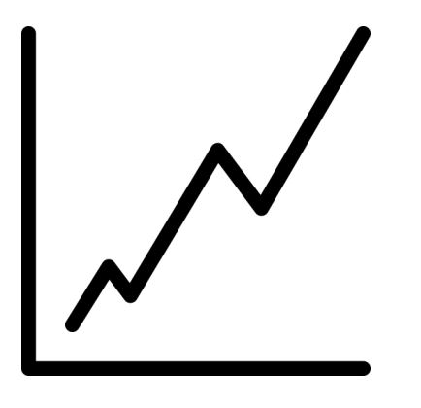

It’s simple to follow, but the line chart may not provide the trader with much detail about price behavior within the period. This type of chart is usually used to get a “big picture” view of price movements.

The line chart also shows **trends** the best, which is simply the **slope**of the line.

Here is an example of a line chart for **EUR/USD**:

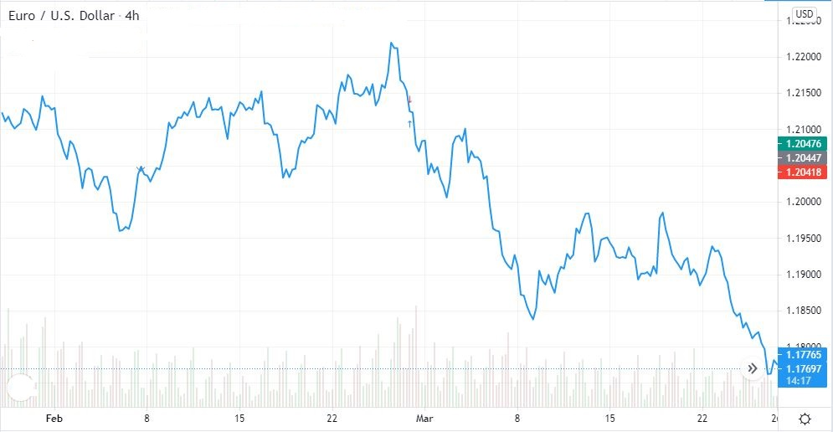

1. **Bar chart**

A bar chart shows the **opening** and **closing** prices, as well as the **highs** and**lows**. Bar charts help a trader see the price range of each period.

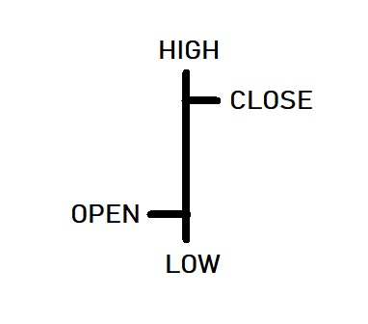

**Open**: The horizontal line on the left is the opening price

**Close**: The horizontal line on the right is the closing price

**High**: The top of the vertical line defines the highest price of the time period

**Low**: The bottom of the vertical line defines the lowest price of the time period

Bars may increase or decrease in size from one bar to the next, or over a range of bars. The vertical bar itself indicates the currency pair’s trading range as a whole. As the price fluctuations become increasingly volatile, the bars become larger. As the price fluctuations become quieter, the bars become smaller.

Here is an example of a bar chart for **EUR/USD**:

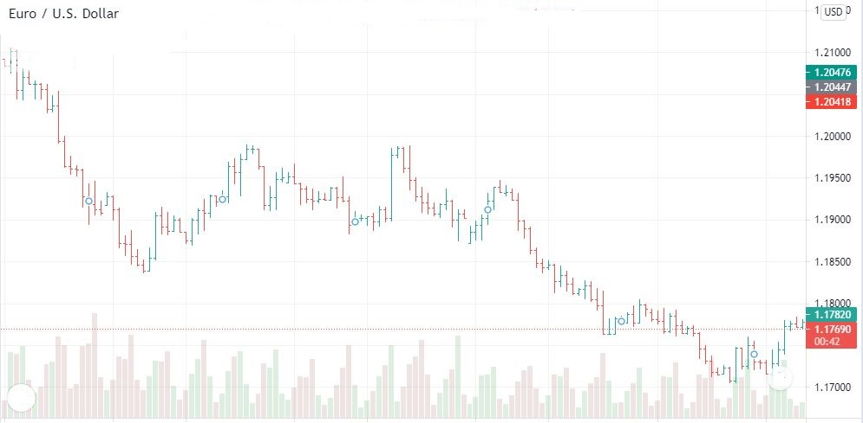

A bar is simply one segment of time, whether it is one day, one week, or one hour. When you see the word ‘bar’ going forward, be sure to understand what time frame it is referencing.

Bar charts are also called “OHLC” charts because they indicate the Open, the High, the Low, and the Close for that particular currency pair.

1. **Candlesticks Charts**

The candlestick chart is a variation of the bar chart. Candlestick charts show the same price information as a bar chart but in a prettier, graphic format. Many traders like this chart because not only is it prettier, but it’s easier-to-read.

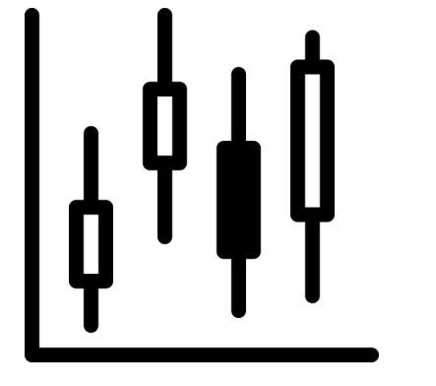

Candlestick bars still indicate the high-to-low range with a vertical line. However, in candlestick charting, the larger block (or body) in the middle indicates the range between the opening and closing prices. Candlesticks help visualize bullish or bearish sentiment by displaying “bodies” using different colors.

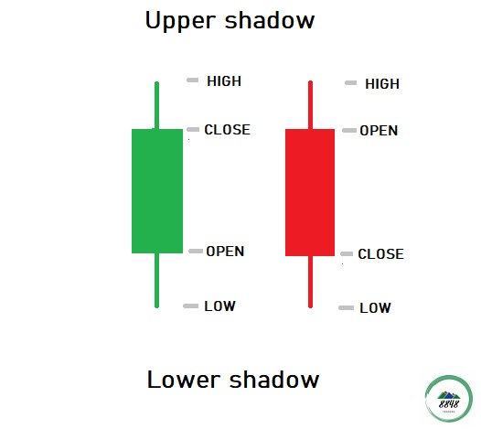

If the price closed higher than it opened, the candlestick would be green.

If the price closed lower than it opened, the candlestick would be red.

Here is an example of a candlestick chart for **EUR/USD**.

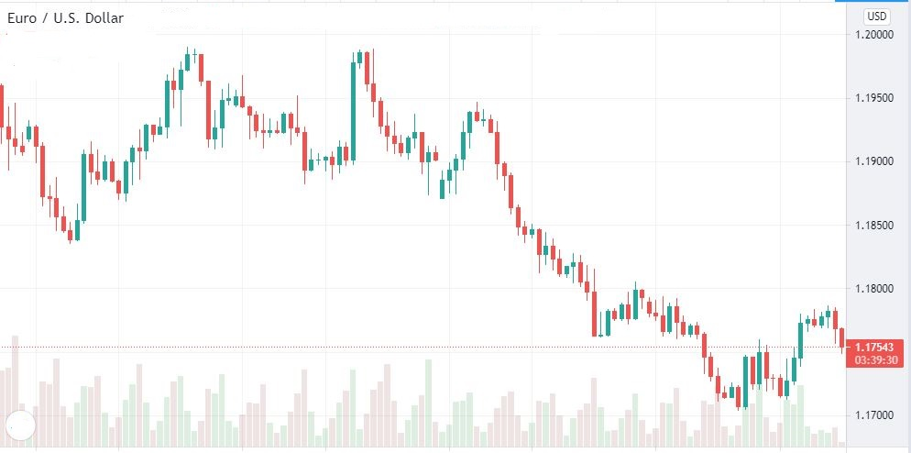

The purpose of candlestick charting is strictly to serve as a visual aid since the exact same information appears on an OHLC bar chart.

The advantages of candlestick charting are:

* Candlesticks are easy to interpret and are a good place for beginners to start figuring out forex chart analysis.
* Candlesticks are easy to use! Your eyes adapt almost immediately to the information in the bar notation. Plus, research shows that visuals help with studying, so it might help with trading as well!
* Candlesticks and candlestick patterns have cool names such as the “shooting star,” which helps you to remember what the pattern means.
* Candlesticks are good at identifying market turning points – reversals from an uptrend to a downtrend or a downtrend to an uptrend.

There are many different types of charts available, and one is not necessarily better than the other**. The data may be the same to create the chart** but the way that **data is presented and interpreted will vary**. Each chart will have its own advantages and disadvantages. You can choose any type or use multiple types of charts for [**technical analysis**](https://www.babypips.com/forexpedia/technical-analysis).

**TECHNICAL ANALYSIS**

* **Triangle pattern charts:**

T[riangles](https://www.investopedia.com/terms/t/triangle.asp) fall under the category of continuation patterns meaning that after the pattern completes, it’s assumed that price will continue in the trend direction it was moving before the pattern appeared. Triangle patterns are a commonly-used technical analysis tool and they help to indicate the continuation of a [bullish or bearish](https://corporatefinanceinstitute.com/resources/knowledge/finance/bullish-and-bearish/) market. We will now take a closer look at the various triangle chart patterns.

There are three types of triangle chart formations:

1. **Symmetrical Triangle**
2. **Ascending Triangle**
3. **Descending Triangle**
4. **Symmetrical Triangle**

The symmetrical triangle is a situation on the chart where the tops of the price action are lower and the bottoms are higher. Also, the two sides of the triangle are inclined with the same angle. This creates the symmetrical character of the triangle.

* A symmetrical triangle implies that the market cannot decide whether to break up or down. Once the triangle is broken by the price, there may be a substantial move in the direction of the break.

 The sketch below illustrates the symmetrical triangle formation and possible [breakout scenarios](https://forextraininggroup.com/a-step-by-step-guide-to-trading-breakouts-in-forex/):

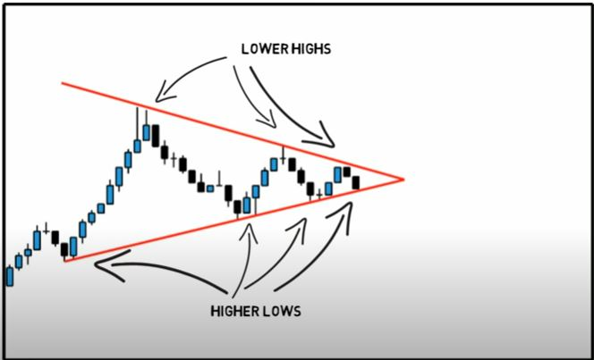

In the chart above, we can see that neither the buyers nor the sellers could push the price in their direction. When this happens we get lower highs and higher lows. It means that a breakout is getting near. We don’t know what direction the breakout will be, but we do know that the market will most likely break out. Eventually, one side of the market will give in.

We can place entry orders above the slope of the lower highs and below the slope of the higher lows of the [symmetrical triangle](https://www.babypips.com/forexpedia/symmetrical-triangle).

Since we already know that the price is going to break out, we can just hitch a ride in whatever direction the market moves.

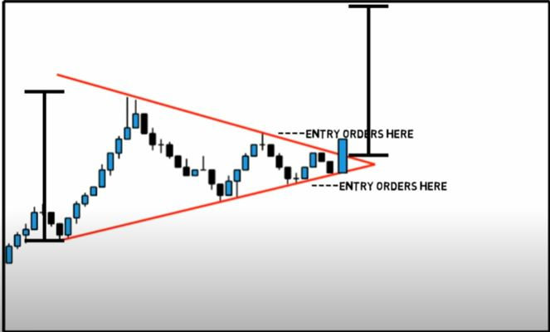

In this example, if we placed an entry order above the slope of the lower highs, we would’ve been taken along for a nice ride up. And another entry order below the slope of the higher lows, then you would cancel it as soon as the first order was hit.

1. **Ascending Triangle**

An [ascending triangle](https://www.babypips.com/forexpedia/ascending-triangle) is a type of triangle chart pattern that occurs when there is a **resistance level** and a slope of higher lows. In an ascending triangle chart pattern, the upper trend line is flat, while the bottom trend line is sloping upward. This is generally considered a bullish pattern and one in which chartists look for an upside breakout.

The sketch below illustrates the ascending triangle

formation:

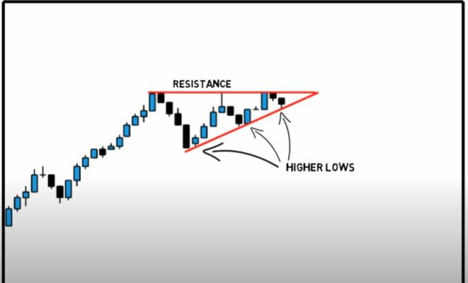

In the chart above, you can see that the buyers are starting to gain strength because they are making higher lows. They keep putting pressure on that resistance level and as a result, a breakout is bound to happen.

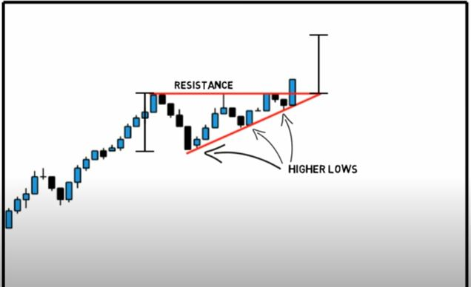

In this scenario, the triangle takes shape after resistance to the upside is encountered. The shares here had been in an upward trend. A trader seeing this pattern may purchase the shares after the price bounces off the ever-increasing support price level, or when the stock finally breaks through the previous level of resistance.

1. **Descending Triangle**

[Descending triangles](https://www.babypips.com/forexpedia/descending-triangle) are the exact opposite of ascending triangles. The descending triangle is a bearish pattern that is characterized by a descending upper trendline and a flat lower trendline that acts as [**Support**](https://www.dailyfx.com/forex/education/trading_tips/daily_trading_lesson/2019/04/24/support-and-resistance-trading.html). This pattern indicates that sellers are more aggressive than buyers as price continues to make lower highs. The pattern completes itself when price breaks out of the triangle in the direction of the overall trend.

The sketch below illustrates the Descending triangle formation:

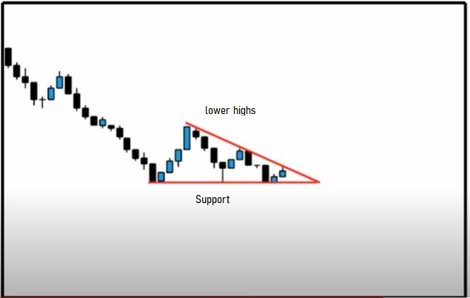

In the chart above, you can see that the price is gradually making lower highs which tell us that the sellers are starting to gain some ground against the buyers. Now most of the time, and we do say MOST, the price will eventually break the support line and continue to fall. However, in some cases, the support line will be too strong, and the price will bounce off of it and make a strong move up. The good news is that we don’t care where the price goes. We just know that it’s about to go somewhere. In this case, we would place entry orders above the upper line (the lower highs) and below the support line.

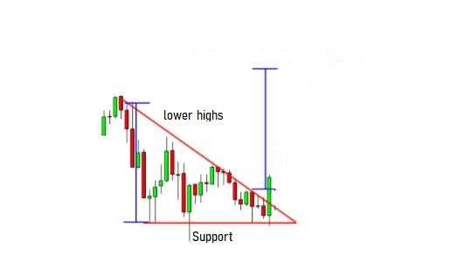

In this case, the price ended up breaking above the top of the triangle pattern. After the upside breakout, it proceeded to surge higher, by around the same vertical distance as the height of the triangle. Placing an entry order above the top of the triangle and going for a target as high as the height of the formation would’ve yielded nice profits.

# **Pennants pattern:**

A Pennant pattern is a continuation chart pattern, seen when a security experiences a large upward or downward movement, followed by a brief consolidation, before continuing to move in the same direction. The pattern looks like a small symmetrical triangle called a Pennant, which is made up of numerous forex candlesticks. Depending on the direction of the movement and act in a similar nature to a Flag pattern, the actual look of the trend is more like a Triangle pattern. Pennant patterns are usually described as being bearish or bullish.

Let's see an example of this:

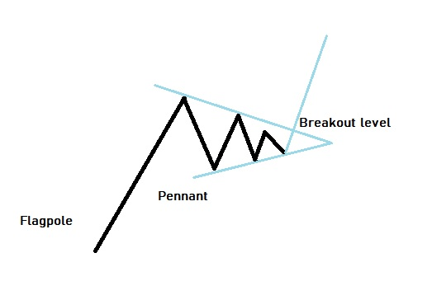

You see above that the "Flagpole" if you want to call it that had a strong upward movement (nearly vertical). The buyers then began to close their positions and made the trend stall and form what's called a pennant pattern. Some sellers got in before new buyers made entries and eventually kept the main trend going to the upside. This is essentially what happens every time a pennant pattern is formed.

There are two types of pennants that form on charts:

1. **Bearish Pennant**
2. **Bullish Pennant**

# **How to Trade Bearish and Bullish Pennants?**

Let’s describe bearish and bullish pennants in this question.

1. **Bearish Pennant**

A bearish pennant structure indicates selling pressure on the price following the breakout. The confirmation of a bearish pennant pattern comes after a breakout and close below the support line of the formation.

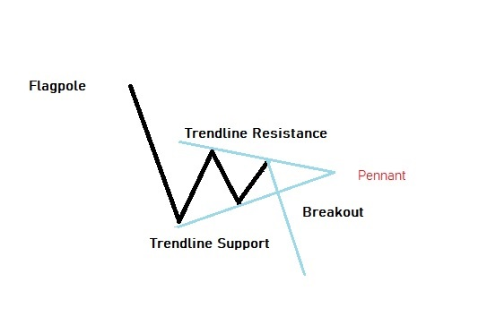

The bearish pennant pattern can be seen following a strong price movement to the downside, which is often seen as an impulsive leg. We refer to this impulsive leg as the flagpole. As with the bullish variation of this pattern, the bearish pennant appears as a short pause within the price action and resembles a shortened version of a contracting or symmetrical triangle. The price action will be contained within this contracting structure, and we can expect a breakout to the downside as the price progresses towards the apex point.

1. **Bullish Pennant**

Bullish Pennants are continuation [candlestick patterns](https://www.dailyfx.com/forex/education/trading_tips/daily_trading_lesson/2018/12/21/how-to-read-a-candlestick-chart.html) that occur in strong uptrends. The Pennant is formed from an upward flagpole, a consolidation period and then the continuation of the uptrend after a breakout. Traders look for a break above the Pennant to take advantage of the renewed bullish momentum.

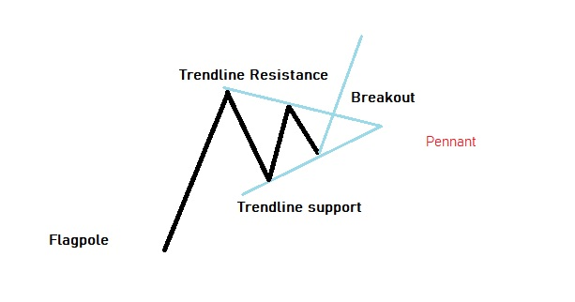

The bullish pennant pattern occurs after a sharp price move to the upside. We call this the impulsive leg or the flagpole. Also notice how the bullish pennant pattern appears as a short symmetrical triangle. Can you see how the upper resistance trendline is sloping downward, while the lower support trendline is sloping upward? This creates a convergence of the two trendlines that will [lead to a breakout](https://forextraininggroup.com/a-step-by-step-guide-to-trading-breakouts-in-forex/) near the apex point.

* **Flag**

The “Flag” pattern is a technical analysis tool that predicts continuation of the current market tendency (trend) and consists of two parts: the “flagpole” and the “Flag” (the channel within which the price moves). A flag is a relatively rapid chart formation that appears as a small [channel](https://www.babypips.com/forexpedia/trend-channel) after a steep trend, which develops in the opposite direction. After an uptrend, it has a downward slope. After a downtrend, it has an upward slope.

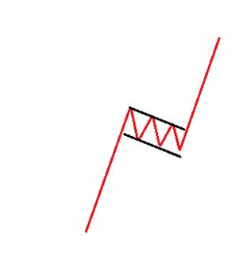

A “flag” is composed of an explosive strong price move forming a nearly vertical line. This is known as the” flagpole”.

After the flagpole forms, bearish (bullish) traders, eager to capitalize on instant profits, begin selling (buying) off their holdings. Flag patterns can be bullish or bearish:

* A bullish flag is known as a [**Bull Flag**](https://www.babypips.com/forexpedia/bull-flag).
* A bearish flag is known as a [**Bear Flag**](https://www.babypips.com/forexpedia/bear-flag).

## What are Bullish and Bearish Flags?

* Bullish flags are formations occur when the slope of the channel connecting highs and lows of consolidating prices after a significant move up is parallel and declining. The trend before the flag must be up.
* Bearish flags are formations occur when the slope of the channel connecting highs and lows of consolidating prices after a significant move down is parallel and rising. The trend before the flag must be down.

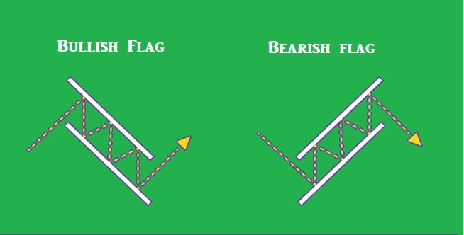

# **Support and Resistance Basics**

The concepts of trading level [**support**](https://www.investopedia.com/terms/s/support.asp) and [**resistance**](https://www.investopedia.com/terms/r/resistance.asp) are undoubtedly two of the most highly discussed attributes of technical analysis.  Part of analyzing chart patterns, these terms are used by traders to refer to price levels on charts that tend to act as barriers, preventing the price of an asset from getting pushed in a certain direction.

Let’s take a look at the diagram first.

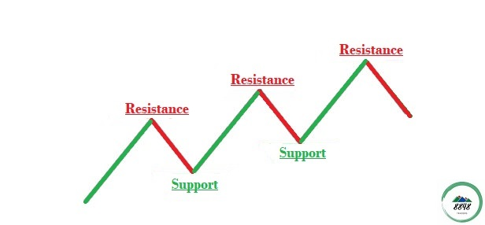

As you can see, this zigzag pattern is making its way up (a “[bull](https://www.babypips.com/forexpedia/bull) market”).When the price moves up and then pulls back, the highest point reached before it pulled back is now **resistance**. **Resistance** levels indicate where there will be a surplus of sellers. When the price continues up again, the lowest point reached before it started back is now **support**. **Support** levels indicate where there will be a surplus of buyers.

* **What is Resistance?**

Resistance is something which stops the price from rising further. The resistance level is a price point on the chart where traders expect maximum supply (in terms of selling) for the stock/index. **The resistance level is always above the current market price.**

* **What is Support?**

Understanding the support level should be quite simple. support is something that prevents the price from falling further. The support level is a price point on the chart where the trader expects maximum demand (in terms of buying) coming into the stock/index. Whenever the price falls to the support line, it is likely to bounce back. **The support level is always below the current market price**.

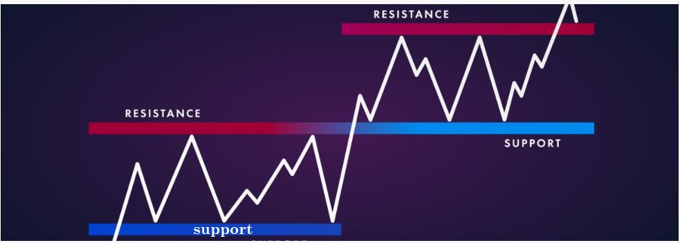

**Trade the “Bounce”**

* Buy when the price falls towards support.
* Sell when the price rises towards resistance.

**Trade the “Break”**

* Buy when the price breaks up through resistance.
* Sell when the price breaks down through support.
* **Trend and Trendlines**

A trendlines is a tool used by the traders to find out the direction of the price. Trendlines are probably the most common form of [technical analysis](https://www.babypips.com/forexpedia/technical-analysis) in [forex trading](https://www.babypips.com/forexpedia/forex-trading). If you can draw trendlines correctly, you will be able to define buy and sell zones and maximize your trading potential.

There are three types of Trendlines:

1. Uptrend line (ascending)
2. Downtrend line (descending)
3. Sideways trendline (horizontal)
4. **Uptrend line** (ascending)

The trendline which has an upward slope is called as an Uptrend line. The Uptrend lines represent an up-trending market and tell us that the buyers are controlling the market. This is known as an [ascending trend line](https://www.babypips.com/forexpedia/ascending-trend-line).

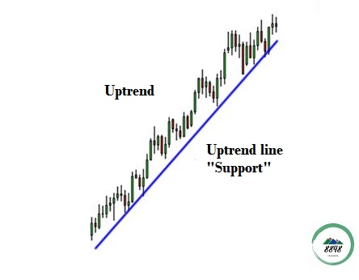

1. **Downtrend line** (descending)

The trendline which has a downward slope is called a downtrend line. The downtrend line represents a down-trending market. This also tells us that the momentum of the market is with the sellers. This is known as a [descending trend line](https://www.babypips.com/forexpedia/descending-trend-line).

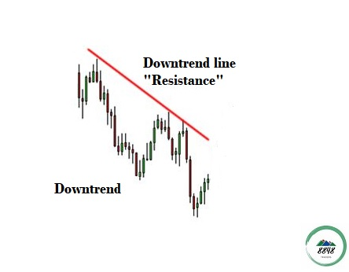

1. **Sideways trendline** (horizontal)

A sideways trendline is the horizontal price movement that occurs when the forces of [supply and demand](https://www.investopedia.com/terms/l/law-of-supply-demand.asp) are nearly equal. This typically occurs during a period of [consolidation](https://www.investopedia.com/terms/c/consolidation.asp) before the price continues a prior trend or reverses into a new trend. This is known as a [horizontal trend line](https://www.babypips.com/forexpedia/descending-trend-line).

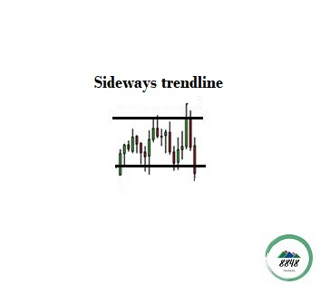

# **How are trendlines formed**?

A trendline is a line drawn by connecting the swing highs or the swing lows to find the exact direction of the trend.

Consider the price is in an up-trending market, so this means that the buyers are in control of the market, and they are causing the price to move up. Now, while the price is moving up, sooner or later, a point will come where few buyers will take profit and get out of the trade and new sellers will enter? Consider this point at which the buyers take profit as your higher high.

 Now as some buyers got out of the trade and some sellers came in, it will create a counter pressure and hence will cause the price to retrace and therefore will create a new higher low. After this retracement, if the price continues to move back up, this means that there still aren’t enough sellers to take away the momentum from the buyers and so it will move past the previous higher high and hence create a new higher high. Again some buyers will take profit and cause the price to retrace creating a new higher low.

 So, now in an up-trending market when you connect these swing low and higher lows through a line, then it forms a trendline. The trendline formed here acts as vertical support for the price, and the buyers have a strong belief that the price is going to reverse from this line, so anytime it touches the trendline new buyers adds up, and the price bounces back up. So, this was the main psychology behind the formation and significance of trendline.