**Entity Identification**

1. punch_time 🡪 (dimension table)
2. shift 🡪 (dimension table)
3. role 🡪 (dimension table)
4. department 🡪 (dimension table)
5. bi_week 🡪 (dimension table)
6. employee 🡪 (fact table)

**Logical Design**

|  |  |  |
| --- | --- | --- |
| Entity | Attributes | description |
| punch_time | punch_id (PK)  punch_on_time  punch_out_time  punch_date  punch_day  pay_code  cover_status | auto generated primary key  time type data  time type data  date type data  shows the weekdays  shows the paycode of employee  shows if employee need to cover (BOOLEAN) |
| shift | shift_id (PK)  shift_start_time  shift_type | auto generated primary key  punch_on_time  type of shift based on punch_on_time |
| role | role_id (PK)  role_name | auto generated primary key  shows the name of role of employee |
| department | department_id (PK)  department_name | auto generated primary key  shows the department name |
| bi_week | bi_week_id (PK)  start_date  to_date | auto generated primary key  shows the start date for starting biweekly analysis  shows to which date do the biweekly analysis is |
| employee | punch_id (FK)  shift_id (FK)  department_id (FK)  bi_week_id (FK)  employee_id  work_hour  salary | valid id from punch_time table  valid id from shift table  valid id from department table  valid id from bi_week table  shows the employee id of the employee  shows the working hour of the employee  shows the salary of the employee |

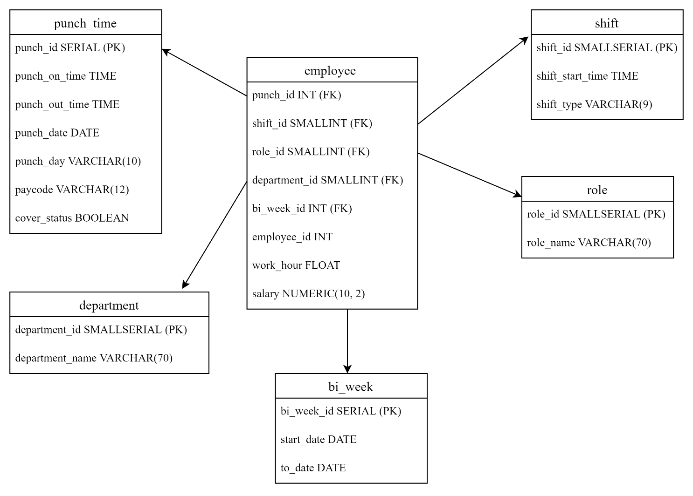

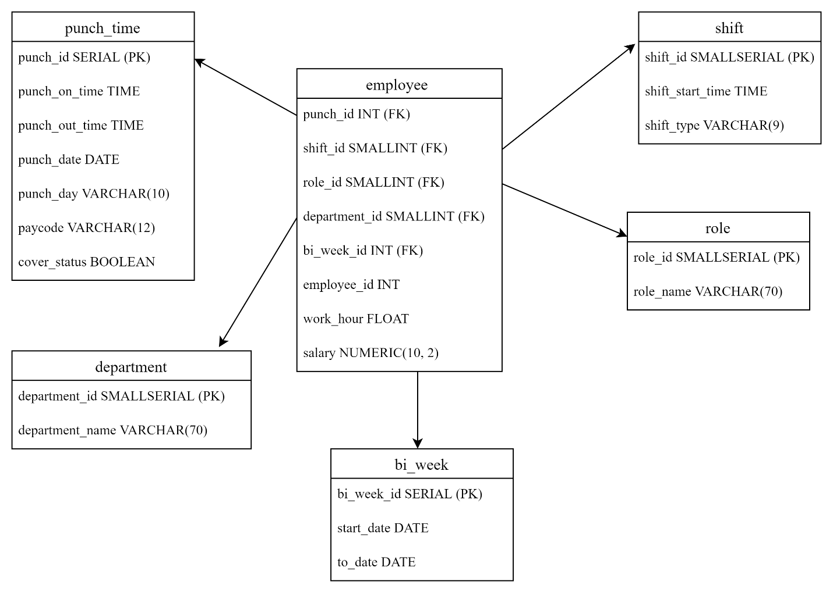**Physical model**

[**Diagram link**](https://drive.google.com/file/d/1UbG9wT3NE1uVtc_kQ3KX5xsqVqaRd7-W/view?usp=sharing)

**Physical implementation**

CREATE SCHEMA IF NOT EXISTS etl;

CREATE TABLE IF NOT EXISTS etl.punch_time(

punch_id SERIAL PRIMARY KEY,

punch_on_time TIME,

punch_out_time TIME,

punch_date DATE,

punch_day VARCHAR(10),

pay_code VARCHAR(12) NOT NULL,

cover_status BOOLEAN NOT NULL

);

CREATE TABLE IF NOT EXISTS etl.department(

department_id SMALLSERIAL PRIMARY KEY,

department_name VARCHAR(70) NOT NULL

);

CREATE TABLE IF NOT EXISTS etl.shift(

shift_id SMALLSERIAL PRIMARY KEY,

shift_start_time TIME,

shift_type VARCHAR(9)

);

CREATE TABLE IF NOT EXISTS etl.role(

role_id SMALLSERIAL PRIMARY KEY,

role_nane VARCHAR(70)

);

CREATE TABLE IF NOT EXISTS etl.bi_week(

bi_week_id SERIAL PRIMARY KEY,

start_date DATE,

to_date DATE

);

CREATE TABLE IF NOT EXISTS etl.employee(

punch_id INT,

shift_id SMALLINT,

role_id SMALLINT,

department_id SMALLINT,

bi_week_id INT,

employee_id INT,

work_hour FLOAT,

salary NUMERIC(10, 2),

FOREIGN KEY (punch_id) REFERENCES etl.punch_time(punch_id),

FOREIGN KEY (shift_id) REFERENCES etl.shift(shift_id),

FOREIGN KEY (role_id) REFERENCES etl.role(role_id),

FOREIGN KEY (department_id) REFERENCES etl.department(department_id),

FOREIGN KEY (bi_week_id) REFERENCES etl.bi_week(bi_week_id)

);