

Android project proposal
On
Liquor store
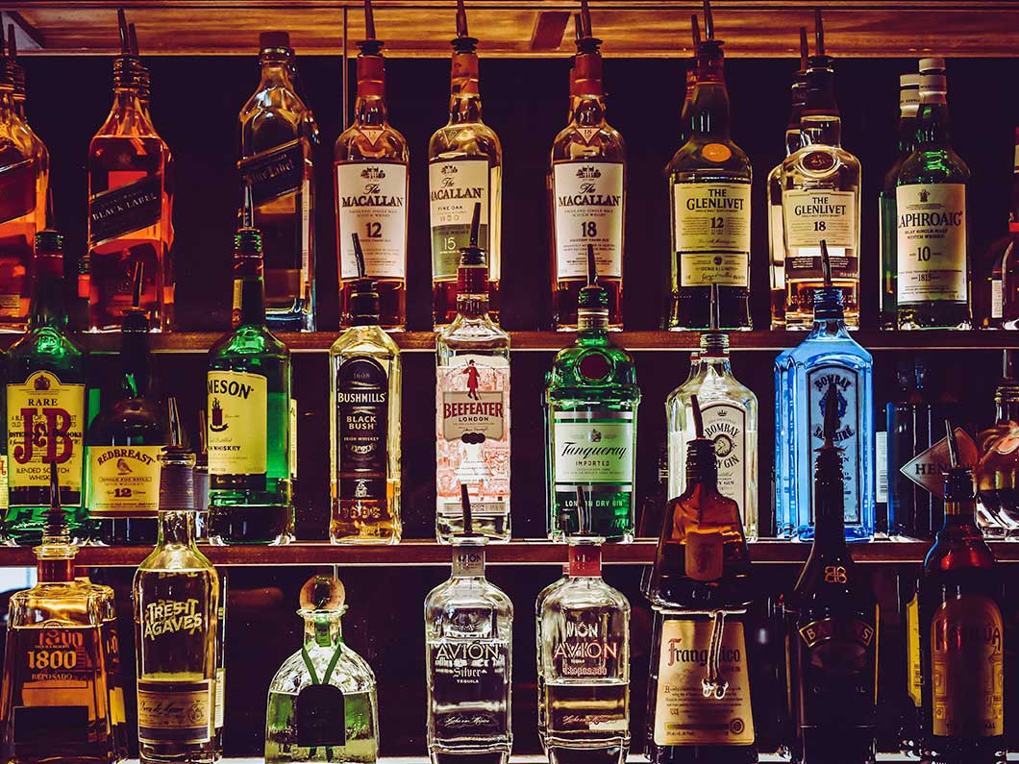

Submitted by : Nabin Thakurathi
Batch: November 2019, Batch: 22B
Module Leader : Kiran Rana

Introduction

a. Project Introduction.
Liquor store is the android application which will sell all the possible liquor related products such as beers, wines and other kind of drinks. This application will fully focuses on selling the products related with liquor. Now the alcohol related products has become the inseparable part of our society so its the right time to use technology for serving this kind of products. Liquor store mobile app will help clients to order their favorite drink. This mobile application will help to earn the maximum revenue in the following years and provide job opportunities.

b. Justification of the project.

1. Background of the project.
The project that is going to be developed is fully based on the android system so the user can order the product from nearby possible area where the delivery will be possible. This application will provide user-friendly environment. Products will be listed by sorting them in the certain categories such as category of beers. So that user can choose their required category and can order the product.

2. Problem statements.
As the project will be about selling alcohol related products so there may arises many problems as policies made by the government. There may be the problem of maintaining the organization growth rate for that the application must be updated with the new features. There may arises the problem of application crash as many orders will be added at the same timeline. Many people will feel difficult to flow many processes for ordering the products so application will be fully ISO based and will provide user satisfaction. These problems will be solved through this application which provide the desired product in the minimum time.

c. Description of the project.
Liquor store is the ISO based application, which will provide the facility of ordering the liquors products. With this application customer can view product and their prices. But for the ordering the product customer have to register and login into the system. This application provides the best user interface.

1. Features of the project
- Can Register and Login to the system.
- Can view and order products.
- Can edit their details.
- Admin can add and remove products.
- Admin can view and confirm orders.
- User can reset their password.

Aims and Objectives

1. Aims
- To develop a android based application so that everything related to our liquor store can be made available anywhere.
- To provide better, reliable and faster service.
- To expand the business and to provide the best products.
- To maintain custom satisfaction and to promote new products.
- To save money, time and effort which waste on visiting the shops.
- Promote the use of the technology.

2. Objectives
- To keep all the record of the products and customer details.
- To provide better service to the customers.
- To keep the customer data systematically.
- To create the secured database.
- Members login to view their details.
- Registering new members through the system.
- To provide the better quality product to the customer.

Development methodology
A software development methodology or system development methodology is a framework that is used to structure, plan, and control the process of developing an information system. There are many methodologies for the development the system projects. Some of them are Joint Application Development (JAD), Rapid Application Development (RAD), Scrum, Spiral, Systems Development Life Cycle (SDLC), Agile and Waterfall.

a. Description of the methodology.
For this project, I have used waterfall model because it is simple and easy to understand and use. This process is also easy to manage due to the rigidity of the model. In this model, each phase has specific deliverable and a review process. Steps applied in the waterfall model are Requirement analysis, System design, Implementation, Testing, Deployment, and Maintenance. All these are implemented sequentially. In this process another step will be start after the completion of previous step.(Sharma, 2019)
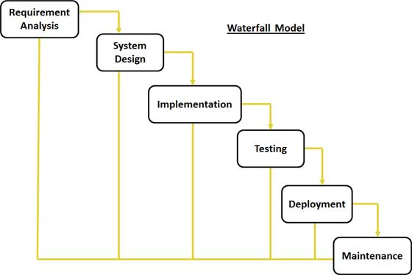
Fig: Waterfall model

I have chosen waterfall methodology rather than Agile methodology because Agile methodology is mainly implemented for group projects. As this project is individual project as the part of college assignment so waterfall methodology is the best option for this project.

b. Design pattern
In software engineering, a design pattern is a general repeatable solution to a commonly occurring problem in software design. A design pattern is not a finished design that can be transformed directly into code. It is a description or template for how to solve a problem that can be used in many different situations.(EDUCBA, 2019)
For this project I have used MVC (Model View Controller) design pattern as it that separates domain/application/business (whatever you prefer) logic from the rest of the user interface. It does this by separating the application into three parts: the model, the view, and the controller.

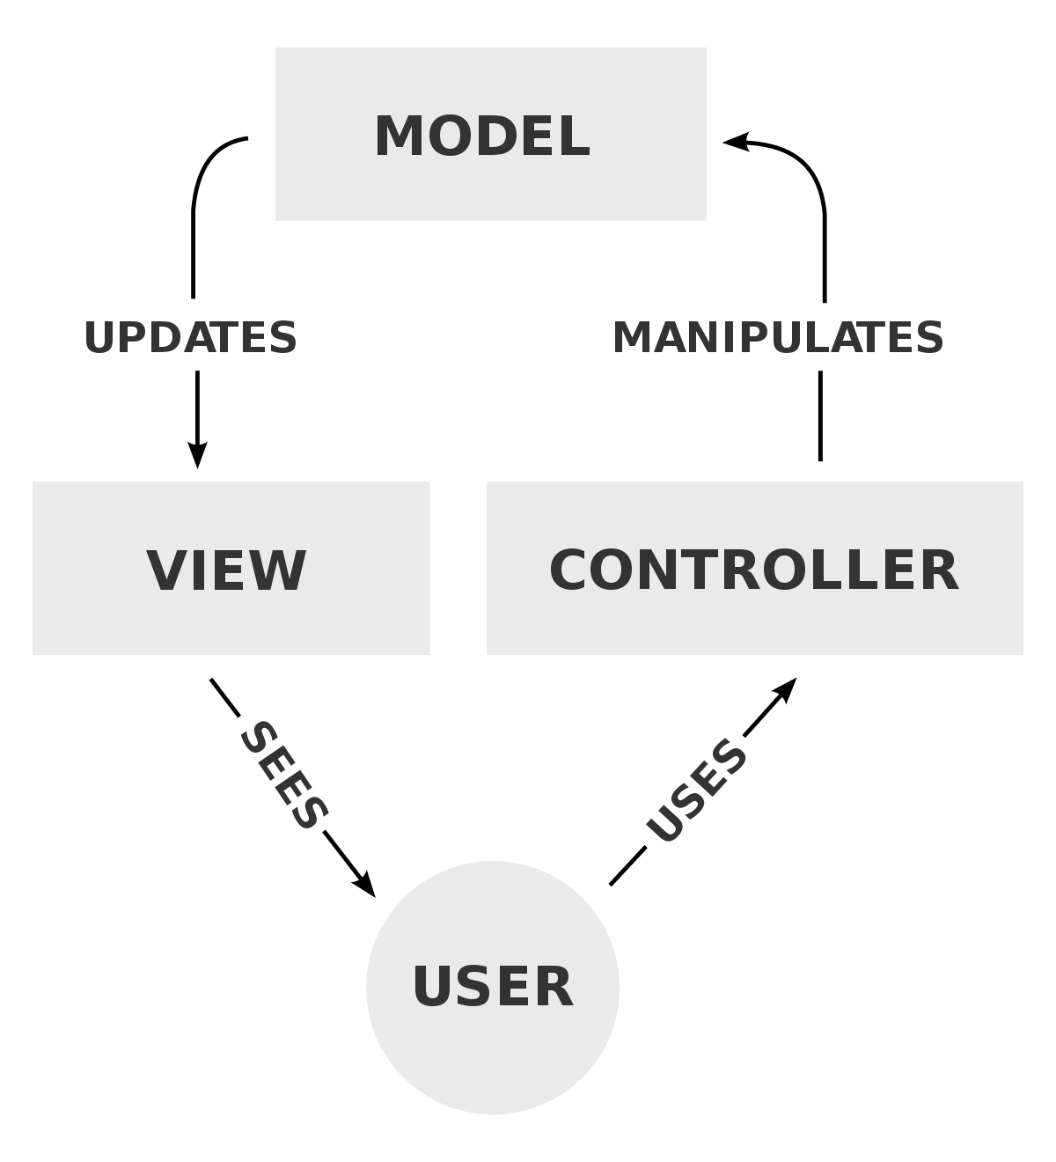
Fig: MVC design pattern

- Model
The model handles all the data related logic that user work with. This represent data that is transfer between view and controller.

- View
The view handles all UI logic of application.

- Controller
Controller acts as transitional between model and view to process incoming requests and logic.

4. Configuration Management
Configuration management is a systems manufacturing process for establishing and maintaining consistency of a product's performance, functional, and physical attributes with its requirements, design, and operational information throughout its life. This management is closely link with the quality and controlling of the project. Configuration management basically implemented to protect project from the risk of theft and many more.
Below is the screenshot of my project uploaded in the GitHub.
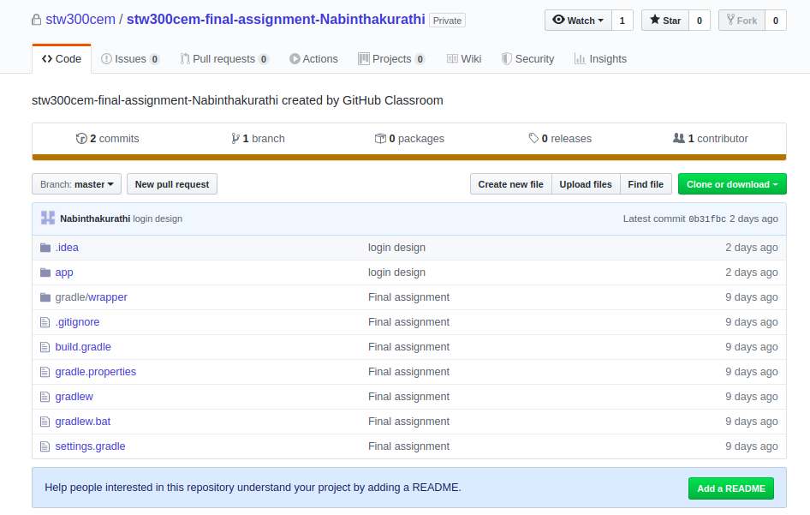

5. Prototyping
Prototyping is an initial stage of a system development which developmental progress and product solutions may occur before a better release is initiated. These kinds of actions can also sometimes be called a beta phase, where an initial task gets estimated by a smaller class of users before full development of the system.
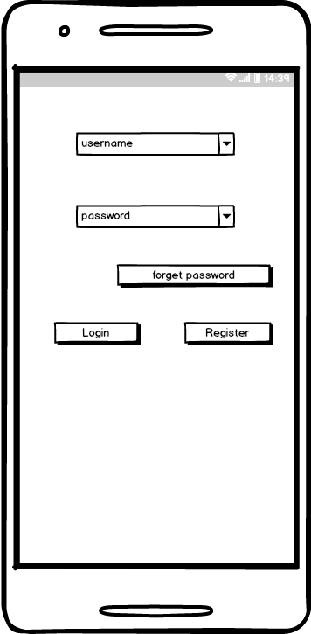
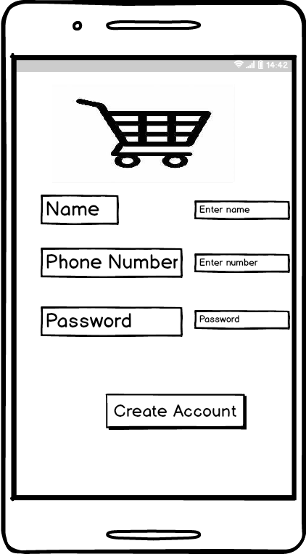

Fig:Login Fig: Register

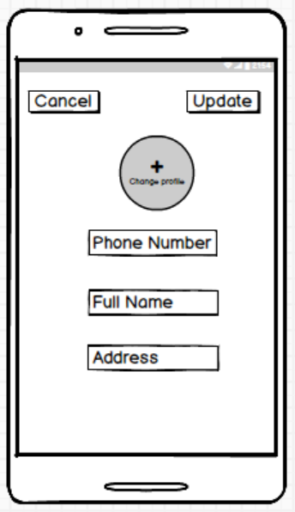
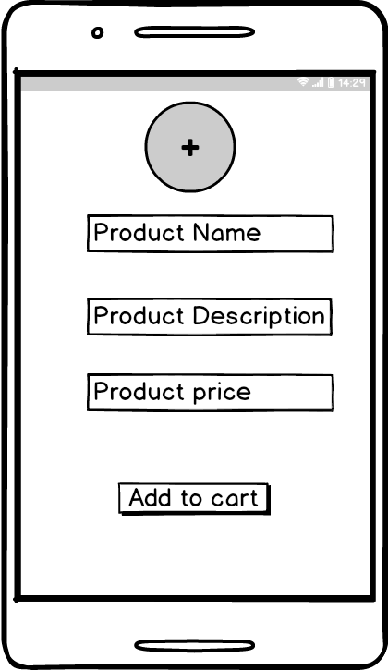

Fig: Add to cart Fig: update profile

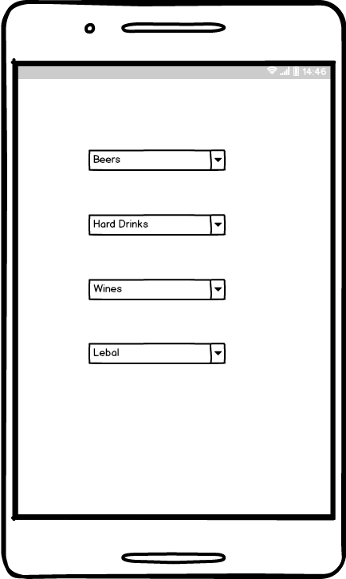

Fig : Categories

6. Conclusion
Liquor store is the ISO-based application which will provide different kind of drinks. In this application you can register and login into the system and order the product as you wanted. You can edit your information on this system. This application will provide mobile application for ordering the liquor products.

7. Reference
Sharma, L. (2019). WaterFall Model in Software Developement Life Cycle | SDLC. [online] TOOLSQA. Available at: https://www.toolsqa.com/software-testing/waterfall-model/ [Accessed 27 Nov. 2019].

EDUCBA. (2019). What is mvc design pattern | How IT Works | Skills & Scope | Advantages. [online] Available at: https://www.educba.com/what-is-mvc-design-pattern/ [Accessed 28 Nov. 2019].

