# Chapter: 3 Design

Project design refers to the set of logical and theoretic formations, basic assumptions, and decision-making finding which allows people to complete the project within given conditions.

## Tools

Following tools are used to develop my project:.

* Sublime text for coding
* MySQL for database
* Star UML for class diagram, DFD, Activity diagram, sequence diagram
* Visual Paradigm for ER diagram

## Structural Model

A model that shows the limit level that would cause a default considering the estimation of an organizations resources liabilities and capital. For my project in structural model phase, I have design class diagram and DFD.

### **Class diagram:**

A class diagram shows the static structure of a system. It shows relationships between classes, objects, attributes, and operations. Classes represent an abstraction of entities with common characteristics. Associations represent the relationships between classes. The class diagram is the primary structure build of object oriented objects. It is utilized for general reasonable displaying of the structure of the application, and for converting structures into codes.

Class Diagram for online Liquor store is below:

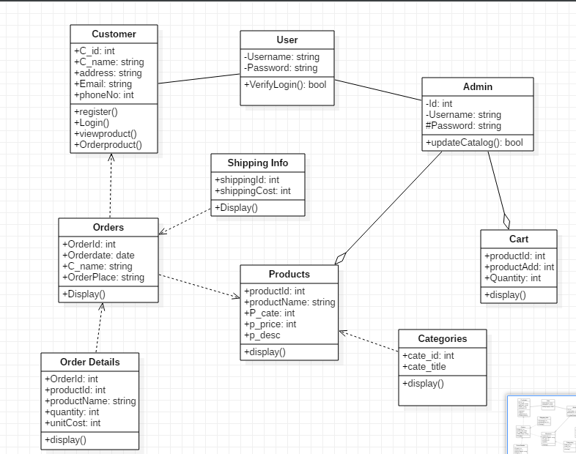

Fig: Class diagram

### Justification

Above class diagram includes important classes for project design. In this customer and admin can abstract user attributes. Order details are dependent in orders. Admin can add, remove products. Admin also can check carts before delivery.

### **Data Flow Diagram:**

An information stream outline (DFD) maps out the progression of data for any system. They can be designed to analysis a current system or model new one. The DFD additionally gives data about the input and output of every entity and the processes. An data flow diagram has no control flow, there are no decision rules and no loops.

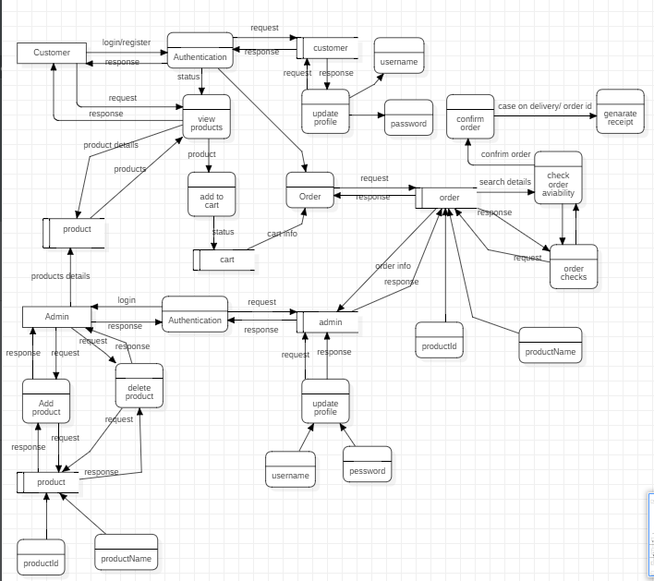

Fig: DFD for online liquor store

### Justification

In this customer can view products without login to the system. Admin have to login before making any changes to the system. DFD provides the working process of the system.

## Behavioral Model

Behavioral modeling means utilizing accessible and relevant purchaser and business spending data assess future behavior. Behavioral modeling is utilized by money related foundations to evaluate the risk related with giving assets to an individual or business but at the same time is used in promoting, publicizing, etc.

### Activity Diagram

Activity diagrams are graphical representations of workflows of stepwise actions with help for decision, emphasis and simultaneousness. In the UML, activity diagram are expected to demonstrate both computational and authoritative procedures, just as the information streams converging with the related exercises.

Activity diagram for the project is follow:

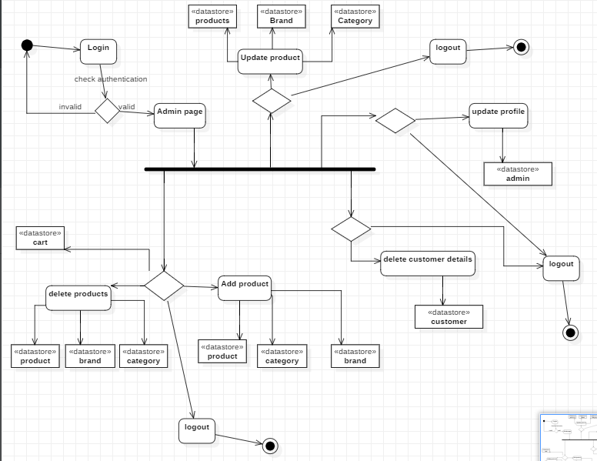

Fig: activity diagram for admin

## Justification

Admin have to login to the system before making any changes to the system. After login admin dashboard is opened then admin can operate the system.

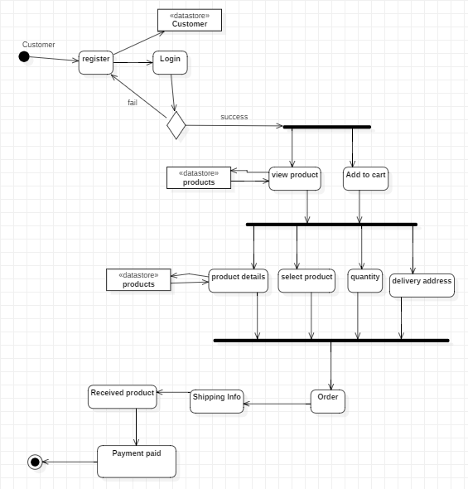

Fig: activity diagram for customer

### Justification

Customer have to register before interacting to the system. They can order the products with entering required details. In the process customer have to pay after the delivery with cash.

## Sequence diagram

Sequence diagrams define relations among classes in terms of an exchange of messages over time. A sequence diagram is a good way to imagine and authenticate various runtime scenarios. These can help to calculate how a system will perform and to discover responsibilities a class may need to have in the process of modeling a new system.

Sequence diagram is also called event diagram of online liquor store is given below:

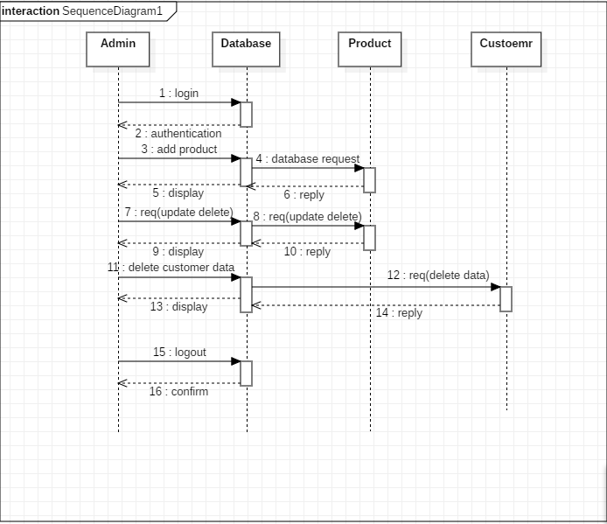

Fig: sequence diagram for admin

### Justification

Above sequence diagram illustrates the actions performed by the admin in the system. Required entities and proper notations are used for the diagram.

Sequence diagram for customer:

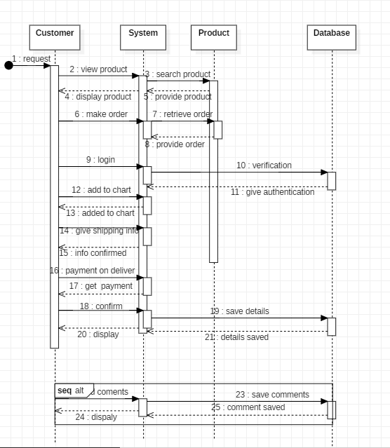

Fig: sequence diagram for customer

### Justification

The above sequence diagram illustrates the process of customer perform in the system. It consists of the messages and replies from the server.

## Database

Database is the collection of the data that is managed so that it can be easily accessed, managed and updated. System databases basically contain combinations of data record such as sales transactions, product catalogs and inventories, and customer profiles.

## Entity Relationship Diagram

An entity relationship diagram (ERD) illustrations the relationships of entity sets stored in a database. An entity in this context is an object, a component of data. An entity set is a collection of similar entities. These entities can have attributes that define its properties.

ER diagram for the online liquor store:

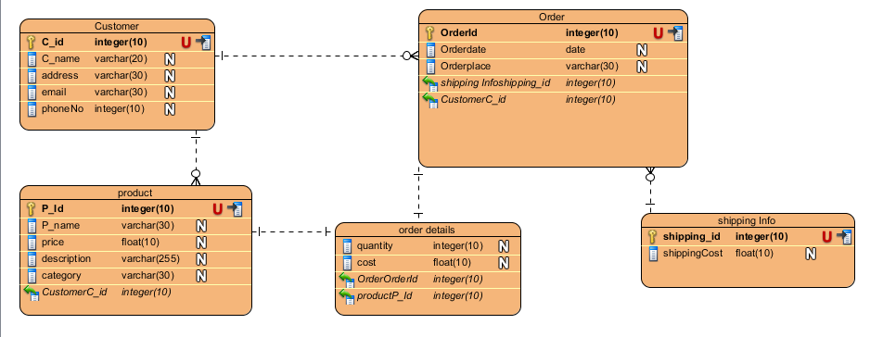

Fig: ER diagram for the online liquor store

## Data Dictionary:

Database tables

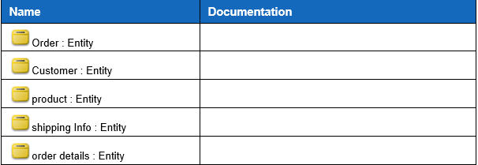

Customer table

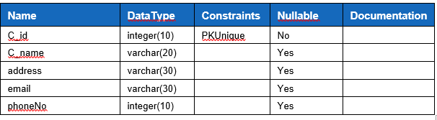

Order table

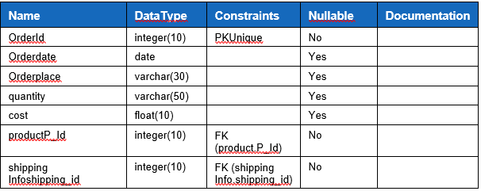

Order details

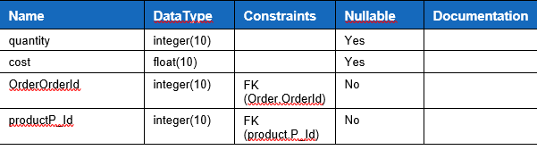

Shipping table

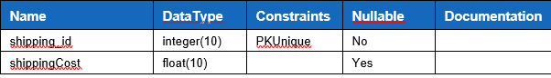

Products table

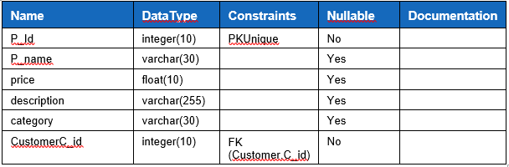

Fig: tables of database

## Prototyping

Prototyping is an initial stage of a system development which developmental progress and product solutions may occur before a better release is initiated. These kinds of actions can also sometimes be called a beta phase, where an initial task gets estimated by a smaller class of users before full development of the system.

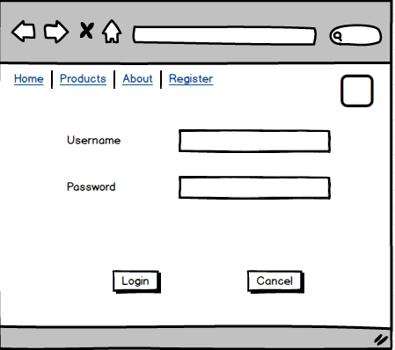

Fig: prototype for login page

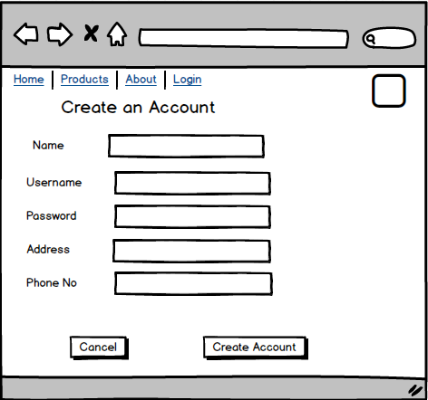

Fig: prototype for register page

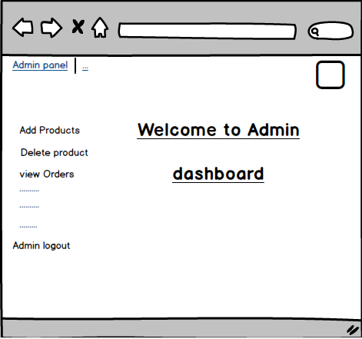

Fig: prototype for admin dashboard

# Conclusion

Hence, the design phase of project is successfully completed. All the step of this phase are done with proper search. In this phase all the required diagram are designed with project keeping in mind.