**Project proposal**

**On**

**Online Liquor Store**

Nabin Thakurathi

00174403

Computing Project

L5DC

Softwarica College of IT and E-Commerce

Kathmandu, Nepal

04/09/2019

Submitted to Niman Maharjan

Contents

[Introduction 3](#_Toc5692418)

[Project background 3](#_Toc5692419)

[Features of the website 4](#_Toc5692420)

[Scopes of the project 5](#_Toc5692421)

[Aims 5](#_Toc5692422)

[Objectives 5](#_Toc5692423)

[Limitations 5](#_Toc5692424)

[Development Methodology 6](#_Toc5692425)

[Methodology used 6](#_Toc5692426)

[Design pattern 7](#_Toc5692427)

[Scheduling 9](#_Toc5692428)

[Work Breakdown Structure (WBS) 9](#_Toc5692429)

[Milestones 10](#_Toc5692430)

[Gantt chart 11](#_Toc5692431)

[Risk Management 13](#_Toc5692432)

[Configuration Management: 15](#_Toc5692433)

[Conclusion 17](#_Toc5692434)

[References 17](#_Toc5692435)

# Introduction

Now online business became the easy and faster growing business. As the use of technology is rapidly increasing day after day. In the present time, technology is being use for every possible thing. Online business is also the must growing network. People are now modern and technology dependent they want everything easy and faster. Mobile phones, laptops and other technologies are being use rapidly. Nowadays everything is possible by the use of these technologies. By the use of these now people can order everything at their place, which end the tension of going to the market to buy anything. This type of business now provides faster services.

## Project background

Online liquor store is the online business, which is going to sell every possible wines, beers, or other types of liquors. Nowadays ton of people, male and female alike, consume liquor on a daily basis. This proves that there is a big market for liquor business and as an aspiring entrepreneur looking for a business to start. Online liquor market will be the big project to complete as their possibly will be the large demand of the product.

For this project, there will be the web application that will provide the details about the liquor available and their price. This web site will be the user friendly as people can easily order their products. By the use of this site people need not to visit stores to buy liquors, they can order to their place. Now anyone can track everything about liquors, price of liquor just clicking it of web app on online. I have used PHP for programming and My SQL for manage database of liquors.

## Features of the website

* **User can Register and Login to the system.**

New user can register to system from registration form and then login through login from which check valid username and password in database.

* **User can order products from nearby places.**

User can order the products on online and also check status of availability of products.

* **User can rate products and service of the organisation.**

User can rate products and services after they received their order.

* **User also can see the reviews in each products.**

User can see the reviews before ordering.

* **Admin can add new products.**

Admin can add new products; can makes changes to the system.

* **User can see lists of Upcoming products with prices.**

User can see lists of upcoming products and their prices.

* **Database will be designed to keep the details of the products and customers.**

# Scopes of the project

Online liquor store business is established to make profits at the same also to provide the good services to our customer’s and value for their money and time. This project will help people to order the product to their place by the help of the website. They can review our projects and service.

## Aims

* To develop a web based online website so that everything related to our online liquor store can be made available online with better quality and faster service.
* To provide the latest products related to liquor business.
* To expand the business and to provide the best products.
* To maintain custom satisfaction and to promote new products in internet.
* System will provide complete details of products to the customers.
* System will store the details of the customers.

## Objectives

* To keep all the record of the products and customer details.
* To provide anytime anywhere services to the customers.
* To keep the customer data systematically.
* To create the secured database.
* Members login to view their details.
* Registering new members through the system.
* Testing of project.

## Limitations

Limitation for this project is that there is no online payment system available right so customer have to pay at the time of delivery.

# Development Methodology

A software development methodology or system development methodology is a framework that is used to structure, plan, and control the process of developing an information system. There are many methodologies for the development the system projects. Some of them are Joint Application Development (JAD), Rapid Application Development (RAD), Scrum, Spiral, Systems Development Life Cycle (SDLC), and Waterfall.

## Methodology used

For this project, I have used waterfall model (www.tutorialspoint.com, 2019) because it is simple and easy to understand and use. This process is also easy to manage due to the rigidity of the model. In this model, each phase has specific deliverables and a review process. Steps applied in the waterfall model are listed below:

* **Requirement analysis:** All possible requirements of the system to be developed are captured in this phase and documented in a requirement specification document.
* **System design:** The requirement specifications from first phase are studied in this phase and the system design is prepared.
* **Implementation:** With inputs from the system design, the system is first developed in small programs called units, which are integrated in the next phase.
* **Testing:** All the units developed in the implementation phase are integrated into a system after testing of each unit. Post integration the entire system is tested for any faults and failures.
* **Deployment:** Once the functional and non-functional testing is done; the product is deployed in the customer environment or released into the market.
* **Maintenance:** There are some issues which come up in the client environment. To fix those issues, patches are released. Maintenance is done to deliver these changes in the customer environment.

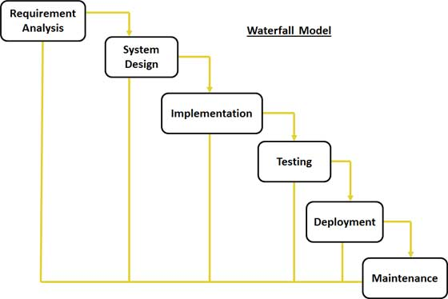

Fig: Waterfall model

## Design pattern

In software engineering, a **design pattern** is a general repeatable solution to a commonly occurring problem in software design. A design pattern is not a finished design that can be transformed directly into code. It is a description or template for how to solve a problem that can be used in many different situations.

For this project I have used MVC (Model View Controller) design pattern as it that separates domain/application/business (whatever you prefer) logic from the rest of the user interface. It does this by separating the application into three parts: the model, the view, and the controller.

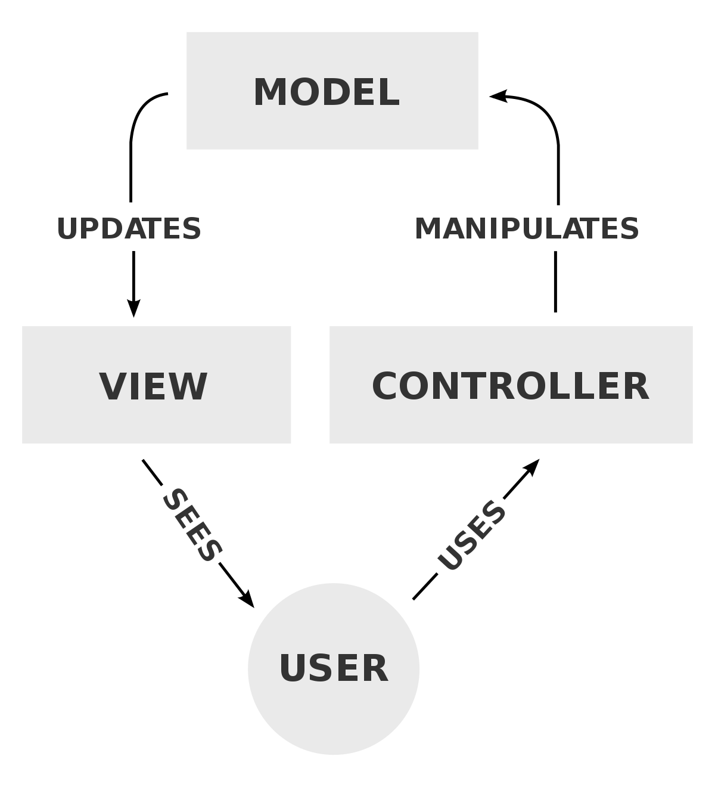

Fig: MVC design pattern

* **Model**

The model handles all the data related logic that user work with. This represent data that is transfer between view and controller.

* **View**

The view handles all UI logic of application.

* **Controller**

Controller acts as transitional between model and view to process incoming requests and logic.

# Scheduling

## Work Breakdown Structure (WBS)

Dividing complex projects to simpler and manageable tasks is the process identified as Work Breakdown Structure (WBS).Usually; the project managers use this method for simplifying the project execution. In WBS, much larger tasks are broken down to manageable portions of work. These portions can be easily supervised and estimated. WBS is not restricted to a specific field when it comes to application. This methodology can be used for any type of project management.

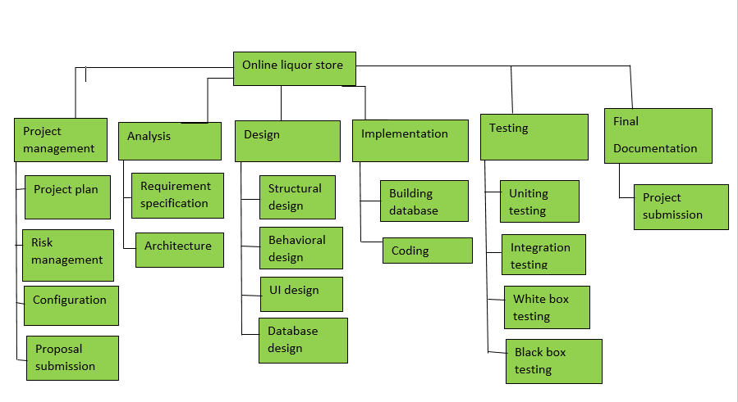

Fig: WBS structure

The above figure indicates the work breakdown of the project I have chosen. The above figure illustrates the project is divided in the six different parts. In the first stage of the project, I have done the project management through which the planning can be done. After the proposal, I will be doing the analysis part of the project, which will be the first step after proposal submission. By doing analysis I will know about the features that should be include and some that should not be included. In the analysis part, there are two sub groups and they are requirement specification and diagrams. In the requirement specification, the requirements for the project are listed. Similarly, in the diagram part different diagrams related to the project are drawn such as class diagram, activity diagram, use case diagram etc. if possible. After the analysis, the design part will be done. In this part, the design of the web application will be designed. The design will created user friendly and more attractive. Attractive web application can catch the eyes of the user, which is good for the business. With this, I will be doing coding and the design specification in the implementation part. This is the part where I will be developing the application. After all this, I will be doing the testing part because there may be minor bugs, which I may have done in the coding time. I will be doing Integration and Unit testing. This will let know that the website that I have designed is workable or not. In addition, in the end of the work breakdown, I will be doing the documentation part. This part will help other people to understand about the application. They will provide the hint about the application that I have designed through documentation.

# Milestones

Project milestones are specific points along a project timeline. They are your short terms goals that lead to your overall project objective. These milestones act as major project progress points and indicate your project progress. If you achieve the milestones along the way, then you are moving in the right direction to achieve your overall project objectives.

|  |  |  |
| --- | --- | --- |
| Milestone | Date | No. of days |
| Proposal | 25th march to 9th April | 16 |
| Analysis | 10th April to 8th may | 28 |
| Design | 9th may to 3rd June | 25 |
| Implementation | 4th June to 24th June | 20 |
| Testing | 25th June to 1st July | 7 |
| Final document | 2nd July to 12th July | 11 |

This project has been started from the 25th of March and the deadline of the proposal will be 9th of April. When the proposal will be issued, analysis should be started and it will be finished in 28 days i.e. from 10th of April to 8th of May. Design steps will be finished in 25 days and the date will be from 9th of May to 3rd of June. Implementation phase will be finished in 20 days and the date will be from 4th of June to 24th of June. And testing will be finished in 7 days with date 25th June to 1st of July and finally Documentation part will be finished in 11 days and the date will 2nd of July to 12th July.

# Gantt chart

A Gantt chart is a type of bar chart that illustrates a project schedule. This chart lists the tasks to be performed on the vertical axis, and time intervals on the horizontal axis. The width of the horizontal bars in the graph shows the duration of each activity. Gantt charts illustrate the start and finish dates of the terminal elements and summary elements of a project. Terminal elements and summary elements constitute the work breakdown structure of the project. Modern Gantt charts also show the dependency (i.e., precedence network) relationships between activities. Gantt charts can be used to show current schedule status using percent-complete shadings and a vertical "TODAY" line as shown here. Gantt charts are sometimes equated with bar charts.

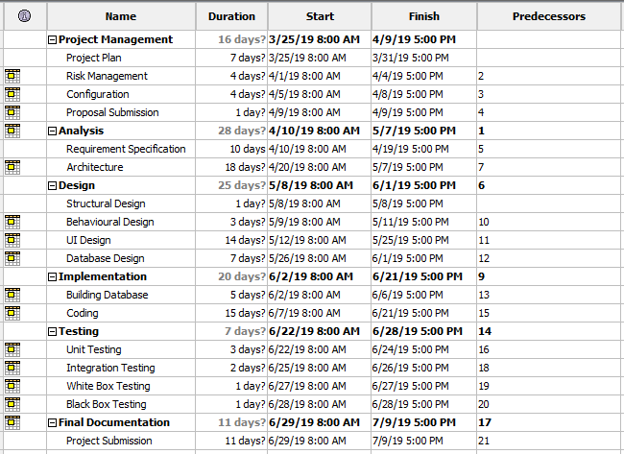

Fig: Gantt chart

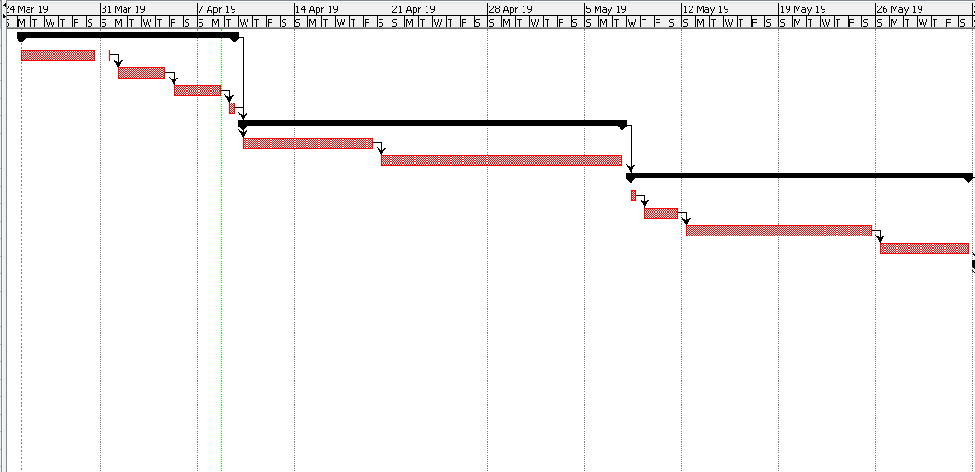

Fig: Gantt chart

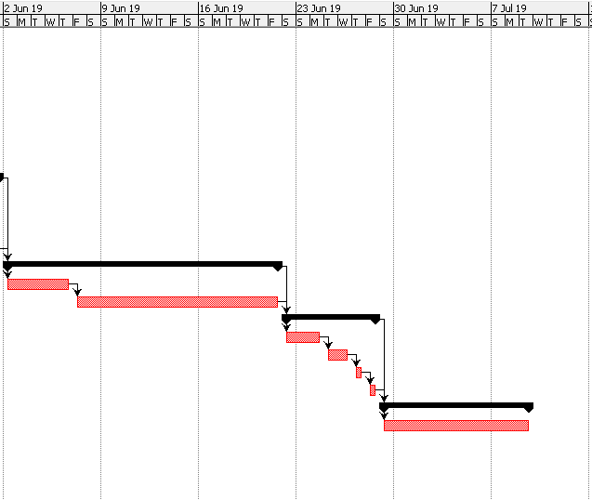

Fig: Gantt chart

# Risk Management

Risk management is the process of identifying, measuring and controlling threats to an organization's investment and earnings. These threats, or risks, could stalk from a wide variety of sources, including financial hesitation, legal liabilities, plan management errors, accidents and natural disasters. IT security threats and data-related risks, and the risk management strategies to ease them, have become a top priority for digitized companies. As a result, a risk management plan increasingly includes companies' processes for identifying and controlling threats to its digital assets, including exclusive commercial data, a customer's personally identifiable information and intellectual property.

Likelihood and values are listed below:

|  |  |
| --- | --- |
| Likelihood | Values |
| Low | 1 |
| Medium | 2 |
| High | 3 |

Consequences and values are listed below:

|  |  |
| --- | --- |
| Consequences | values |
| Very low | 1 |
| Low | 2 |
| Medium | 3 |
| High | 4 |
| Very high | 5 |

Some of the risks that can affect the project are following:

**[Impact = Likelihood \* Consequence].**

|  |  |  |  |  |
| --- | --- | --- | --- | --- |
| Risks | Likelihood | Consequences | Impact | Action needed |
| Server failure | 2 | 3 | 6 | Data backup must be done |
| Lack of Budgets | 2 | 4 | 8 | Sponsors should be arranged |
| Natural disaster | 2 | 4 | 8 | System backup should be done |
| Insufficient resources | 2 | 3 | 6 | All required resources for the project should be collected. |
| Too many bugs | 2 | 2 | 4 | Testing must be done. |

# 

# Configuration Management:

Configuration management is a systems manufacturing process for establishing and maintaining consistency of a product's performance, functional, and physical attributes with its requirements, design, and operational information throughout its life.

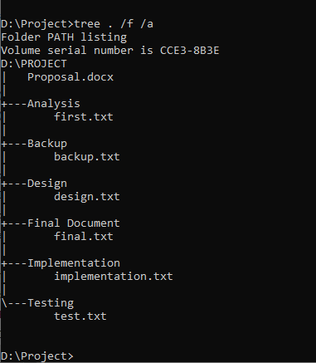

Fig: command prompt screenshot

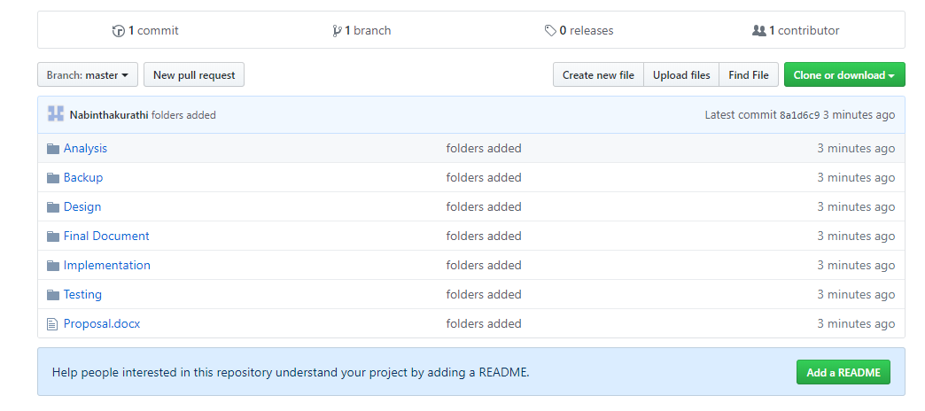

Fig: Github screenshot

Github link: <https://github.com/Nabinthakurathi/computing-project>

# Conclusion

Here my project will be online website (online liquor store) which will be completed with different website developing tools like PHP, CSS, HTML, MYSQL, J Query, Java Script. In this project, non-registered members can also browse through website to review and get the information regarding the product. Using this website, customer can feel free and easy to order and buy different liquor products wherever they want and need to. The web-based application will be very user friendly and reliable. Admin can add the product and their respective prices.

# References

[www.tutorialspoint.com. (2019). *SDLC Waterfall Model*. [online] Available at: https://www.tutorialspoint.com/sdlc/sdlc\_waterfall\_model.htm [Accessed 8 Apr. 2019].](www.tutorialspoint.com.%20(2019). SDLC%20Waterfall%20Model.%20%5bonline%5d%20Available%20at:%20https:/www.tutorialspoint.com/sdlc/sdlc_waterfall_model.htm%20%5bAccessed%208%20Apr.%202019%5d.)

[Smartsheet. (2019). *All About Work Breakdown Structures (WBS) | Smartsheet*. [online] Available at: https://www.smartsheet.com/getting-started-work-breakdown-structures-wbs [Accessed 8 Apr. 2019].](Smartsheet.%20(2019). All%20About%20Work%20Breakdown%20Structures%20(WBS)%20|%20Smartsheet.%20%5bonline%5d%20Available%20at:%20https:/www.smartsheet.com/getting-started-work-breakdown-structures-wbs%20%5bAccessed%208%20Apr.%202019%5d.)

# 