**PROJECT REPORT**

**TRAVELTRAX TOURS**

Team Leader: M.Nabisha Banu

Team Members: A. Maheswari

R. Meenakshi

C.Nandhini

Project Title: Traveltrax Tours (Hospitality and Tourism-Industry)

1**. INTRODUCTION:**

1.1 Overview:

Project description:

Traveltrax Tours, a tour operator, leverages Zoho Books to manage their bookings, track expenses, and handle invoicing for their customers. They can generate professional invoices, reconcile payments, and monitor their financial performance. Zoho Books helps them streamline their financial operations and enhance customer service.

1.2 PURPOSE:

Easy to calculate purchase order, sales, customer order. And easy to understanding the Information.

2. PROBLEM DEFINITION AND DESIGN THINKING:

2.1 Empathy Map

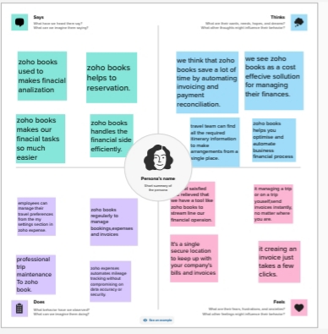

2.2 Ideation& Brain Storming Map

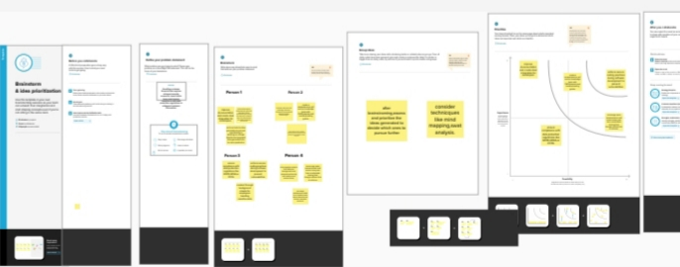

3. RESULT:

Dashboard

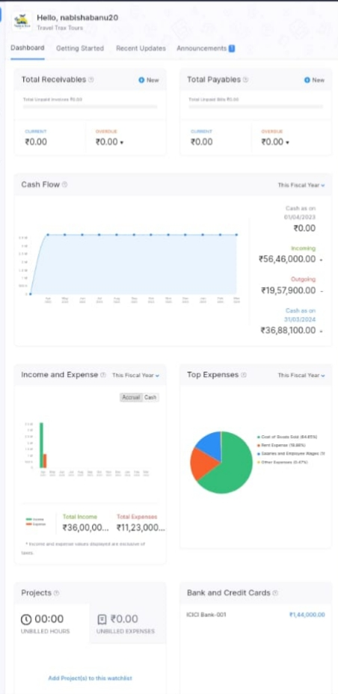

Profit&Loss

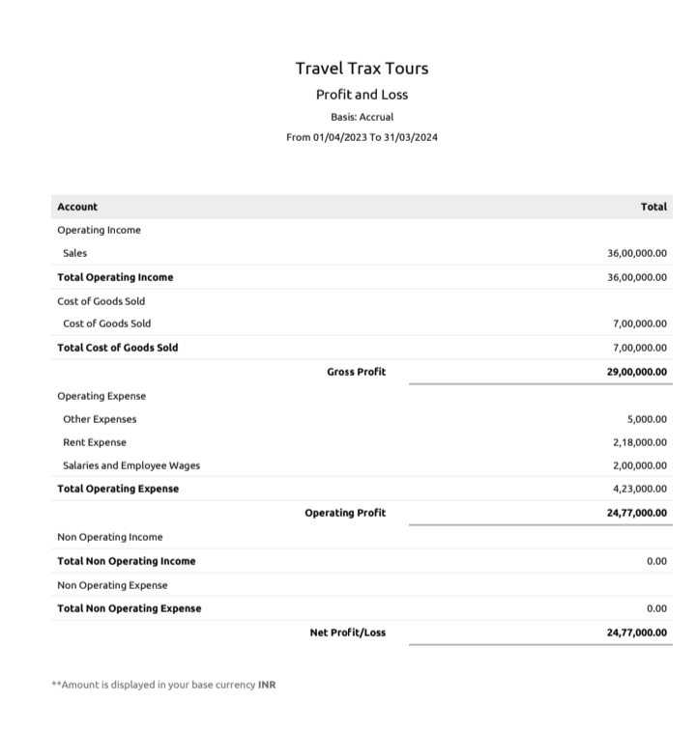

Balance sheet

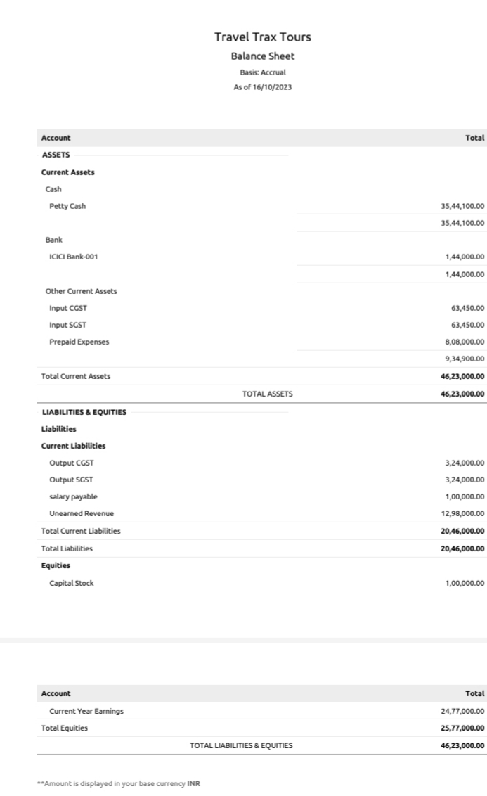

4. ADVANTAGES&DISADVANTAGES:

Advantages

* Employment Creation.
* Economic Growth.
* Preservation and Production.
* Enriches Geographic Identity Globally.
* Objecting to Stereotypes.

Disadvantages

* Expand of Time
* Complex Booking Process.
* Difficulty in Managing Inquiries.
* Unaware of Customer Requirement.
* Biosecurity threats and natural disasters.

5. APPLICATION:

GITGUB : Easy to Upload Files.

ZOHOBOOK : Easy to Access for ZOHOBOOK.

SMAR INTERNZ : Easy to Using.

6. CONCLUSION:

I learnt many new things about the project and it was Wonderful learning experience.

7. FUTURE SCOPE:

Endless job opportunities that candidates can avail in both private and public sectors after pursuing Travel and Tourism courses.