**PROJECT ASSIGNMENT – TASK 2 b: To explore Github-level1**

**1. Member 1- Module 1 (SRS - ____ Function)**

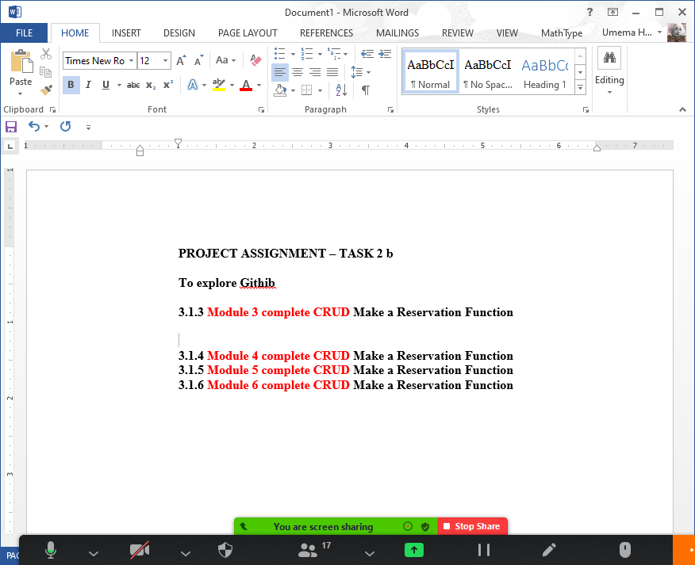

1. **Member 1- Module 1 (SRS - ____ Function)**
2. **Member 1- Module 1 (SRS - ____ Function)**
3. **Member 1- Module 1 (SRS - ____ Function)**