# Instructions for running the FitMI research tools

# Disclaimer

This is not meant to be comprehensive documentation of our python API. This is just the bare minimum to get you started.

# Setting up your environment

These instructions assume that you are using windows. The tools in this package all use python, so to use them you will have to install python.

You can get python27 (the version we recommend) here

<https://www.python.org/downloads/release/python-2713/>

After installing python, add it to your system path. You will also need to add the python27/scripts folder to your system path. To add these locations to your system path, press the windows key, type “advanced system setting” and then press enter.

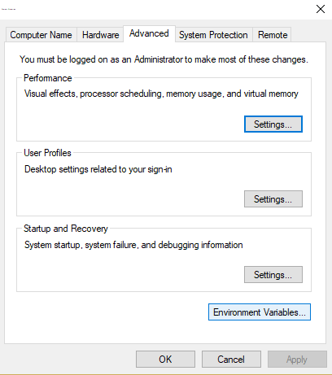

Click on the Environment Variables button. In “user” section on the top of the new window, select path, and then press the edit button

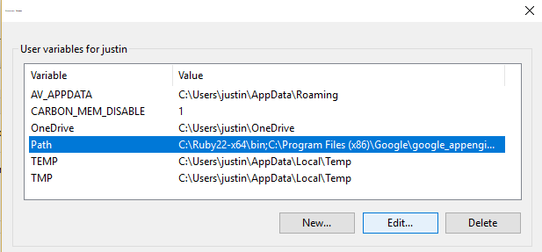

Then add the location of your python installation and the scripts folder nested inside it to the list. The location will probably be something like “C:\Python27” or “C:\Python27_64”.

Once you have installed python, open a command window (windows key + “cmd” + enter) and navigate to the folder in which you have stored the research tools folder (cd “whatever the path is”).

Now you need to install the dependencies. You can install most of the dependencies with pip (a python package manager) by typing “pip install -r requirements.txt” into the console. If you have trouble installing numpy and scipy, try installing the C compiler located here.

<https://www.microsoft.com/en-us/download/details.aspx?id=44266>

There is one more module that you need to install by hand. This is the module for communicating with HID devices. To build it, navigate to the cython-hidapi folder (cd cython-hidapi).

Once inside this folder, run the following commands

Python setup.py build

Python setup.py install

That’s it! You should be able to use the tools now.

# Overview of the research tools

## Puckplot.py

This program plots a few of the different puck values from the puck in real time. It should be relatively easy for you to change the values that it plots. Look at lines 88 through 91.

## Show_orientation.py

This program plots a coordinate system representing the orientation of the puck.

## Log_puckdata.py

This program records data from both pucks and then logs that data to both a shelved python dictionary and a .mat file.

## How to run these programs

To run these programs, open a command window and navigate to the folder they are stored in. Then type “python puckplot.py”

Some of the program will ask you for to enter additional information.