18309008

Nabil Madih

Due: January 5, 2020

Restaurant menu and Ordering APP

This project is an Android application focused on a modern app for restaurants. The major components of this project are implementing a Parse server, and taking orders from clients, as well as allowing users to browse the menu and store the number available food in the database as well. In today’s age restaurants need speeding up their order taking process and digitalizing their menu for a better user experience It is a simple to use app that does not have a large number of features that can confuse users. User can use this app for an easy access as well as call the server for help if needed. However, what I am used to is apps with very simple, yet pleasant features.

As with many apps today, the first screen when opening the app is a login/greeting screen

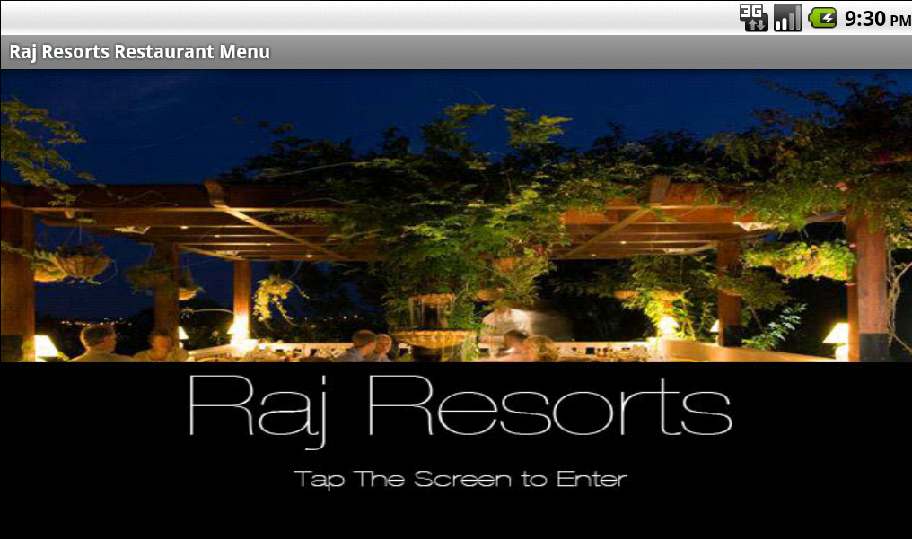

The user is then greeted to the home screen where they can navigate to any of the menu items or call a server for help and view previous orders

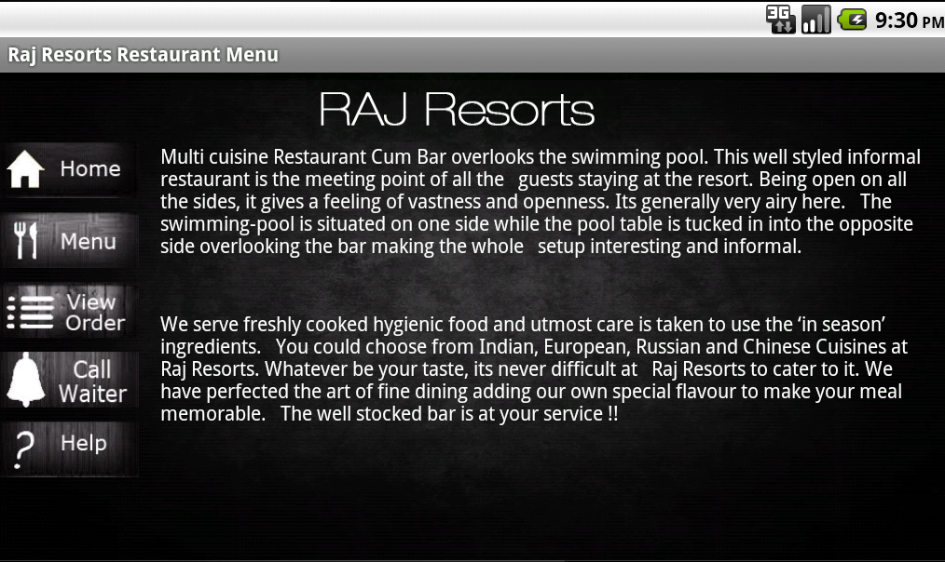

The user is able to Brows the menue freely and find what you the useris looking for easely instead of turning a lot of papers my category

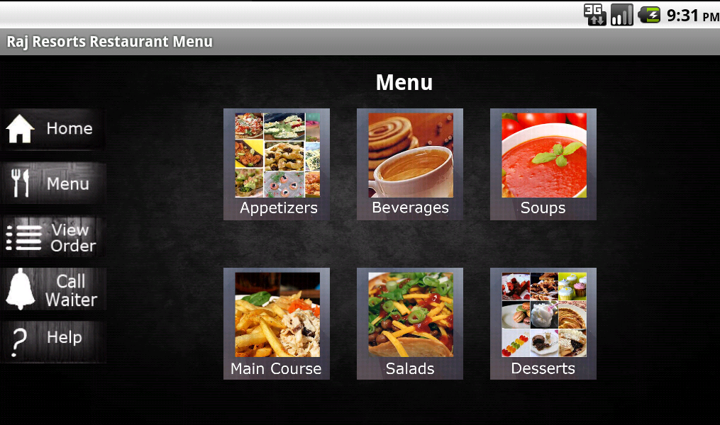

The User can then select from multiple item from each category that are layed out in a catogorized manner

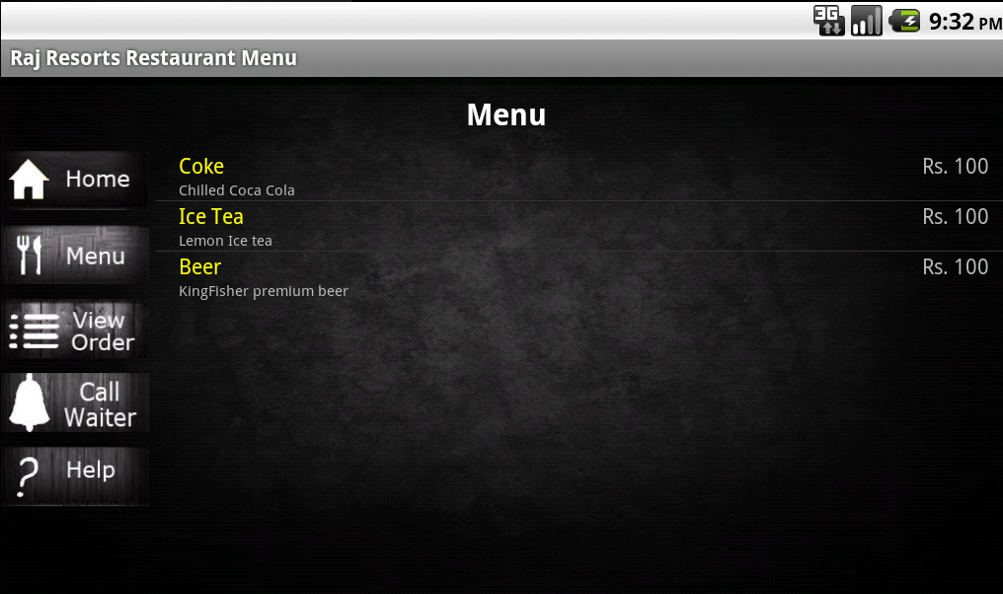

User can select any item they would like and add it to there carts as well as check the ratings from previous users and the aproximate time that it will take for the the item to arrive.

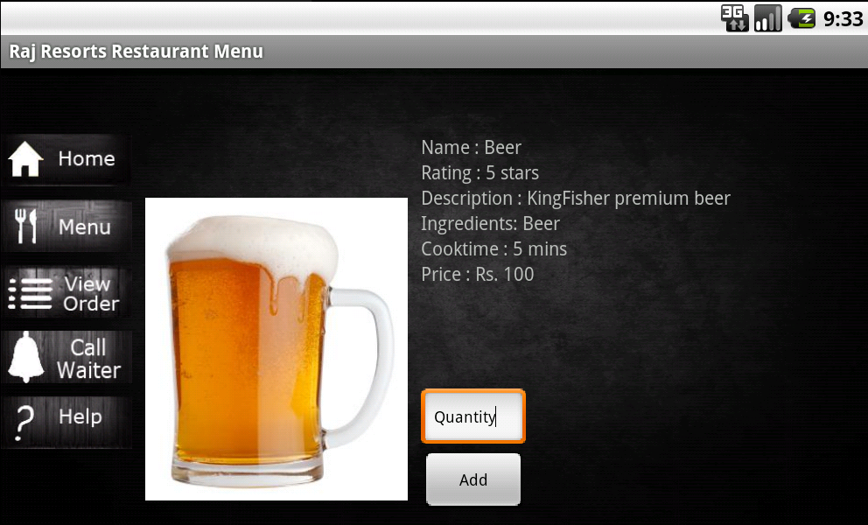

After the user selects all the items that he/she would like to buy they can confirm the order and the order is gone straight through to the kitchen staff where they can take his order.

