After downloading the Exercise solution. Please follow the steps below to make in run on your machine locally.

# Software requirement:

1. Visual Studio 2019 (or any preferred IDE)
2. Microsoft SQL Server Management Studio (SSMS)
3. SQL Express (Database)
4. Dotnet - SDK 5.0.301

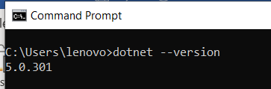

# appsettings.json

In appsettings.json file, add your database credential. In my case, its as follow:

"DefaultConnection": "Server=NABEELSAWAR\\SQLEXPRESS;Database=MyIdentityDemo;Trusted_Connection=True;MultipleActiveResultSets=true;integrated security = true"

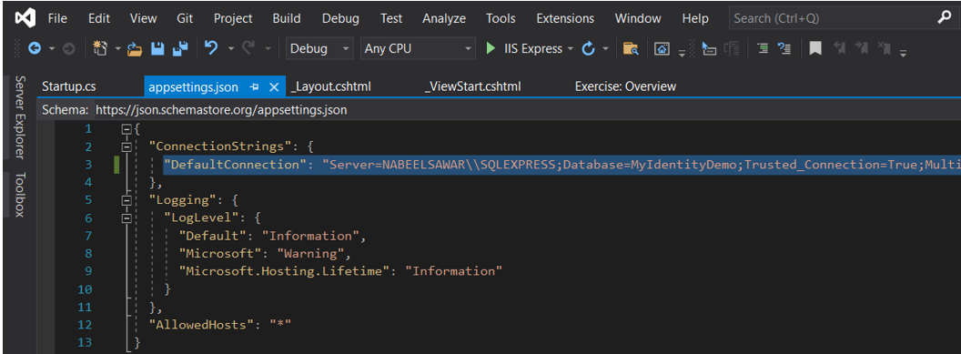

# Run the database migration, so that the database MyIdentityDemo will be created.

After opening your solution, please follow the steps below:

1. Open nuget console manager (tool menu)
2. Run the command: Update-Database
3. Go in SQL server check if Database (MyIdentityDemo) has been created

Or the Database dump provided can also be imported.

# Setting up your SmtpClient in HomeController file.

Enter your gmail password in the method ReadCreateExcel controller before running the application

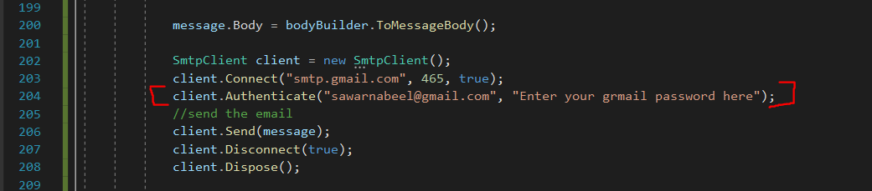

# Excel File

Source file (1) should be place in Exercise folder:

After clicking on the “Read, Create Excel and Send Email” under Excel menu. The Excel file “Result.xlsx” (2) will be generated under the Exercise folder.

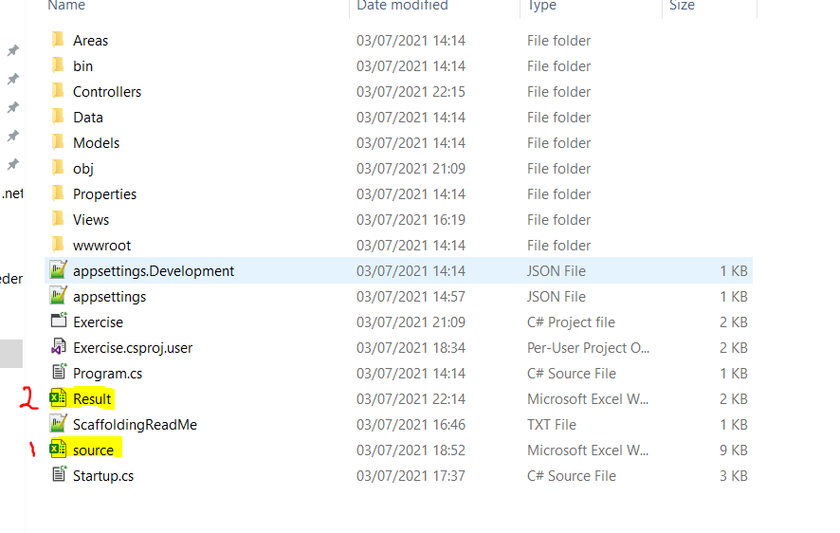

# Application Overview

Upon running the application, user will be redirected to the following page.

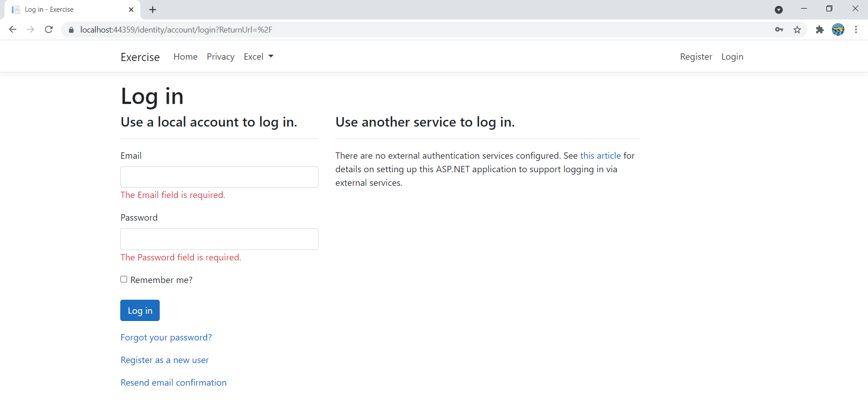

User will need to enter their login credential if they have already been registered.

Else they will need to register by clicking on the register menu.

Currently we have two types of users in the system **Admin** and **Guest**.

|  |  |
| --- | --- |
| **Email** | **Password** |
| [sawarnabeel@gmail.com](mailto:sawarnabeel@gmail.com) | Paris@2039 |
| [zarahgoolfee@gmail.com](mailto:zarahgoolfee@gmail.com) | Zarah@123 |

Admin user will be able to access the Home and Excel Menu. He will not be able to view the Privacy menu(testing purposes)

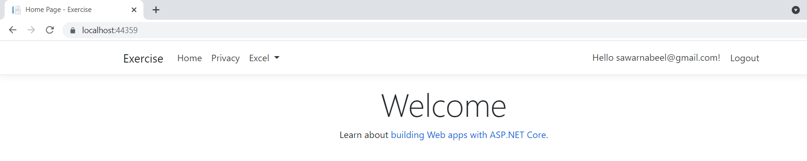

While access the Privacy, user will get the error below as guest role should be able to view this page only.

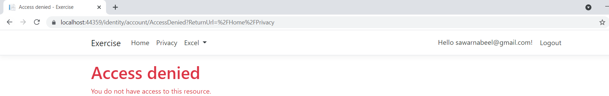

Guest user will be able to see the Privacy page only.

## Logout

On Clicking on logout menu. User will be log out of the system and will be redirected to the login page.

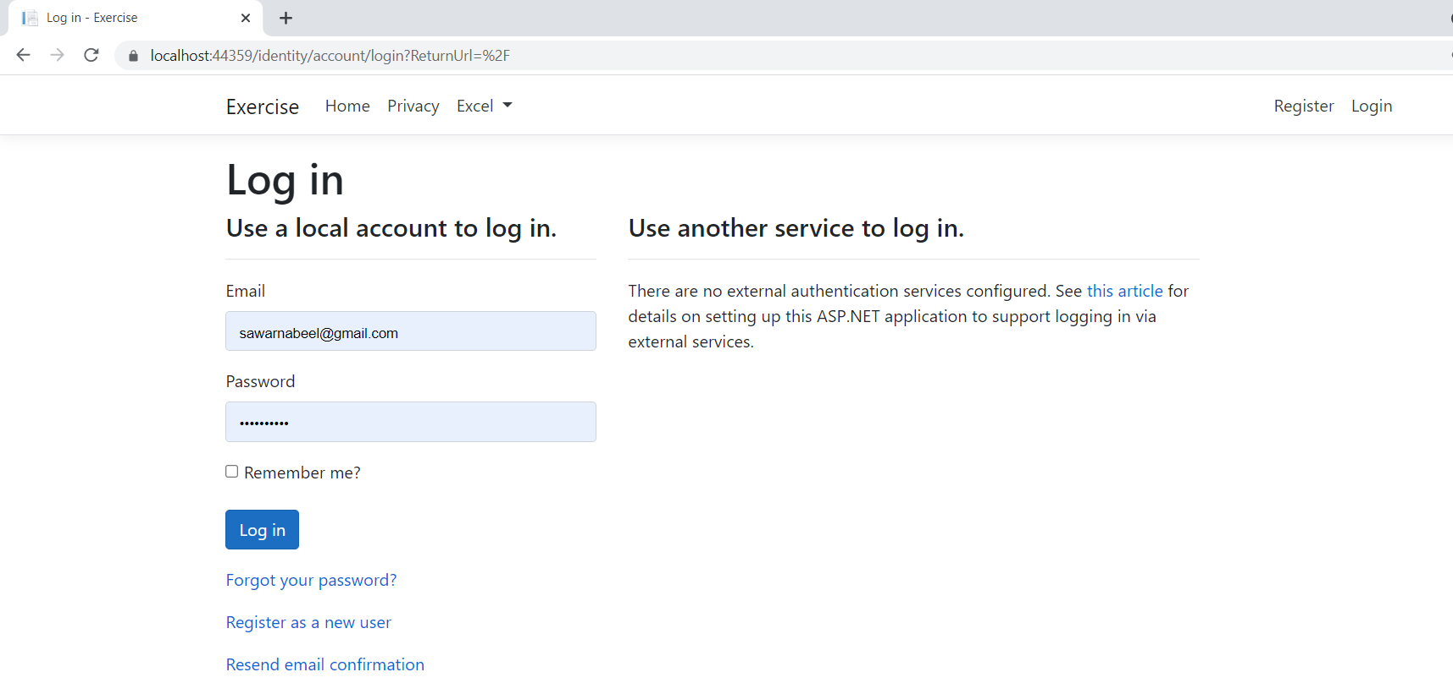

## Read, Create and Send Email of an Excel file.

User should be an admin.

User should click on the Excel menu, then click on the item “Read, Create Excel and Send Email”.

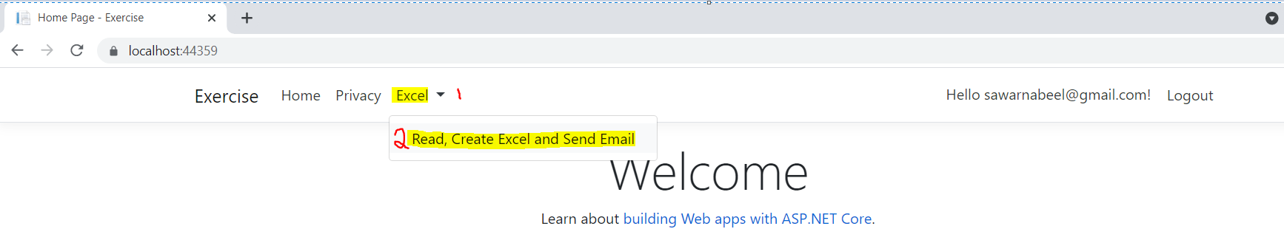

NOTE before click on the item above:

Source Excel file (source.xlsx) should be in the below format:

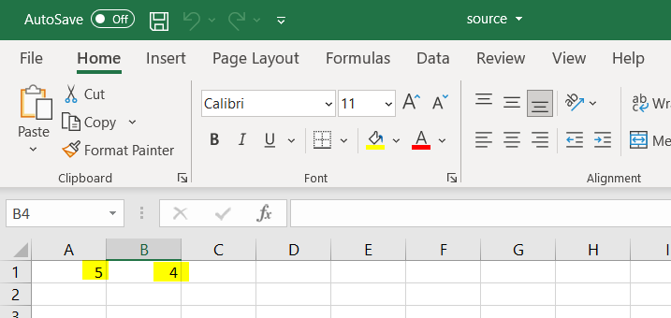

File should be placed in the Exercise folder.

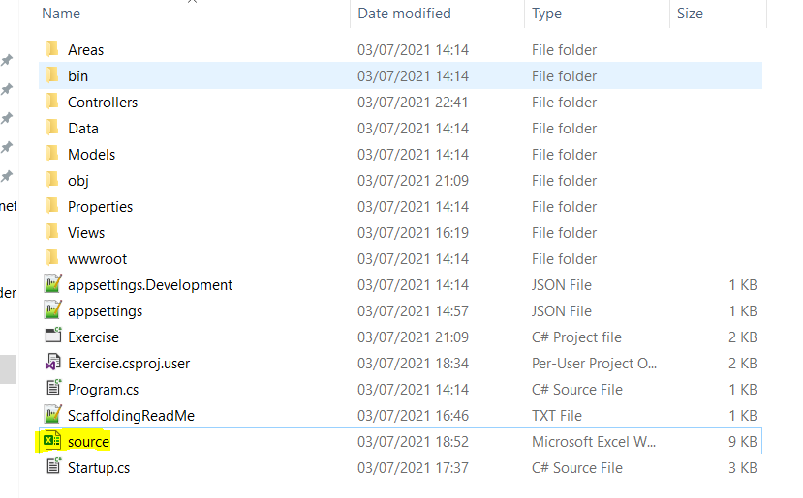

On Clicking on the item above, result excel file will be generated and below message will be displayed.

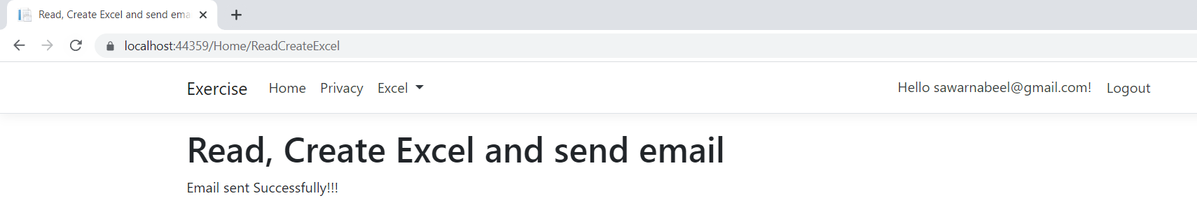

Result.xlsx file generated

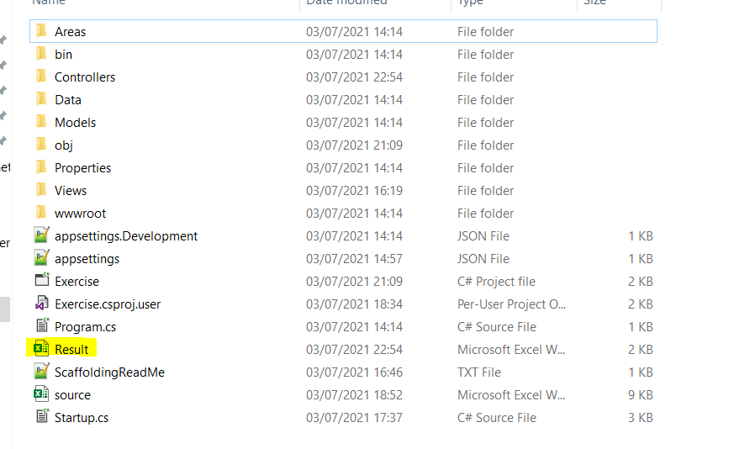

Email sent to user

