**System Design Document**

**Project: Zealand Immigration Website and Integration**

**By: Sammy John Rawlinson**

**1 Introduction**

The purpose of this document is to outline the system design for the redesign and integration of the Zealand Immigration Services website. The project aims to address the challenges of managing operations and client interactions efficiently by streamlining processes, ensuring seamless data integration, and enhancing client communication channels.

1.1 Purpose

Zealand Immigration is replacing their website with a more responsive, modern UI design, improving UX to enhance the customer experience. Additionally, the project will explore potential future feature enhancements and integration with internal systems, principally Zoho CRM.

1.2 Description

The solution involves maintaining the relationship with the external website developers who are migrating the site from Cake PHP and WordPress to Shopify (Ruby on Rails, Liquid, GraphQL). The redesigned website will feature a modern, responsive UI and UX design. Developers will provide access to Google Analytics for the General Manager to facilitate transparent and informative data viewing, enabling data-driven decision-making. The new CMS will allow the in-house team to update content and make relevant posts to boost SEO based on customer and industry feedback.

This project identifies the requirements needed for the redesign and, in the next iteration, will explore additional system solutions and designs for potential future development and business needs.

1.3 Scope

The first release will focus on re-designing the website UI.

The core user story is:

* As a customer I want to view a site about immigration to New Zealand that provides relevant information clearly, is easy to navigate, can be viewed on different devices and allows seamless communication with the company to acquire their services.

The following supporting user stories for first iteration:

* As General Manager, I want a site that meets and exceeds customer experience and attracts more clients that leads to a better conversion rate.
* As General Manager, I want to be able to see key metrics and data on the performance of the site that can be used to improve aspects of the business.
* As General Manager/Front Office/Agents, I want to be able to change content and make posts based on changing customer needs, feedback and legal considerations.
* As Front Office/Agents, I want a more streamlined communication with clients that can utilise the site to automate procedures rather than manual input.

1.4 Target Users

The users of the website for this release will be:

* **Customers –** Reading content and contacting the business about visa services
* **General Manager –** Using analytical data to inform content and digital marketing strategy.
* **Front Office/Agents –** Changing content and creating posts based on user needs and feedback, improving communication, and automating steps of the process with the client.

**2 Solution Design**

2.1 Architecture Overview

Since the detailed architecture design is handled by the external development team, this section will provide a high-level overview based on the requirements and the technologies being used: Shopify, Ruby on Rails, Liquid, and GraphQL.

2.1.1 High-Level Architecture

The high-level architecture of the redesigned Zealand Immigration Services website can be summarized as follows:

* Frontend: The frontend of the website will be built using Liquid, Shopify’s templating language. This will ensure a modern, responsive, and visually appealing user interface (UI) that adheres to the latest UX design principles. Liquid will be used to dynamically render content and interface components.
* Backend: The backend will be powered by Ruby on Rails, which will handle the business logic, server-side processing, and integration with other systems such as Zoho CRM. Rails is chosen for its robustness, scalability, and ease of integration with other technologies.
* API Layer: GraphQL will be utilized as the API layer to facilitate efficient and flexible data retrieval and manipulation. GraphQL will allow the frontend to query only the necessary data, improving performance and user experience.
* Content Management System (CMS): The CMS will be integrated within the Shopify platform, allowing the in-house team to easily update content, create posts, and manage SEO settings without requiring developer intervention.
* Analytics and Monitoring: Google Analytics will be integrated to track user interactions, monitor performance metrics, and provide insights to the General Manager for data-driven decision making. The data from Google Analytics will be accessible through Zoho for comprehensive monitoring.

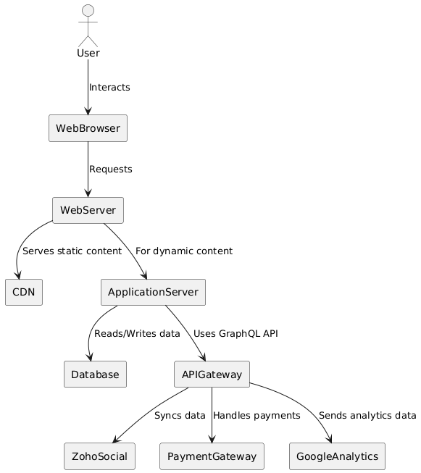

2.2 Model Design: Data Model

This is outside of my scope, responsibility of the data model is the external developers responsibility, integration with Zoho is the internal team integration projects responsibility based on the current schema and Zoho database setup.

As part of the vision document in iteration 2, will investigate a fully integrated system requirements. Here is a preliminary high-level diagram of what this could look like.

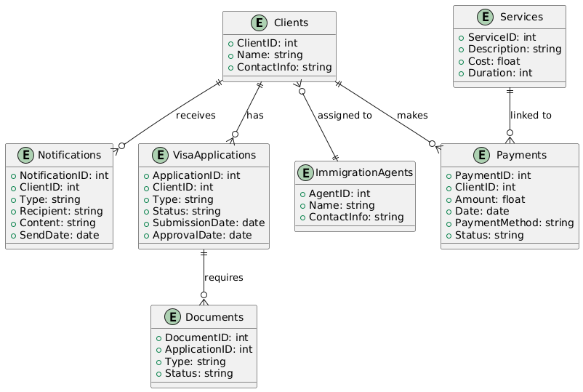

2.3.1 Overview

The functional decomposition of the redesigned Zealand Immigration Services website will focus on key functionalities required for the first iteration. These functionalities are derived from the requirements and user stories provided earlier.

2.3.2 Core Functions

1. User Interface and Navigation
   * Responsive Design: Ensure the website is optimized for different devices (desktops, tablets, smartphones).
   * Modern UI: Implement a visually appealing and intuitive interface.
   * Navigation: Provide clear and concise navigation to facilitate a positive user journey.
2. Content Management
   * Dynamic Content Rendering: Use Liquid templates to render content dynamically.
   * SEO Optimization: Implement features that allow the internal team to optimize content for search engines.
   * CMS Integration via Zoho Social: Allow the internal team to easily update content and create posts using Zoho Social.
3. Client Interactions
   * Information Access: Provide relevant information about visa types and pathways.
   * Contact and Communication: Enable users to contact the business and receive automated responses.
   * Payment Processing with Stripe: Integrate Stripe for secure online transactions.
4. Data Integration and Analytics
   * Zoho CRM Integration: Sync user data and manage client interactions through Zoho CRM.
   * Zoho Social Analytics: Track user interactions and performance metrics via Zoho Social.
   * Data Reporting: Provide analytical data to the General Manager for decision-making.
5. Automation and Notifications
   * Automated Email System: Set up automated emails for notifications and updates.
   * Task Automation: Automate routine tasks to reduce manual input and improve efficiency.

2.3.3 Sub-Functions

1. User Interface and Navigation
   * Responsive Design
     + Optimize layout for different screen sizes.
     + Ensure all elements are accessible on various devices.
   * Modern UI
     + Apply consistent styling and branding.
     + Use high-quality images and graphics.
   * Navigation
     + Design an intuitive menu structure.
     + Implement breadcrumbs and other navigation aids.
2. Content Management
   * Dynamic Content Rendering
     + Use Liquid templates to render pages based on user interactions.
   * SEO Optimization
     + Implement meta tags, alt text, and keyword-rich content.
   * CMS Integration via Zoho Social
     + Allow in-house team to edit and publish content via Zoho Social interface.
3. Client Interactions
   * Information Access
     + Organize visa information in an easily navigable structure.
   * Contact and Communication
     + Provide contact forms and chat options.
     + Automate responses to common inquiries.
   * Payment Processing with Stripe
     + Integrate Stripe for secure transaction processing.
4. Data Integration and Analytics
   * Zoho CRM Integration
     + Sync client data with Zoho CRM.
     + Automate data updates and synchronization.
   * Zoho Social Analytics
     + Track page views, user interactions, and other metrics.
     + Provide detailed reports to the General Manager.
   * Data Reporting
     + Generate reports based on analytics data.
     + Use insights to improve website performance and user experience.
5. Automation and Notifications
   * Automated Email System
     + Set up email templates for various notifications.
     + Schedule automated emails based on user actions.
   * Task Automation
     + Identify repetitive tasks and automate them.
     + Use scripts and tools to streamline processes.

2.4 View Design: UI

Overall site map will need:

* Home Page
* Individuals Page
* Employers Page
* About Us Page
* News and Updates Page
* Services Page

2.4.1 US1 As a Website User

I want to find information about New Zealand visas and an agency that provides visa assistance services.

* Home Page – Provides easy to navigate, simple content to access required information and links to appropriate sections of the site.
  + Link to Individuals Page – Provides easy to digest snapshots of potential visas
  + Link to Employers Page – Provides easy to digest snapsthots of potential visas
  + Schools and Universities/Passport Support – Sections on main page providing information
  + About Us – Small snapshot of details about the organisation
  + Link to About Page – More detailed description of the organisation
  + Information About New Zealand Immigration – Links to arcticles and their website
  + Get In Touch/Contact Information – Streamline communication process and how to find office.
  + Recent Posts: Detailed articles about Immigration issues.
  + Link to Services Page – Provides specific features for the application process: Payment, Status Request, Upload Files, WhatsApp Messenger, Provide Feedback, Request CallBack
* Throughout the site are CTA buttons and links to various forms to encourage contact and subscription.

2.4.2 Other User Stories

General Manager and Front Office/Agent stories are out of the scope of this project.

CMS – Handled by Integration Project and External Development team to connect API endpoints to allow internal team to use Zoho Social to connect to the Shopify CMS to update content and make posts.

Analytics- Google Analytics is now integrated into Zoho Social to give access to data to the General Manager to see key metrics and data to use for strategic planning.

Automated Email Responses for streamlined communication during the services process – To be implemented by External development team with APIs to Zoho CRM which is out of scope of this project and being implemented by Integration Project.

Further examination of these processes will occur in Iteration 2

2.5 Design Considerations

2.5.1 User Authentication

Out of Scope for Iteration 1: User authentication is not required as there are no user login features in this iteration. Future iterations may consider adding user authentication if the need for user accounts and personalized services arises.

2.5.2 Security

* Data Protection: Ensure all personal data is securely encrypted both in transit and at rest. Compliance with GDPR and other relevant data protection regulations is mandatory.
* Access Control: While user authentication is out of scope, internal access to the CMS and other administrative functions will require secure access controls to prevent unauthorized changes.
* Regular Audits: Conduct regular security audits and vulnerability assessments to identify and mitigate potential security risks.
* Incident Response: Establish a clear incident response plan to handle potential data breaches and security incidents promptly and effectively.

2.5.3 Usability

* User Interface (UI): Design the website to have a modern, intuitive, and visually appealing UI. Use consistent styling and branding across all pages.
* User Experience (UX): Ensure the website provides a seamless and engaging user experience with easy navigation and quick access to information.
* Accessibility: Comply with WCAG 2.1 AA standards to ensure the website is accessible to people with disabilities.
* Responsive Design: Ensure the website is fully responsive, providing an optimal viewing experience across a wide range of devices (desktops, tablets, smartphones).
* Performance: Optimize page load times to ensure they fall within the 2-3 seconds range, improving the overall user experience. Techniques include image optimization, caching, and minimizing HTTP requests.

2.5.4 Interoperability

* Zoho CRM Integration: Ensure seamless integration with Zoho CRM to synchronize user data and manage client interactions efficiently.
* Zoho Social Integration: Integrate Zoho Social for content management and analytics, providing the General Manager with access to performance metrics and data.
* Stripe Payment Gateway: Implement secure integration with Stripe for online transactions, ensuring a smooth and secure payment process for users.
* Email Systems: Ensure interoperability with email systems for automated notifications and communications.

2.5.5 Portability

* Platform Independence: The website should be platform-independent, functioning consistently across different operating systems (Windows, macOS, Linux).
* Browser Compatibility: Ensure compatibility with all major web browsers (Chrome, Firefox, Safari, Edge).
* Scalability: Design the website architecture to be scalable, allowing for easy updates and enhancements without significant rework. This includes considering cloud-based hosting solutions for better scalability and performance.

**3 Detailed Design**

This is all wireframes, Images of various design iterations and notes from myself, new and old website, General Manager to be added.