Comprehensive Study of Vapor Compression Refrigeration System

Introduction
Vapor compression refrigeration is defined as a process that utilizes a compressor to compress refrigerant gas, which then moves to a condenser to release heat and condense into a liquid, followed by an expansion valve that reduces pressure and temperature, allowing the refrigerant to evaporate in an evaporator that absorbs heat from the surrounding air [1]. It (VCRC) is the oldest cooling method and widely used for air conditioning of buildings and automobiles [2]. A conventional VCRC consists of an evaporator, a compressor, a condenser and an expansion unit.

Objective
- To study the operation principle of vapor compression refrigeration system.
- To Study the different equipment’s and accessories of the vapor compression refrigeration system.
- To study the various controlling devices like temperature and superheat control devices etc.

Apparatus
- Compressor
- Condenser Coil
- Expansion Valve
- Evaporator Coil
- Refrigerant (F-12)
- High, Low and Thermostat Trip

Operation Principal
Stage 1: Compression
In the first stage of the refrigeration cycle, refrigerant enters a compressor as a low-pressure vapor. The compressor compresses the refrigerant to a high-pressure vapor, causing it to become superheated. Once compressed and heated, the refrigerant leaves the compressor and enters the condensation stage [3]. Since this process requires work, an electric motor may be used. Compressors themselves can be scroll, screw, centrifugal or reciprocating types [4].
$$Compressor Work,W_{c}=m_{f}\left(h_{B}-h_{A}\right)=m_{f}C_{p}(T_{B}-T_{A})$$
Where,
$$m_{f}=Mass flow rate of refrigerant in kg/min$$
$$h=Enthalpy of refrigerant at respective state KJ/Kg$$
$$T=Tempetarure in °C$$
$$C=Specific heat at constant pressure KJ/Kg °C$$
Step 2: Condensation
The condenser is essentially a heat exchanger. Heat is transferred from the refrigerant to a flowing liquid. This liquid is circulated through an external cooling system in the case of liquid-cooled condensation. As the refrigerant flows through the condenser, it remains at a nearly constant pressure [4].
$$Amount of heat rejection, Q_{r}=m_{f}(h_{B}-h_{C})$$
Step 3: Expansion
When the refrigerant enters the expansion valve, it expands and releases pressure. Consequently, the temperature drops at this stage. Because of these changes, the refrigerant leaves the expansion valve as a liquid vapor mixture, typically in proportions of around 75 % and 25 % respectively. Expansion valves play two crucial roles in the vapor compression cycle. First, they maintain a pressure differential between low- and high-pressure sides. Second, they control the amount of liquid refrigerant entering the evaporator [4].
$$Amount of heat absorption, Q_{c}=m_{f}(h_{A}-h_{D})$$
Stage 4: Evaporation
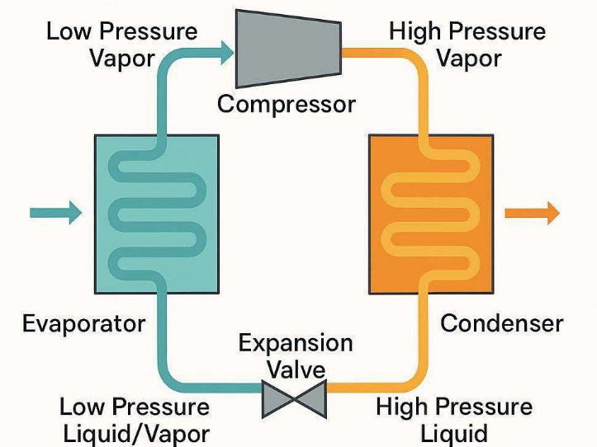
In the evaporator stage, the refrigerant enters as a cool, low-pressure liquid and absorbs heat from the conditioned space. After leaving the metering device, the refrigerant flows through the coiled tubes of the evaporator. Fans circulate warm air from the conditioned space across the evaporator coils, facilitating heat transfer. The relatively cooler refrigerant within the coils absorbs heat from the warmer air, thereby lowering the temperature of the conditioned space [3].
As heat absorption continues, the refrigerant undergoes a phase change, boiling and transforming into a low-pressure vapor. This low-pressure vapor then returns to the compressor, where it is compressed and the refrigeration cycle repeats [3].

Coefficient of Performance (COP)
The performance of a refrigeration cycle is measured by the Coefficient of Performance (COP), defined as the ratio of net refrigeration effect $(Q)$ to the compressor work input $(W_{c})$. A higher COP indicates a more efficient system, with typical values often ranging from 1.7 to 3.14 depending on conditions like evaporator temperature.
$$COP_{cooling}=\frac{Q_{c}}{W_{c}}$$
$$COP_{heating}=\frac{Q_{r}}{W_{c}}$$
Diagram
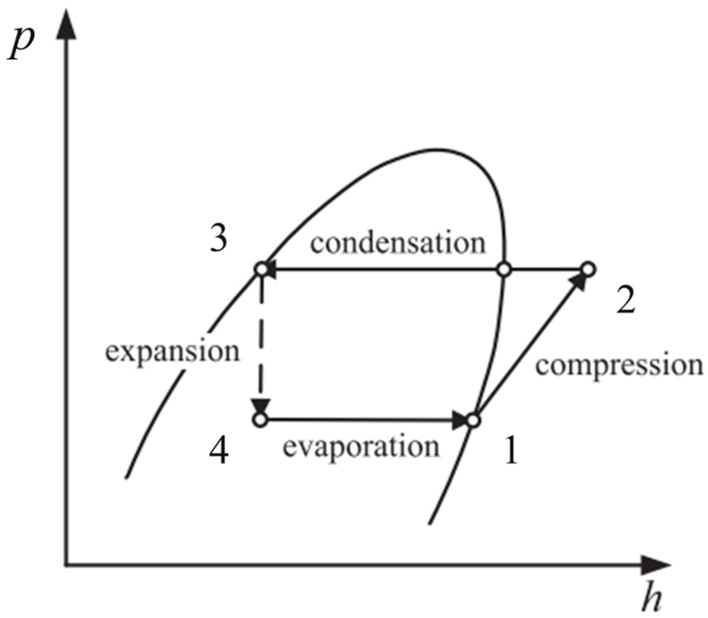
Figure 1 Pressure–enthalpy diagram of the VCR system.
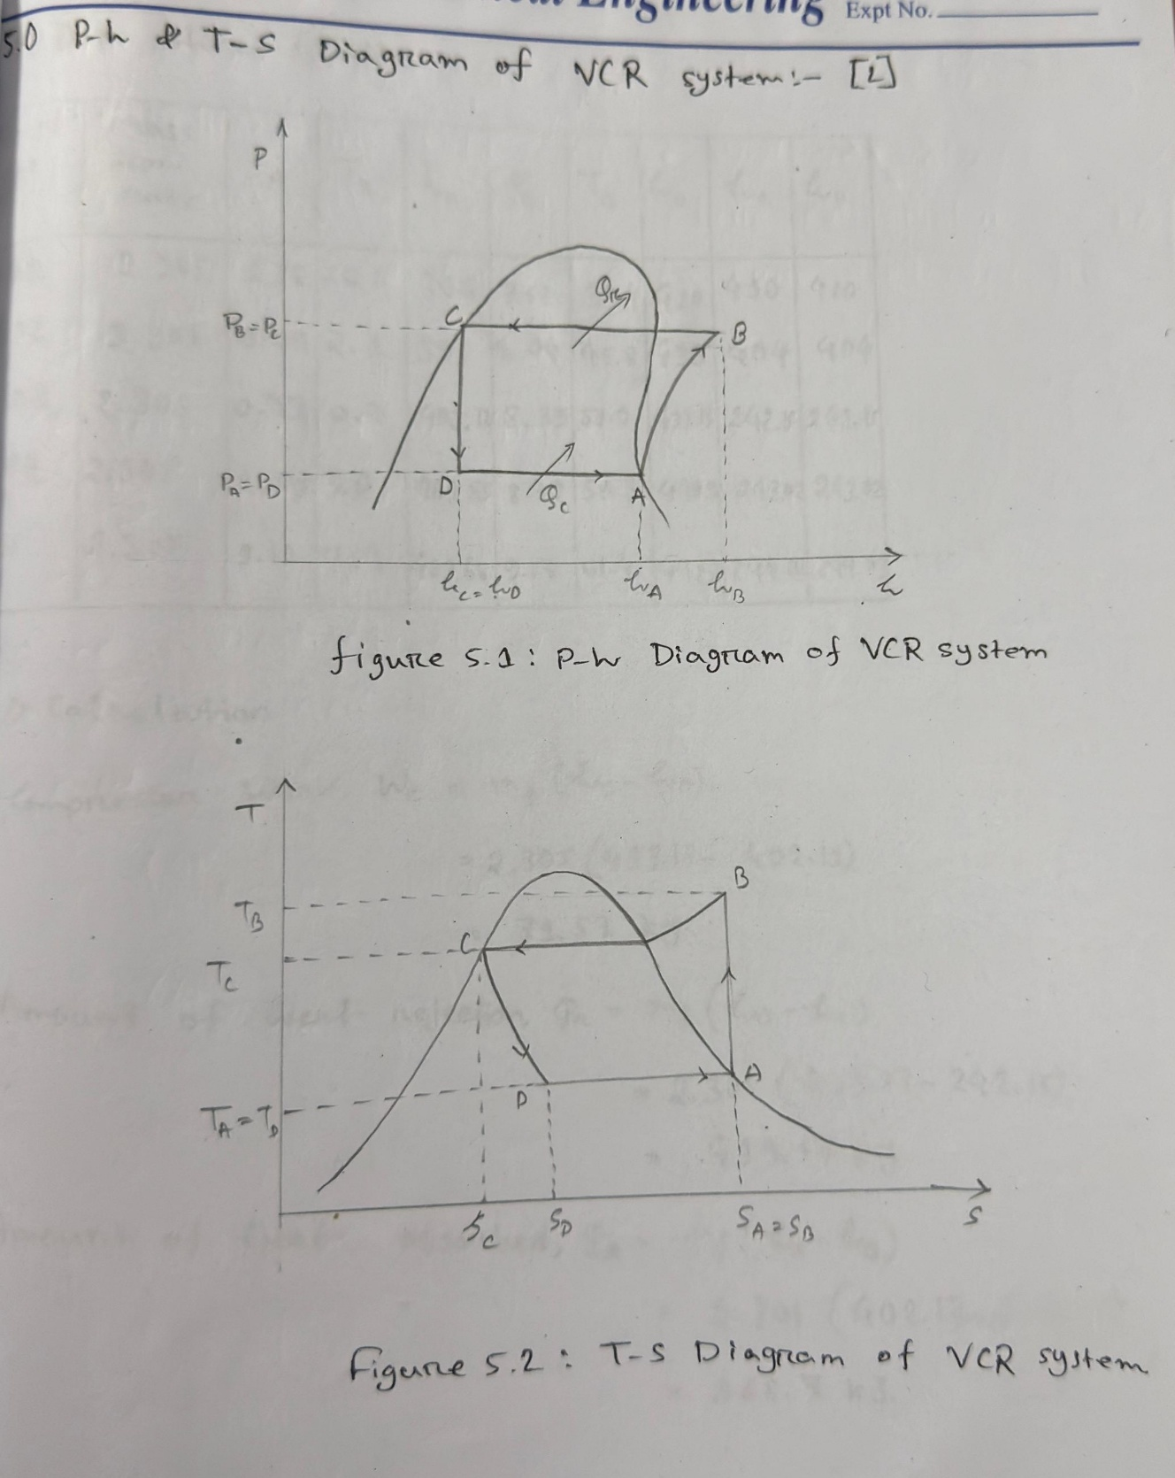
Figure 2 T–entropy diagram of the VCR system.

Result
No of obs. | Mass flow rate ppm $(Ib/min)$ | $$P_{A}$$ | $$P_{B}$$ | $$T_{A}$$ | $$T_{B}$$ | $$h_{A}$$ | $$h_{B}$$ | $$h_{C}$$ | $$h_{D}$$ | $$W_{c}$$ | $$Q_{r}$$ | $$Q_{c}$$ | $$COP_{heating}$$ | $$COP_{cooling}$$
1. | $$2.305Kg/s$$ | 1.16 | 9.10 | 10 | 47.4 | 405 | 440 | 230 | 230 | 80.67 | 484.05 | 403.37 | 6 | 5
2. |  | 1.68 | 9.68 | 7.4 | 55.9 | 457 | 465 | 235 | 235 | 18.44 | 530.15 | 511.71 | 28.75 | 27.75
3. |  | 1.64 | 10.27 | 7 | 59.7 | 465 | 485 | 245 | 245 | 46.1 | 553.2 | 507.1 | 12 | 11

Discussion
In this experiment, the mass flow rate of the refrigerant was observed and the enthalpy at various phases of the refrigerant was measured. The coefficient of performance (COP) of the heating effect and the cooling effect was determined for different pressure levels and enthalpy values. A slight variation was observed in the coefficients of performance for both cooling and heating under different pressure conditions and mass flow rates of the refrigerant. The pressure levels were analyzed using the pressure–enthalpy (P–h) diagram. The enthalpy at different points of the cycle— such as the evaporator, compressor, condenser, and expansion valve—was measured and analyzed to evaluate the system performance.

Conclusion
From this experiment, the performance characteristics of a vapor compression refrigeration system were analyzed. The mass flow rate of the refrigerant and the enthalpy at different stages of the cycle were determined. Using these values, the coefficient of performance (COP) for both the heating and cooling effects was calculated.
The results show that the system performance varies with changes in pressure and refrigerant mass flow rate. Slight differences were observed in the COP values for both cooling and heating under different operating conditions. The pressure–enthalpy (P–h) diagram helped in understanding the thermodynamic processes occurring in the evaporator, compressor, condenser, and expansion valve.
Overall, the experiment successfully demonstrated the working principles of the vapor compression refrigeration cycle and highlighted how pressure, enthalpy, and refrigerant flow rate influence the efficiency and performance of the system.

Reference
[1] D. Tanner, “Refrigeration Systems,” in Reference Module in Food Science, Elsevier, 2016, p. B978008100596521144X. doi: 10.1016/B978-0-08-100596-5.21144-X.
[2] “Vapor-compression refrigeration,” Wikipedia. Feb. 19, 2026. Accessed: Mar. 12, 2026. [Online]. Available: https://en.wikipedia.org/w/index.php?title=Vapor-compression_refrigeration&oldid=1339312139
[3] “How Does a Compression Refrigeration System Work?,” Process Solutions, Inc. Accessed: Mar. 12, 2026. [Online]. Available: https://processsolutions.com/how-does-a-compression-refrigeration-system-work/
[4] Araner, “Vapor Compression System | Compression Cycle | ARANER.” Accessed: Mar. 12, 2026. [Online]. Available: https://www.araner.com/blog/vapor-compression-refrigeration-cycle

