

University Of Science And Technology Houari Boumediene

Faculty of computer science

**information and communications technologies (ICT)**

Team 41

DJEMA Dima

ARBANE Sirine

NACER BEY Abderrahmane Zakaria

HARRIDI Mohamed Alaa Eddine

BERRABAH Amira

**Prof .BOUCHKIR Redouane.**

**Content :**

Definition : 2

Its importance : 2

Technologies related to ICT: 3

a. Overview of ICT technologies: 3

b. Examples of key technologies: 4

1. google services: 4

i. what do these services include? : 4

ii. How Google's services intertwine with ICT: 6

2. microsoft tools: 7

3. Git/GitHub : 8

i. Overview of Git and GitHub: 8

A. GIT: 8

B. GITHUB: 9

ii. Git vs. GitHub in Simple Terms: 9

4. Artificial Intelligence(AI) and Machine Learning(ML) : 10

i. Definition: 10

ii. Intersecting with TIC: 10

**List of tables :**

Tableau 1 : statistics related to Information and Communication Technologies (ICT) 2

Tableau 2 : some statistics regarding the user base for several key Google services 6

# Definition :

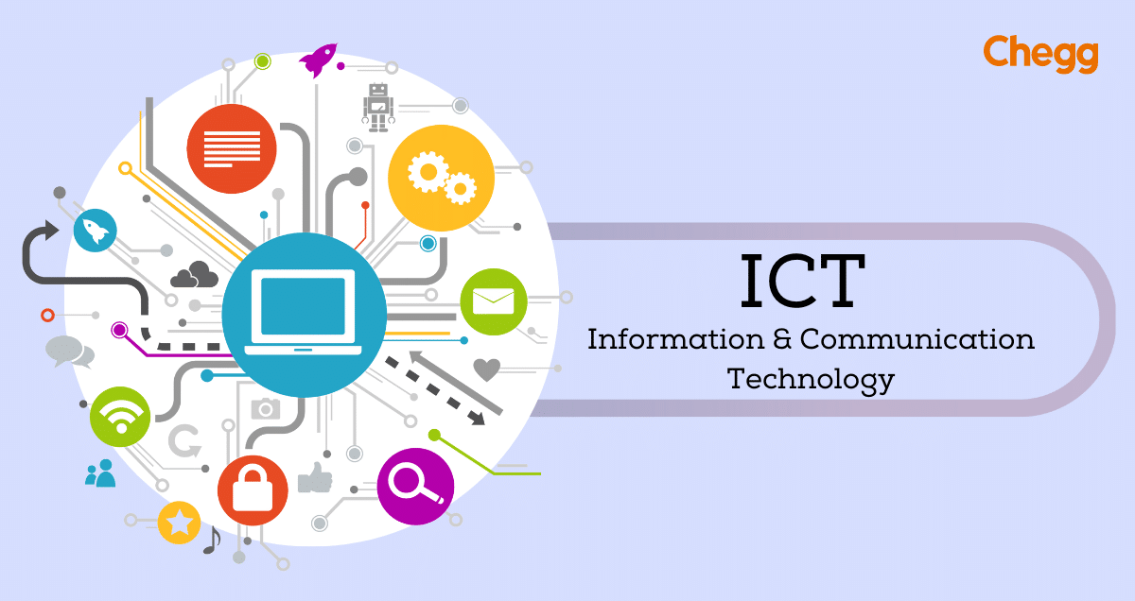 ICT, or information and communications technology (or technologies), is the infrastructure and components that enable modern computing. Among the goals of IC technologies, tools and systems is to improve the way humans create, process and share data or information with each other. Another is to help them improve their abilities in numerous areas, including business; education; medicine; real-world problem-solving; and even leisure activities related to sports, music, and movies.

There is no single, universal definition of ICT because the technologies, devices and even ideas related to ICT are constantly evolving. However, the term is generally accepted to mean all devices, networking components and applications. When combined, these help people and organizations interact in the digital world.

-Here's an example of a table presenting statistics related to Information and Communication Technologies (ICT):

|  |  |
| --- | --- |
| **TIC metrics** | **Value** |
| Global Internet Users | 4.66 billion (Jan 2022) |
| Mobile Phone Users | 5.31 billion (Jan 2022) |
| Social Media Users | 3.8 billion (2021) |
| Internet Penetration Rate | 59.5% of the global population |
| E-commerce Sales (2021) | $4.9 trillion USD globally |
| Research & Development Spending | $1.8 trillion |

**Tableau 1 :** statistics related to Information and Communication Technologies (ICT)

# Its importance :

* **Connectivity:** ICT bridges distances, connecting individuals, businesses, and communities globally, fostering collaboration and communication.
* **Access to Information:** It democratizes knowledge, providing easy access to vast amounts of information, education, and resources for people worldwide.

* **Economic Growth:** ICT fuels innovation, productivity, and economic development, driving advancements in various industries and creating new opportunities.
* **Efficiency and Productivity:** It streamlines processes, automates tasks, and enhances efficiency in businesses, education, healthcare, and government services.
* **Improved Communication:** ICT enables real-time communication through various platforms, fostering better interaction, collaboration, and information exchange.
* **Education and Learning:** It transforms education by offering online learning, interactive resources, and digital tools that enhance teaching and learning experiences.
* 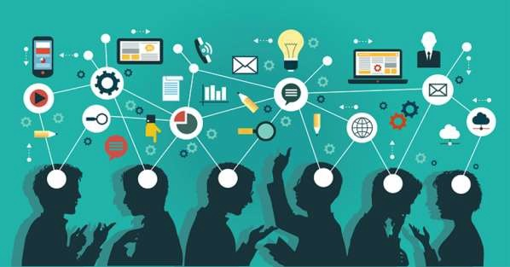**Healthcare Advancements:** ICT contributes to medical research, telemedicine, electronic health records, and remote patient care, improving healthcare accessibility and outcomes.

* **Societal Impact:** ICT plays a pivotal role in social interactions, governance, and civic engagement, empowering communities and promoting inclusivity.

Overall, the significance of ICT lies in its ability to drive progress, innovation, and connectivity, fundamentally altering how we live, work, learn, communicate, and interact in the modern world.

# Technologies related to ICT:

## Overview of ICT technologies:

Information and Communication Technologies (ICT) encompass various technologies crucial for managing and disseminating information. Here's an overview of some key TIC technologies:

* **Computing Technology:** Includes hardware like computers, servers, and mobile devices, along with software, operating systems, and applications that facilitate data processing and manipulation.
* **Networking Technologies:** Encompasses networking equipment, protocols, and infrastructure enabling communication and data transfer, including routers, switches, LANs (Local Area Networks), and WANs (Wide Area Networks).
* **Internet Technologies:** Fundamental for online connectivity, web services, and access to information, involving web browsers, internet protocols, domain systems, and web development tools.
* **Telecommunications Technology:** Covers devices and systems for voice and data transmission, such as telephones, mobile networks, satellites, and communication protocols.
* **Data Storage and Management:** Encompasses databases, data centers, cloud storage, and data management systems crucial for storing, organizing, and retrieving vast amounts of information efficiently.
* **Cybersecurity Technologies:** Encompasses tools and practices to protect systems, networks, and data from cyber threats, including firewalls, encryption, antivirus software, and intrusion detection systems.
* **Digital Media Technologies:** Involve technologies for creating, distributing, and consuming digital content, such as streaming platforms, multimedia editing tools, and digital publishing software.
* **E-commerce and Digital Transaction Tools:** Facilitate online transactions, payment gateways, digital currencies, and e-commerce platforms for buying and selling goods and services online.
* **Wireless Technologies:** Technologies that enable communication without physical connections, such as Wi-Fi, Bluetooth, and cellular networks.

These technologies collectively form the backbone of ICT, enabling the acquisition, storage, processing, and transmission of information, pivotal in shaping our digital world.

## Examples of key technologies:

### google services:

#### what do these services include? :

Google services encompass a comprehensive suite of digital tools, applications, and platforms provided by Google, catering to various needs and aspects of digital life. These services include:

* **Google Search:** The widely used search engine that enables users to access a vast repository of information available on the internet.

 -Google has 4.3 billion users worldwide. Based on 4.72 billion internet users worldwide and a market share of 92.24%.

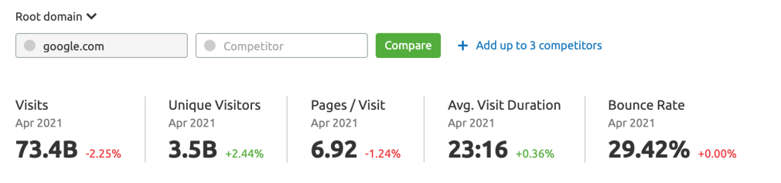

* **Gmail:** A popular email service offering ample storage, intuitive interface, and integration with other Google services.
* **Google Maps:** Provides detailed maps, navigation, and location-based services for route planning and geographical information.
* **Google Drive:** A cloud-based storage service allowing users to store, share, and collaborate on documents, spreadsheets, and files online.
* **YouTube:** A leading video-sharing platform where users can upload, watch, and share videos on various topics.
* **Google Docs, Sheets, and Slides:** Web-based applications for creating documents, spreadsheets, and presentations with real-time collaboration features.
* **Google Chrome:** A popular web browser known for its speed, simplicity, and synchronization across devices.

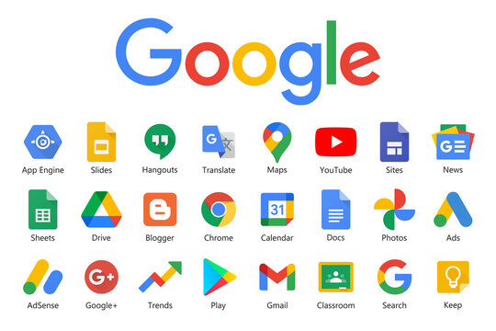

* **Google Photos:** Offers storage, organization, and sharing of photos and videos, including features like automatic backup and AI-powered search.
* **Google Calendar:** A tool for scheduling events, reminders, and managing time efficiently, accessible across devices.
* **Google Translate:** Provides language translations for text, websites, and even spoken words across multiple languages.
* **Google Workspace (formerly G Suite):** A suite of productivity tools for business and education, including Gmail, Calendar, Drive, Docs, Sheets, Slides, and more, designed for collaboration and productivity.
* **Google Ads:** A platform for businesses to create and manage online advertising campaigns, allowing them to reach potential customers through Google's advertising network.

These services collectively provide users with access to information, communication tools, productivity solutions, and entertainment, showcasing Google's commitment to enhancing digital experiences across various domains.

As of the last update in January 2022, Google's services were widely used globally. Here are some statistics regarding the user base for several key Google services

|  |  |
| --- | --- |
| **Google services** | **Number of users** |
| Gmail | 1.5 billion (2021) |
| Google drive, google photos | 1 billion (2021) |
| Youtube | 2 billion monthly (2021) |
| Google play | 2.5 billion monthly (2021) |

**Tableau 2 :** some statistics regarding the user base for several key Google services

#### How Google's services intertwine with ICT:

Google services have a profound relationship with Information and Communication

Technologies (ICT), fundamentally influencing and shaping how information is accessed, managed, and communicated. Here's how Google's services intertwine with ICT:

* Access to Information: Google Search revolutionized information retrieval, becoming a cornerstone of internet access. It's a prime example of how ICT enables the efficient access and management of vast amounts of data.
* Communication Tools: Services like Gmail and Google Meet exemplify how ICT facilitates communication. These platforms leverage technology to enable seamless email communication and video conferencing, connecting individuals and businesses globally.
* Collaboration and Productivity: Google Drive, Docs, Sheets, and Slides exemplify ICT's role in enhancing collaboration and productivity. These cloud-based tools allow real-time collaboration, document creation, and data storage, streamlining workflows and information sharing.
* Geospatial Services: Google Maps demonstrates how ICT aids in geospatial data management. It provides mapping, navigation, and location-based services, showcasing the integration of technology in managing and accessing geographical information.
* Cloud Computing: Google Cloud Platform offers cloud-based services, reflecting ICT's role in providing scalable computing resources, storage solutions, and databases for businesses and developers.
* Multimedia and Content Sharing: YouTube, a Google service, illustrates how ICT facilitates multimedia content creation, sharing, and consumption, showcasing the integration of technology in media dissemination.
* Language and Translation Services: Google Translate is an example of ICT enabling language translation, showcasing how technology aids in overcoming language barriers and facilitating global communication.

Google's services epitomize the fusion of technology, data management, communication, and collaboration, showcasing how ICT innovations have revolutionized information access, communication modalities, and collaborative work environments on a global scale

### microsoft tools:

Microsoft tools encompass a wide array of software applications, platforms, and services developed by Microsoft Corporation, catering to various needs across personal, business, and enterprise settings. Some key Microsoft tools include:

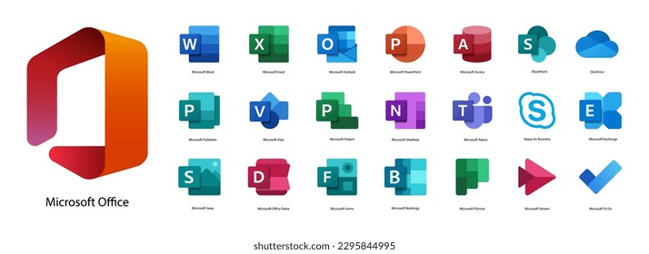

* **Microsoft Office Suite:** Includes applications like Word, Excel, PowerPoint, Outlook, and Access, tools for word processing, spreadsheets, presentations, email management, and database creation.
* **Microsoft Windows Operating System:** The dominant operating system for personal computers, providing the user interface and platform for running applications and managing computer resources.
* **Microsoft Azure:** A cloud computing platform providing services for building, deploying, and managing applications and services through Microsoft's global network of data centers.
* **Microsoft Teams:** A collaboration platform offering chat, video conferencing, file storage, and application integration for teamwork and communication within organizations.

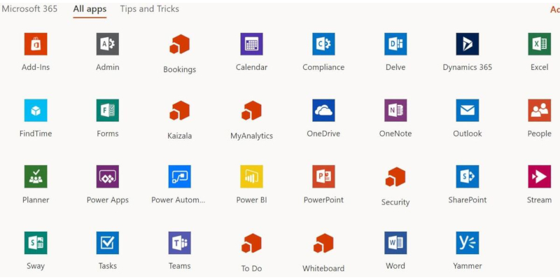

* **Microsoft Dynamics 365:** An integrated suite of business applications for customer relationship management (CRM) and enterprise resource planning (ERP).
* **Visual Studio:** A comprehensive integrated development environment (IDE) used to develop computer programs, websites, mobile apps, and other software solutions.
* **Power BI:** A business analytics tool used for data visualization, sharing insights, and generating reports from various data sources.
* **Microsoft Edge:** A web browser developed by Microsoft, offering tools for browsing, searching, and accessing the internet.

These tools exemplify Microsoft's commitment to providing a wide range of solutions for productivity, communication, development, data management, and business operations across different industries and user segments.

### Git/GitHub :

Git and GitHub are related but distinct tools used in software development for **version control**, collaboration, and code management. 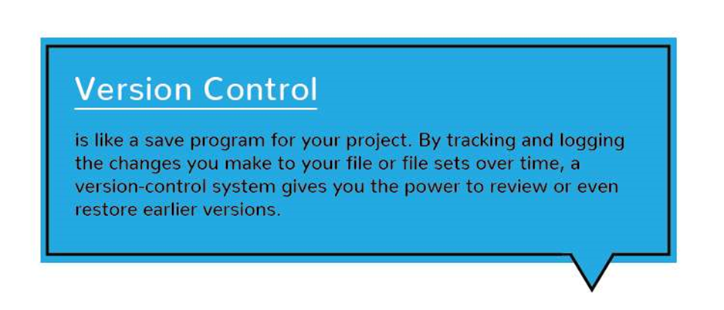

1. Overview of Git and GitHub:

##### Update now! Two critical flaws in Git's code found, patchedGIT:

* **Version Control System:** Git is a distributed  version control system designed for tracking

changes in source code during software

development.

* **Decentralized:** It allows developers to work on a project simultaneously without the need for a central server. Each developer has a complete copy of the repository, including its history.
* **Commit-Based System:** Developers make changes to their local repository and then commit those changes, creating a snapshot of the code at that moment.
* **Branching and Merging:** Git enables branching, allowing developers to create separate lines of development, experiment with new features, and merge changes back into the main codebase.
* **History Tracking:** Git maintains a detailed history of changes, making it easy to trace back, compare versions, and revert to previous states if necessary.
* **Command Line Interface:** Git primarily operates through a command line interface, although several graphical user interfaces (GUIs) also exist.

##### GITHUB:

* **eb-Based Platform:** GitHub is a web-based platform that hosts Git repositories.
* **Remote Repository Hosting:** Developers can store their Git repositories on GitHub's servers, making it easier to collaborate with others and share code.
* **Collaboration Features:** GitHub provides tools for issue tracking, project management, pull requests, code review, and collaboration among developers and teams.
* **Social Coding:** It allows users to follow projects, star repositories, fork code (create a personal copy of a repository), and contribute to open-source projects.
* **Community and Integration:** GitHub fosters a community of developers around projects, enabling discussions, contributions, and integrations with various tools and services.
* **Accessible Interface:** GitHub has a user-friendly web interface in addition to supporting Git commands, making it accessible for both beginners and experienced users.

#### Git vs. GitHub in Simple Terms:

So, taken all together: Git vs. GitHub… what’s the difference?

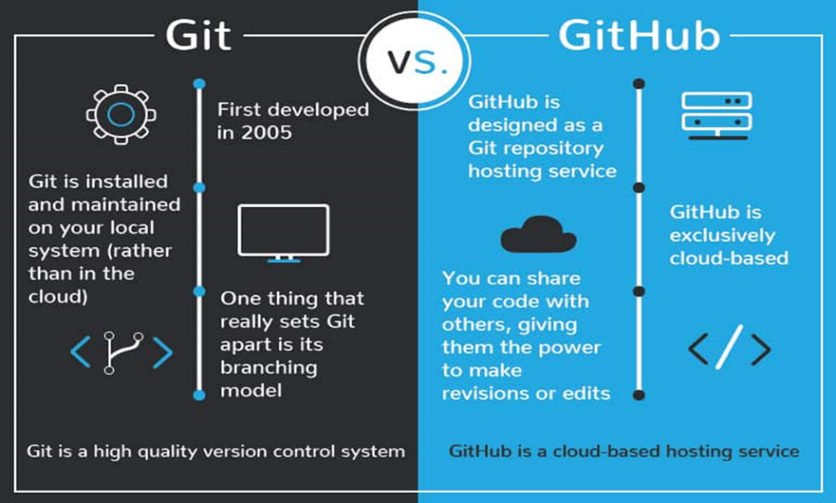 Simply put, Git is a version control system that lets you manage and keep track of your source code history. GitHub is a cloud-based hosting service that lets you manage Git repositories. If you have open-source projects that use Git, then GitHub is designed to help you better manage them.

After all, in the world of programming, naming conventions aren’t always intuitive. That’s why it’s worth recognizing the connections and the differences in the similarly named *Git* and *GitHub*. Both Git and GitHub give programmers valuable version-control functionality so that they can build ongoing coding projects without being afraid of messing everything up. GitHub just takes things a little bit further than Git, offering more functionality and resources, as well as a place online to store and collaborate on projects.

### Artificial Intelligence(AI) and Machine Learning(ML) :

#### Definition:

**AI:** The simulation of human intelligence in machines to perform tasks such as visual 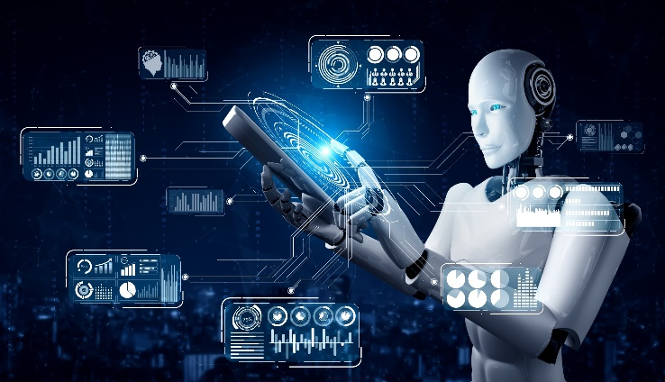perception, speech recognition, decision-making, and language translation.

**ML:** A subset of AI that enables systems to learn from data without explicit programming, improving their performance over time.

#### Intersecting with TIC:

* **Data Analysis and Interpretation:**AI and ML algorithms are used to analyze vast amounts of data, extracting meaningful insights and patterns.

Implication: Improved decision-making and strategic planning in various industries.

* **Automation and Efficiency:**Automation of routine tasks and processes using AI and ML technologies.

Implication: Increased efficiency,reduced operational costs, and faster task execution.

* **Personalization:**AI-powered recommendation engines analyze user behavior to provide personalized content and services.

Implication: Enhanced user experience in e-commerce, streaming, and online platforms.

* **Predictive Analytics:**ML algorithms predict future trends and outcomes based on historical data.

Implication: Anticipating market trends, demand forecasting, and risk management.