E-VOTING SYSTEM

**Problem Statement:-**

This Project is about an automated E-voting system which is an online voting technique. This system validates only voters with registered voter ID and are eligible to vote that is above 18 years are allowed to vote on the online mode without physical presence. The polled votes are counted error free. Generally there are always problems involved in general voting system such as ridging votes during election, insecure or inaccessible polling stations, inadequate polling materials and also inexperienced personnel.

Registration is mainly done by the system administrator for security reasons. The system Administrator registers the voters on a special site of the system visited by him where he can view the list of people eligible and registered is seen. Citizens seeking registration are expected to contact the system administrator to submit their details. After the validity of them being citizens of India has been confirmed by the system administrator by comparing their details submitted with those in existing databases such as those as the Registrar of Persons, the citizen is then registered as a voter. After registration, the voter is assigned a secret Voter ID with which he/she can use to log into the system and can cast their vote. If invalid details are submitted, then the citizen is not registered to vote. Only once these credentials are allowed to use. Electronic voting system will make the work of the voters easy and is more useful at all times and situations (even in this pandemic one).

**Identification of classes:**

**a) Conceptual class category list:**

|  |  |
| --- | --- |
| Conceptual class category | Identified classes |
| Physical or tangible objects | E-voting |
| Specification or description of things | Voter Details, Admin Details, Election Details |
| Roles of people | Admin, voter |
| Containers of things | E-voting |
| Things in a container | Voter, Admin |
| Events | Voting, Registration, Validation, Result |
| process | Get Details, Registration, Authentication, Voting |

**b)Identification of Noun Phrases:**

VOTER:

1. The **voter** enters their login details.

2. The **voter** is taken to **voting page** after **authentication.**

3. If voter is a **new voter** he can **register**.

4. The **voter** can choose his **preferred party**.

5. After selecting the **party** the **voter** will exit.

6. If the **voter** has already voted he cannot vote again.

ADMIN:

1. The **admin** enters their login details.

2. The **admin** is taken to **admin page** after **authentication.**

3. The **admin** can register **new parties** into the database.

4. The votes given by the **voters** and the votes got by each **party** can be monitored by the **admin**.

4. After the election is over **admin** can check the votes received by each party and declare the **winning party**.

**c) Association category list:**

|  |  |
| --- | --- |
| Category | Examples |
| A is a member of B | Admin – E-voting  Voter -- E-voting |
| A uses or manages B | Register – Voter  Result – E-voting |
| A communicates with B | Voter -- Party |
| A related to a transaction B | Voter – Voting  Voter – Registration  Admin – Result |
| A is a transaction related to another transaction B | Result -- Voting |

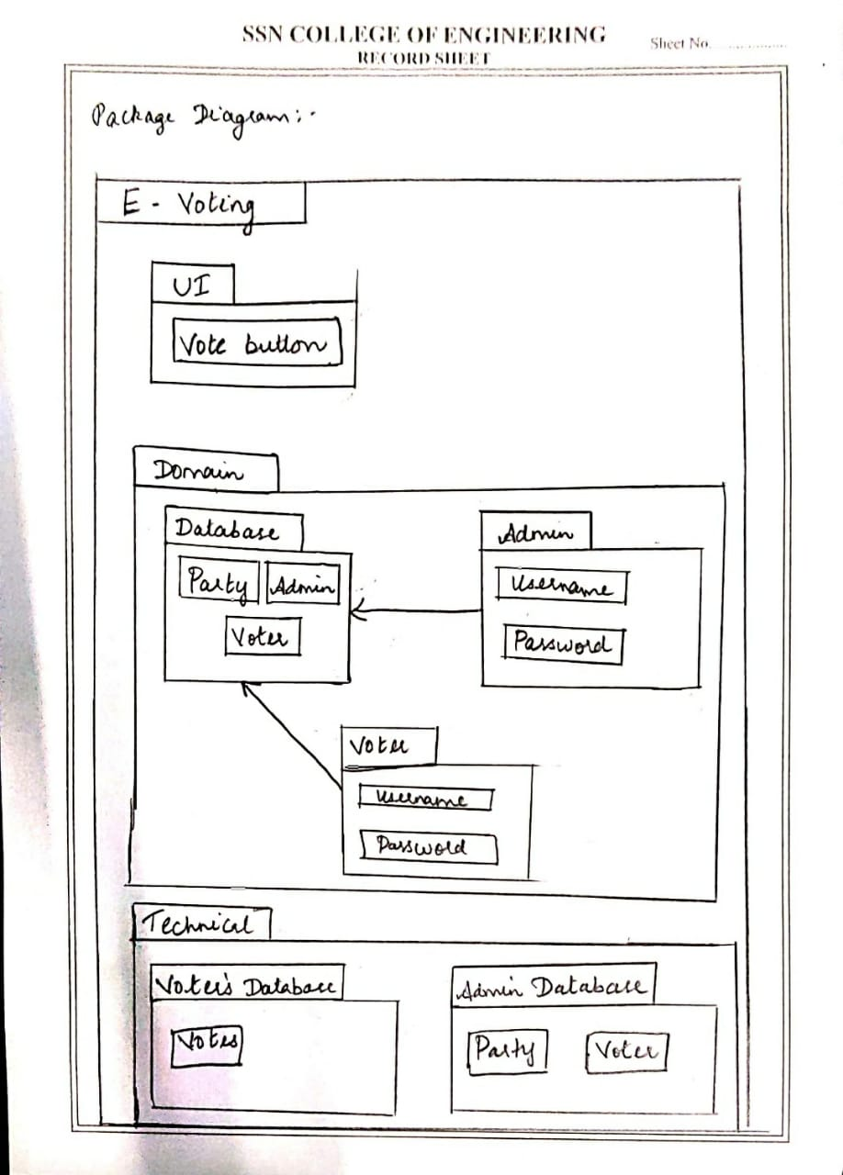

**Identification of testing scenarios:-**

* Login to Vote
* Register to vote
* View the Party details and vote
* Admin Login
* Admin viewing the list

**Test Cases:-**

|  |  |  |  |  |  |  |
| --- | --- | --- | --- | --- | --- | --- |
| Test_Id | Test Scenario | Test Steps | Test Data | Predicted Result | Actual Result | Pass/Fail |
| T01 | Login for the voter | Enter the user name & password | Name: rama@gmail.com  Password: rama | Logged in | Logged in | Pass |
| T02 | Login for the voter | Enter the user name & password | Name: 1235469  Password:1234 | Invalid, Try Again | Logged in | Fail |
| T03 | Register to vote | Enter the voter details | Voter name: Ramaprabha  Voter_ID:123  Location: Chennai | Registration done Successfully | Registration done Successfully | Pass |
| T04 | Register to vote | Enter the voter details | Voter name: Ramaprabha  Voter_ID:  Location: Chennai | Fill the required field | Registration done Successfully | Fail |
| T05 | Admin | Admin can view the details of the voter | Button clicked: View voter list  Voter name: Ramaprabha  Voter_ID:123  Location: Chennai | Voter’s list can be viewed | Voter’s list can be viewed | Pass |
| T06 | Admin | Admin can view the details of the voter | Button clicked: View voter list  Voter name: Ramaprabha  Voter_ID:123  Location: Chennai | Voter’s list can be viewed | Database Retrieval Error  List cannot be viewed | Fail |
| T07 | View the Party details and vote | Once the voter is logged in they are allowed to view the part details and vote | Button clicked : View party Details and vote | Party details viewed and voted | Party details viewed and voted will be saved in the database | Pass |
| T08 | View the Party details and vote | Once the voter is logged in they are allowed to  view the part details and vote | Button clicked : View party Details and vote | Party details viewed and voted | Database Retrieval Error  Details cannot be viewed | Fail |
| T09 | Admin Login | Enter the username & Password | Username: admin  Password: root | Logged in Successfully | Logged in Successfully | Pass |
| T10 | Admin Login | Enter the username & Password | Username: admin  Password: root | Invalid, Try again | Logged in | Fail |

**Improvement**:-

With the help of test cases we ensured that if different features within an application are working as expected.

It validated whether our software is free of defects and is working as per the expectations of the end users. With Test case scenarios we also improved the quality of our Project.

**Implementation Of Code:-**

**Login:**

Login page:

<form method="post" action="/">

    <input type='text' id='mail' name='mail' placeholder="Email id" required> <br>

    <input type='password' id='password' name='password' placeholder="Enter password" required> <br>

    <button type="submit" id='button' name="button"   >login</button><br>

    <a href="/register">Register</a><br>

</form>

**Admin:**

<a href="/addparty">Add Party</a><br>

<table >

    <thead>

       <tr>

          <th scope="col">Voter Reference ID</th>

          <th scope="col">Party</th>

        </tr>

    </thead>

    <tbody>

       <br><br><br><br>

       {% for item in list %}<tr>

          <td >{{ item['id'] }}</td>

          <td>{{ item['party'] }}</td>

       </tr>

       {% endfor %}

       <a href="/">LOGOUT</a><br>

    </tbody>

 </table>

**Register:**

<h2 style:"align:center">Register</h2>

<form action="/register" method="POST" >

    <input type="text" id="name" name="name"   placeholder="Enter Name" >

    <br>

    <input type="password" id="password" name="password" placeholder="Enter Password">

    <br>

    <input type="text" id="voterid" name="voterid"   placeholder="Enter VoterId" >

    <br>

    <input type="email" id="email" name="email"  placeholder="Email" >

    <br>

    <input type="text" id="tel" name="tel"  placeholder="Contact Number" >

    <br>

    <input type="text" id="address" name="address"  placeholder="Address">

    <br>

    <input type="date" id="dob" name="dob" placeholder="Date of birth" >

    <br>

    <input type="text" id="gender" name="gender"  placeholder="Enter gender" >

    <br>

    <button type="submit" >Register</button>

    </center>

    <br><br>

</form>

**Voting:**

{%if status%}

<table >

    <thead>

       <tr>

          <th scope="col">ID</th>

          <th scope="col">Party</th>

        </tr>

    </thead>

    <tbody>

       <br><br><br><br>

       {% for item in list %}<tr>

          <td >{{ item['id'] }}</td>

          <td>{{ item['party'] }}</td>

          <td>

            <form method="post" action="/voting">

             <button name="button" value="{{item.party}}" >Vote</button>

            </form>

          </td>

       </tr>

       {% endfor %}

{%endif%}

<br>

{{message}}

<br>

<a href="/logout">LOGOUT</a><br>

    </tbody>

 </table>

**Add Party:**

<form method="post" action="/addparty">

    <input type='text' id='party' name='party' placeholder="Enter party name" required> <br>

    <button type="submit" id='button' name="button"   >add</button><br>

</form>

**Output:-**

**Login to vote:**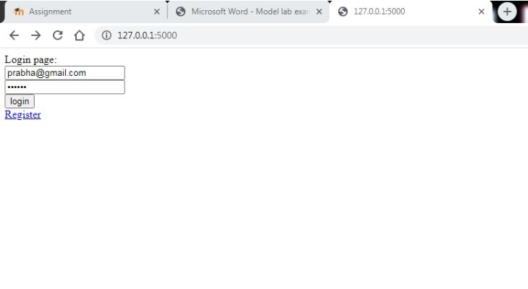

**Cast your vote:**

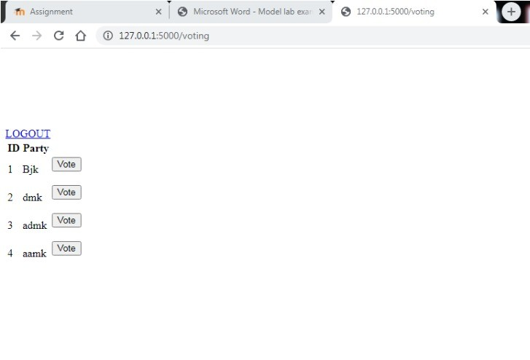

**Voting done:**

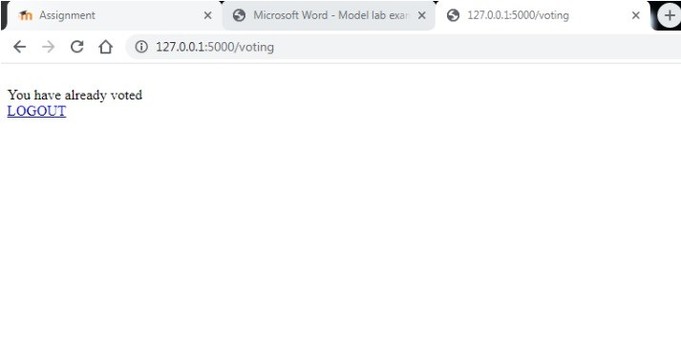

**Register to Vote:**

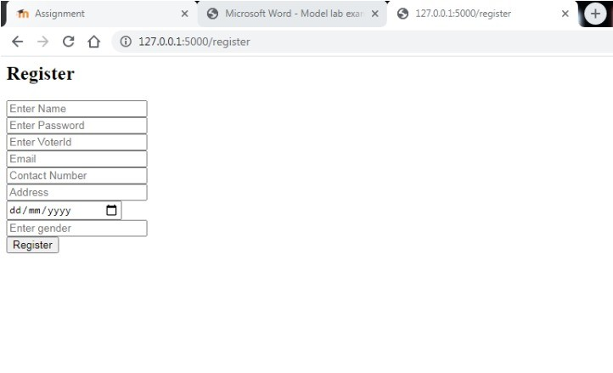

**Login to vote:**



**Already voted**



**Admin Login:**

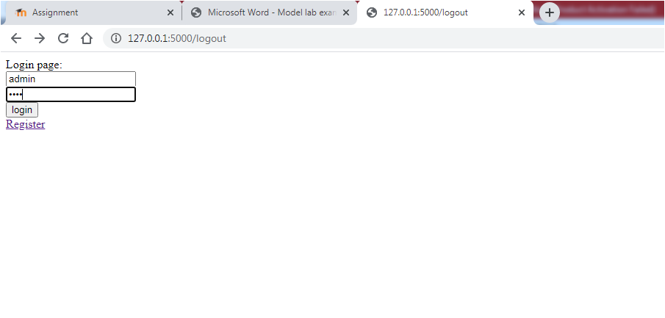

**Adding a Party:**

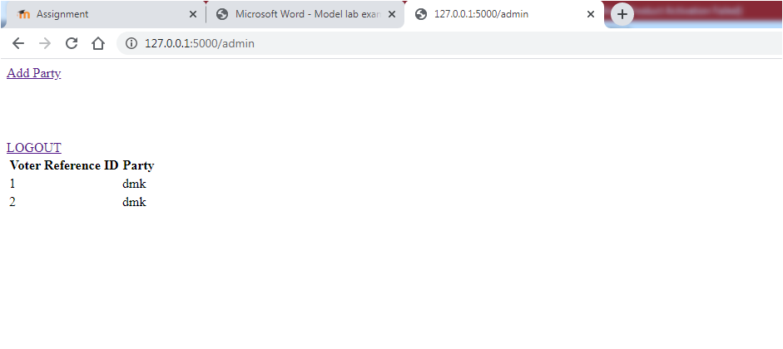

**Party added:**

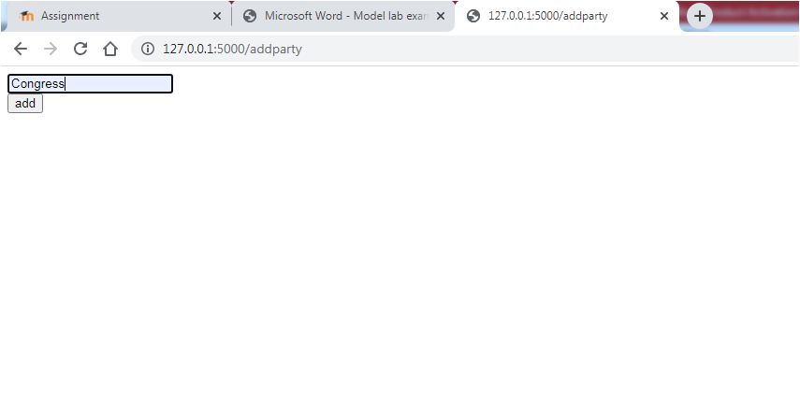

**Database:**

**Party initially:**

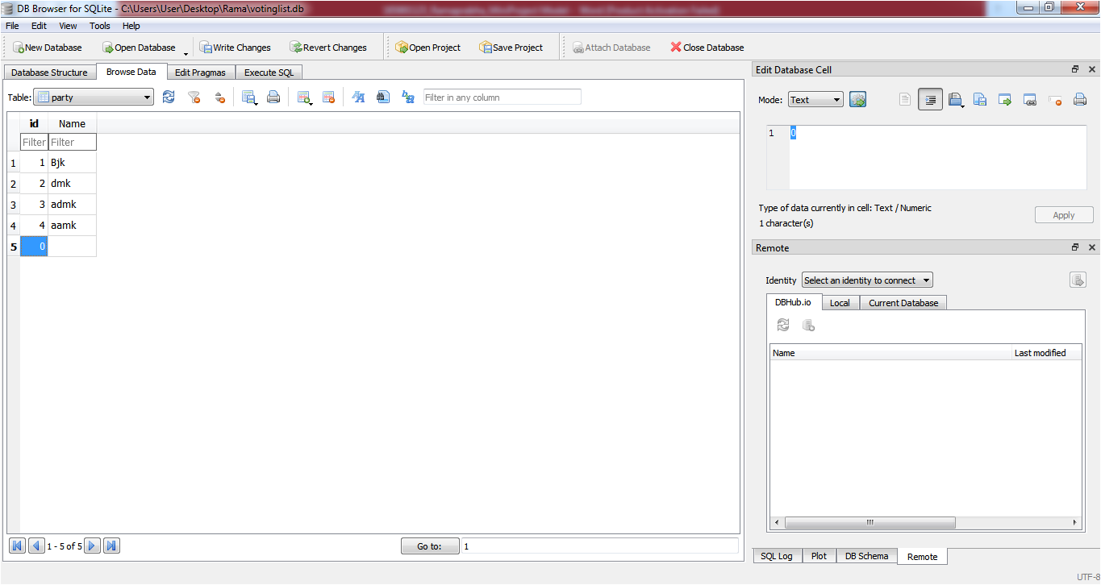

**Party Added:**

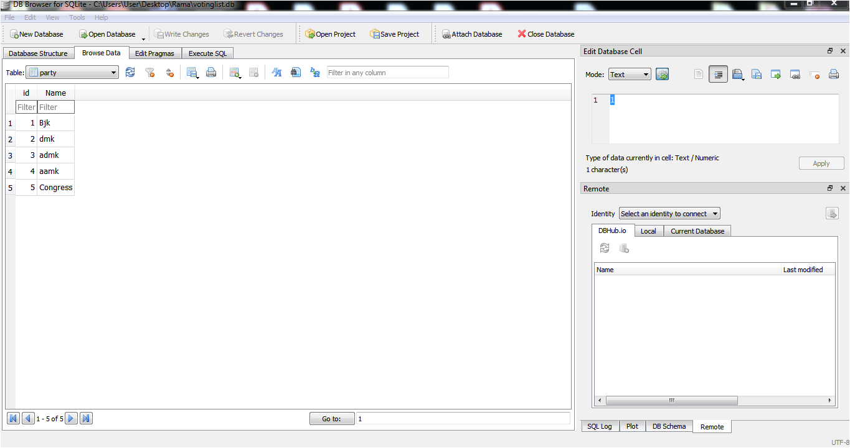

**Voted party and ID list:**

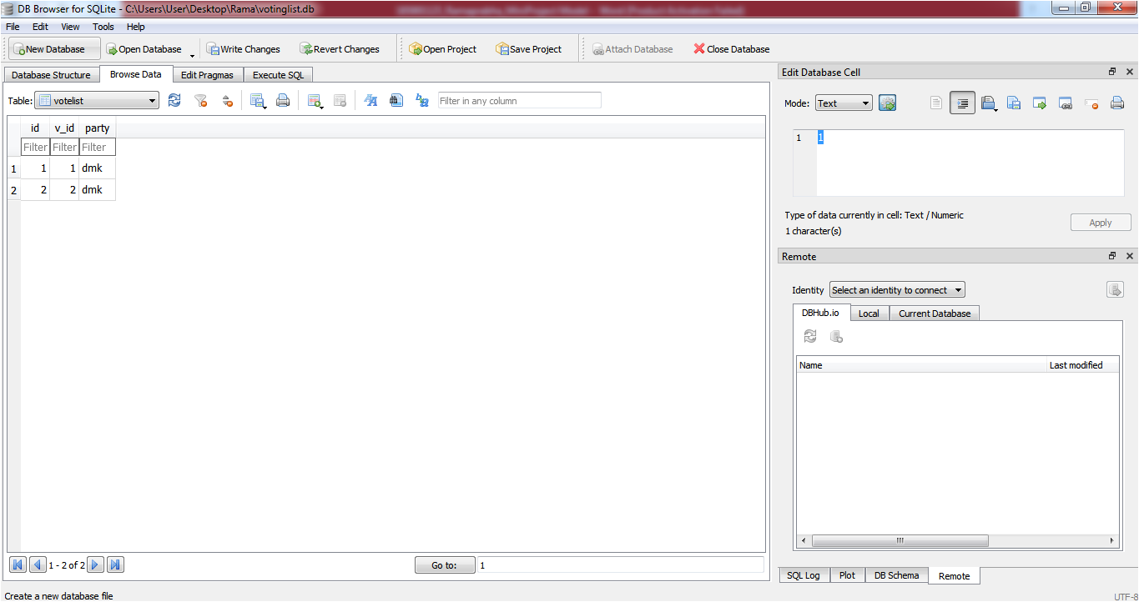

**Voter Details:**

