# Tables

1. **Patient**
   * **PatientID**: Unique identifier for the patient (Primary Key)
   * **Name**: Name of the patient
   * **ContactDetails**: Contact details of the patient
   * **PersonalInformation**: Additional personal information of the patient
2. **Doctor**
   * **DoctorID**: Unique identifier for the doctor (Primary Key)
   * **Name**: Name of the doctor
   * **Specialty**: Specialty of the doctor
   * **ContactDetails**: Contact details of the doctor
3. **Record**
   * **RecordID**: Unique identifier for the record (Primary Key)
   * **PatientID**: Identifier of the patient (Foreign Key referencing **Patient**)
   * **Diagnosis**: Diagnosis of the patient
   * **DoctorID**: Identifier of the doctor (Foreign Key referencing **Doctor**)
4. **PrescribedMedication**
   * **MedicationID**: Unique identifier for the medication (Primary Key)
   * **Name**: Name of the medication
   * **Dosage**: Dosage of the medication
   * **RecordID**: Identifier of the record associated with the medication (Foreign Key referencing **Record**)
5. **Appointment**
   * **AppointmentID**: Unique identifier for the appointment (Primary Key)
   * **DateAndTime**: Date and time of the appointment
   * **PatientID**: Identifier of the patient (Foreign Key referencing **Patient**)
   * **DoctorID**: Identifier of the doctor (Foreign Key referencing **Doctor**)
6. **Payment**
   * **PaymentID**: Unique identifier for the payment (Primary Key)
   * **Amount**: Amount of the payment
   * **Date**: Date of the payment
   * **MedicationID**: Identifier of the medication associated with the payment (Foreign Key referencing **PrescribedMedication**)
7. **User_Authentication**
   * **UserID**: Unique identifier for the user (Primary Key)
   * **PatientID**: Identifier of the associated patient (Foreign Key referencing **Patient**)
   * **Username**: Username for authentication
   * **Password**: Password for authentication

# URM

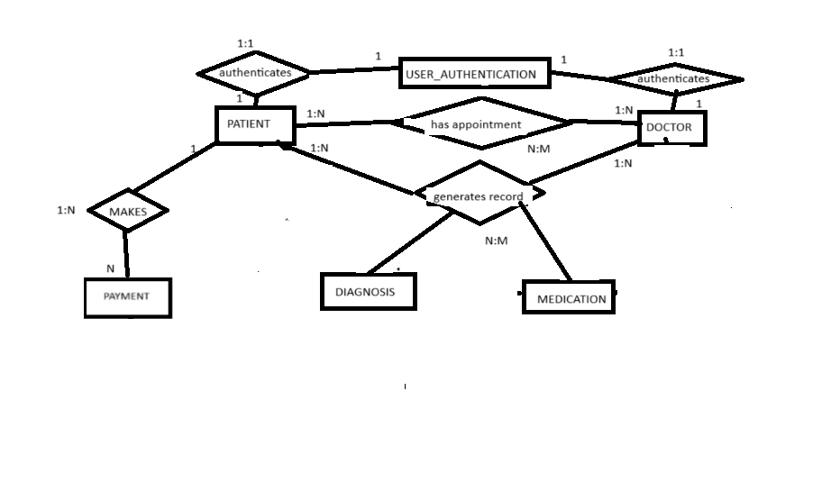

(cardinality is kind of wrong)

# Creating SQL Tables

CREATE TABLE Patient (

PatientID INT AUTO_INCREMENT PRIMARY KEY,

Name VARCHAR(255),

ContactDetails VARCHAR(255),

PersonalInformation TEXT

);

CREATE TABLE Doctor (

DoctorID INT AUTO_INCREMENT PRIMARY KEY,

Name VARCHAR(255),

Specialty VARCHAR(255),

ContactDetails VARCHAR(255)

);

CREATE TABLE Record (

RecordID INT AUTO_INCREMENT PRIMARY KEY,

PatientID INT,

Diagnosis VARCHAR(255),

DoctorID INT,

FOREIGN KEY (PatientID) REFERENCES Patient(PatientID),

FOREIGN KEY (DoctorID) REFERENCES Doctor(DoctorID)

);

CREATE TABLE PrescribedMedication (

MedicationID INT AUTO_INCREMENT PRIMARY KEY,

Name VARCHAR(255),

Dosage VARCHAR(255),

RecordID INT,

FOREIGN KEY (RecordID) REFERENCES Record(RecordID)

);

CREATE TABLE Appointment (

AppointmentID INT AUTO_INCREMENT PRIMARY KEY,

DateAndTime DATETIME,

PatientID INT,

DoctorID INT,

FOREIGN KEY (PatientID) REFERENCES Patient(PatientID),

FOREIGN KEY (DoctorID) REFERENCES Doctor(DoctorID)

);

CREATE TABLE Payment (

PaymentID INT AUTO_INCREMENT PRIMARY KEY,

Amount DECIMAL(10, 2),

Date DATE,

MedicationID INT,

FOREIGN KEY (MedicationID) REFERENCES Medication(MedicationID)

);

CREATE TABLE User_Authentication (

UserID INT AUTO_INCREMENT PRIMARY KEY,

PatientID INT,

Username VARCHAR(255),

Password VARCHAR(255),

FOREIGN KEY (PatientID) REFERENCES Patient(PatientID)

);

# Data Inserting

For patient:

INSERT INTO Patient (Name, ContactDetails, PersonalInformation) VALUES ('John Doe', '123-456-7890', 'Male, 35 years old, non-smoker');

INSERT INTO Patient (Name, ContactDetails, PersonalInformation) VALUES ('Jane Smith', '456-789-0123', 'Female, 45 years old, occasional smoker');

INSERT INTO Patient (Name, ContactDetails, PersonalInformation) VALUES ('Michael Johnson', '789-012-3456', 'Male, 50 years old, diabetic');

INSERT INTO Patient (Name, ContactDetails, PersonalInformation) VALUES ('Emily Davis', '012-345-6789', 'Female, 25 years old, no significant medical history');

INSERT INTO Patient (Name, ContactDetails, PersonalInformation) VALUES ('David Wilson', '234-567-8901', 'Male, 40 years old, hypertension');

For doctor:

INSERT INTO Doctor (Name, Specialty, ContactDetails) VALUES ('Dr. Smith', 'Cardiologist', '555-1234');

INSERT INTO Doctor (Name, Specialty, ContactDetails) VALUES ('Dr. Johnson', 'Pediatrician', '555-5678');

INSERT INTO Doctor (Name, Specialty, ContactDetails) VALUES ('Dr. Williams', 'Dermatologist', '555-9012');

INSERT INTO Doctor (Name, Specialty, ContactDetails) VALUES ('Dr. Brown', 'Psychiatrist', '555-3456');

INSERT INTO Doctor (Name, Specialty, ContactDetails) VALUES ('Dr. Martinez', 'Orthopedic Surgeon', '555-7890');

For Record:

INSERT INTO Record (PatientID, Diagnosis, DoctorID) VALUES (1, 'Hypertension', 5);

INSERT INTO Record (PatientID, Diagnosis, DoctorID) VALUES (2, 'Bronchitis', 2);

INSERT INTO Record (PatientID, Diagnosis, DoctorID) VALUES (3, 'Diabetes', 1);

INSERT INTO Record (PatientID, Diagnosis, DoctorID) VALUES (4, 'Allergy', 3);

INSERT INTO Record (PatientID, Diagnosis, DoctorID) VALUES (5, 'Fractured arm', 4);

For Appointment:

INSERT INTO Appointment (DateAndTime, PatientID, DoctorID) VALUES ('2024-03-15 10:00:00', 1, 5);

INSERT INTO Appointment (DateAndTime, PatientID, DoctorID) VALUES ('2024-03-16 11:30:00', 2, 2);

INSERT INTO Appointment (DateAndTime, PatientID, DoctorID) VALUES ('2024-03-17 14:00:00', 3, 1);

INSERT INTO Appointment (DateAndTime, PatientID, DoctorID) VALUES ('2024-03-18 15:45:00', 4, 3);

INSERT INTO Appointment (DateAndTime, PatientID, DoctorID) VALUES ('2024-03-19 09:30:00', 5, 4);

For User_Authentication:

INSERT INTO User_Authentication (PatientID, Username, Password) VALUES (1, 'johndoe123', 'password123');

INSERT INTO User_Authentication (PatientID, Username, Password) VALUES (2, 'janesmith456', 'smith789');

INSERT INTO User_Authentication (PatientID, Username, Password) VALUES (3, 'michaelj789', 'mikejohnson');

INSERT INTO User_Authentication (PatientID, Username, Password) VALUES (4, 'emilydavis25', 'davise123');

INSERT INTO User_Authentication (PatientID, Username, Password) VALUES (5, 'davidwilson40', 'davidw234');

For Payment:

INSERT INTO Payment (Amount, Date, MedicationID) VALUES (50.00, '2024-03-15', 1);

INSERT INTO Payment (Amount, Date, MedicationID) VALUES (30.00, '2024-03-16', 2);

INSERT INTO Payment (Amount, Date, MedicationID) VALUES (100.00, '2024-03-17', 3);

INSERT INTO Payment (Amount, Date, MedicationID) VALUES (20.00, '2024-03-18', 4);

INSERT INTO Payment (Amount, Date, MedicationID) VALUES (15.00, '2024-03-19', 5);

For PrescribedMedication

INSERT INTO PrescribedMedication (Name, Dosage, RecordID) VALUES ('Aspirin', '100mg', 1);

INSERT INTO PrescribedMedication (Name, Dosage, RecordID) VALUES ('Ventolin', '2 puffs', 2);

INSERT INTO PrescribedMedication (Name, Dosage, RecordID) VALUES ('Insulin', '10 units', 3);

INSERT INTO PrescribedMedication (Name, Dosage, RecordID) VALUES ('Zyrtec', '10mg', 4);

INSERT INTO PrescribedMedication (Name, Dosage, RecordID) VALUES ('Painkillers', '1 tablet every 4 hours', 5);

# Queries Exercise

## List all appointments made for a specific doctor

SELECT Appointment.*, Doctor.Name AS DoctorName, Patient.Name AS PatientName

FROM Appointment

INNER JOIN Doctor ON Appointment.DoctorID = Doctor.DoctorID

INNER JOIN Patient ON Appointment.PatientID = Patient.PatientID

WHERE Doctor.DoctorID = {ID_del_Medico};

## Find the total amount paid by each patient

SELECT Patient.Name AS PatientName, SUM(Payment.Amount) AS TotalPayment

FROM Patient

LEFT JOIN PrescribedMedication ON Patient.PatientID = PrescribedMedication.RecordID

LEFT JOIN Payment ON PrescribedMedication.MedicationID = Payment.MedicationID

GROUP BY Patient.PatientID;

## Display the medications prescribed for each patient

SELECT Patient.Name AS PatientName, PrescribedMedication.Name AS MedicationName, PrescribedMedication.Dosage

FROM Patient

LEFT JOIN Record ON Patient.PatientID = Record.PatientID

LEFT JOIN PrescribedMedication ON Record.RecordID = PrescribedMedication.RecordID;

## List all appointments scheduled for a specific date

SELECT Appointment.*, Doctor.Name AS DoctorName, Patient.Name AS PatientName

FROM Appointment

INNER JOIN Doctor ON Appointment.DoctorID = Doctor.DoctorID

INNER JOIN Patient ON Appointment.PatientID = Patient.PatientID

WHERE DATE(Appointment.DateAndTime) = '2024-03-15';

## Find the patient with the highest total payment

SELECT Patient.Name AS PatientName, SUM(Payment.Amount) AS TotalPayment

FROM Patient

LEFT JOIN PrescribedMedication ON Patient.PatientID = PrescribedMedication.RecordID

LEFT JOIN Payment ON PrescribedMedication.MedicationID = Payment.MedicationID

GROUP BY Patient.PatientID

ORDER BY TotalPayment DESC

LIMIT 1;

## Display patient login details (username and associated patient name)

SELECT User_Authentication.Username, Patient.Name AS PatientName

FROM User_Authentication

INNER JOIN Patient ON User_Authentication.PatientID = Patient.PatientID;

## Find the patients who have not made any payment

SELECT Patient.*

FROM Patient

LEFT JOIN PrescribedMedication ON Patient.PatientID = PrescribedMedication.RecordID

LEFT JOIN Payment ON PrescribedMedication.MedicationID = Payment.MedicationID

WHERE Payment.PaymentID IS NULL;