# Decision Table, State Transition Testing and Pairwise Testing

# Homework

**Decision Table Testing**

1. Below is a decision table for daily activities. Fill in the columns with true and false:

|  |  |  |  |  |  |  |  |  |
| --- | --- | --- | --- | --- | --- | --- | --- | --- |
| **Conditions** | **1** | **2** | **3** | **4** | **5** | **6** | **7** | **8** |
| **Is today a weekday?** | 1 | 1 | 1 | 1 | 0 | 0 | 0 | 0 |
| **Is today a holiday?** | 1 | 1 | 0 | 0 | 1 | 1 | 0 | 0 |
| **Is it raining?** | 1 | 0 | 1 | 0 | 1 | 0 | 1 | 0 |
| **Actions** |  |  |  |  |  |  |  |  |
| **Go to work** | 0 | 0 | 1 | 1 | 0 | 0 | 0 | 0 |
| **Go on a picnic** | 0 | 1 | 0 | 0 | 0 | 1 | 0 | 1 |
| **Stay home** | 1 | 0 | 0 | 0 | 1 | 0 | 1 | 0 |

1. A store wishes to program a decision on non-cash receipts for goods into their intelligent tills.

The conditions to check are agreed as:

* Transaction under £50
* Pays by cheque with cheque card (guarantee £50)
* Pays by credit card

The possible actions that a cashier could take are agreed as:

* Ring up sale
* Call a supervisor
* Automatic check of credit card company database

Using the rules above construct a decision table showing all possible combinations of alternatives.

|  |  |  |  |  |  |  |  |
| --- | --- | --- | --- | --- | --- | --- | --- |
| **Conditions** | **1** | **3** | **4** | **5** | **6** | **7** | **8** |
| **Transaction under £50** | 1 | 1 | 1 | 0 | 0 | 0 | 0 |
| **Pays by cheque with cheque card (guarantee £50)** | 1 | 0 | 0 | 1 | 1 | 0 | 0 |
| **Pays by credit card** | - | 1 | 0 | 1 | 0 | 1 | 0 |
| **Actions** |  |  |  |  |  |  |  |
| **Ring up sale** | 0 | 1 | 1 | 0 | 1 | 1 | 0 |
| **Call a supervisor** | 1 | 0 | 0 | 1 | 0 | 0 | 0 |
| **Automatic check of credit card company database** | 0 | 1 | 0 | 0 | 0 | 1 | 0 |

**State Transition Testing**

1. For the examples perform the following:

* Draw a state transition diagram
* Determine the level of coverage
* Make a state transition table from the diagram
* Define logical test cases

1. Tape player

* A tape player has three operations: play, fast forward and fast play.
* Play and fast forward are activated using the play and fast forward button respectively. These operations can be cancelled using the stop button. When in play mode, the fast forward can be used to fast play. When in fast play mode, the fast forward button can be pressed again to enter fast forward or the stop button can be used to return to play. When in fast forward the play button can be pressed to enter play mode directly.
* 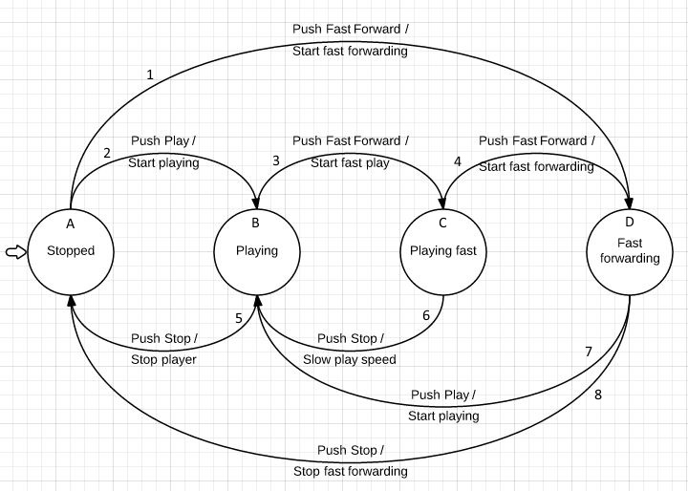Draw a state transition diagram
* Determine the level of coverage – All states are covered with all possible valid transitions

Make 0-switch and 1-switch coverage.

|  |  |  |  |  |  |
| --- | --- | --- | --- | --- | --- |
| 0 - switch | | 1 - switch | | | |
| A1 | A2 | A1D7 | A1D8 | A2B3 | A2B5 |
| B3 | B5 | B3C4 | B3C6 | B5A1 | B5A2 |
| C4 | C6 | C4D7 | C4D8 | C6B3 | C6B5 |
| D7 | D8 | D7B3 | D7B5 | D8A1 | D8A2 |

* Make a state transition table from the diagram



* Define logical test cases



1. Using that State Transition Diagram, complete the state transition table below.

Create logical test cases based on that diagram.

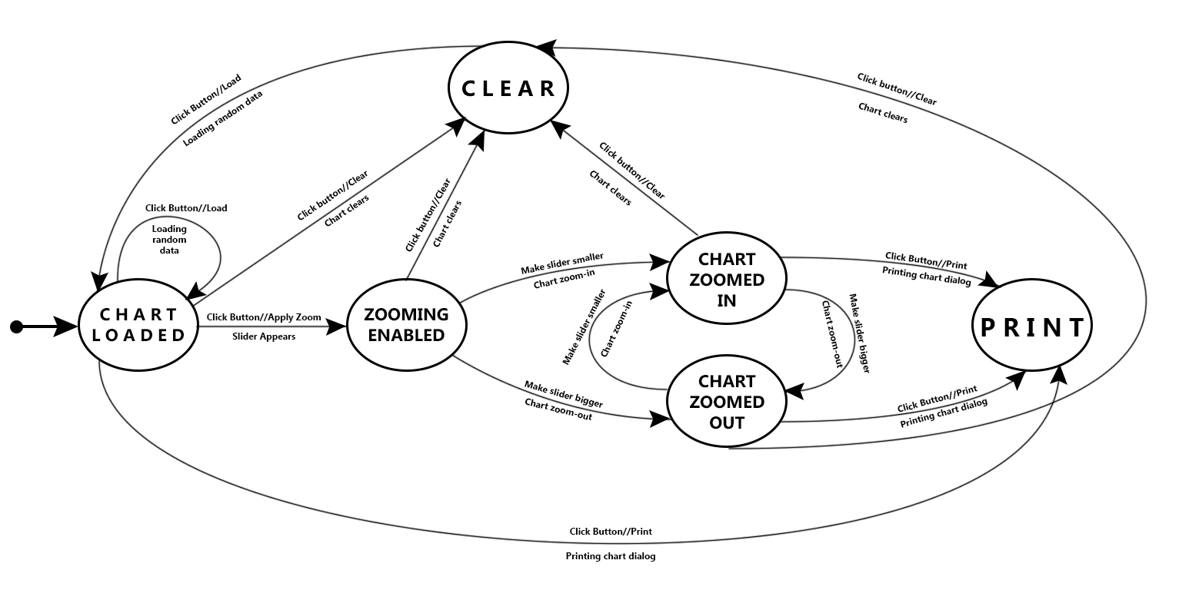



Finished in the Excel file: ChartTables.xlsx

**Pairwise Testing**

1. Determine the set of pairwise test cases for the examples below. Do it once by using an orthogonal array and once again – using an all-pairs algorithm
2. Suppose you need to test compatibility of various kiosk configurations based on three major factors, each set to one of the options shown:

Operating System: Windows XP or Linux

Browser: Internet Explorer (Windows only), Netscape, or Opera

Connection: DSL, dial-up, or cable

Completed in the Excel file: PairwiseTesting.xlsx / Sheet: TaskA

1. Suppose you need to test a web site and the combinations of software it should operate with, considering the following factors:

Browser - Internet Explorer, Netscape, Mozilla, and Opera

Plug-in - None, RealPlayer, and MediaPlayer

Client operating system - Windows 95, 98, ME, NT, 2000, and XP

Server - IIS, Apache, and WebLogic

Server operating system - Windows NT, 2000, and Linux

Completed in the Excel file: PairwiseTesting.xlsx / Sheet: TaskB