RODS TECH SKILLS SHOWCASE 2026

TruthShift
Project documentation: features, tech stack, architecture, scoring method and datasets
Team: [Team name] · [Member 1], [Member 2], [Member 3], [Member 4], [Member 5]
Date: October 15, 2026
Challenge: The Ethical Consumer Compass (Regina Open Door Society)

1. Overview 2
2. Features 2
3. Tech stack 3
4. Architecture 3
5. Scoring method 4
6. Datasets 5
7. How to run and customize 7
Backend (API on http://localhost:8000, docs at /docs) 7
Frontend (app on https://localhost:5173) 7
8. Business model and running costs 7
How it is paid for 8
Free vs Plus (proposal) 8
Running costs (USD per month, October 2026) 8
9. Limitations and future work 9
Next steps 9

1. Overview
TruthShift is a web app that scores grocery products against each shopper’s own values, and shows how sure it is about every fact. We built it for the Regina Open Door Society (RODS) Tech Skills Showcase 2026 challenge, “The Ethical Consumer Compass”.
The problem. People want to buy Canadian, support Regina businesses, choose fair trade, protect animal welfare and cut packaging waste. The information they need (where a product is made, who owns the company, how workers and animals are treated, what happens to the packaging) is scattered and hard to compare.
Our solution. The shopper sets how much each issue matters to them. They scan or search a product and get a personal score from 0 to 100, a plain-language explanation, and better alternatives at a similar price in nearby stores. Every fact carries an evidence label: Verified, Claimed by the business, or Unknown. Unknown facts never count against a product; they lower a separate confidence meter instead. The app is built for newcomers to Regina, with English and French screens and local recycling guidance.

2. Features
The app has five screens, and each one answers part of the challenge brief.
Screen | What the shopper does | Challenge point it answers
My priorities | Sets 7 sliders (Buy Canadian, Support Regina/SK, Fair trade, Animal welfare, Environment, Low-waste packaging, Affordability) or picks a preset | Users set their own priorities; different definitions of ethical
Scan & search | Scans a barcode with the camera or a photo, types a barcode, or searches by name. Gets a personal score, confidence meter, evidence badge on every fact, Canadian-content tier, Regina recycling tip and better alternatives with the price difference | Buy Canadian scanner; barcode app that explains its score
Compare | Sees every product in a category side by side, sorted by their own score | Ethical product comparison tool; personalized dashboard
Ask TruthShift | Asks in plain words (“Canadian, no plastic, under $5”) and gets a ranked list, plus a written answer from Claude in English or French | AI shopping assistant
Nearby | Picks an area or shares location; sees Regina stores on an OpenStreetMap map with distances and the best picks at each store | Local shopping tool; geo-locator; availability

Three design choices answer the brief’s “communicate uncertainty and avoid misleading consumers” point directly:
- Evidence labels. Every fact is Verified, Claimed or Unknown, and the source is shown.
- Unknown is not bad. Unknown facts are left out of the score and lower a separate confidence meter. Products with fewer than 40% of facts known get a “Limited data” flag.
- Canadian-content tiers. “Product of Canada”, “Made in Canada with imported ingredients”, “Canadian-owned” and “Imported” are kept apart instead of one Canadian checkmark.
The brief also asks for price and access context. The app shows price differences on every alternative, includes affordability as a priority, and lists which nearby stores carry each product.

3. Tech stack
The app is a React single-page app talking to a Python FastAPI backend; the dataset lives in plain JSON files.
Layer | Technology | Why we chose it
Frontend | React 19 + Vite 8 (JavaScript) | Component-based UI that is easy to extend; Vite gives instant reloads
Maps | Leaflet 1.9 + React Leaflet 5, OpenStreetMap tiles | Free, open map data; no API key needed
Barcode scanning | html5-qrcode 2.3 | Reads EAN/UPC barcodes from the camera or an uploaded photo, in the browser
Backend | Python 3.13, FastAPI, Uvicorn | Simple to read, fast, and auto-generates interactive API docs at /docs
HTTP client | httpx | Calls the Open Food Facts API from the backend (avoids browser CORS limits)
AI assistant | Anthropic Python SDK, model claude-opus-5-5 at low effort, with refusal fallbacks | Writes plain-language answers in English or French using only our data. Optional: runs only when an API key is set
Data | JSON files (products, stores, reference tables) | Anyone on the team can edit them without touching code
Real product data | Open Food Facts API | Free, open, crowd-sourced database with Canadian products

4. Architecture
The browser only talks to our backend; the backend owns the dataset, the scoring rules and every outside API except the map tiles.
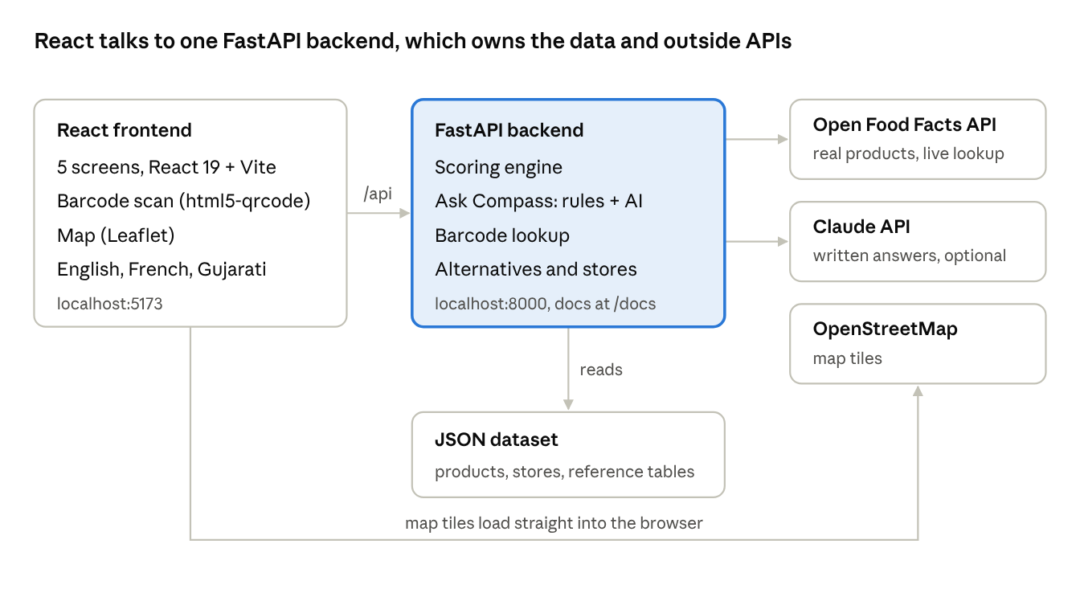
Figure 1. System architecture
Scoring runs on the backend, so the same rules serve every screen and could serve a future mobile app.
Endpoint | Method | What it returns
/api/meta | GET | Factors, Canadian-content tiers, categories, default weights, dataset counts
/api/stores | GET | All Regina stores with coordinates
/api/score | POST | Every product (optionally filtered by category or search text) with score, confidence and breakdown for the given weights
/api/products/{id} | POST | One product’s breakdown, up to 3 better alternatives, and the stores that carry it
/api/barcode/{code} | GET | A product by barcode: our dataset first, then a live Open Food Facts lookup
/api/ask | POST | Rule-based ranking for a plain-language question, plus Claude’s answer when an API key is set
/api/health | GET | Health check

5. Scoring method
The personal score is a weighted average of only the facts we know, weighted by how much the shopper cares and how trustworthy each fact is.
score = Σ (w × t × s) ÷ Σ (w × t)
confidence = Σ (w × t) ÷ Σ w
Here w is the shopper’s weight for a factor (0 to 5), s is the factor’s score (0 to 100), and t is the trust given to its evidence.
Evidence | Trust t | Effect
Verified (certifier, government, registry) | 1.0 | Counts fully
Claimed (company or community database) | 0.6 | Counts, but less
Unknown | 0 | Left out of the score; lowers confidence
Not applicable (e.g. animal welfare for pasta) | — | Ignored completely

- Confidence labels: High at 75% or more, Medium at 45% or more, otherwise Low. Below 40% the product is flagged “Limited data”.
- Affordability is relative within a category: the cheapest product scores 100 and the most expensive scores 0.
- Rankings (alternatives, Ask TruthShift) multiply the score by (0.5 + 0.5 × confidence), so well-documented products rank above ones we know little about.
- Explanations are generated from the same numbers: the two strongest factors, the weakest ones, which facts are only claimed, and which are unknown.
Worked example. With the default priorities, Prairie Creamy Peanut Butter (a demo product) scores 76 with Medium confidence: strong on Support Regina and Buy Canadian, two facts only claimed by the company, and fair trade unknown, so it is not counted against it.

6. Datasets
The app serves 118 products in 18 categories: 46 synthetic demo products we wrote, and 72 real products sold in Canada, imported from Open Food Facts.
Dataset | File | Size | Real or synthetic | Evidence status
Demo products | backend/data/products_synthetic.json | 46 products, 18 categories | Synthetic: fictional brands, invented certifications, ownership and prices (allowed by the challenge) | Verified, claimed, unknown or N/A per fact
Real products | backend/data/products_off.json | 72 products, 12 categories (6 each) | Real, from Open Food Facts (ODbL licence), imported with scripts/import_off.py | Claimed (crowd-sourced) or unknown; no prices
Live barcode lookups | In memory only | Any barcode scanned | Real, from the Open Food Facts product API | Same as above
Regina stores | backend/data/stores.json | 10 stores | 7 real chains or markets with approximate coordinates; 3 fictional independent grocers | N/A
Reference tables | backend/data/reference.json | 7 factors, 4 Canadian-content tiers | Written by us from the CFIA “Product of Canada” / “Made in Canada” labelling rules | N/A
Map | OpenStreetMap tiles | Regina | Real, loaded live | N/A

Across the 46 demo products, the 276 facts break down as 139 verified, 42 claimed, 38 unknown and 57 not applicable.
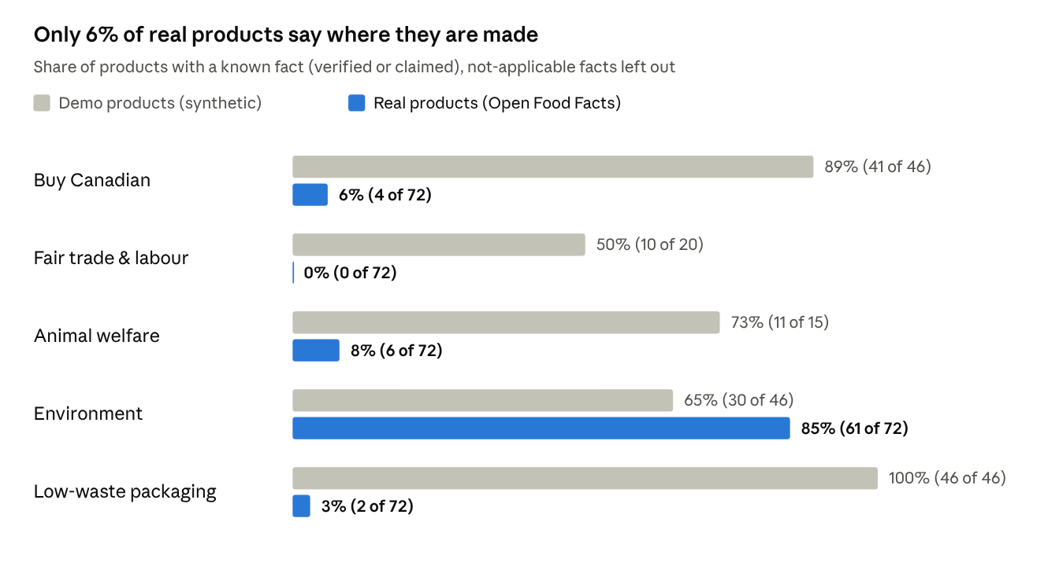
Figure 2. Share of products with a known fact, demo vs real data
The real data shows why the evidence labels matter: 68 of the 72 real products don’t list where they are made, and none record a fair-trade label. Only the Eco-Score (85% of products) is usually present. A tool that scored missing facts as zero would call almost every real product unethical.
Background facts in the demo notes (CFIA label tiers, Saskatchewan as a major lentil and wild-rice producer, Canadian supply-managed eggs and milk) were written from general knowledge and should be checked before any public launch.

7. How to run and customize
Easiest way: double-click truthshift/start.bat on Windows (or run ./start.sh on Mac/Linux). It installs packages the first time and starts both servers. Python 3.10+ and Node.js 20+ are required. To start them by hand, use two terminals:

Backend (API on http://localhost:8000, docs at /docs)
cd truthshift/backend
pip install -r requirements.txt
uvicorn app.main:app --port 8000

Frontend (app on https://localhost:5173)
cd truthshift/frontend
npm install
npm run dev
To turn on Claude’s written answers, set an Anthropic API key before starting the backend (PowerShell: $env:ANTHROPIC_API_KEY="sk-ant-..."). Without a key, Ask TruthShift still works using the rule-based ranking.
To change | Edit | Code change?
Add or fix a product | backend/data/products_synthetic.json | No, restart the backend
Add a store | backend/data/stores.json | No
Factor names, Canadian-content tiers | backend/data/reference.json | No
Refresh real products | python -m scripts.import_off (in backend/) | No
Trust levels, default weights | backend/app/scoring.py | Small
Add a language | frontend/src/i18n.js (copy the en block) | Small
Priority presets | frontend/src/components/Priorities.jsx | Small

On an Android phone: connect the phone to the same Wi-Fi, open the Network: https://…:5173 address that Vite prints in Chrome, tap Advanced → Proceed on the certificate warning, and allow the camera. The app is served over https with a local certificate, so live barcode scanning works. Chrome menu → Add to Home screen gives a TruthShift app icon.

8. Business model and running costs
TruthShift stays free for every shopper, because its main users are newcomers on tight budgets. One rule protects the app’s purpose: money never changes a score. Only evidence does.

How it is paid for
Source | Who pays | How it works
Grants | Settlement agencies, City of Regina, community foundations | The app supports newcomer integration and local business, which matches their funding goals
Verified listings | Local Regina businesses | A business pays to have its claims checked (ownership, certifications). If the evidence holds, the fact changes from Claimed to Verified. Paying never raises a score.
TruthShift Plus (future) | Shoppers who want extra features | Optional subscription, proposed at about $3 a month; free for RODS clients through a sponsorship

Free vs Plus (proposal)
Free (for everyone, always) | TruthShift Plus (~$3/month, proposed)
Scanning and personal scores | Unlimited AI assistant
Evidence label on every fact | Shopping-list planner that finds the best store
Compare, store map, all languages | Price-drop alerts from store flyers
A few AI questions a day | Family profiles

Today every feature is free and there is no limit on AI questions; the Plus features and the daily limit are proposals to test with users.

Running costs (USD per month, October 2026)
Item | Cost | Notes
Frontend hosting | $0 | React app as a free static site
Backend hosting | $7 | Render Starter web service (0.5 CPU, 512 MB)
Domain (.ca) | ~$1 | About $8–10 a year
Product data | $0 | Open Food Facts (open data, ODbL)
Maps | $0 to start | OpenStreetMap; at higher traffic a provider such as MapTiler (free up to 5,000 sessions a month, non-commercial)
AI answers | ~$0.02 per question | Claude (claude-opus-5-5) with prompt caching; each question sends about 12,000 tokens of product data

That is about $8 a month to launch, about $28 a month with 1,000 AI questions, and about $208 a month with 10,000. The AI is the only cost that grows with use, which is why unlimited AI is the Plus feature. These are estimates from public prices; check them before launch.
Sources: Render pricing, MapTiler Cloud pricing, .ca domain prices, Claude API pricing (Anthropic).

9. Limitations and future work
The biggest limitation is data: most product facts are synthetic, so the scores demonstrate the method rather than judge real brands.
- Synthetic products. All 46 demo products use fictional brands; certifications, ownership and prices are invented. Real products from Open Food Facts carry only crowd-sourced facts, no prices and no store availability.
- Approximate locations. Store coordinates are approximate, and three independent grocers are fictional.
- Regina recycling tips were written from general knowledge and should be checked against the City of Regina’s official waste guide.
- No accounts. Priorities are saved only in the shopper’s browser.
- AI answers need an API key and cost a small amount per question.

Next steps
- Photograph labels of 20 to 30 real products at Regina stores and replace the synthetic records
- Check certifications against Fairtrade Canada, Certified Humane and organic registries
- Add real prices from store flyers and a weekly price tracker
- Add more languages used by RODS clients (Arabic, Ukrainian, Tigrinya, Dari)
- Deploy with https so the phone camera scanner works everywhere

