**SVKM’s NMIMS**

**School of Technology Management & Engineering, Chandigarh**

A.Y. 2023 - 24

**Course: Database Management Systems**

**Project Report**

|  |  |  |
| --- | --- | --- |
| Program |  | |
| Semester |  | |
| Name of the Project: |  | |
|  | | |
| Details of Project Members |  |  |
| Batch | Roll No. | Name |
|  |  |  |
|  |  |  |
|  |  |  |
| Date of Submission: | | |

**Contribution of each project Members:**

|  |  |  |
| --- | --- | --- |
| Roll No. | Name: | Contribution |
|  |  |  |
|  |  |  |

**Github link of your project:**

**Note:**

1. Create a readme file if you have multiple files
2. All files must be properly named (Example:R004_DBMSProject)
3. Submit all relevant files of your work ( Report, all SQL files, Any other files)
4. **Plagiarism is highly discouraged (Your report will be checked for plagiarism)**

**Rubrics for the Project evaluation:**

|  |  |
| --- | --- |
| First phase of evaluation:  Innovative Ideas (5 Marks)  Design and Partial implementation (5 Marks) | 10 marks |
| Final phase of evaluation  Implementation, presentation and viva, Self-Learning and Learning Beyond classroom | 10 marks |

**Project Report**

**Selected Topic**

**by**

**Student 1, Roll number: xx**

**Student 2, Roll number: xx**

**Student 3, Roll number: xx**

**Course: DBMS**

**AY: 2023-24**

**Table of Contents**

|  |  |  |
| --- | --- | --- |
| **Sr no.** | **Topic** | **Page no.** |
| **1** | Storyline |  |
| **2** | Components of Database Design |  |
| **3** | Entity Relationship Diagram |  |
| **4** | Relational Model |  |
| **5** | Normalization |  |
| **6** | SQL Queries |  |
| **7** | Learning from the Project |  |
| **8** | Project Demonstration |  |
| **9** | Self-learning beyond classroom |  |
| **10** | Learning from the project |  |
| **8** | Challenges faced |  |
| **9** | Conclusion |  |

Title: Enhancing Banking Operations through a Robust Database System*

**I. Storyline**

*Storyline:*

In the dynamic landscape of modern banking, where transactions occur in milliseconds and customer data is the lifeblood of operations, our team embarked on a mission to revolutionize banking systems through the development of a comprehensive database solution. Our journey was fueled by a commitment to efficiency, accuracy, and security, recognizing the pivotal role technology plays in shaping the future of finance.In the dynamic landscape of modern banking, where transactions occur in milliseconds and customer data is the lifeblood of operations, our team embarked on a mission to revolutionize banking systems through the development of a comprehensive database solution. Our journey was fueled by a commitment to efficiency, accuracy, and security, recognizing the pivotal role technology plays in shaping the future of finance.

**II. Components of Database Design**

*Components of Database Design:*

1. *Data Modeling*: We meticulously analyzed the intricate web of banking operations, identifying key entities such as customers, accounts, transactions, and employees. Through Entity-Relationship Diagrams (ERD) and thorough stakeholder consultations, we delineated the relationships between these entities, laying the foundation for a cohesive data model.

2. *Normalization*: Recognizing the significance of data integrity, we embarked on the process of normalization, dissecting the sprawling datasets into manageable fragments. By adhering to normalization forms, we eradicated redundancy and dependency issues, ensuring that each piece of information was stored in the most efficient and logical manner.

3. *Database Management System (DBMS)*: After careful evaluation of various options, we selected a DBMS that aligned with the unique requirements of banking operations. Factors such as scalability, reliability, and compatibility were meticulously weighed, culminating in the adoption of a robust system capable of handling the rigors of real-time financial transactions.

4. *Security Measures*: With cyber threats looming large in the digital realm, fortifying our database against potential breaches was paramount. We implemented a multi-layered security framework encompassing encryption protocols, access control mechanisms, and comprehensive audit trails. These measures fortified the system's defenses, safeguarding sensitive financial data from unauthorized access or tampering.

5. *User Interface*: Recognizing that the efficacy of our database hinged on user acceptance and adoption, we devoted significant attention to crafting an intuitive and user-friendly interface. Through iterative design processes and usability testing, we fine-tuned the interface to empower bank employees with seamless access to critical functionalities, thereby enhancing productivity and user satisfaction.

**III. Entity Relationship Diagram**

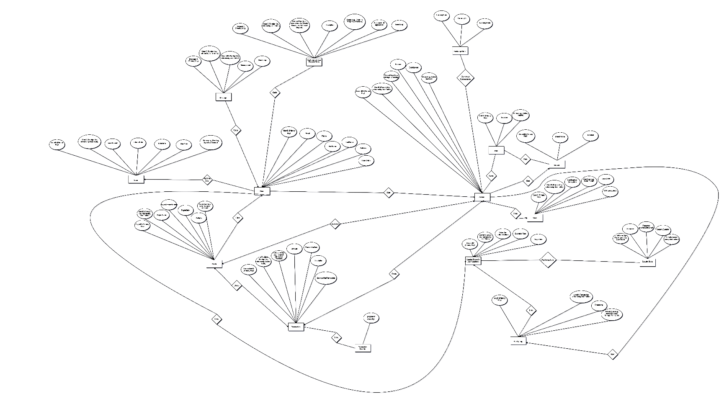

**IV. Relational Model**

Convert the ER diagram to the relational model using the concepts learned in the class.

List the various tables obtained.

**V. Normalization**

Perform normalization (1NF, 2NF, 3NF, BCNF) as applicable for the entire database.

**VI. SQL Queries**

Create database Project;

use Project;

create table User(

Username varchar(20),

Pass varchar(22),

FirstName varchar(20),

LastName varchar(20),

EmailPhone varchar(20),

Address varchar(20),

DateOfBirth numeric,

UserID numeric,

Primary Key(UserID));

create table Account(

AccountID numeric,

UserID numeric,

AccountType varchar(4),

Balance numeric,

DateOpened numeric,

Status_acc varchar(8),

primary key(AccountID),

foreign key(UserID)references User(UserID));

create table Transaction(

TransactionID numeric,

AccountType varchar(4),

AccountID numeric,

Balance numeric,

DateOpened numeric,

Status_acc varchar(8),

TransactionType varchar(10),

Amount numeric,

TransactionDate numeric,

Description_Trans varchar(22),

BalanceAfterTransaction numeric,

primary key(TransactionID),

foreign key(AccountID)references Account(AccountID));

create table Payee(

PayeeID numeric,

Primary Key(PayeeID),

UserID numeric,

foreign key(UserID)references User(UserID),

PayeeName varchar(22),

PayeeAccountNumber numeric,

PayeeBank varchar(22),

Autopay char(2),

PayeeType varchar(10));

create table Session_table(

SessionID numeric,

Primary Key(SessionID),

UserID numeric,

foreign key(UserID)references User(UserID),

Token char(5),

ExpirationTime numeric,

LoginTime numeric);

create table Security_Table(

UserID numeric,

foreign key(UserID)references User(UserID),

SecurityQuestion varchar(22),

SecurityAnswer varchar(22));

create table Card_Table (

CardID numeric,

Primary Key(CardID),

UserID numeric,

foreign key(UserID)references User(UserID),

CardNumber numeric,

CardType varchar(15),

ExpiryDate numeric,

CVV numeric);

create table Interest_Rate(

AccountType varchar(10),

InterestRate float);

create table Loan_Table(

LoanID numeric,

Primary Key(LoanID),

UserID numeric,

foreign key(UserID)references User(UserID),

LoanAmount numeric,

InterestRate float,

LoanTerm numeric,

StartDate numeric,

Loan_Status varchar(15));

create table Message_Table(

MessageID numeric,

Primary Key(MessageID),

UserID numeric,

foreign key(UserID)references User(UserID),

MessageText varchar(20));

create table Exchange_Rate (

CurrencyFrom varchar(15),

CurrencyTo varchar(15),

ExchangeRate numeric);

create table Branch_Table(

BranchID numeric,

Primary Key(BranchID),

BranchName varchar(20),

Location varchar(22));

create table ATM_Table(

ATMID numeric,

Primary Key(ATMID),

Location varchar(20),

ATM_Status varchar(22));

create table Customer_Service_Request(

RequestID numeric,

Primary Key(RequestID),

UserID numeric,

foreign key(UserID)references User(UserID),

RequestType varchar(22),

CSR_Description varchar(22),

CSR_Status varchar(10),

AssignedTo varchar(22));

create table Activity_Log(

LogID numeric,

Primary Key(LogID),

UserID numeric,

foreign key(UserID)references User(UserID),

ActivityType varchar(22));

**VI. Project demonstration**

*Project Demonstration:*

During the project demonstration, we orchestrated an immersive showcase of our banking database system, meticulously designed to encapsulate the essence of our efforts and the transformative potential of our solution. The demonstration served as a pivotal moment, wherein stakeholders, ranging from bank executives to IT specialists, embarked on a journey of discovery through the intricacies of our creation.

*Live System Simulation*: To provide stakeholders with a firsthand experience of our system's capabilities, we simulated real-world banking scenarios within a controlled environment. Through a seamless integration of user interfaces, backend functionalities, and data processing algorithms, we facilitated live demonstrations of account creation, fund transfers, balance inquiries, and transaction histories. Stakeholders were invited to interact with the system, exploring its features and functionalities with a sense of immersion and engagement.

*Comprehensive Feature Showcase*: Our demonstration encapsulated a comprehensive array of features designed to cater to the diverse needs of banking operations. From customer onboarding to transaction processing, each feature was meticulously curated to showcase the system's versatility, reliability, and user-friendliness. We highlighted functionalities such as multi-level authentication, transaction categorization, real-time data updates, and customizable reporting tools, underscoring the breadth and depth of our solution.

*Scalability and Performance Benchmarking*: In addition to showcasing core functionalities, we conducted rigorous performance benchmarking tests to demonstrate the system's scalability and robustness. Through simulated stress tests and load balancing scenarios, we showcased the system's ability to handle peak transaction volumes with minimal latency and downtime. Stakeholders witnessed firsthand the system's resilience under varying workloads, instilling confidence in its ability to scale alongside the evolving needs of the bank.

*Interactive Q&A Sessions*: To foster engagement and facilitate a deeper understanding of our solution, we curated interactive Q&A sessions wherein stakeholders could pose questions, share feedback, and engage in constructive dialogue. These sessions served as a platform for clarifying technical intricacies, addressing concerns, and soliciting suggestions for further enhancements. By fostering open communication and collaboration, we fostered a sense of ownership and partnership among stakeholders, laying the groundwork for future iterations and improvements.

*Visualizations and Impact Metrics*: To contextualize the significance of our solution, we leveraged data visualizations and impact metrics to illustrate its tangible benefits. Through intuitive dashboards, charts, and graphs, we showcased key performance indicators such as transaction processing times, error rates, and cost savings achieved through process optimization. Stakeholders gained a holistic understanding of the transformative impact of our solution on operational efficiency, customer satisfaction, and regulatory compliance.

*Strategic Roadmap Presentation*: Concluding the demonstration, we presented a strategic roadmap outlining future enhancements, expansion plans, and potential integration with emerging technologies. By articulating our vision for the evolution of the banking database system, we instilled a sense of anticipation and excitement among stakeholders, inspiring confidence in our ability to adapt and innovate in response to evolving market dynamics and technological advancements.

In essence, our project demonstration transcended mere technical showcase, serving as a testament to our collective ingenuity, dedication, and vision for redefining the future of banking through cutting-edge technology and innovation. As stakeholders departed with a newfound appreciation for the transformative potential of our solution, we embarked on the next phase of our journey with renewed determination and resolve, poised to usher in a new era of excellence in banking operations.

*Self-learning beyond the Classroom:*

Beyond the confines of traditional education, we embraced a culture of lifelong learning, leveraging a myriad of resources to augment our knowledge and skills. Online courses, industry forums, and scholarly publications served as beacons of enlightenment, offering insights into emerging trends, best practices, and cutting-edge technologies in the realm of database management and banking technology.

**VII. Self -Learning beyond classroom**

:

* What new aspects did you learn on your own ? You have to mention learning beyond the classroom

**VIII. Learning from the Project**

*Learning from the Project:*

- *Team Collaboration*: The project underscored the importance of effective collaboration and communication within a team setting. By leveraging each team member's strengths and expertise, we fostered an environment conducive to innovation and problem-solving.

- *Domain Knowledge*: Immersion in the intricacies of banking operations provided invaluable insights into the complexities of financial transactions, regulatory compliance, and customer relationship management. This deepened understanding laid a robust foundation for informed decision-making and solution development.

- *Problem-solving Skills*: The project presented a myriad of challenges, from data complexity to security concerns. By adopting a systematic approach to problem-solving and embracing creativity in finding solutions, we honed our ability to navigate obstacles and adapt to evolving requirements.

- *Technical Proficiency*: Hands-on experience with database design and management elevated our technical proficiency to new heights. From schema design to query optimization, each phase of the project served as a crucible for refining our skills and expanding our knowledge base.

**IX. Challenges Faced**

Expanding on the challenges faced during the development of our banking database system provides deeper insight into the complexities inherent in such a project:

1. *Data Complexity and Volume*: The sheer magnitude and intricacy of banking data presented a formidable challenge. Managing diverse datasets including customer profiles, transaction histories, and regulatory information required sophisticated data modeling techniques and robust storage solutions. Wrangling with vast volumes of data while maintaining optimal performance demanded meticulous planning and execution.

2. *Security Concerns and Compliance*: Safeguarding sensitive financial data against cyber threats and ensuring compliance with stringent regulatory requirements emerged as a critical challenge. Balancing the imperatives of data security with the need for seamless accessibility posed a delicate balancing act. Implementing comprehensive security measures such as encryption, access controls, and audit trails necessitated meticulous attention to detail and constant vigilance against emerging threats.

3. *Integration with Legacy Systems*: The integration of our modern database system with existing legacy systems posed significant interoperability challenges. Ensuring seamless data exchange and compatibility with disparate systems required intricate mapping of data schemas, middleware development, and rigorous testing to mitigate the risk of data corruption or loss. Addressing legacy system constraints while embracing modern technologies demanded creative solutions and robust change management strategies.

4. *User Adoption and Training*: Transitioning bank employees to the new database system necessitated comprehensive training and change management initiatives. Overcoming resistance to change and ensuring user buy-in required effective communication, user-centric design, and tailored training programs. Balancing the need for productivity with the learning curve associated with the new system posed challenges in optimizing the adoption process while minimizing disruption to daily operations.

5. *Scalability and Performance Optimization*: Anticipating future growth and ensuring the scalability of the database system emerged as a pressing concern. Designing a solution capable of accommodating increasing transaction volumes, expanding customer bases, and evolving regulatory requirements demanded meticulous capacity planning, performance tuning, and infrastructure optimization. Striking the right balance between scalability, performance, and cost-effectiveness required continuous monitoring, iterative refinement, and proactive capacity management strategies.

6. *Data Quality and Consistency*: Maintaining data quality and consistency across disparate systems and operational workflows presented a persistent challenge. Addressing data discrepancies, anomalies, and duplication required robust data governance frameworks, data validation mechanisms, and data cleansing processes. Ensuring the accuracy and reliability of data inputs while facilitating seamless data integration across the organization demanded a concerted effort to establish data quality standards and enforce data stewardship practices.

7. *Vendor Selection and Collaboration*: Choosing the right vendors for database management systems, security solutions, and integration tools posed a critical challenge. Evaluating vendor offerings, negotiating contracts, and ensuring alignment with project requirements demanded meticulous due diligence and vendor management expertise. Collaborating effectively with vendors to address technical challenges, resolve issues, and leverage vendor expertise necessitated strong relationship management and communication skills.

Navigating these challenges demanded a combination of technical expertise, strategic foresight, and collaborative teamwork. By embracing innovation, resilience, and a commitment to excellence, our team successfully overcame these obstacles, paving the way for the successful implementation of a cutting-edge banking database system poised to revolutionize banking operations

**X. Conclusion**

* What are the key takeaways from the project?

*Conclusion:*

In conclusion, the development of a banking database system epitomizes the convergence of technology, innovation, and domain expertise in reshaping the future of finance. Through meticulous planning, collaborative effort, and a relentless pursuit of excellence, we have crafted a solution poised to enhance efficiency, security, and customer satisfaction in banking operations. As we reflect on the challenges overcome and lessons learned, we emerge emboldened and empowered, ready to embrace the opportunities that lie ahead in the ever-evolving landscape of banking technology.