

Made By:

1)Nachiket Palekar(A175)

2)Yash Pandey(A122)

**Alarm Clock using Arduino**

**MM Project**

|  |  |
| --- | --- |
| **SR NO** | **Topic** |
| 1  2  3  4  5  6  7  8 | Title of Project  About  Components  Why have we chosen this topic?  Connections  Circuit diagram  Code  Conclusion |

**About**

**Index**

In today's fast-paced world, waking up on time is crucial. Yet, traditional alarm clocks often lack the flexibility and customization desired by users. Enter the Arduino Alarm Clock—a revolutionary project designed to merge functionality with innovation. Through the powerful platform of Tinkercad, this project showcases how Arduino can be utilized to create a personalized, feature-rich alarm clock that not only wakes you up but does so in style.

**Features**

Customized Alarms: Say goodbye to generic alarm tones. With Arduino, users can personalize their wake-up experience by selecting from a wide range of tones, melodies, and even recorded messages.

LCD Display: A clear and intuitive LCD provides users with vital information such as current time, alarm settings, and even weather updates, making it a versatile addition to any bedside table.

Customized Timer: For specific work, the user wants to perform within the time.

Stopwatch: For measuring the time for particular tasks like (running, racing, etc)

Time: For checking normal time

**Components**

1. Arduino uno r3
2. Potentiometer (10k)
3. Buzzer
4. Pushbutton
5. Led
6. Resistor (10k) x 6

**Why have we chosen this topic?**

We have chosen the topic of creating an Arduino Alarm Clock on Tinkercad for several compelling reasons. Firstly, in today's digital age, where technology permeates every aspect of our lives, there is a growing interest in DIY electronics and home automation projects. An alarm clock is a common household item, but by integrating Arduino, we can elevate its functionality beyond mere timekeeping to offer customizable features that cater to individual preferences and lifestyles.

Moreover, the Arduino platform is renowned for its accessibility and versatility, making it an ideal choice for both beginners and experienced makers alike. By selecting this topic, we aim to showcase how Arduino can be leveraged to create practical solutions to everyday problems, fostering creativity and innovation within the maker community.

Additionally, Tinkercad provides a user-friendly platform for designing and simulating electronic circuits, making it an excellent tool for prototyping projects before transitioning to physical construction. By utilizing Tinkercad, we can demonstrate the iterative design process and encourage experimentation and refinement in project development.

Furthermore, the concept of an Arduino Alarm Clock presents an opportunity to explore various electronic components, such as sensors, actuators, and displays, thereby offering valuable hands-on experience in electronics and programming principles. This aligns with our goal of promoting STEM education and empowering individuals to develop essential skills for the future.

**Connections**

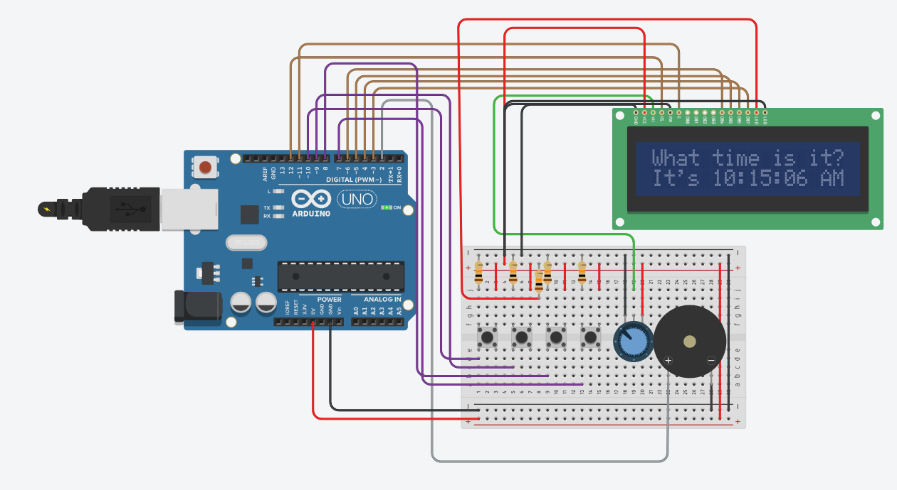

**Circuit diagram**

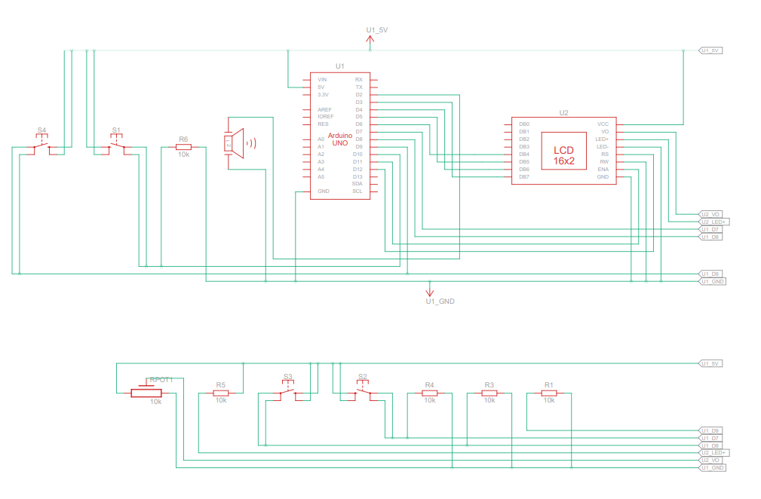

**Code**

<https://github.com/Nachiket-Palekar/MM-Mini-Project/blob/28c1d9f1605ecf5031bc710e6de2e78a597a0177/exquisite_bombul_leelo1.ino>

**Conclusion**

The Arduino Alarm Clock project on Tinkercad embodies the spirit of innovation and creativity by empowering users to reimagine their wake-up routine. By combining the versatility of Arduino with the accessibility of Tinkercad, this project opens doors to endless possibilities in the realm of DIY electronics. Whether you're a hobbyist, student, or technology enthusiast, the Arduino Alarm Clock invites you to wake up to a world of innovation.

**GitHub link of Project:-** <https://github.com/Nachiket-Palekar/MM-Mini-Project.git>