Employee Churn Analysis & Prediction
This project analyses 14,999 employee records to understand attrition behaviour and build a model that predicts churn risk. The dataset shows 3,571 employees left, representing an overall churn rate of 23.81%. The analysis combines exploratory analytics, clustering, machine learning, model interpretation, feature importance analysis, Power BI dashboarding, and business-focused recommendations to identify why employees leave an organization.

1. Business Problem
Employee attrition is one of the most critical problems faced by organizations. High churn leads to increased recruitment costs, productivity loss, reduced employee morale, and operational instability. The goal of this project is to identify patterns associated with employee churn and provide actionable insights that HR teams can use to improve employee retention.

2. Project Objectives
- Analyze employee behavior and satisfaction patterns
- Identify employee segments using clustering techniques
- Predict employee churn using machine learning models
- Understand the most important factors contributing to attrition
- Visualize churn patterns and employee segments
- Provide business recommendations to reduce employee turnover

3. Dashboard Overview
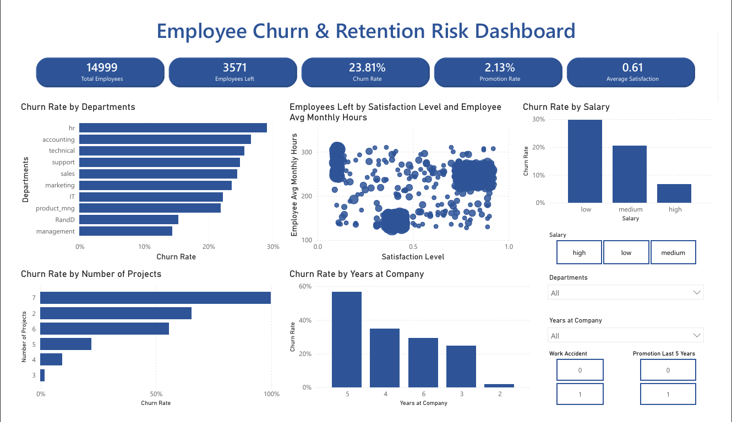

4. Key Dashboard Insights
- Employees in low salary bands exhibit the highest churn rate.
- HR and Accounting departments experience the highest employee attrition.
- Employees handling 6–7 projects are significantly more likely to leave the company.
- Employees staying around 5 years show elevated resignation patterns.
- Low satisfaction scores strongly correlate with employee churn.
- Employees with high satisfaction are leaving due to burnout.

5. Key Metrics
Metric | Value
Total Employees | 14,999
Employees Left | 3,571
Overall Churn Rate | 23.81%
Average Satisfaction | 0.61
Average Monthly Hours | 201.1
Model ROC-AUC | 0.980
Model F1 Score | 0.975

6. Dataset Information
Dataset Used: HR_comma_sep.csv
The dataset contains employee-level information such as satisfaction score, evaluations, workload, project count, average monthly hours, salary category, department, tenure, and attrition status.

7. Features Used
- satisfaction_level - Employee satisfaction score from 0 - 1
- last_evaluation - Latest performance evaluation score 0 - 1
- number_project - Number of projects assigned
- average_montly_hours - Average monthly working hours
- time_spend_company - Years spent at the company
- Work_accident - Whether the employee had a workplace accident 0 and 1
- promotion_last_5years - Whether the employee was promoted in the last 5 years 0 and 1
- salary - Salary level: low, medium, high
- Department - Employee department
- left (Target Variable) - Churn target variable 0-stayed and 1-left

8. Project Workflow
- Data loading and preprocessing using pandas
- Exploratory Data Analysis (EDA)
- Feature selection and scaling using StandardScaler
- Employee segmentation using KMeans Clustering
- Machine Learning churn prediction model development
- Feature importance analysis
- Model evaluation using Accuracy, Precision, Recall, F1-Score, and ROC-AUC
- Visualization of employee behavior and churn patterns
- Business recommendations and retention strategies

9. Clustering Analysis
KMeans clustering was used to segment employees into distinct behavioral groups based on satisfaction, workload, evaluations, project count, and tenure.
- Burnout Employees – low satisfaction and high workload with elevated churn risk
- Disengaged Employees – low engagement and reduced involvement
- Stable Employees – balanced workload with low attrition risk
- High-Performing Leavers – highly evaluated employees who still leave due to possible career stagnation

10. Machine Learning Model
A supervised machine learning model such as Logistic Regression and Random Forest Classifier was built to predict employee churn. The project includes preprocessing, train-test splitting, encoding categorical variables, model training, prediction, and evaluation. From the metrics I found that Random Forest was the better model over LR.
Metric | Value
Accuracy | 0.988
Precision | 0.987
Recall | 0.963
F1 Score | 0.975
ROC-AUC | 0.980

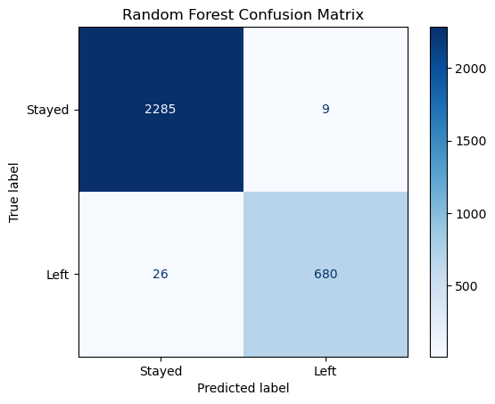
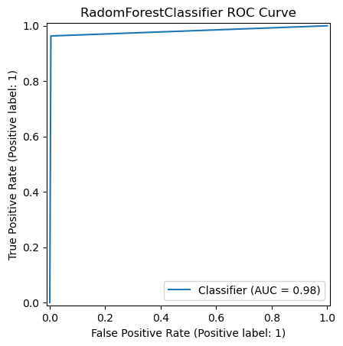

11. Feature Importance Analysis
Feature importance analysis was conducted to identify the strongest drivers of employee churn. The analysis showed that employee satisfaction, workload, project count, and monthly hours were among the most influential variables.
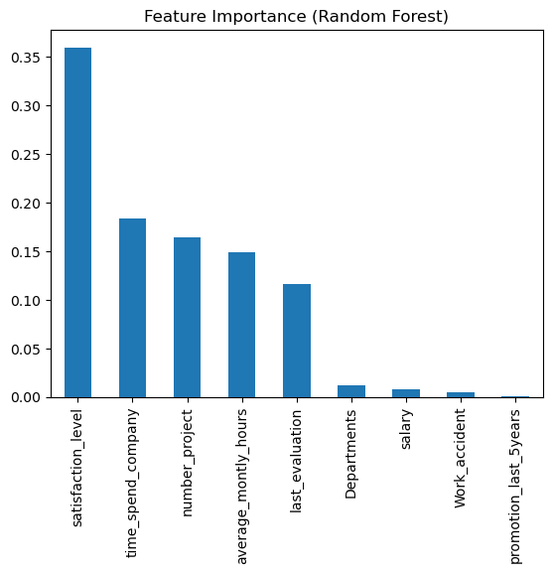

12. Key Insights
- Low satisfaction and high workload strongly correlate with churn.
- Burnout-driven employees exhibited the highest resignation rates.
- Long-tenure high performers also showed elevated churn risk.
- Some highly satisfied employees still left due to career growth limitations.
- Disengaged employees with low workload had high attrition.
- Employee satisfaction is one of the strongest retention indicators.

13. Business Recommendations
- Monitor employees with low satisfaction and high workload as a priority retention group.
- Review employees working on 6 or 7 projects to prevent burnout-related exits.
- Create promotion planning, salary benchmarking, and leadership pathways for experienced employees.
- Use stay interviews, role redesign, mentoring, and internal mobility to reconnect employees with meaningful work.
- Investigate salary competitiveness for low-salary groups with elevated churn.
- Use dashboard filters to identify high-risk departments and design targeted HR interventions.

14. Exploratory Data Analysis Visuals

Visualization 1
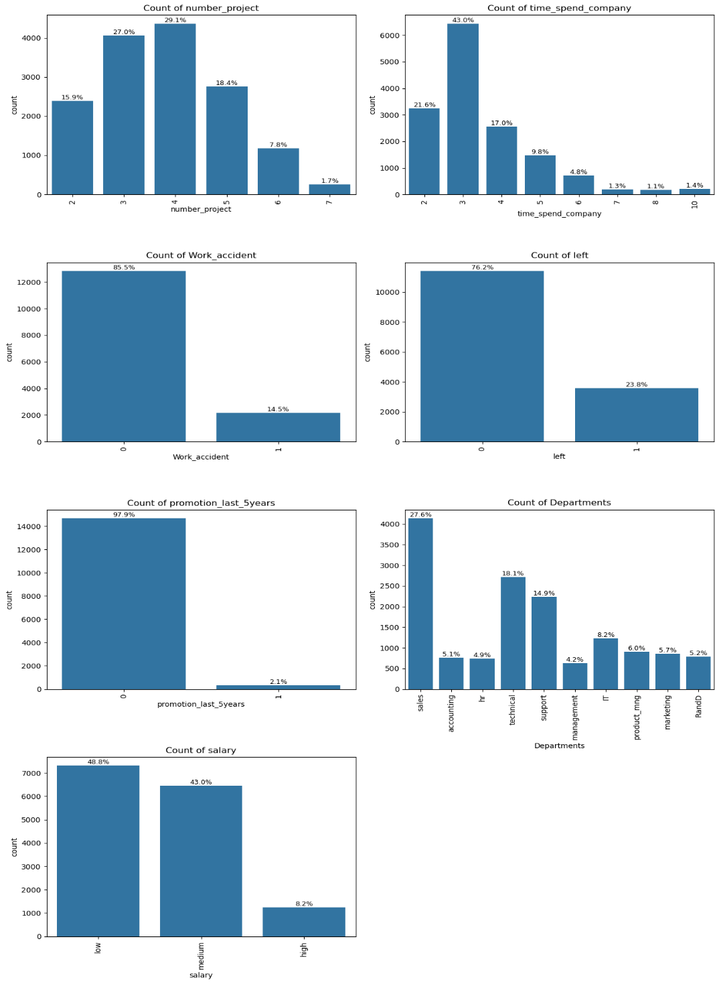
The chart provides insight into workload, tenure, salary level, departments, promotion and retention relationships within the organization.

Visualization 2
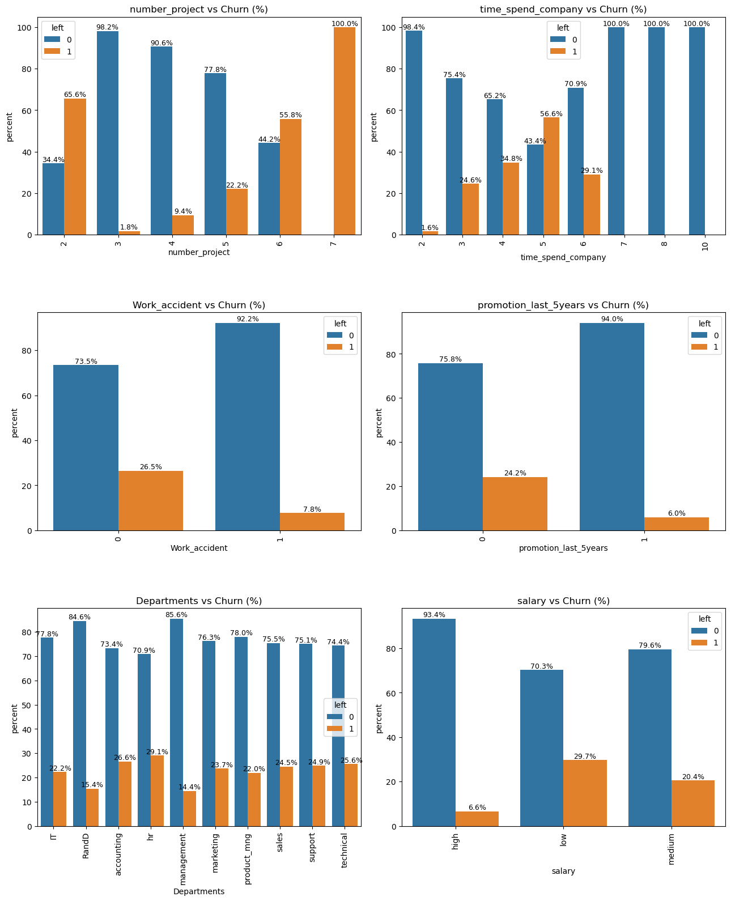
This visual demonstrates how employee behavior and HR metrics influence churn.

Visualization 3
The visualization supports decision-making by identifying high-risk categories contributing to attrition.
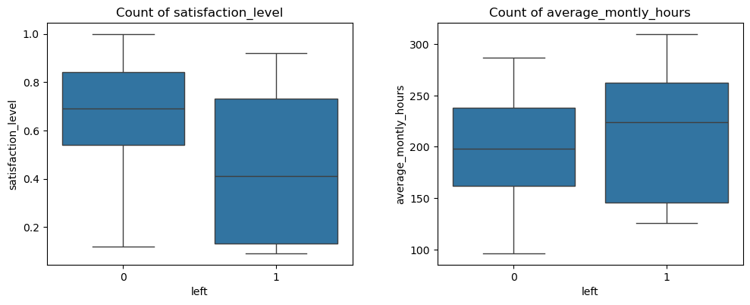

Visualization 4
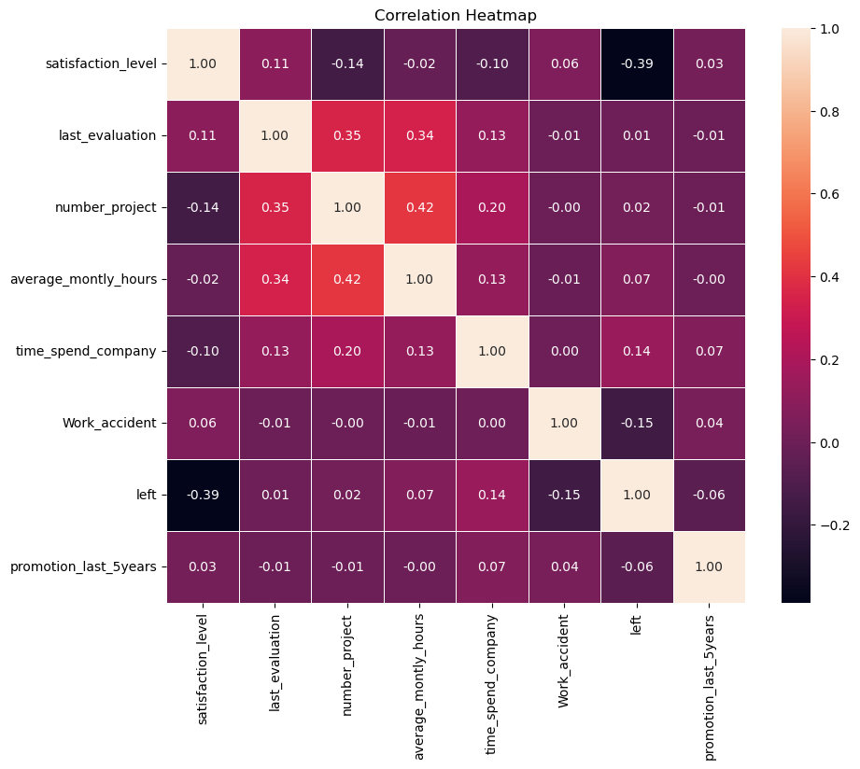
This visualization highlights employee churn distribution and helps identify attrition patterns across different employee features.

Visualization 5
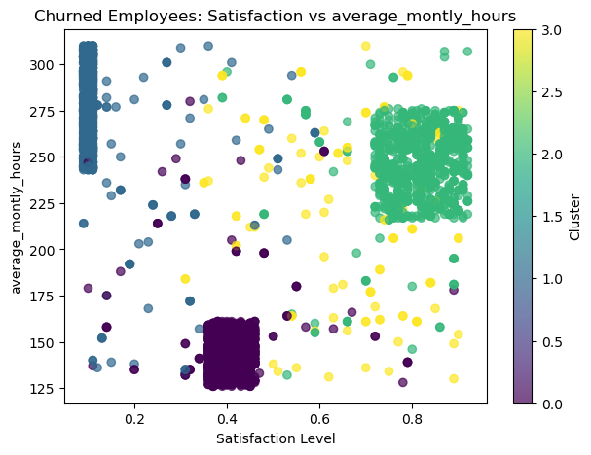
This visualization highlights employee churn within various segments of satisfaction vs workload.

Visualization 6
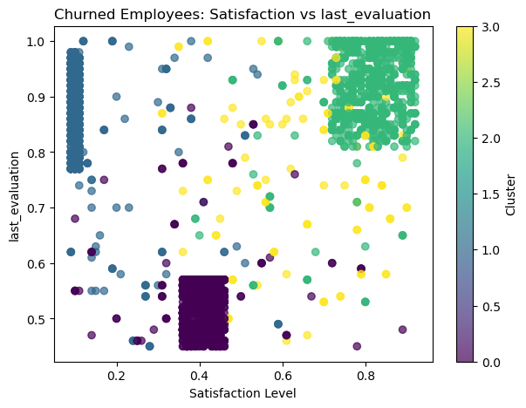
This visualization highlights employee churn within various segments of satisfaction vs last evaluation.

15. Skills Demonstrated
- Python data analysis with Pandas and NumPy
- Machine learning classification with Scikit-learn
- Unsupervised learning with KMeans clustering
- Model evaluation using precision, recall, F1-score, Confusion Matrix, and ROC-AUC
- Feature importance and model interpretation
- Power BI dashboard design
- Business storytelling and recruiter-ready communication

16. Tech Stack
- Python
- Pandas
- NumPy
- Scikit-learn
- Matplotlib
- Seaborn
- Jupyter Notebook
- VS Code
- Power BI

17. Conclusion
The analysis successfully identified key drivers behind employee attrition. satisfaction score, workload, tenure, and number of projects assigned were found to be major indicators of churn risk. The final Power BI dashboard transforms raw HR data into actionable business intelligence for HR teams and management.

