Factory Reallocation and Shipping Optimization for Nassau Candy Distributor
A data driven recommendation system using historical distributor orders
Prepared by Nachiket-kh
September 2026

Abstract
This paper presents a shipping-mode recommendation system for Nassau Candy Distributor using 10,194 historical order-line records. The dataset contains orders, customers, products, geography, shipping mode, sales, units, gross profit, and cost, but no factory-level attributes. The system validates and cleans the source data, constructs profitability and calendar features, evaluates three multiclass classifiers, and combines model probabilities with descriptive historical cost, profit, and delivery benchmarks. HistGradientBoosting achieved the strongest weighted F1 score among the evaluated models at 0.497, with top-three accuracy of 0.953. However, the most-frequent-mode baseline produced a higher top-one accuracy of 0.600, showing the importance of reporting baseline results and not overstating model performance. Factory reallocation is deliberately implemented as an extensible architecture rather than a fabricated recommendation because the source does not include factory locations, capacities, production costs, or product compatibility.

1 Introduction
Distributor operations require decisions about transportation speed, cost, service level, and inventory origin. A useful decision-support system should make its assumptions visible, distinguish historical association from causal effect, and avoid proposing operational entities that are absent from the data. This project addresses the available shipping-mode decision while preserving a pathway for future factory allocation when real factory configuration data is supplied.

2 Research Objectives
The study has four objectives: validate and profile the supplied transactional dataset; measure historical sales, cost, gross-profit, and shipping patterns; train and evaluate shipping-mode classifiers using only order-time and operational attributes; and provide an explainable recommendation that combines model likelihood with historical benchmarks. A separate objective is to define the minimum data contract required for real factory allocation.

3 Data and Validation
The primary source is Nassau Candy Distributor.csv. It contains 18 source columns and 10,194 records. All expected columns were present. The source contained no missing values and no exact duplicate rows. Numeric values were converted explicitly, dates were parsed day-first, and shipping_days was calculated as Ship Date minus Order Date.
Category | Observed result
Rows and source columns | 10,194 rows and 18 columns
Missing values | 0 across all source columns
Exact duplicate rows | 0
Order-date range | 2 Jan 2024 to 31 Dec 2025
Ship-date range | 30 Jun 2026 to 28 Jun 2030
Shipping-days range | 904 to 1,642 days
Countries | United States and Canada
Shipping-mode classes | Standard Class, Second Class, First Class, Same Day

The shipping-date range produces unusually long shipping durations. All calculated durations are non-negative, but the 904 to 1,642 day range is not operationally plausible for normal parcel delivery. The project does not alter these values because doing so would create unverified data. Shipping duration remains available for descriptive benchmarking and is prominently treated as a data-quality limitation.

4 Exploratory Findings
Total sales are $141,783.63, total cost is $48,340.83, total gross profit is $93,442.80, and total units are 38,654. Mean sales per order line are $13.91 and mean cost is $4.74. The mean line-level profit margin is 66.5 percent. Chocolate dominates the recorded business, while Pacific is the highest-sales region.
Division | Sales | Gross profit | Units
Chocolate | $131,692.90 | $88,824.62 | 37,275
Other | $9,663.25 | $4,333.45 | 1,242
Sugar | $427.48 | $284.73 | 137

Region | Sales | Gross profit | Units
Pacific | $46,301.53 | $30,485.94 | 12,466
Atlantic | $41,197.24 | $26,973.70 | 11,159
Interior | $32,037.60 | $21,282.49 | 8,820
Gulf | $22,247.26 | $14,700.67 | 6,209

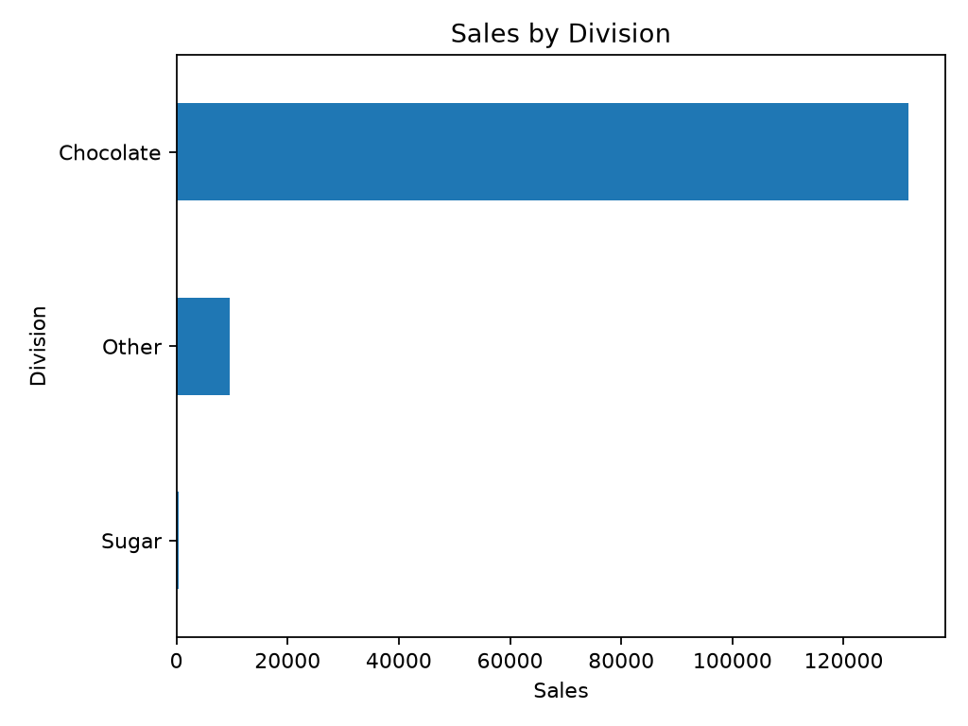
Figure 1. Sales by division from the supplied distributor data.
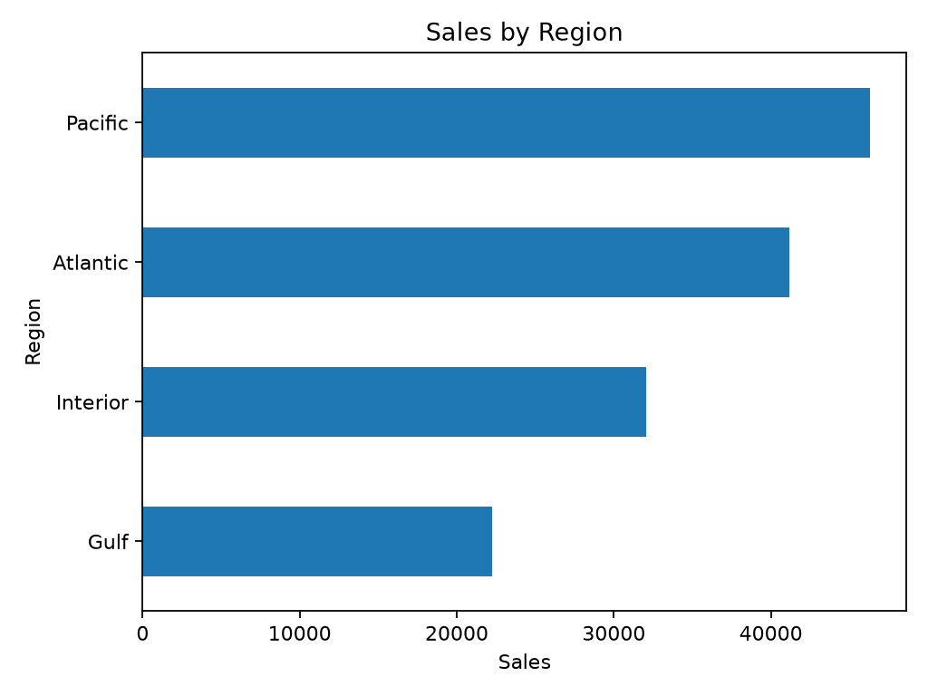
Figure 2. Sales by region from the supplied distributor data.

5 Feature Engineering and Leakage Control
Features include shipping days, profit margin, cost per unit, sales per unit, gross profit per unit, cost-to-sales ratio, units-to-sales ratio, order month, order year, order quarter, and order day of week. The classifier uses units, sales, cost, gross profit, selected calendar attributes, division, region, country, state or province, and product ID. No historical target aggregate is included in the classifier feature set. This avoids directly leaking shipping-mode information from target-derived aggregates into held-out prediction.

6 Modeling Method
Shipping mode is modeled as a multiclass classification target. The data is split with an 80 percent training and 20 percent test partition using stratification by shipping mode. A shared preprocessing pipeline median-imputes and standardizes numeric variables, most-frequent-imputes categorical variables, and one-hot encodes categories with unknown-category handling. Logistic Regression, Random Forest, and HistGradientBoosting are evaluated. Model selection uses weighted F1 because class frequency is imbalanced and performance across all observed shipping modes matters.
Model | Accuracy | Weighted precision | Weighted recall | Weighted F1 | Top-three accuracy
Logistic Regression | 0.239 | 0.445 | 0.239 | 0.277 | 0.801
Random Forest | 0.397 | 0.478 | 0.397 | 0.424 | 0.910
Hist Gradient Boosting | 0.595 | 0.511 | 0.595 | 0.497 | 0.953

HistGradientBoosting was selected because it had the strongest measured weighted F1 score (0.497). The frequency baseline, which always predicts the most common mode, achieved accuracy of 0.600. Therefore, the selected model is not presented as universally superior to the baseline. Its value is in probability-ranked alternatives and input-specific recommendations, while the baseline remains a necessary benchmark.

7 Cost Aware Recommendation Method
For each observed shipping mode, the system calculates historical average cost, shipping days, sales, gross profit, profit margin, and order count. Candidate modes are ranked by a configurable weighted score: 55 percent model probability, 20 percent lower historical cost, 15 percent higher historical gross profit, and 10 percent lower historical shipping duration. These weights are transparent configuration choices; they are not claimed to be mathematically optimal. The output includes the recommended mode, up to two alternatives, model confidence, benchmark table, and a data-backed explanation.
Ship mode | Order count | Average cost | Average gross profit | Average shipping days
Standard Class | 6,120 | $4.75 | $9.22 | 1,314.3
Second Class | 1,979 | $4.83 | $9.25 | 1,323.8
First Class | 1,548 | $4.72 | $9.05 | 1,338.3
Same Day | 547 | $4.41 | $8.59 | 1,333.4

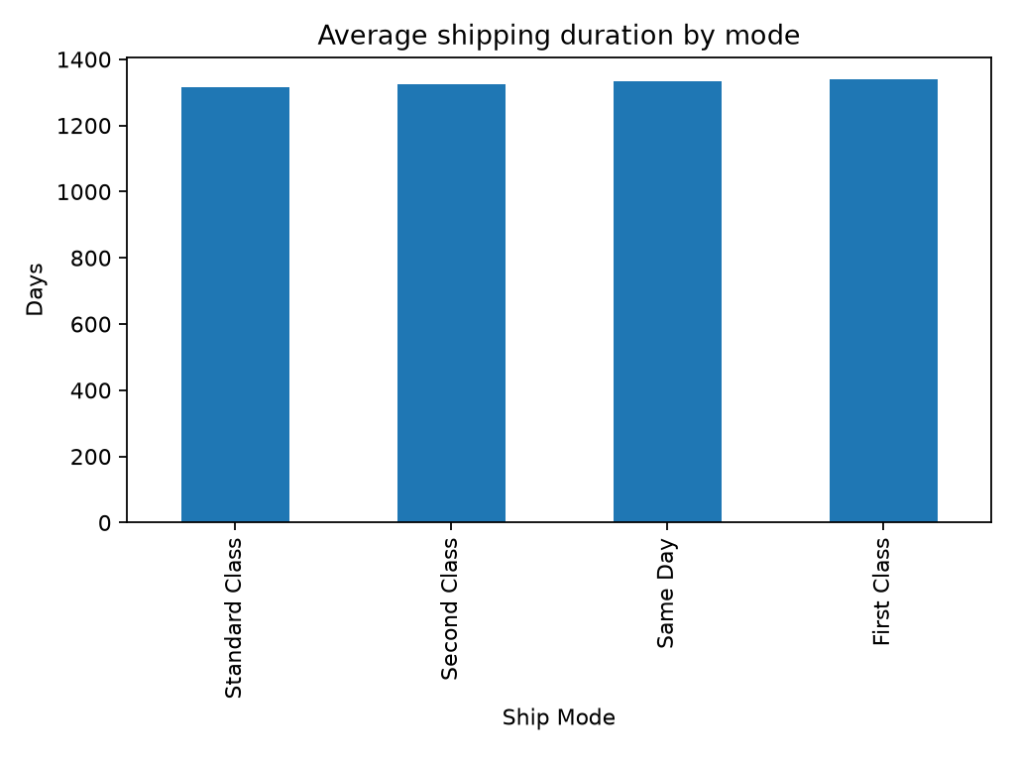
Figure 3. Historical mean shipping duration by observed shipping mode. Values inherit the source-date limitation.

8 Factory Reallocation Architecture
The current dataset cannot support real factory allocation. It contains no factory ID, factory name, factory location, latitude, longitude, capacity, fixed cost, variable manufacturing cost, or factory-product compatibility. The application returns an explicit availability message instead of making a fictional factory recommendation. The repository includes data/raw/factories_template.csv to document the required contract for future operational data.
When real factory data is available, the allocation engine can evaluate feasible factory and shipping-mode pairs using manufacturing cost, shipping cost, capacity, division or product compatibility, geographic distance, and historical service measures. A future optimization objective can minimize manufacturing plus logistics cost subject to capacity and compatibility constraints. Those constraints are intentionally not activated without valid supporting data.

9 System Implementation
The implementation is a modular Python project with centralized paths and configuration. data_loader.py validates the schema and parses types; preprocessing.py applies reproducible cleaning and preprocessing; feature_engineering.py creates derived variables; model_training.py fits and stores the selected pipeline; recommendation.py ranks modes; optimization.py handles the factory-data contract; and app.py exposes the results through a six-tab Streamlit dashboard. The dashboard includes overview metrics, data analysis, shipping recommendation, optimization, model performance, and business insights.

10 Limitations and Threats to Validity
The data describes historical shipping choices, not experimental assignments. Consequently, differences in cost, profit, or duration across shipping modes must not be interpreted as causal effects. The anomalous ship dates limit any delivery-time interpretation. Product and regional coverage may be uneven, especially for infrequent classes. Finally, because factory attributes are absent, factory-level cost savings, capacity feasibility, and geographic allocation cannot be estimated from this source.

11 Conclusion and Future Work
This work delivers a reproducible, source-backed shipping recommendation system and a clear factory-allocation extension point. It demonstrates responsible treatment of data limitations: the actual classes are discovered programmatically, model metrics are reported alongside a baseline, historical benchmarks are distinguished from causal claims, and no synthetic factories are created. Next steps are to obtain verified factory configuration data, repair or explain the source-date process, collect real service-level outcomes, and evaluate recommendations prospectively with an operationally defined objective.

References
Nassau Candy Distributor. Nassau Candy Distributor.csv. Supplied project dataset, accessed September 2026.
Project model evaluation. models/metrics.json generated by train.py using an 80/20 stratified holdout split.
Pedregosa, F. et al. Scikit-learn: Machine Learning in Python. Journal of Machine Learning Research, 12, 2825-2830, 2011.

