GoodFoods AI Concierge - Use Case Template

Goal

Long Term Goal
Transform the restaurant reservation experience into a seamless, AI-powered conversational journey that eliminates booking friction, maximizes table utilization, and delivers hyper-personalized dining recommendations. This positions GoodFoods as the category leader in AI-driven hospitality services, expanding into adjacent verticals like spas, entertainment, and professional services, targeting a $500M+ TAM with 395%+ Year 1 ROI.

Success Criteria
- 70%+ booking conversion rate (vs. 45% baseline)
- 4.5/5 average customer satisfaction (CSAT)
- <1% critical system downtime
- 80+ restaurants actively using the platform
- 5,000+ successful reservations in the first 6 months
- $2M ARR with 40% gross margins by 18 months
- 500 restaurant partners across 15 cities
- Validation of 2 adjacent verticals (e.g., spas and entertainment)
- Series A funding secured ($8-12M)

Use case
GoodFoods AI Concierge is an intelligent conversational agent that assists diners in discovering, recommending, and booking restaurant tables via natural language chat. Users describe preferences (e.g., “Italian for 4 at 7 PM under $50”), and the bot handles search, availability checks, bookings, and modifications. For restaurants, it optimizes capacity by reducing no-shows (20-30% industry rate) and filling off-peak slots, saving 15-20 hours/week in staff time. This creates a two-sided marketplace with personalized upsells, dynamic pricing, and cross-location recommendations, boosting revenue by 15%+ per location while cutting customer acquisition costs from $25-50. (98 words)

Key Steps (Bot flow)
- User Initiation: User starts conversation (e.g., “Help me book dinner tonight”).
- Intent & Preference Gathering: Bot asks clarifying questions (e.g., cuisine, party size, budget, location) while retaining context.
- Recommendation & Search: Bot suggests 3-5 matched venues with reasons (e.g., “Based on your love for sushi, try XYZ—available at 7 PM”).
- Availability Check: Bot verifies real-time slots and presents options.
- Booking Confirmation: User selects; bot processes payment/confirmation and sends reminders.
- Follow-Up: Post-booking upsell (e.g., “Add wine pairing?”) or modification/cancellation if needed.
- Feedback Loop: Bot solicits quick CSAT rating to refine future interactions.

State Transition Diagram
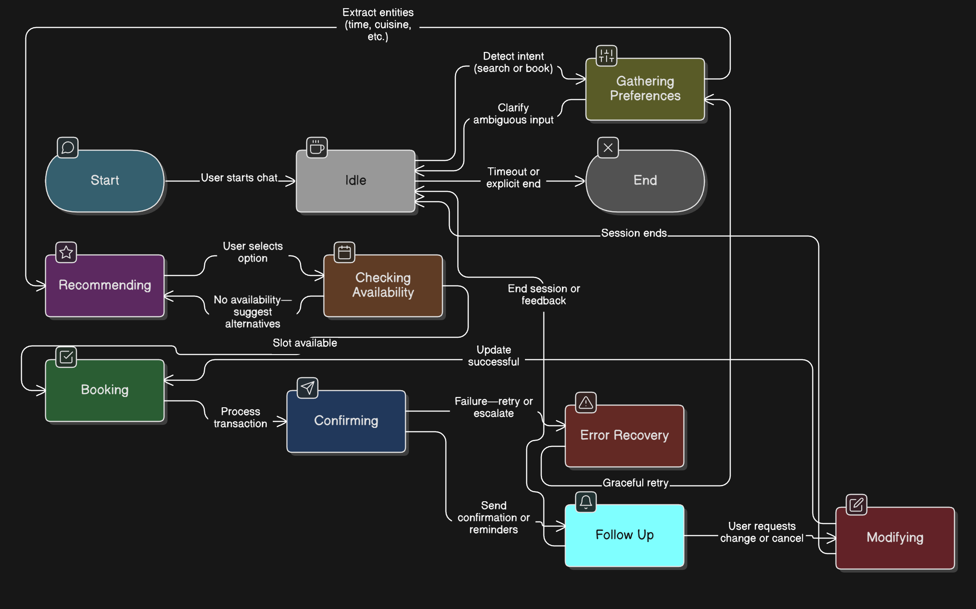

Bot Features
- Key specifications that the customer cares about:
  - Natural language understanding for multi-turn conversations (intent detection, entity extraction).
  - Hyper-personalized recommendations based on preferences, budget, and context (e.g., date night vs. family).
  - Real-time availability and conflict-free bookings.
  - Voice interface support (Google Assistant, Alexa) for hands-free use.
  - Dietary restriction handling (vegan, gluten-free, kosher).
- KBs (Knowledge Bases):
  - Restaurant database (80-100 seeds initially: menus, hours, features).
  - User preference profiles (anonymized patterns from past interactions).
  - Dining corpus (500K+ conversations for preference inference).
- Does it need Tools?:
  - Yes: Autonomous tool orchestration for function calling (e.g., search API, availability checker, booking processor, SMS/email via Twilio).
- Which Languages:
  - English (primary); expand to Spanish, Mandarin, French for international markets.
- Any new features asked for?:
  - Predictive no-show reminders to reduce losses by 30%.
  - Multi-location upselling for travelers.
  - Group booking for 20+ parties with preference conflict resolution.
- Color Green, Yellow, Red basis difficulty:
Feature | Difficulty | Rationale
Intent Detection & Entity Extraction | Green | Standard LLM capabilities (Gemini 2.5).
Personalized Recommendations | Yellow | Requires preference learning models; moderate data needs.
Real-Time Inventory Management | Yellow | Atomic transactions and conflict prevention; integration-heavy.
Voice Interface | Red | Multi-modal (speech-to-text); higher latency/error risks.
International Language Support | Red | Cultural nuances, translation accuracy; phased rollout.
- What integrations are needed:
  - POS systems for real-time capacity (e.g., Toast, Square).
  - LLM API (Gemini 2.5) for core NLU/recommendations.
  - Twilio for SMS/email confirmations.
  - Payment gateways (Stripe) for bookings.
  - Analytics dashboard (Google Analytics/Mixpanel) for KPIs.

Scale up / Rollout Strategy
- Phase 1: MVP Testing (Months 1-3): Deploy to 5 pilot GoodFoods locations with 500 target bookings. Internal beta with staff incentives; A/B test vs. phone bookings. Gather feedback via in-bot surveys.
- Phase 2: Internal Rollout (Months 4-6): Scale to all 80 GoodFoods sites. Monitor KPIs (conversion rate, CSAT) with usage quotas to control API costs. Free tier for first 100 bookings per restaurant.
- Phase 3: External Expansion (Months 7-12): Onboard 200 independent restaurants via case studies and local partnerships. Regional focus (e.g., NYC, LA); dedicated success managers for adoption.
- Phase 4: National/Vertical Growth (Months 13-24): Target 1,500 partners, $5M ARR. Validate adjacent verticals (spas first) with white-label APIs. Trade shows for leads; monitor ROI quarterly.

Key Challenges
- LLM Hallucinations & Reliability: Medium-high risk of incorrect recommendations/bookings; mitigate with tool validation, confidence scoring, and human escalation.
- API Cost Overruns: High query volume (2M/year) could exceed $18K budget; address via caching, quotas, and cheaper model fallbacks.
- Restaurant Adoption Resistance: Operators may resist change from phone systems; counter with free trials, ROI demos, and testimonials.
- Data Privacy & Regulatory Compliance: Handling user profiles across sessions; ensure GDPR/CCPA/SOC 2 by Month 9.
- Competitive Cloning: Fast followers like OpenTable adding AI; build moat via proprietary data flywheel and restaurant relationships.
Document Version 1.0 Last Updated: November 27, 2025 Author: GoodFoods AI Strategy Team

