**Question 1**

1. Directed graph of activities. Each box has the activity name and the duration.

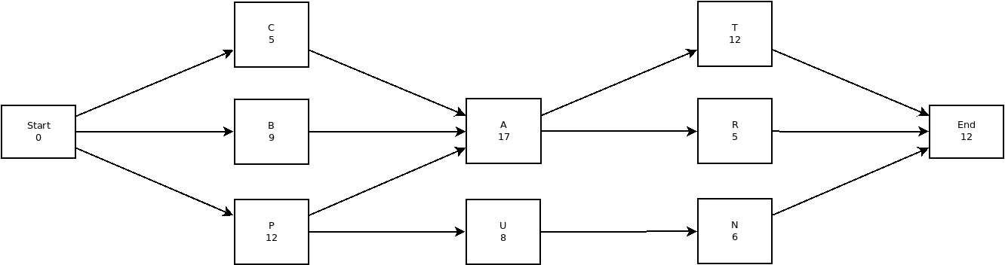

1. Applying the critical path method to the graph and adding the [LS, ES] to each activity and then calculating the slack produces the following the graph. The graph contain a key explaining the meaning of the content inside the boxes. First the ES and EF times were calculated from left to right, then the LS and LF times were calculated from right to left.

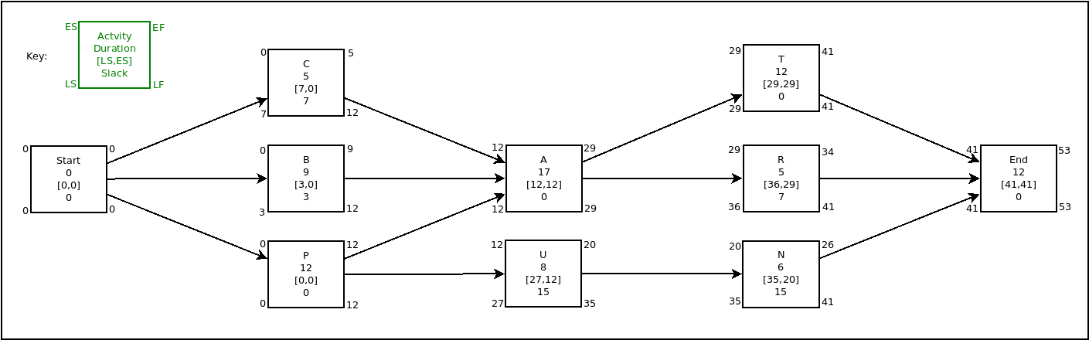

1. The critical path is shown in the figure below highlighted in red. The total duration of the critical path is 53 days.

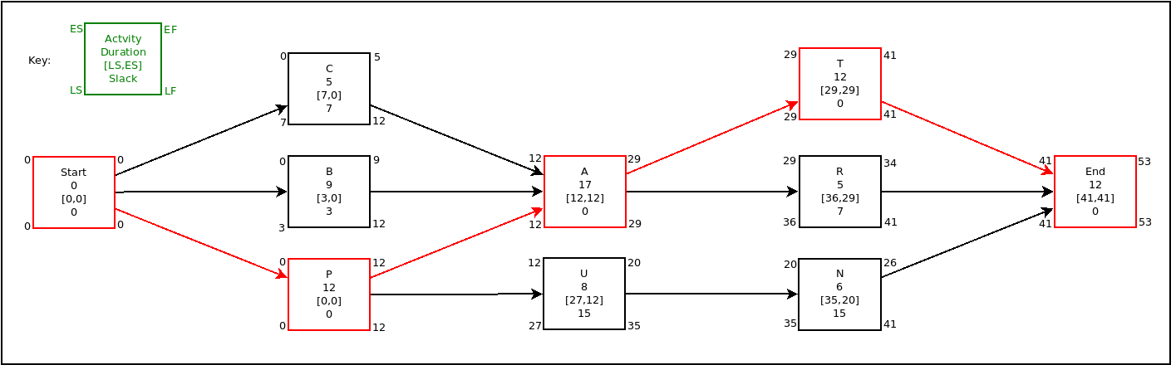

1. If every activity starts at their ES time but activity P takes 5 extra days to finish then estimated, because P is on the critical path it would delay the completing of the project by 5 days.
2. If activity R takes half a day longer than the estimated time then it would not make any difference to the project duration because it has a slack of 7 which allows this activity to be delayed by up to 7 days without affecting the project time.