**Day01:**

**Cloud Computing:**

Using Applications, Databases, Hardware Resources, Networks, Services etc. over the internet.

**Benefits of Cloud Computing:**

1) **Availability :** Depending on the service-level agreement (SLA) that you choose, your “cloud-based apps can provide a continuous user experience with no apparent downtime, even when things go wrong.”

2) **Reliability:** cloud-based backup services, data replication, and geo-distribution gives you confidence that “Your data is safe even in case of natural disaster.”

3) **Scalability:** Ability to increase the amount of resources as and when needed.

**Horizontal Scalability:** You will plug in extra server to serve the additional requests.

**Vertical Scalability :** You will add RAM, Hard Disk, increase CPU Power to serve additional requests.

4) **Elasticity:** Ability to decrease the amount of resources when not needed.

**CSP: Cloud Service Provider :** Company that provides you cloud computing services.

**E.g. -** Microsoft, Amazon, Google

**Cloud Computing Platforms:** CSPs offer cloud computing services via cloud computing platforms.

**E.g.-** Microsoft Azure, Amazon Web Services (AWS), Google Cloud Platform (GCP)

**Reference URL:** [What are Cloud Computing Services [IaaS, CaaS, PaaS, FaaS, SaaS] | by Nilesh Suryavanshi | Medium](https://medium.com/@nnilesh7756/what-are-cloud-computing-services-iaas-caas-paas-faas-saas-ac0f6022d36e)

Majorly there are three **categories of Cloud Computing Services / Cloud Computing Models:**

a) **Infrastructure as a Service (IaaS) :** It provides only a base infrastructure (Virtual machine, Software Define Network, Storage attached). End user have to configure and manage platform and environment, deploy applications on it.

**E.g. - AWS (EC2), GCP (CE), Microsoft Azure (VM)**

b) **Software as a Service (SaaS) :** It is sometimes called to as “on-demand software”. Typically accessed by users using a thin client via a web browser. In SaaS everything can be managed by vendors: applications, runtime, data, middleware, OSes, virtualization, servers, storage and networking, End users have to use it.

**E.g. – Gmail, SAP, Salesforce, Office 365 etc.** GMAIL is Best example of SaaS. Google team managing everything just we have to use the application through any of client or in browsers.

c) **Platform as a Service (PaaS):**It provides a platform allowing end user to develop, run, and manage applications without the complexity of building and maintaining the infrastructure.

**E.g.- Google App Engine, CloudFoundry, Heroku, AWS (Beanstalk) etc.**

Below diagram while give you more idea on it.

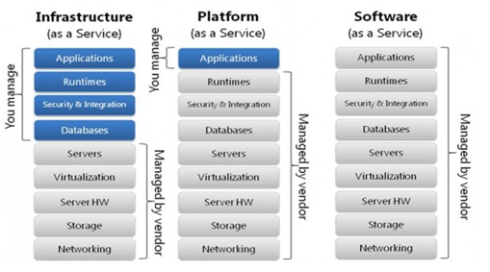

d) **Container as a Service (CaaS):** Is a form of container-based virtualization in which container engines, orchestration and the underlying compute resources are delivered to users as a service from a cloud provider.

**E.g. - Google Container Engine(GKE), AWS (ECS), Azure (AKS) and Pivotal (PKS) etc.**

e) **Function as a Service (FaaS):** It provides a platform allowing customers to develop, run, and manage application functionalities without the complexity of building and maintaining the infrastructure.

**E.g. – Azure Functions, AWS (Lamda), Google Cloud Function etc.**

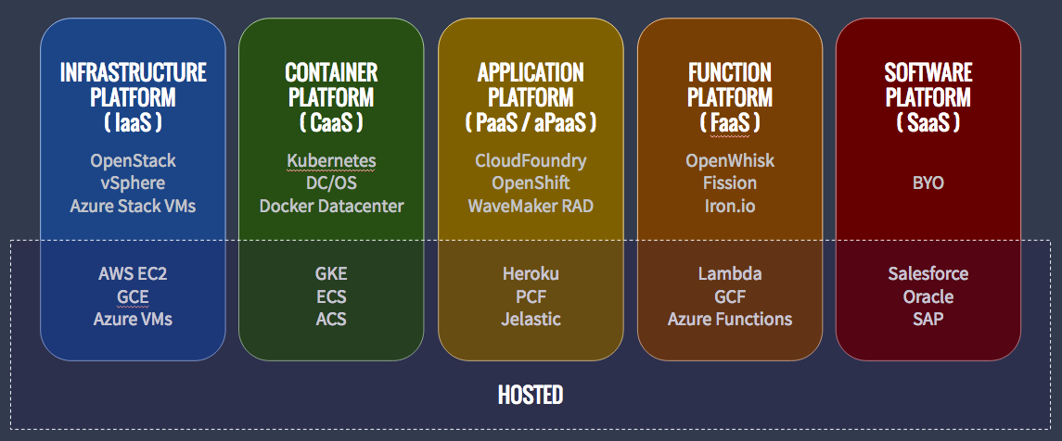

**Cloud Deployment Models / Types of Cloud:**

1) **Public Cloud:** Suitable for most of the requirements. Used by Retailers like McDonalds, KFC etc.

2) **Private Cloud:** Dedicated to Single Organization. Offers more security and gives better flexibility. Used by Government Organizations like NASA, ISRO etc.

3) **Hybrid Cloud:** Non-Sensitive data like Name, Email, Contact No etc. is on Public Cloud and Sensitive Data like Medical Information is on Private Cloud. You have a connection between Public Cloud and Private Cloud that bypasses the internet. This connection is termed as Express Route. Used by Insurance Companies like Max New York or TPAs like MediAssist etc.

**Reference URL:** <https://docs.microsoft.com/en-us/learn/modules/fundamental-azure-concepts/types-of-cloud-computing>