KARNATAK LAW SOCIETY’S
GOGTE INSTITUTE OF TECHNOLOGY
UDYAMBAG, BELAGAVI-590008
(An Autonomous Institution under Visvesvaraya Technological University, Belagavi)
(APPROVED BY AICTE, NEW DELHI)

Department of Information Science and Engineering

Project Report on
Accident Detection and Alert System Using IoT
Submitted in partial fulfillment of the requirement for the award of the degree of
Bachelor of Engineering
in
Information Science and Engineering

Submitted by
S Aditya Vardhan | 2GI20IS003
Basavraj R Duganavar | 2GI20IS006
Chinmay Chinchanikar | 2GI20IS009
Nachiket Magadum | 2GI20IS016

Guide
Dr. H. H. Kenchannavar

2023 – 2024

KARNATAK LAW SOCIETY’S
GOGTE INSTITUTE OF TECHNOLOGY
UDYAMBAG, BELAGAVI-590008
(An Autonomous Institution under Visvesvaraya Technological University, Belagavi)
(APPROVED BY AICTE, NEW DELHI)

Department of Information Science & Engineering

CERTIFICATE
Certified that the project entitled ACCIDENT DETECTION AND ALERT SYSTEM USING IOT carried out by Mr. S Aditya Vardhan (2GI20IS003), Mr. Basavraj R Duganavar (2GI20IS006), Mr. Chinmay Chinchanikar (2GI20IS009), Mr. Nachiket Magadum (2GI20IS016) students of KLS Gogte Institute of Technology, Belagavi, can be considered as a bonafide work for partial fulfillment for the award of Bachelor of Engineering in Information Science & Engineering of the Visvesvaraya Technological University, Belagavi during the year 2023-2024. It is certified that all corrections/suggestions indicated have been incorporated in the report. The project report has been approved as it satisfies the academic requirements prescribed for the said Degree.

Guide HOD Principal
Dr. H. H. Kenchannavar Dr. Kiran. K. Tangod Dr. M S Patil
Date:
Final Viva-Voce
 | Name of the examiners | Date of Viva -voce | Signature
1.
2.

DECLARATION BY THE STUDENTS

We, Mr. S Aditya Vardhan, Mr. Basavraj R Duganavar, Mr. Chinmay Chinchanikar, Mr. Nachiket Magadum, hereby declare that the project report entitled Accident Detection and Alert System using IoT submitted by us to KLS Gogte Institute of Technology, Belagavi, in partial fulfillment of the Degree of Bachelor of Engineering in Information Science and Engineering is a record of the project carried out at us. This report is for the academic purpose.

We further declare that the report has not been submitted and will not be submitted, either in part or full, to any other institution and University for the award of any diploma or degree.

Name of the student | USN | Signature
S Aditya Vardhan | 2GI20IS003
Basavraj R Duganavar | 2GI20IS006
Chinmay Chinchanikar | 2GI20IS009
Nachiket Magadum | 2GI20IS016

Place: Belagavi
Date:

Acknowledgement

We would like to express our deepest gratitude to our esteemed project guide, Dr Harish.H.Kenchannavar for their invaluable guidance and exceptional mentorship throughout the duration of our final year project.

We are deeply thankful to Dr Kiran K Tangod for their constant support and guidance throughout our project tenure.

Special appreciation goes to our Principal, Dr M S Patil, whose visionary leadership has fostered an environment of academic excellence and innovation, providing us with the platform to pursue our academic endeavors.

We would like to thank all the people that worked along with us for the project for their patience and openness in creating an enjoyable working environment.

We are extremely grateful to my ISE department staff members and friends who helped us in successful completion of this project.
Abstract
In the realm of road safety, prompt and accurate accident response is paramount to mitigating fatal injuries and saving lives. The existing approach, reliant on manual reporting to authorities or the injured party's ability to communicate with emergency services, introduces delays that can prove fatal. The work uses a collection of sensors to identify an accident and point out the location of accident. This data is sent in the form of a text message to emergency services through which immediate help can be received. In this system we use an Arduino board, accelerometer sensor, GPS Module and Sim module. The accelerometer send the acceleration values continuously to the Arduino board, the board checks the values against the conditions previously codes. If there is any value that doesn't fall in the mentioned conditions (i.e. a crash is detected) then the sim module is used to send a message to emergency number which has the vehicle number, owner details and the GPS coordinates. The goal is to drastically reduce emergency response time, improving the likelihood of survival and quick recovery of the injured. This innovative approach not only addresses the current gaps in accident reporting but also contributes to an overall improvement in road safety infrastructure.

Table of Contents

 |  | Content | Page No.
 | i. | Declaration | iii
 | ii. | Acknowledgement | iv
 | iii. | Abstract | v
 | iv. | Table of contents | vi
 | v. | List of Tables | vii
 | vi. | List of Figures | vii
 | vii. | List of Abbreviations | ix
1. |  | Chapter 1: Introduction, Problem Statement, Objectives. | 1
 | 1.1 | Introduction | 1
 | 1.2 | Problem Statement | 1
 | 1.3 | Objectives | 2
2. |  | Chapter 2: Literature Survey | 3
 | 2.1 | Introduction | 3
 | 2.2 | Summary of Papers | 3
3. |  | Chapter 3: System Design | 5
 | 3.1 | System Architecture | 5
 | 3.2 | ER Diagram | 6
 | 3.3 | Class Diagram | 7
 | 3.4 | Algorithm design | 8
4. |  | Chapter 4: Requirement Engineering | 9
 | 4.1 | Software and Hardware Tools Used | 9
 | 4.1.1 | Software components used | 9
 | 4.1.2 | Hardware components used | 12
 | 4.2 | Functional requirements | 19
 | 4.2.1 | Use case Diagram | 20
 | 4.2.2 | Sequence Diagram | 21
 | 4.2.3 | Activity Diagram | 22
 | 4.3 | Non-Functional Requirements | 23
5 |  | Chapter 5: Implementation | 24
 | 5.1 | Module Description | 24
 | 5.1.1 | Isolation Forest Algorithm | 24
 | 5.1.2 | Pseudocode | 24
 | 5.2 | Coding Details | 24
 | 5.2.1 | Isolation Forest Code | 24
 | 5.2.2 | Arduino Code | 26
6 |  | Chapter 6: Testing | 29
 | 6.1 | Testing Approach | 29
 | 6.1.1 | Integration Testing | 29
7 |  | Chapter 7: Results and Discussion | 31
 | 7.1 | Results | 31
 | 7.2 | Snapshots | 33
8 |  | Chapter 8: Conclusion | 35
 | 8.1 | Conclusion | 35
9 |  | Reference | 36
10 |  | Appendix | 37

List of Tables
Table No. | Title | Page No.
4.1 | ESP8266 pin configuration | 13
4.2 | Arduino UNO pin configuration | 15
4.3 | SIM Module (SIM800C) pin configuration | 16
6.1 | Integration Test Result | 29

List of Figures
Table No. | Title | Page No.
1.1 | Generic Block diagram of ADAS | 1
3.1 | System Architecture for ADAS | 5
3.2 | ER Diagram for ADAS | 6
3.3 | Class Diagram for ADAS | 7
4.1 | Arduino IDE | 9
4.2 | ThingSpeak | 10
4.3 | ESP8266 | 12
4.4 | ESP8266 Pin Configuration | 13
4.5 | Arduino UNO | 14
4.6 | Accelerometer (ADXL345) | 15
4.7 | Sim Module (SIM800C) | 16
4.8 | GPS Module (NEO6M) | 17
4.9 | Buzzer | 17
4.10 | Bread Board | 18
4.11 | 9V Battery | 18
4.12 | Use Case Diagram for ADAS | 20
4.13 | Sequence Diagram for ADAS | 21
4.15 | Activity Diagram for ADAS | 22
7.1 | Acceleration experienced by Vehicle during Crash | 31
7.2 | Acceleration experienced by Vehicle during Tumbling | 32
7.3 | Acceleration experienced by Vehicle hit on side | 32
7.4 | Acceleration experienced by Vehicle during Explosion | 33
7.5 | Emergency Alert Messager | 33
7.6 | Accurate GPS Location | 34
7.7 | Working Model | 34

List of Abbreviations
Abbreviation | Title
IoT | Internet of Things
EMS | Emergency Medical Services
GPS | Global Positioning System
GSM | Global System for Mobile Communications
ADXL | Analog Device Accelerometer
ADAS | Accident Detection and Alert System
SIM | Subscriber Identity Module
XML | Extensible Markup Language
CVS | Concurrent Versions System
JSON | Java Script Object Notation
Wi-Fi | Wireless Fidelity

Chapter 1
1. Introduction, Problem Statement, Objective, Methodology.
1.1 Introduction
Lately, the incidence of accidents has increased considerably. greater usage of vehicles like cars and bikes have contributed to this rise, often due to over speeding. This poses a significant risk to individuals, and the lack of advanced safety measures has hindered efforts to reduce accident rates. To address this issue, this paper proposes an optimal solution, an automatic alert system for vehicle accidents.
The primary objective is to mitigate accidents by promptly sending alerts to registered mobile devices using wireless communication techniques. In the event of an accident within a city, a message is rapidly dispatched to the registered mobile.
When an accident occurs, a vibration sensor is triggered, and this information is relayed to the registered number through the GSM module. Additionally, a GPS system assists in pinpointing the accident location. The proposed system aims to promptly detect accidents and notify nearby medical centers and registered mobile numbers about the accident's location using GSM and GPS modules. Geographical coordinates can be transmitted through a tracking system to precisely identify the accident site. The vibration sensor serves as a crucial component in detecting accidents within the system.
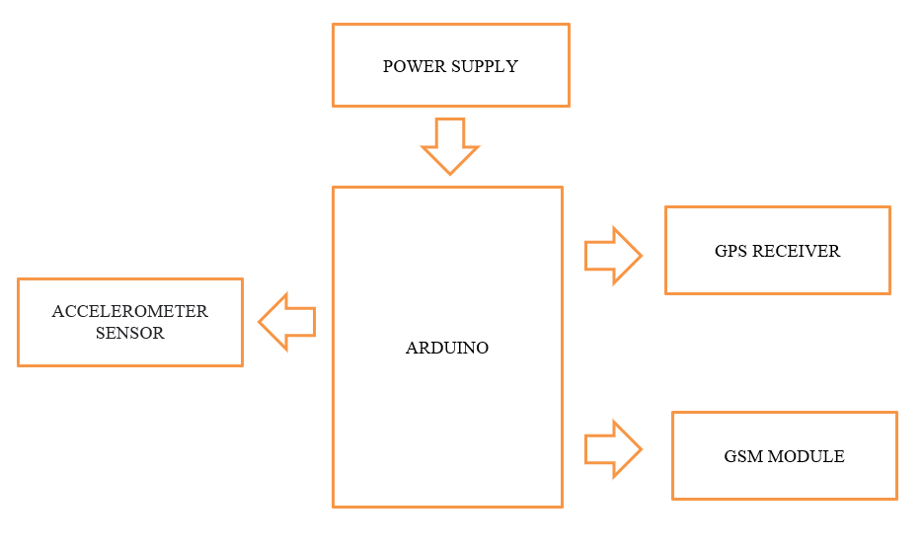
Fig 1.1 Generic Block diagram of ADAS

1.2 Problem Statement
When it comes to road safety, effective and rapid accident response is crucial to reduce fatal injuries and save lives. Unfortunately, delays in reporting accidents to authorities can be fatal. The challenge is to design a robust, energy-efficient, and cost-effective system that accurately detects real accidents while avoiding false alarms, ensuring no incident goes unreported. Recent advancements leverage accelerometers and gyroscope sensors with machine learning to distinguish between normal conditions and accidents effectively. Integration of GPS and GSM technologies enables immediate location transmission to emergency responders, reducing response times. Additionally, IoT connectivity ensures continuous monitoring and immediate response upon accident detection. To minimize false alarms, sophisticated algorithms analyse historical data to learn from false triggers, enhancing system accuracy and reliability.

1.3 Objective
- Design a system that can detect real accidents and ignore non-emergency events
- Avoid false alarms and ensure that no real accidents go unreported.
- The system must be robust, energy efficient and cost-effective allowing widespread use in vehicles.
- reduce the time it takes for emergency personnel to arrive at the scene of an accident, thereby improving the chances of survival and speedy recovery for the injured person.

Chapter 2
2. Literature Survey
2.1 Introduction
A literature survey, also known as a literature review, is a survey of previously published scholarly resources such as books, journals, and articles on specific themes or concerns. It entails searching for and evaluating available material in your selected subject or issue area. It documents the state of the art in the subject or issue about which you are writing. Concerning the project, a literature survey was undertaken to gain a better understanding of the idea, for idea growth, and to learn about the limits inherent in the correct approaches.

2.2 Summary of papers
S. Patil, K. Patil, S. Dhabekar, M. Nirgude, and S. Renushe, "Accident Identification & Alerting System," Int. Res. J. Mod. Eng. Technol. Sci., vol. 02, no. 07, pp. 196-201, July 2020.
This study presents a system to automatically detect vehicular accidents and alert emergency services, hospitals, and family members. It employs an accelerometer to detect sudden acceleration changes and uses a GPS module to track the accident location. Alerts are sent through a GSM modem.
C. K. Gomathy, K. Rohan, B. M. K. Reddy, and V. Geetha, "Accident Detection and Alert System," J. Eng. Comput. Archit., vol. 12, no. 3, pp. 32-43, Mar. 2022.
This paper describes a system designed to detect vehicle accidents using an Arduino, GPS, and GSM module. The system detects sudden changes in a vehicle's axes through an accelerometer and sends an alert message with the vehicle's location and speed to pre-set mobile numbers via GSM.
Dr. R. Prasanthi, M.U. Nitish Babu, B. Jaswanth, and G. Sumith Chandra, "Accident Detection and Alert System Using Arduino," Int. Res. J. Mod. Eng. Technol. Sci., vol. 05, no.04,pp.445-450,Apr.2023.DOI:10.56726/IRJMETS35449.
The research in this paper focuses on developing an accident detection and alert system using an Arduino board. It integrates GPS and GSM technologies to locate the accident and notify emergency services quickly. The system is highlighted as particularly useful in developing countries with high traffic fatalities.
M. Ajay Kumar, Sree Kamya, K. Kiranmai, and S. Pragathi, "Dynamic Accident Detection and Alert System Using Arduino," J. Emerg. Technol. Innov. Res. (JETIR), vol. 10, no. 9, Sept. 2023.
This research develops a system that uses Arduino, GPS, and GSM for accident detection and alert. It is aimed at rapidly increasing vehicle numbers in developing nations, intending to reduce accident response times and improve emergency medical services.
G. Siri, G. Priyanka, B. Divya, G. Sameera, and Ms. M. Pallavi, "Accident Detection and Alert System," Int. Res. J. Mod. Eng. Technol. Sci., vol. 04, no. 06, pp. 3371-3374, June 2022. DOI: 10.7525/irjmets.
This paper discusses a system that uses a combination of GPS, GSM, and additional sensors like vibration and alcohol detection sensors to improve road safety by automatically detecting accidents and alerting emergency services. The system also includes functionality to stop the vehicle if alcohol is detected, aiming to prevent accidents before they occur​​.
L. Vijayaraja, R. Dhanasekar, Magesh Krishna R, Mahidhar M, Prakash D, and Shashikumar P, "A Low Cost and User Friendly Vehicle Crash Alert System Using Arduino," in IOP Conf. Ser.: Mater. Sci. Eng., vol. 1055, 012061, 2021. DOI: 10.1088/1757-899X/1055/1/012061.
The paper focuses on creating a vehicle crash detection system that is economical and easy to implement. This system utilizes an Arduino controller, GPS, GSM, and an accelerometer to detect a crash event and immediately notify through SMS. The accelerometer senses sudden changes in the vehicle's axes, which triggers the system to send an alert along with the vehicle's location—provided by the GPS module—in the form of a Google Maps link. Additionally, the system includes the vehicle's speed in the alert message. The setup also offers potential for expansion into a tracking system with modifications to the hardware and software. The main advantages discussed include the real-time functionality and practicality of the alert system in enhancing vehicle safety and emergency response​​.

Chapter 3
3. System Design
3.1 System Architecture

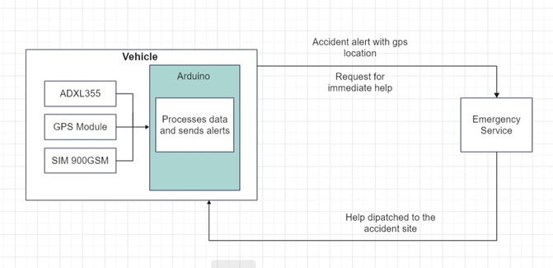
Figure 3.1: System Architecture

A system architecture diagram is a graphical representation of a system’s structural components and their relationships. It provides an abstract view of the system’s component architecture, assisting in understanding component-component relationships and system functioning. This diagram depicts the software architecture, including its context, components, relationships, and dependencies. It’s a useful tool for system designers and developers as it visualizes and helps understand the relationships between different parts of a system. The diagram can include hardware, software, and various subsystems, showing how they interact and work together to make the system function.

The system architecture diagram under discussion represents an innovative ‘Accident detection and alert system’ installed in vehicles. This system is designed to ensure a swift response in the event of a vehicular accident, thereby potentially saving lives by reducing response time. The system is equipped with sensors to detect accidents and identifies the vehicle involved, recording details such as the vehicle number and type. It also identifies the owner of the vehicle, capturing details like the owner’s name and ID. Upon detecting an accident, the system sends a message to emergency services. This message includes a unique identifier for the message, the location of the accident, and the location and contact number of the nearest emergency services. Upon receiving the message, emergency services are alerted to the accident and can dispatch help to the accident location. This system plays a crucial role in ensuring timely assistance in the aftermath of a vehicular accident.
3.2 Entity-Relationship Diagram

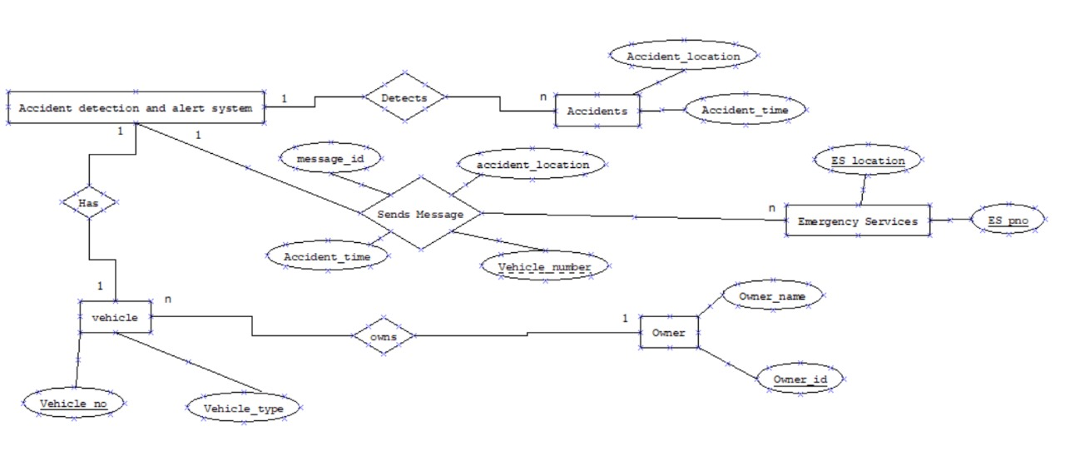

Figure 3.2: ER Diagram

An Entity-Relationship (ER) Diagram is a type of flowchart that illustrates how entities such as people, objects, or concepts relate to each other within a system. ER Diagrams are most often used to design or debug relational databases in the fields of software engineering, business information systems, education, and research. They use a defined set of symbols to depict the interconnectedness of entities, relationships, and their attributes.

The provided diagram illustrates an advanced 'Accident Detection and Alert System' designed for vehicular use. Upon detecting an accident, the system gathers crucial information such as the location and time of the accident. This information, along with a unique message identifier, is sent as a message to emergency services. The system also identifies the vehicle involved in the accident, capturing details such as the vehicle number and type. Furthermore, it identifies the owner of the vehicle, recording details like the owner's name and ID. The emergency services, upon receiving the message, are alerted to the accident and can dispatch help to the accident location promptly. This system plays a pivotal role in ensuring timely assistance in the aftermath of a vehicular accident, thereby enhancing the safety and security of road travel.
3.3 Class Diagram

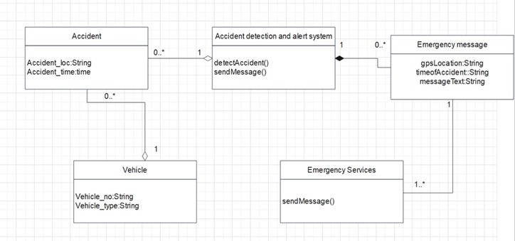

Figure 3.3: Class Diagram
A Class Diagram is a type of static structure diagram that describes the structure of a system by showing the system’s classes, their attributes, operations, and the relationships among objects. Class diagrams are a part of the Unified Modeling Language (UML) and are used in software engineering to visually represent the structure and relationships of classes within a system.
The provided diagram is a UML class diagram representing an “Accident Detection and Alert System”. This system is designed to detect vehicular accidents and alert the necessary emergency services. The diagram consists of four main classes: Accident, Vehicle, Emergency Message, and Emergency Services.
The Accident class has attributes loc (location of the accident) and time (time when the accident occurred). The Vehicle class includes attributes no (vehicle number) and type (type of vehicle involved in the accident). These classes represent the basic entities involved in an accident scenario.
The Emergency Message class contains attributes gpsLocation, timeOfAccident, and messageText. This class represents the alert message generated when an accident is detected. It includes crucial information such as the GPS location of the accident, the time of the accident, and the content of the alert message.
The Emergency Services class has a method named sendMessage(). This class represents the emergency services that receive the alert messages and act upon them.
Associations are shown between Accident, Vehicle, Emergency Message, and Emergency Services with multiplicity notations to indicate how many instances of each are related. This system plays a pivotal role in ensuring timely assistance in the aftermath of a vehicular accident, thereby enhancing the safety and security of road travel.

3.4 Algorithm Design
Accident Detection and Alert System Algorithm:
INPUT: Data from ADAS module during vehicle operation.
OUTPUT: Emergency message with accident details (Vehicle Owner Information, Location of accident, Time of accident).

STEP 1: START
STEP 2: Collect Data:
a. From the ADAS module under varying conditions:
i. Vehicle running on a smooth road
ii. Vehicle going over speed breakers
iii. Vehicle going through potholes
iv. Vehicle crashing into a stationary surface
v. Vehicle rollover
b. Create and maintain a dataset of the collected data.

STEP 3: Data Processing:
a. Clean the dataset to remove noise and irrelevant data.
b. Analyse the cleaned dataset to classify into two groups:
i. Safe conditions
ii. Fatal conditions

STEP 4: Continuous Monitoring:
a. Collect real-time data from the ADAS module while the vehicle is in motion.
b. Check if the acquired data falls within the safe range.
i. IF data falls under the safe range:
- Repeat step 4a.
ii. ELSE:
- Proceed to step 5.

STEP 5: Emergency Response:
a. Send an emergency message that includes:
i. Vehicle number
ii. Time of the accident
iii. GPS location of the accident
b. Direct the message to pre-registered contact numbers and the nearest emergency services for immediate assistance.

STEP 6: STOP
Chapter 4
4. Requirement Engineering
4.1 Software and Hardware Tools Used
4.1.1 Software Components
- Arduino IDE
- Thingspeak
- Arduino libraries [ESP8266WiFi,Wire.h,Adafruit_Sensor.h,Adafruit_ADXL345_U.h,SoftwareSerial.h,TinyGPS++.h ]
- Python pandas

- ARDUINO IDE
Arduino IDEs (Integrated Development Environments) is a software platforms used for writing, compiling, and uploading code to Arduino hardware, which are popular microcontroller boards used in electronics projects.


Figure 4.1: Arduino Ide

- THINGSPEAK
ThingSpeak is an Internet of Things (IoT) analytics platform that facilitates the collection, storage, visualization, and analysis of data from sensors in real-time. It enables users to connect IoT devices like Arduino and Raspberry Pi to the cloud, where data can be securely stored and accessed. With integrated MATLAB support, ThingSpeak allows complex data analysis and processing, offering tools for creating dynamic visualizations like graphs and charts. Additionally, it supports event-driven actions and API integrations, enabling automated responses and interactions with other applications based on specific data conditions, making it ideal for projects requiring immediate data insights and operational efficiency.

Figure 4.2: ThingSpeak

- ARDUINO LIBRARIES
- wire.h
The Wire.h library is an essential component in the Arduino programming environment, used for communication via the I2C/TWI (Two Wire Interface) protocol. It allows Arduino boards to connect and exchange data with I2C devices, such as sensors, displays, and other microcontrollers. The library provides functions to facilitate initiating communication, reading and writing data, and handling transactions between devices.

- ESP8266WIFI
This library enables Wi-Fi capabilities for the ESP8266 module, a popular low-cost Wi-Fi microchip. It allows the module to connect to the internet or local Wi-Fi networks, facilitating tasks like making HTTP requests, sending data to a server, or receiving updates from the internet. Users can manage Wi-Fi connections, perform network diagnostics, and secure data transmission with encryption. The library supports both client and server modes, making it versatile for various IoT applications, such as smart home devices, weather stations, or any project requiring remote internet connectivity.

- Adafruit_Sensor.h
Adafruit_Sensor.h is a foundational library used to create a common interface for all Adafruit sensors. It standardizes sensor interactions, making code reusable across different types of sensors without needing to rewrite it for each specific sensor model. This library provides unified sensor readings, like temperature, pressure, or acceleration, presenting them in a standardized format regardless of the underlying sensor hardware. It's particularly useful in projects requiring the integration of multiple different sensors, providing a consistent and simplified programming interface.

- Adafruit_ADXL345_U.h
This library is designed specifically for the Adafruit ADXL345, a small, thin, low power, three-axis accelerometer that provides high-resolution (13-bit) measurements of acceleration. The library simplifies accessing and managing the ADXL345's capabilities such as measuring acceleration in up to ±16 g. It provides methods for reading acceleration data, configuring the sensor settings like sampling rate and sensitivity, and interpreting the raw data into usable acceleration information. Ideal for motion detection, gaming devices, and orientation detection, this library allows developers to easily incorporate precise motion and orientation sensing into their projects.

- SoftwareSerial.h
SoftwareSerial.h enables Arduino boards to use digital pins to emulate serial communication functionalities, extending the number of serial ports available beyond the hardware serial ports typically used for debugging. This library is crucial for projects needing communication with multiple serial devices, like GPS modules, GSM modules, or additional microcontrollers. It allows users to select any digital pins for serial communication, providing flexibility in pin assignments and hardware layout. The library is essential for complex projects where multiple data streams over serial communication need to be managed simultaneously.

- TinyGPS++.h
TinyGPS++.h is a library for parsing the data from GPS modules into readable information for Arduino projects. It interprets complex NMEA data strings that GPS modules produce and provides easy access to essential GPS parameters such as latitude, longitude, altitude, speed, and time. The library is optimized for low-memory microcontrollers and is efficient in handling and decoding GPS data with high accuracy. It is ideal for projects involving location tracking, navigation, and time synchronization, where accurate and real-time GPS data is crucial.
- PYTHON PANDAS
Pandas is a versatile Python library used for data manipulation and analysis, providing structured data structures such as Data Frames and Series. It simplifies tasks like data reading from various sources (CSV, SQL databases, Excel), data cleaning, complex data manipulations, merging, reshaping, and slicing. Pandas also excels in time series analysis, allowing for easy date range manipulation, frequency conversion, and window statistics. Built on NumPy, it offers efficient and fast performance for handling large datasets. Widely used in finance, statistics, social sciences, and engineering, Pandas is a cornerstone for data scientists seeking to analyze and interpret complex datasets effectively.

    - Hardware Components
- NodeMCU ESP8266
- Arduino UNO
- Accelerometer
- GPS module
- Sim Module
- Bread Board
- Soldering Iron
- Solder Wire
- Jumper wires
- Buzzer
- 9 V battery

- NodeMCU ESP8266
The NodeMCU ESP8266 development board comes with the ESP-12E module containing ESP8266 chip having Tensilica Xtensa 32-bit LX106 RISC microprocessor. This microprocessor supports RTOS and operates at 80MHz to 160 MHz adjustable clock frequency. NodeMCU has 128 KB RAM and 4MB of Flash memory to store data and programs. Its high processing power with in-built Wi-Fi / Bluetooth and Deep Sleep Operating features make it ideal for IoT projects. NodeMCU can be powered using Micro USB jack and Vin pin (External Supply Pin). It supports UART, SPI, and I2C interface.
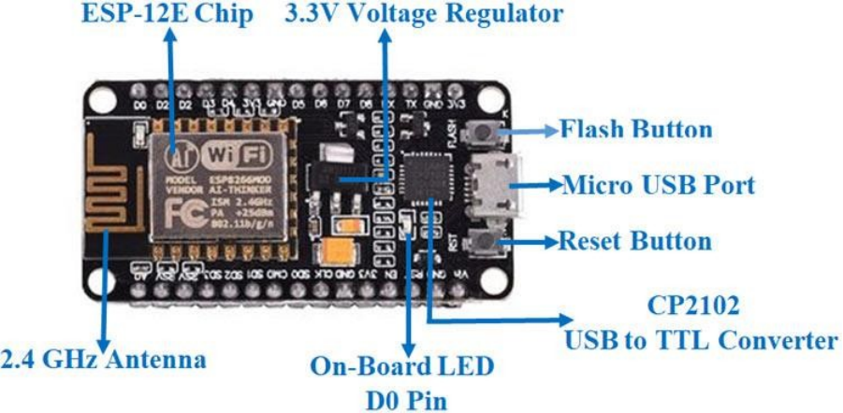
Figure 4.3: ESP 8266
The NodeMCU Development Board can be easily programmed with Arduino IDE since it is easy to use. Programming NodeMCU with the Arduino IDE will hardly take 5-10 minutes. All you need is the Arduino IDE, a USB cable and the NodeMCU board itself. You can check this Getting Started Tutorial for NodeMCU to prepare your Arduino IDE for NodeMCU.
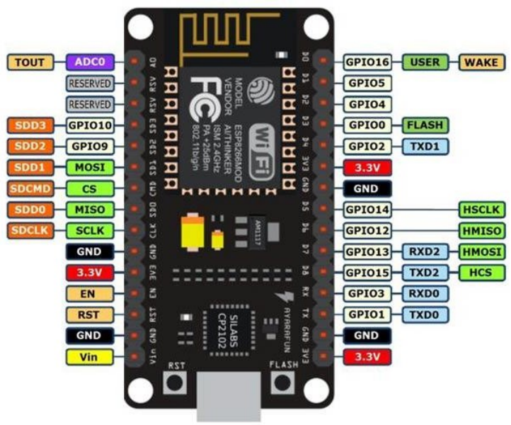
Figure 4.4: ESP 8266 pin configuration
Pin Category | Name | Description
Power | Micro-USB, 3.3V, GND,  Vin | Micro-USB: NodeMCU can be powered through the USB port  3.3V: Regulated 3.3V can be supplied to this pin to power the board  GND: Ground pins  Vin: External Power Supply
Control Pins | EN, RST | The pin and the button reset the microcontroller
Analog Pin | A0 | Used to measure analog voltage in the range of 0-3.3V
GPIO Pins | GPIO1 to GPIO16 | NodeMCU has 16 general purpose input-output pins on its board
SPI Pins | SD1, CMD, SD0, CLK | NodeMCU has four pins available for SPI communication.
UART Pins | TXD0, RXD0, TXD2, RXD2 | NodeMCU has two UART interfaces, UART0 (RXD0 & TXD0) and UART1 (RXD1 & TXD1). UART1 is used to upload the firmware/program.
I2C Pins |  | NodeMCU has I2C functionality support but due to the internal functionality of these pins, you have to find which pin is I2C.

Table 4.1: ESP 8266 pin configuration

- Arduino UNO
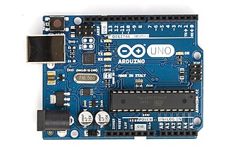
The Arduino UNO is a fundamental microcontroller board based on the ATmega328P. It features 14 digital input/output pins (of which 6 can be used as PWM outputs), 6 analog inputs, a 16 MHz ceramic resonator, a USB connection, a power jack, an ICSP header, and a reset button. It's widely used for its simplicity and versatility in countless electronic and robotics projects, making it an ideal choice for beginners and professionals alike. The board supports various forms of communication, allowing for projects ranging from simple sensors to complex robots and Internet-connected devices.

Figure 4.5: Arduino Uno

Pin | Function | Details
0 | RX (Serial) | Used to receive serial data (connected to TX of other devices)
1 | TX (Serial) | Used to transmit serial data (connected to RX of other devices)
2-13 | Digital I/O | Can be used as input or output, 5V logic level
A0-A5 | Analog Input | Used for analog input (10-bit resolution)
AREF | Analog Reference | Used to set an external reference voltage
GND | Ground | Common ground
RST | Reset | Used to reset the microcontroller
3V3 | 3.3V Output | Supplies 3.3V output (50 mA max)
5V | 5V Output | Supplies 5V output (drawn from USB or external power source)
VIN | Voltage Input | Used when using an external power source of 7-12V

Table 4.2:Arduino Uno pin configuration

- Accelerometer ADXL345
The ADXL345 is a small, thin, and low-power three-axis accelerometer with high resolution (13-bit) measurement capability. It can measure the static acceleration of gravity in tilt-sensing applications, as well as dynamic acceleration resulting from motion or shock. Its high resolution enables the detection of inclination changes less than 1.0°. Several special sensing functions are provided, including activity, inactivity, and tap detection. The ADXL345 is widely used in mobile devices, gaming systems, and personal electronics for user interface control and motion tracking, making it versatile for various applications that require precise motion or orientation detection.
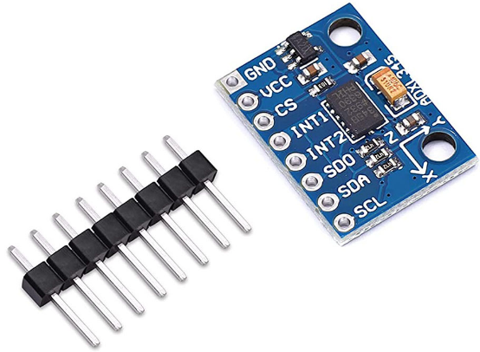

Figure 4.6: Accelerometer (ADXL345)

- Sim Module SIM800C
The SIM800C is a quad-band GSM/GPRS module that enables voice, SMS, and data transmission via the GSM network. It is a compact and reliable solution for mobile communication and is commonly embedded in a range of applications including vehicle tracking, industrial equipment, and home automation systems. The module supports a wide range of frequencies, allowing it to operate globally on GSM networks. It is particularly useful for projects requiring remote communication where no Wi-Fi or other network connections are available, offering capabilities such as Bluetooth and FM radio functionalities as well.
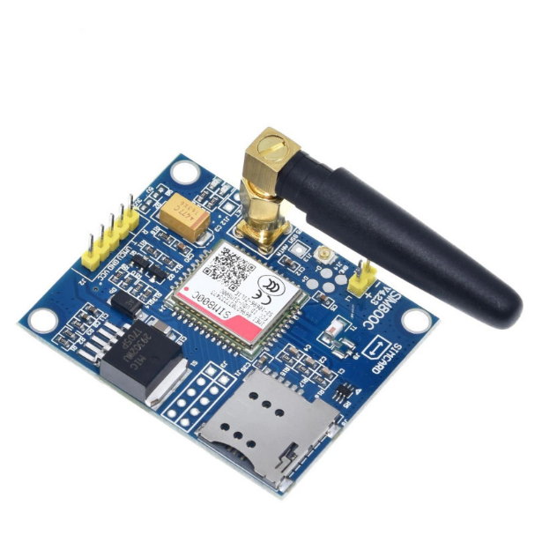
Figure 4.7: Sim Module(SIM 800C)

Sl.no | PIN | Description
 | 5V | 5V power input
 | GND | Ground
 | RX1 | Serial port 1 Data receiver
 | Tx1 | Serial port 2 Data transmission
 | DTR | Sleep control pin. High: Sleep; Low: Wake-up (should set AT+CSCLK=1)
 | RI | Interrupt wake-up pin. this pin defaults to high and keeps low for 120ms when URCs are reported or SMS received. (should set "AT+CFGRI=1")
 | RX2 | Serial port 2 Data receiver
 | TX2 | Serial port 2 Data transmission
 | PWR | Power control pin
 | RESET | When power is on, you can reset the module by pulling down the reset pin. It is unavailable when power off

Table 4.3: Sim Module(SIM 800L) pin configuration

- NEO 6M GPS Module
The NEO-6M GPS module is a compact, high-performance GPS receiver with a built-in antenna, which makes it ideal for applications in navigation, tracking, and mapping. It provides fast and accurate position and speed information, with the capability of maintaining GPS accuracy under low power consumption. Its high sensitivity and strong tracking capabilities make it effective even in difficult environments like urban canyons and dense foliage. The NEO-6M is popular in DIY electronics projects, UAVs, and location-based applications, providing reliable geolocation data essential for accurate positioning and timing tasks.
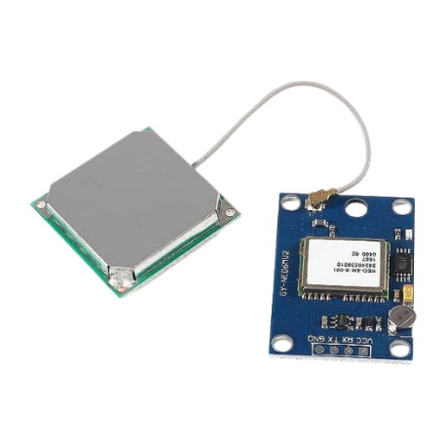

Figure 4.8: GPS Module(NEO 6M)
- BUZZER
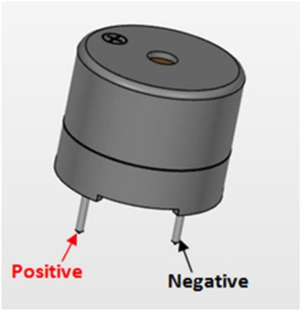
A buzzer or beeper is an audio signaling device, which may be mechanical, electromechanical, or piezoelectric (piezo for short). Typical uses of buzzers and beepers include alarm devices, timers, and confirmation of user input such as a mouse click or keystroke.

Figure 4.9: Buzzer

- Bread Board
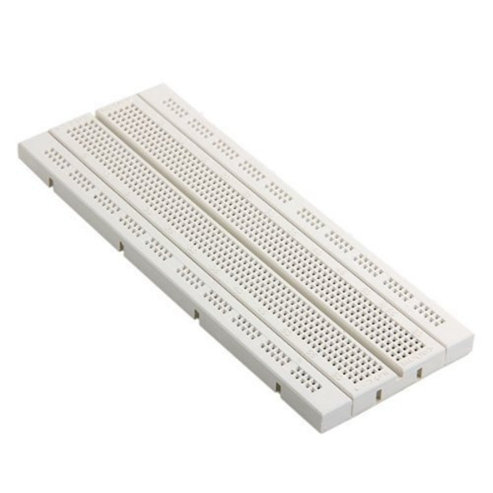
A breadboard, also known as a solderless breadboard or protoboard, is a rectangular plastic board with many small holes that allows you to insert electronic components to build and test prototypes of electronic circuits. Breadboards are reusable and don't require soldering or destroying tracks.
Figure 4.10: Bread Board
8.Battery (9V)

The nine-volt battery, or 9-volt battery, is an electric battery that supplies a nominal voltage of 9 volts. Actual voltage measures 7.2 to 9.6 volts, depending on battery chemistry. Batteries of various sizes and capacities are manufactured; a very common size is known as PP3, introduced for early transistor radios.

Figure 4.11: 9V Battery

4.2 Functional Requirements
- Accurate Crash Detection:
The system should reliably and accurately detect actual vehicle crashes by analyzing data from the ADXL355 accelerometer, considering factors such as impact force, direction, and duration. It should employ sophisticated algorithms to distinguish between genuine accidents and normal driving events, minimizing false positives.

- Real-Time Alert System:
The system must send immediate alerts in real-time to emergency services, including relevant details such as location obtained from the GPS module. It should provide timely notifications to both emergency personnel and predefined contacts, ensuring swift response and assistance.

- Location accuracy:
The crash detection system should achieve a high level of accuracy, minimizing both false positives and false negatives. The GPS module should provide precise location data to within a defined margin of error to ensure emergency services reach the correct accident location.

- Low Response Time:
The system must exhibit low response times in detecting a crash and initiating the alert system.Response time should be measured from the moment of impact to the notification sent to emergency services and contacts.

- False Alarm Prevention:
Implement advanced filtering mechanisms to reduce false alarms caused by non-emergency events like sudden braking or road bumps. Continuous refinement of the crash detection algorithm based on real-world data and machine learning should be integral to the system to improve its ability to discern actual accidents from false triggers.

4.2.1 Use Case Diagram
A use case diagram is a representation of a user's interaction with the system that shows the relationship between the user and the different use cases in which the user is involved. A use case diagram can identify the different types of users of a system and the different use cases and will often be accompanied by other types of diagrams as well. The use cases are represented by either circles or ellipses.

Figure 3.12 shows the use case diagram is a graphical depiction of user’s possible interactions with a system. This diagram shows various use cases the user and the system have.
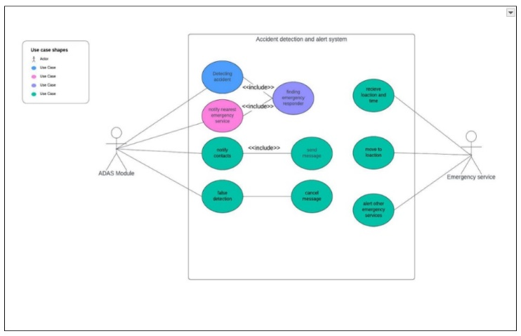
Figure 4.12: Use Case Diagram for ADAS
The use case diagram depicts an "Accident Detection and Alert System" with two actors: the ADAS Module and Emergency Service. The ADAS Module detects accidents, notifies contacts and emergency services, or makes a false detection. Emergency Service retrieves accident location and time, finds emergency help, moves to the location, and alerts other services if needed. The diagram includes interactions like mandatory inclusion ("<include>") between use cases, showing the system's process flow to ensure rapid response in case of accidents, enhancing safety and rescue operations.

4.2.2 Sequence Diagram
Sequence diagrams can be used to model complex interactions between different components of a system, helping developers to understand the sequence of events that occur during the execution of a particular use case or this scenario.

Figure 3.13 shows object interactions arranged in time sequence in the field of software engineering. It depicts the objects involved in the scenario and the sequence of messages exchanged between these objects. It shows the interaction between the user and the system to fetch the predictions.
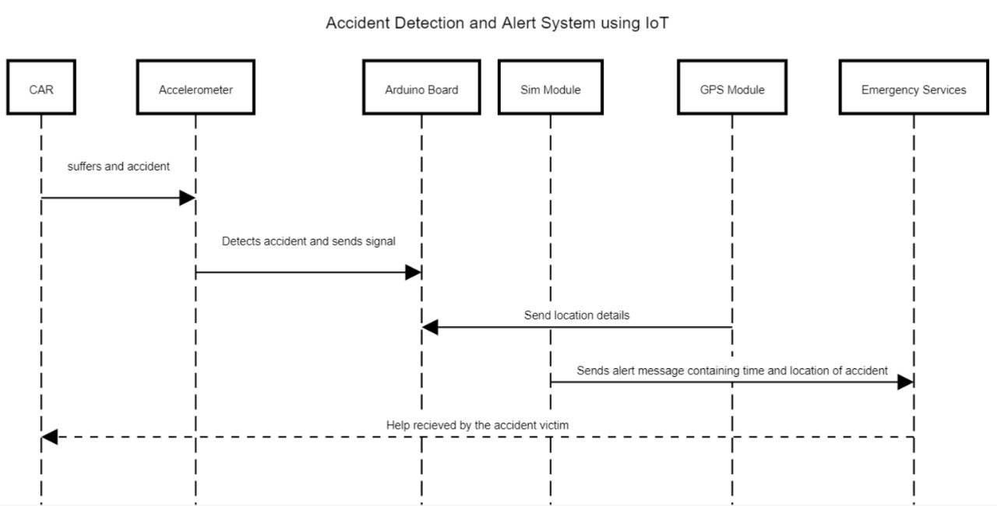
Figure 4.13: Sequence Diagram for ADAS
When a car experiences an accident, an accelerometer mounted in the vehicle detects the sudden change due to impact and sends a signal to an Arduino board. The Arduino then communicates with a SIM module to fetch the precise location from a connected GPS module. Once the location is acquired, the SIM module sends an alert message, which includes the time and location of the accident, to emergency services. This alert enables quick dispatch of help to the accident site, ensuring timely assistance to the accident victim. This sequence effectively utilizes IoT components to automate emergency responses, enhancing safety measures for vehicle occupants.

4.2.3 Activity Diagram
Activity diagrams can be used to depict the financial and operating activities of network elements in the System Development Process. A process map displays the total control flow. An action diagram obviously presents a movement of exercises or stream of control in a system like a flowchart or a data stream outline.
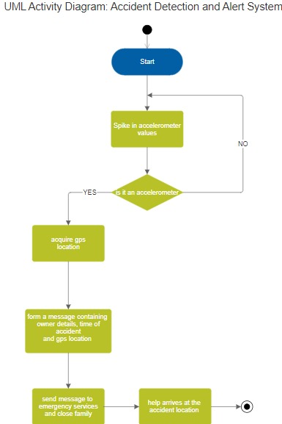
visually presents a series of actions or control flow from a start point to a finish point showing the various decision paths that exist while the activity is being executed.

Figure 4.14: Activity Diagram for ADAS
System starting with monitoring for spikes in accelerometer data to detect potential accidents. If a spike is detected and confirmed to be from an accelerometer, the system then acquires the current GPS location of the device. Subsequently, it forms a detailed message that includes the device owner's information, the time of the accident, and the precise GPS location. This message is then sent to both emergency services and the close family of the owner, ensuring that they are promptly informed. The final step involves the arrival of help at the accident location, completing the emergency response cycle. This automated system is crucial for quickly mobilizing assistance and improving safety outcomes following accidents.
4.3 Non-Functional Requirements
- Security: Ensure secure communication channels, using encryption protocols for data transmission to prevent unauthorized access or tampering. Implement authentication mechanisms to verify the legitimacy of crash alerts, preventing potential misuse or false reporting.

- Cost-Effectiveness: The overall cost of implementing the system, including hardware and connectivity components, should be reasonable, making it accessible for widespread adoption by various vehicle types and users. The system design should prioritize cost-effectiveness without compromising on its primary functions.

- Energy Efficiency: The system should be designed to operate efficiently with minimal energy consumption, considering the power constraints of in-vehicle setups. It should incorporate power-saving mechanisms such as sleep modes or intelligent sensor activation to extend the life of the device without sacrificing its responsiveness.

- Scalability: The system should be designed to scale easily, accommodating updates and improvements to the crash detection algorithm. Consider future enhancements and the addition of new features without requiring significant hardware changes or causing disruptions to existing installations.

Chapter 5
5. Implementation

5.1 Module Description
5.1.1 Isolation Forest Algorithm
Isolation forest algorithm is an algorithm widely used in machine learning for detection of anomalies in a given set of data. The idea is to isolate anomalies by identifying the data points that are outnumbered by the rest of normal data points in a dataset. It creates a group of isolation trees to achieve the result. An isolation tree is basically a binary tree where each node represents a feature (one attribute from the dataset) and each split is a data partition. The tree is made by selecting a random feature from the dataset and selecting a random split value recursively till the datapoints are isolated.
5.1.2 PSEUDOCODE
Algorithm: iTree(X, e, l)
Inputs: X - input data, e - current tree height, l - height limit
Output: an iTree
STEP 1: if e ≥ l or |X| ≤ 1 then
STEP 2: return exNode{Size ← |X|}
STEP 3: else
STEP 4: let Q be a list of attributes in X
STEP 5: randomly select an attribute q ∈ Q
STEP 6: randomly select a split point p from max and min values of attribute q in X
STEP 7: Xl ← filter (X, q < p)
STEP 8: Xr ← filter (X, q ≥ p)
STEP 9: return inNode{Left ← iTree(Xl, e + 1, l), Right ← iTree(Xr, e + 1, l), SplitAtt ← q, SplitValue ← p}
STEP 10: end if
5.2 Coding Details
5.2.1 Isolation Forest Code
import pandas as pd
from sklearn.ensemble import IsolationForest
import matplotlib.pyplot as plt
pd.set_option('display.max_rows', None)
pd.set_option('display.max_columns', None)
df = pd.read_excel('obstacles.xlsx')
X = df[['x_acceleration']]
isolation_forest = IsolationForest(n_estimators=100, contamination=0.04)
isolation_forest.fit(X)
predictions = isolation_forest.predict(X)
df['anomaly_number'] = 0
anomaly_counter = 1
for idx, prediction in enumerate(predictions):
if prediction == -1:
df.loc[idx, 'anomaly_number'] = anomaly_counter
anomaly_counter += 1
anomalies = df[df['anomaly_number'] != 0]
print(anomalies)
plt.plot(df['x_acceleration'], label='x_acceleration')
plt.plot(df['y_acceleration'], label='y_acceleration')
plt.plot(df['z_acceleration'], label='z_acceleration')
anomalies_indices = df.index[predictions == -1] # Indices of anomalies
plt.scatter(anomalies_indices, df.loc[anomalies_indices, 'x_acceleration'], c='red', label='Anomalies (x_acceleration)')
plt.scatter(anomalies_indices, df.loc[anomalies_indices, 'y_acceleration'], c='red', label='Anomalies (y_acceleration)')
plt.scatter(anomalies_indices, df.loc[anomalies_indices, 'z_acceleration'], c='red', label='Anomalies (z_acceleration)')
plt.xlabel('Time(s)')
plt.ylabel('Acceleration(m/s^2)')
plt.title('Acceleration Data with Anomalies')
plt.legend()
plt.show()
accuracy = 100*list(data['anomaly_score']).count(-1)/(anomaly_count)
print("Accuracy of the model:", accuracy)

5.2.2 Arduino Code
#include <Wire.h>
#include <Adafruit_Sensor.h>
#include <Adafruit_ADXL345_U.h>
#include <SoftwareSerial.h>
#include <TinyGPS++.h>
#define ADXL345_ADDRESS (0x53) // ADXL345 sensor I2C address
#define buzzer 9 // Define the pin number for the buzzer
#define MIN_X -8 // Minimum threshold for x-axis
#define MAX_X 8 // Maximum threshold for x-axis
#define MIN_Y -8 // Minimum threshold for y-axis
#define MAX_Y 8 // Maximum threshold for y-axis
#define MIN_Z 4 // Minimum threshold for z-axis
#define MAX_Z 15 // Maximum threshold for z-axis
#define SIM800_TX_PIN 2
#define SIM800_RX_PIN 3
#define PHONE_NUMBER "+91XXXXXXXXXX" // Change to your phone number
Adafruit_ADXL345_Unifiedaccel=Adafruit_ADXL345_Unified(ADXL345_ADDRESS);
SoftwareSerial mySerial(SIM800_TX_PIN, SIM800_RX_PIN);
static const int RXPin = 4, TXPin = 5; // GPS module pins
static const uint32_t GPSBaud = 9600;
TinyGPSPlus gps;
SoftwareSerial ss(RXPin, TXPin);
void setup() {
Serial.begin(9600);
while (!Serial);
mySerial.begin(9600);
Serial.println("Initializing SIM800C...");
delay(1000);
mySerial.println("AT");
delay(1000);
mySerial.println("SIM800C initialized.");
Serial.println("Initializing ADXL345...");
if (!accel.begin()) {
Serial.println("Couldn't find ADXL345 sensor");
while (1); }
Serial.println("ADXL345 sensor found!");
accel.setRange(ADXL345_RANGE_16_G);
ss.begin(GPSBaud); // Start GPS module }
void loop() {
sensors_event_t event;
accel.getEvent(&event);
float x = event.acceleration.x + 2.59;
float y = event.acceleration.y + 4.41;
float z = event.acceleration.z - 22.4;
Serial.print("Acceleration (X, Y, Z): ");
Serial.print(x);
Serial.print(", ");
Serial.print(y);
Serial.print(", ");
Serial.println(z);
if (x < MIN_X || x > MAX_X || y < MIN_Y || y > MAX_Y || z < MIN_Z || z > MAX_Z) {
Serial.println("Out of range! Buzzing the buzzer...");
tone(buzzer, 1000); // Generate sound
delay(1000); // Sound duration
noTone(buzzer); // Stop sound
delay(1000); // Pause before sending SMS
sendSMSWithGPS(); }
while (ss.available() > 0) {
if (gps.encode(ss.read())) {
if (gps.location.isUpdated()) {
Serial.println("GPS Location updated."); }
}
}
delay(1000); // Delay for stability
}
void sendSMSWithGPS() {
mySerial.println("AT+CMGF=1"); // Set SMS mode to text
delay(100);
mySerial.print("AT+CMGS=\""); // Start SMS sending command
mySerial.print(PHONE_NUMBER); // Set the phone number
mySerial.println("\"");
delay(100);
mySerial.print("Latitude: "); // Include latitude in SMS
mySerial.println(gps.location.lat(), 6);
delay(100);
mySerial.print("Longitude: "); // Include longitude in SMS
mySerial.println(gps.location.lng(), 6);
delay(100);
mySerial.println((char)26); // End SMS
delay(1000); // Wait for SMS to send
}

Chapter 6
6. Testing

6.1 Testing Approach
Software testing is a process of determining whether the actual software product meets the expected requirements and ensuring that the software product is free of defects. It entails the use of manual or automated tools to execute software/system components to evaluate one or more properties of interest. The goal of software testing is to find mistakes, gaps, or missing requirements in comparison to the actual requirements. Software testing is important because faults or problems in software can be found early and fixed before the software product is delivered. A thoroughly tested software product provides dependability, security, and excellent performance, which saves time, money, and increases customer satisfaction. Performance analysis is a process of evaluating a project's success or failure based on various parameters. It involves studying the performance of a specific scenario and comparing it to the intended objective. When it comes to vulnerability assessment tools, performance analysis entails measuring the tool's time cost, accuracy, and comparing its performance with that of existing applications.

6.1.1 Integration testing
Integration testing is checking whether the different components work with each other within the machine learning pipeline and produces accurate result. Integration testing is a type of software testing that tests the interactions between different components or modules of a software system to ensure that they function correctly when integrated together.

Test No. | Test Data (Input  Parameters) | Expected  Result | Actual Result | Pass/ Fail
1 | X=3.5  Y=2.6  Z=10.0 | No accident detected | No accident detected | Pass
2 | X=8.5  Y=10.0  Z= -2.0 | Accident detected,  Alert Message sent to EMS | Accident detected,  Alert message sent to EMS | Pass
3 | X= -8.0  Y= -6.0  Z= -3.0 | Accident detected,  Alert Message sent to EMS | Accident detected,  Alert Message sent to EMS | Pass
Table 6.1: Integration Test Result

Chapter 7
7. Results and Discussion

7.1 Results
After going through the data collected, we can see that at certain data points the value of acceleration in one or more directions(X,Y,Z) shoots up dramatically .These values usually correlate to the point at where the vehicle is going through an abnormal condition like a crash, being hit by another vehicle etc. These values (found by analyzing the dataset) are used to set the boundary values to figure out whether the spike in the values was an accident or just a false indication.
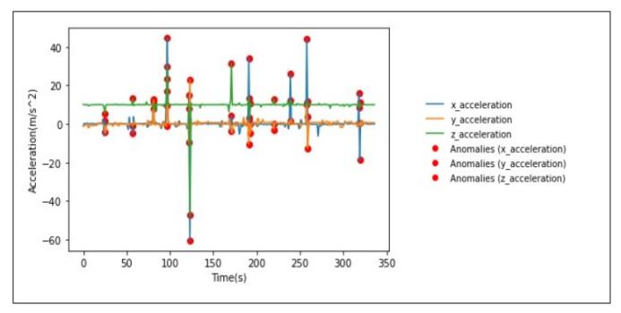
Figure 7.1: Acceleration experienced by Vehicle during Crash

The Fig.7.1 is a graphical representation of acceleration experience by a vehicle when it crashes into something. Whenever a car crashes into an object its speed/velocity decreases drastically, in turn resulting in change in acceleration (a=V2-V1/t). The spike in acceleration is marked using a red dot (as an anomaly). We use this information to distinguish between a fatal accident and a normal movement of vehicle.
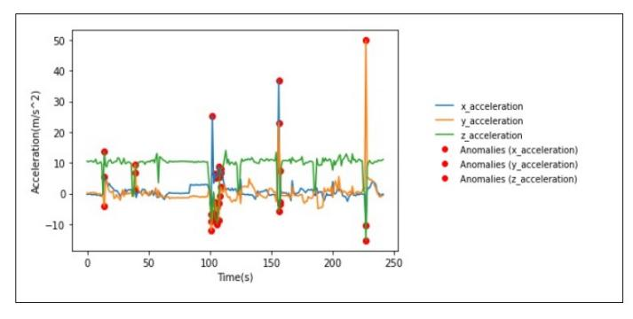
Figure 7.2: Acceleration experienced by Vehicle during Tumbling

The Fig.7.2 is a graphical representation of acceleration experience by a vehicle when it falls from a height. Whenever a car freefall from a certain height its acceleration in Y-axis changes drastically. The spike in acceleration is marked using a red dot (as an anomaly). We use this information to distinguish between a fatal accident and a normal movement of vehicle.
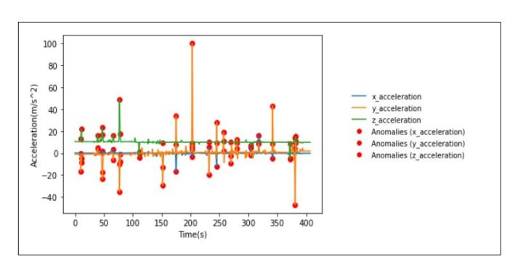
Figure 7.3: Acceleration experienced by Vehicle hit at sides
The Fig.7.3 is a graphical representation of acceleration experience by a vehicle when it hit from sides. Whenever a car crashes into an object its speed/velocity decreases drastically, in turn resulting in change in acceleration. The spike in acceleration is marked using a red dot (as an anomaly). We use this information to distinguish between a fatal accident and a normal movement of vehicle.
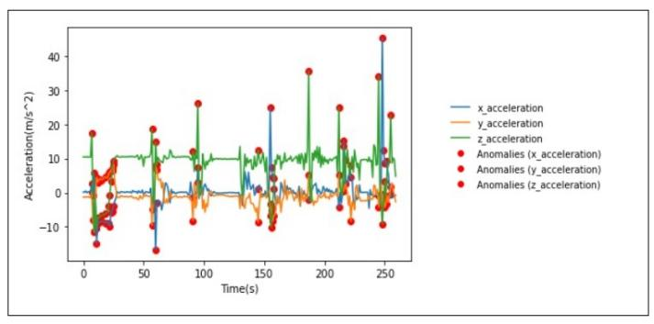
Figure 7.4: Acceleration experienced by Vehicle during Explosion
The Fig.7.4 is a graphical representation of acceleration experience by a vehicle when it explodes. Whenever a car explodes its speed/velocity increases drastically in Z- axis, in turn resulting in change in acceleration. The spike in acceleration is marked using a red dot (as an anomaly). We use this information to detect a fatal accident.

7.2 Snapshots
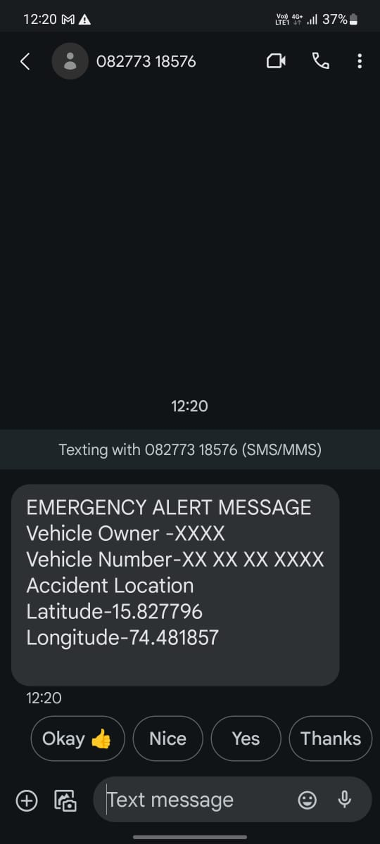
Figure 7.5: Emergency Alert Message
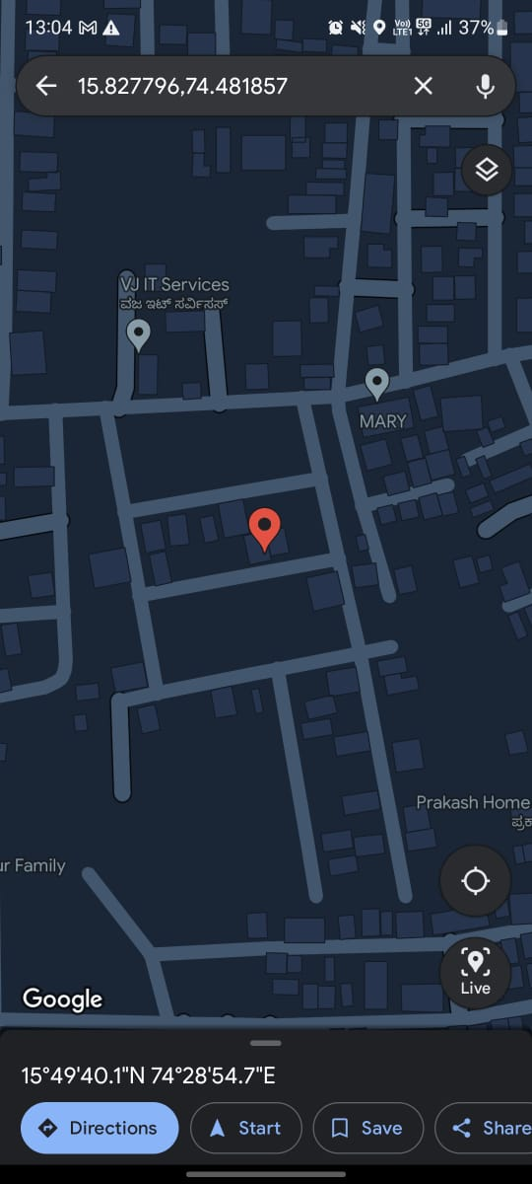
Figure 7.6: Accurate GPS Location
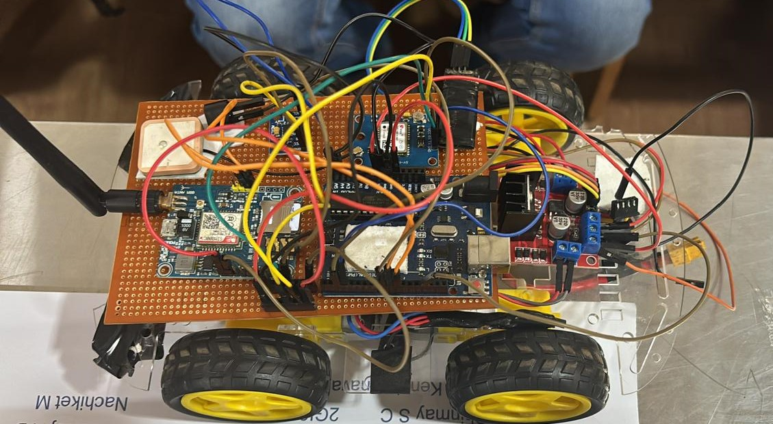
Figure 7.7: Working Model

Chapter 8
8. Conclusion
8.1 Conclusion
This project is a cutting-edge Accident Detection and Alert System in this initiative using technology to improve road safety. The system is built around an Arduino Uno as the processor, a SIM800 GSM module, for connectivity an ADXL345 3-axis accelerometer for motion sensing and a GPS module for location tracking. This setup ensures reliability and efficiency in operation. Ultimately this project aims to enhance the safety of driving environments by offering a solution that can be adapted to different vehicle types and settings. By reducing emergency response times and enhancing the precision of accident notifications our Accident Detection and Alert System represents a step, in automotive safety technology.

References

- Dr. C. K. Gomathy, K Rohan, Bandi Mani Kiran Reddy, Dr. V Geetha, “Accident Detection And Alert System”, Journal Of Engineering, Computing & Architecture”, MARCH 2022B. Rieder, Engines of Order: A Mechanology of Algorithmic Techniques. Amsterdam, Netherlands: Amsterdam Univ. Press, 2020.

- Dr. R. Prasanthi, M.U. Nitish Babu, B. Jaswanth, G.Sumith Chandra, “Accident Detection And Alert System Using Arduino”, April 2023.

- M. Ajay Kumar, Sree Kamya,K. Kiranmai, Pragathi (2023),"Dynamic Accident Detection And Alert System Using Arduino”, Journal of Emerging Technologies and Innovative Research (JETIR).

- G. Siri, G. Priyanka, B. Divya, G. Sameera, Ms. M. Pallavi (2022),"Accident Detection And Alert System", International Research Journal of Modernization in Engineering Technology and Science.

- L Vijayaraja, R Dhanasekar, Magesh Krishna, Mahidhar, Prakash and Shashikumar P,"A low cost and user-friendly vehicle crash alert system Using Arduino “, IOP Conf. Series: Materials Science and Engineering (2020).

- S. Patil, K. Patil, S. Dhabekar, M. Nirgude, and Prof. S. Renushe,"Accident Identification & Alerting System," in International Research Journal of Modernization in Engineering Technology and Science, vol. 2, no. 7, Jul. 2020.

- J. P. Byrne, N. C. Mann, M. Dai, S. A. Mason, P. Karanicolas, S. Rizoli, and A. B. Nathens, "Association Between Emergency Medical Service Response Time and Motor Vehicle Crash Mortality in the United States," JAMA Surg., vol. 154, no. 4, pp. 286–293, Apr. 2019.

APPENDIX
All the data collected during the testing phase of the project has been formed into a dataset and is uploaded in given below GITHUB link.
- https://github.com/Basavraj004/ADAS_DATASET

