Smart Accident Detection and Emergency Response System for Enhanced Road Safety
Basavraj R Duganavar S Aditya Vardhan Chinmay Chinchanikar Nachiket Magadum Dr.Harish H K
Student,Department of Student,Department of Student,Department of Student,Department of Professor,Department
Information Science Information Science Information Science Information Science of Information Science
and Engineering and Engineering and Engineering and Engineering and Engineering
KLS,GIT,Belagavi, KLS,GIT,Belagavi, KLS,GIT,Belagavi, KLS,GIT,Belagavi, KLS,GIT,Belagavi,
India India India India India

Abstract— In the realm of road safety, prompt and accurate accident response is paramount to mitigating fatal injuries and saving lives. The existing approach, reliant on manual reporting to authorities or the injured party's ability to communicate with emergency services, introduces delays that can prove fatal.
The presented system uses a combination of IoT modules to detect the accident and alert the EMS. It uses an accelerometer to detect the accident, a sim module equipped with a 2G sim to send an alert message consisting of the drivers details, car details, and crash location, acquired by the GPS module to the authorities and few selected individuals.
The goal is to drastically reduce emergency response time, improving the likelihood of survival and quick recovery of the injured. This innovative approach not only addresses the current gaps in accident reporting but also contributes to an overall improvement in road safety infrastructure. This work uses a collection of sensors to identify an accident and point out the accident location. This data is sent as a text message to emergency services through which immediate help can be received.

Keywords— Sensors, Emergency services, Immediate help, Response time.

INTRODUCTION
Lately, the incidence of accidents has increased considerably. greater usage of vehicles like cars and bikes have contributed to this rise, often due to over speeding. This poses a significant risk to individuals, and the lack of advanced safety measures has hindered efforts to reduce accident rates. To address this issue, this paper proposes an optimal solution, an automatic alert system for vehicle accidents.
The research conducted across 28 counties in the USA[7] revealed a correlation between EMS response times and mortality rates in motor vehicle accidents. In counties where EMS response times exceeded 12 minutes, the mortality rate stood at 11.9 per 100,000 person-years, significantly higher than the rate of 4.9 per 100,000 person-years in counties with response times under 7 minutes. This underscores the critical influence of EMS response times on mortality outcomes in such incidents, emphasizing the imperative for efficient emergency response systems to minimize response times and potentially save lives.
The primary objective is to mitigate accidents by promptly sending alerts to registered mobile devices using wireless communication techniques. In the event of an accident within a city, a message is rapidly dispatched to the registered mobile.
Upon occurrence of an accident, activation of a vibration sensor initiates the transmission of relevant data via the GSM module to pre-registered contact numbers. Simultaneously, the integrated GPS system aids in accurately determining the accident's location. The envisaged system is designed to swiftly detect accidents and promptly inform nearby medical facilities and designated mobile contacts about the precise accident site utilizing GSM and GPS technology. Utilizing a tracking mechanism, geographical coordinates are relayed to facilitate accurate identification of the accident location. The vibration sensor plays a pivotal role in the system's accident detection process.
FIG. 1 : Generic Block Diagram

ABBREVIATIONS
1. IoT - Internet of Things
2. EMS - Emergency Medical Services
3. GPS - Global Positioning System
4. GSM - Global System for Mobile Communications
5. ADXL - Analog Devices Accelerometer
6. ADAS - Advanced Driver Assistance Systems
7. SIM - Subscriber Identity Module
8. SMS - Short Message Service
9. XML - Extensible Markup Language
10. CVS - Concurrent Versions System
11. JSON - JavaScript Object Notation
12. Wi-Fi - Wireless Fidelity

Literature Survey

S. Patil [1]: This study presents a system to automatically detect vehicular accidents and alert emergency services, hospitals, and family members. It employs an accelerometer to detect sudden acceleration changes and uses a GPS module to track the accident location. Alerts are sent through a GSM modem.

C. K. Gomathy [2]: This paper describes a system designed to detect vehicle accidents using an Arduino, GPS, and GSM module. The system detects sudden changes in a vehicle's axes through an accelerometer and sends an alert message with the vehicle's location and speed to pre-set mobile numbers via GSM.

Dr. R. Prasanthi [3]: The research in this paper focuses on developing an accident detection and alert system using an Arduino board. It integrates GPS and GSM technologies to locate the accident and notify emergency services quickly. The system is highlighted as particularly useful in developing countries with high traffic fatalities.

M. Ajay Kumar [4]: This research develops a system that uses Arduino, GPS, and GSM for accident detection and alert. It is aimed at rapidly increasing vehicle numbers in developing nations, intending to reduce accident response times and improve emergency medical services.

G. Siri [5]: This paper discusses a system that uses a combination of GPS, GSM, and additional sensors like vibration and alcohol detection sensors to improve road safety by automatically detecting accidents and alerting emergency services. The system also includes functionality to stop the vehicle if alcohol is detected, aiming to prevent accidents before they occur​​.

L. Vijayaraja[6]: The document focuses on creating a vehicle crash detection system that is economical and easy to implement. This system utilizes an Arduino controller, GPS, GSM, and an accelerometer to detect a crash event and immediately notify through SMS. The accelerometer senses sudden changes in the vehicle's axes, which triggers the system to send an alert along with the vehicle's location—provided by the GPS module—in the form of a Google Maps link. Additionally, the system includes the vehicle's speed in the alert message. The setup also offers potential for expansion into a tracking system with modifications to the hardware and software. The main advantages discussed include the real-time functionality and practicality of the alert system in enhancing vehicle safety and emergency response​​.

METHODOLOGY

Problem Statement: When it comes to road safety, effective and rapid accident response is crucial to reduce fatal injuries and save lives. Unfortunately, delays in reporting accidents to authorities can be fatal. The challenge is to design a robust, energy-efficient, and cost-effective system that accurately detects real accidents while avoiding false alarms, ensuring no incident goes unreported.

Recent advancements leverage accelerometers and gyroscope sensors with machine learning to distinguish between normal conditions and accidents effectively. Integration of GPS and GSM technologies enables immediate location transmission to emergency responders, reducing response times. Additionally, IoT connectivity ensures continuous monitoring and immediate response upon accident detection.

To minimize false alarms, sophisticated algorithms analyze historical data to learn from false triggers, enhancing system accuracy and reliability."

Algorithm
Algorithm: Accident Detection and Emergency Alert
Input: Data from ADAS module during vehicle operation
Output: Emergency message with accident details if needed

1. START
2. Collect Data:
a. From the ADAS module under varying conditions:
i. Vehicle running on a smooth road
ii. Vehicle going over speed breakers
iii. Vehicle going through potholes
iv. Vehicle crashing into a stationary surface
v. Vehicle rollover
b. Create and maintain a dataset of the collected data.

3. Data Processing:
a. Clean the dataset to remove noise and irrelevant data.
b. Analyse the cleaned dataset to classify into two groups:
i. Safe conditions
ii. Fatal conditions

4. Continuous Monitoring:
a. Collect real-time data from the ADAS module while the vehicle is in motion.
b. Check if the acquired data falls within the safe range.
i. IF data falls under the safe range:
- Repeat step 4a.
ii. ELSE:
- Proceed to step 5.

5. Emergency Response:
a. Send an emergency message that includes:
i. Vehicle number
ii. Time of the accident
iii. GPS location of the accident
b. Direct the message to pre-registered contact numbers and the nearest emergency services for immediate assistance.

6. STOP

Dataset Creation
- Data collection:
The method used to collect the data used for data analysis falls under primary data collection.
Primary data collection refers to the process of collecting data directly from the source for a study. It involves collecting data that has not been published or gathered previously.
A remote-controlled bot is mounted with a WI-FI module (ESP32) that is connected to an accelerometer sensor (ADXL345). This setup is used to collect the data from the bot by simulating situations such as encountering a pothole, a speed bump, crash etc. to get accelerometer data. The data is sent from the Wi-Fi module to an online IoT platform (ThingSpeak, Adafruit IO, Ubidots, etc.) for the data to be stored into a database. The Data collected is extracted into an XML/ excel/ CSV/ JSON file to be analyzed.
- Data analysis
The extracted data is cleaned and analysed. The data is analysed and segregated into 2 sets i.e. Safe and Fatal set of data. This analysed data is used in the system to differentiate between fatal situations and non-accidents. The Isolation Forest Algorithm is used to analyse the collected data.

ISOLATION FOREST ALGORITHM
Isolation forest algorithm is an algorithm widely used in machine learning for detection of anomalies in a given set of data. The idea is to isolate anomalies by identifying the data points that are outnumbered by the rest of normal data points in a dataset. It creates a group of isolation trees to achieve the result. An isolation tree is basically a binary tree where each node represents a feature (one attribute from the dataset) and each split is a data partition. The tree is made by selecting a random feature from the dataset and selecting a random split value recursively till the datapoints are isolated.

Result Analysis
After going through the data collected, we can see that at certain data points the value of acceleration in one or more directions(X,Y,Z) shoots up dramatically .These values usually correlate to the point at where the vehicle is going through an abnormal condition like a crash, being hit by another vehicle etc. These values(found by analyzing the dataset) are used to set the boundary values to figure out whether the spike in the values was an accident or just a false indication.
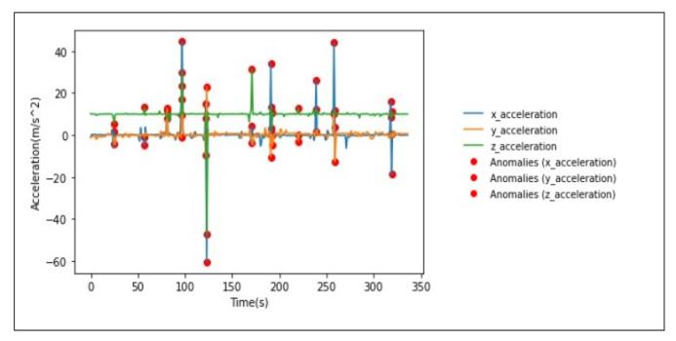
Fig.2: This figure is a graphical representation of acceleration experience by a vehicle when it crashes into something. Whenever a car crashes into an object its speed/velocity decreases drastically, in turn resulting in change in acceleration (a=V₂-V₁/t). The spike in acceleration is marked using a red dot (as an anomaly). We use this information to distinguish between a fatal accident and a normal movement of vehicle.
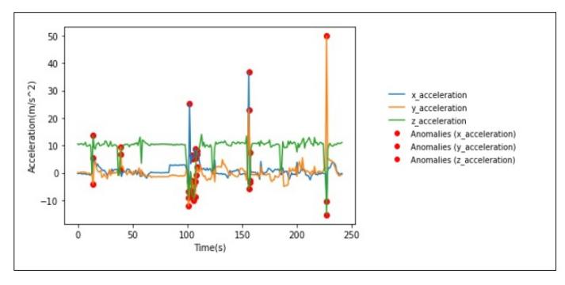
Fig.3: This figure is a graphical representation of acceleration experience by a vehicle when it falls from a height. Whenever a car freefall from a certain height its acceleration in Y-axis changes drastically. The spike in acceleration is marked using a red dot (as an anomaly). We use this information to distinguish between a fatal accident and a normal movement of vehicle.
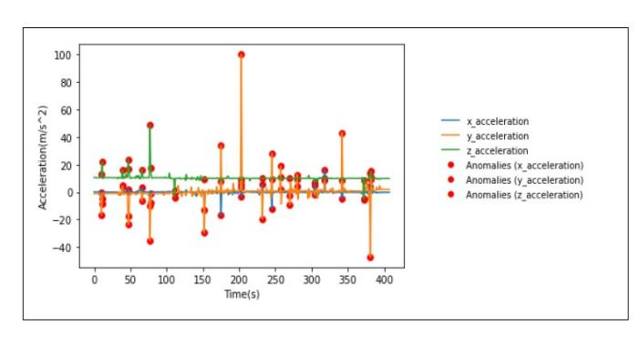
Fig.4: This figure is a graphical representation of acceleration experience by a vehicle when it hit from sides. Whenever a car crashes into an object its speed/velocity decreases drastically, in turn resulting in change in acceleration. The spike in acceleration is marked using a red dot (as an anomaly). We use this information to distinguish between a fatal accident and a normal movement of vehicle.
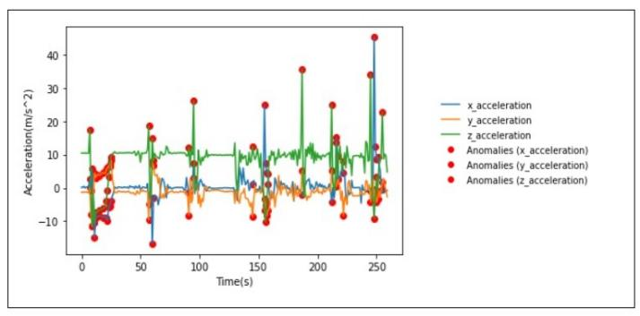
Fig.5: This figure is a graphical representation of acceleration experience by a vehicle when it explodes. Whenever a car explodes its speed/velocity increases drastically in Z- axis, in turn resulting in change in acceleration. The spike in acceleration is marked using a red dot (as an anomaly). We use this information to detect a fatal accident.

CONCLUSION

This project is a cutting-edge Accident Detection and Alert System in this initiative using technology to improve road safety. The system is built around an Arduino Uno as the processor, a SIM800 GSM module, for connectivity an ADXL345 3-axis accelerometer for motion sensing and a GPS module for location tracking. This setup ensures reliability and efficiency in operation. Ultimately this project aims to enhance the safety of driving environments by offering a solution that can be adapted to different vehicle types and settings. By reducing emergency response times and enhancing the precision of accident notifications our Accident Detection and Alert System represents a step, in automotive safety technology.

References
- Dr. C. K. Gomathy, K Rohan, Bandi Mani Kiran Reddy, Dr. V Geetha, “Accident Detection And Alert System”, Journal Of Engineering, Computing & Architecture”, MARCH 2022B. Rieder, Engines of Order: A Mechanology of Algorithmic Techniques. Amsterdam, Netherlands: Amsterdam Univ. Press, 2020.

[2] Dr. R. Prasanthi, M.U. Nitish Babu, B. Jaswanth, G.Sumith Chandra, “Accident Detection And Alert System Using Arduino”, April 2023.

[3] M. Ajay Kumar, Sree Kamya,K. Kiranmai, Pragathi (2023),"Dynamic Accident Detection And Alert System Using Arduino”, Journal of Emerging Technologies and Innovative Research (JETIR).

[4] G. Siri, G. Priyanka, B. Divya, G. Sameera, Ms. M. Pallavi (2022),"Accident Detection And Alert System", International Research Journal of Modernization in Engineering Technology and Science.

[5] L Vijayaraja, R Dhanasekar, Magesh Krishna, Mahidhar, Prakash and Shashikumar P,"A low cost and user-friendly vehicle crash alert system
Using Arduino “, IOP Conf. Series: Materials Science and Engineering (2020).

[6] S. Patil, K. Patil, S. Dhabekar, M. Nirgude, and Prof. S. Renushe, "Accident Identification & Alerting System," in International Research Journal of Modernization in Engineering Technology and Science, vol. 2, no. 7, Jul. 2020.

[7] J. P. Byrne, N. C. Mann, M. Dai, S. A. Mason, P. Karanicolas, S. Rizoli, and A. B. Nathens, "Association Between Emergency Medical Service Response Time and Motor Vehicle Crash Mortality in the United States," JAMA Surg., vol. 154, no. 4, pp. 286–293, Apr. 2019.

