



KARNATAKA STATE COUNCIL FOR SCIENCE AND TECHNOLOGY
Indian Institute of Science campus, Bengaluru
Telephone: 080 -23600978, 23341652 || Email: spp@kscst.org.in
Website: www.kscst.org.in/spp.html or https://kscst.karnataka.gov.in/en
FORMAT FOR STUDENT PROJECT PROPOSAL FOR THE
47th SERIES OF STUDENT PROJECT PROGRAMME
(Handwritten proposals will not be accepted, please fill all the details in this MS word file, insert images / diagrams wherever necessary. Convert to pdf file, get it approved from the project guide / head of the department and principal of your institution. Keep ready the scanned pdf file of 1) Declaration and Endorsement 2) details of processing fees made and fill-up the Google Form.
https://forms.gle/mE8Q4pM2nwZQuHbi9
Name of the College: KLS GOGTE INSTITUTE OF TECHNOLOGY, BELGAVI

Project Title: Accident detection and alert system using IOT

Branch: Information Science and Engineering

Theme (as per KSCST poster): Integrated Internet of things

Name of project guide:
- Name: Dr. Harish Kenchannavar
Email id: harishhk@git.edu
Contact No.: 7411475126
Name of Team Members:
Name: BASAVRAJ R DUGANAVAR
USN No.: 2GI20IS006
Email id: basavarajdeepti@gmail.com
Mobile No: 8618709461

Name: CHINMAY C
USN No.: 2GI20IS009
Email id: chinmaychinchanikar@gmail.com
Mobile No.: 7022096732

Name: ADITYA VARDHAN
USN No.: 2GI20IS003
Email id: adityavardhan5673@gmail.com
Mobile No.: 6364433459

Name: NACHIKET M
USN No.: 2GI20IS016
Email id: nachiketmagadum@gmail.com
Mobile No.: 9611504055
Team Leader of the Project:
Name: BASAVRAJ R DUGANAVAR
USN No.: 2GI20IS006
Email id: basavarajdeepti@gmail.com
Mobile No.: 8618709461
Processing Fee Details (Through Online Payment only):
(processing fee of Rs. 1000/-)
Please furnish the payment details in the format provided in the last page of the proposal.
Date of commencement of the Project: 20/11/2023

Probable date of completion of the project: 20/05/2024

Scope / Objectives of the project:

- Design a system that can detect real accidents and ignore non-emergency events
- Avoid false alarms and ensure that no real accidents go unreported.
- Reduce the time it takes for emergency personnel to arrive at the scene of an accident, thereby improving the chances of survival and speedy recovery for the injured person.

Methodology:
ALGORITHM:
- Accident Detection and Alert System using Arduino can prevent uncertain deaths by sending a message alert to a registered mobile number, providing the precise location of the accident through a Google map link.
- We Collect real-world accident data, including various scenarios and conditions. This will serve as foundation for training the system.
- To the collected data, machine learning algorithms(Clustering / Partitioning Algorithms) are applied to get the range of values that determine whether the disturbance was an accident or not
- The Accident Detection and Alert System checks the readings from the sensors and compares it with the analyzed range of values to distinguish between accidents and false alarms(Speed Bumps, Potholes, etc).
- If the disturbance is found to be an accident then an emergency message containing information such as GPS co-ordinates of the accident, time of the accident, Vehicle number is sent to the emergency services and the contact numbers mentioned by the user.
- Flowchart:

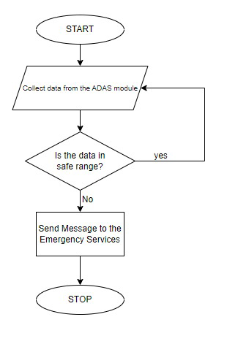

Block Diagram:
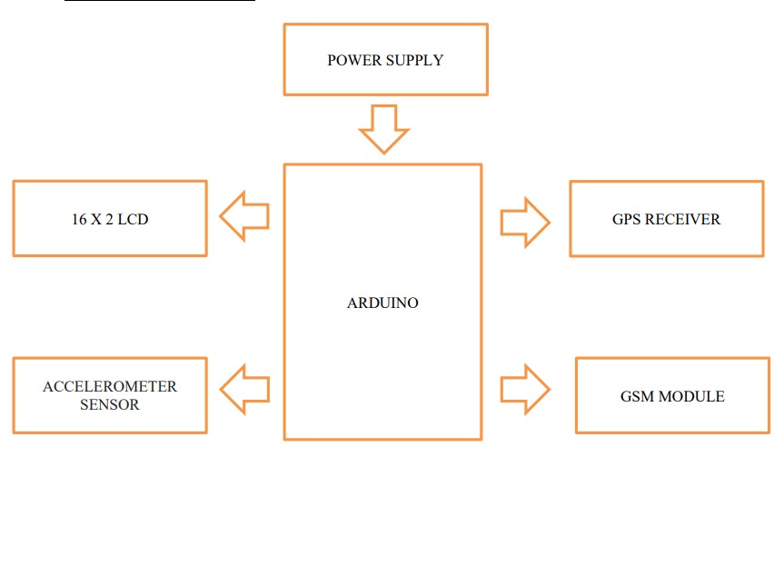
Expected Outcome of the project:
Reduced Emergency Response Time:
By quickly detecting and accurately assessing the severity of accidents, the system facilitates a rapid response from emergency services, potentially reducing the time it takes for personnel to arrive at the accident scene.
Improved Survival Rates:
Swift and efficient communication with emergency services enhances the chances of timely medical intervention, contributing to improved survival rates and minimizing the impact of injuries sustained in accidents.
Enhanced Reporting to Authorities:
The system automates the reporting process to authorities, providing them with timely and accurate information about accidents. This can streamline emergency response coordination and enable better-informed decision-making by relevant agencies.
Is the project proposed relevant to the Industry / Society or Institution?

Yes / No: Yes(Societal)
Can the product or process developed in the project be taken up for filing a Patent?
Yes / No: Yes

Prior Art search done?
Yes/No: Yes
Budget details (break-up details should be given):
Note: KSCST will provide nominal grant support for carrying out the project by students if selected by the project selection committee.
Budget | Amount
a) Materials / Consumables (Please specify)  - SIM800 L(sim module)  - NEO GPS module  - ARDUNIO mega  - ADXL335/345  - MQ-2 smoke sensor  - Heat sensor  - Tilt sensor  - Bread board  - LCD screen  - Wires | ₹ 600/-  ₹ 1500/-  ₹1500/-  ₹1500/-  ₹300/-  ₹200/-  ₹ 300/-  ₹200/-  ₹400/-  ₹400/-
b) Labor (Describe)  Cost of 3D Printing . | 2000.00/-
c) Travel (Describe)  Travel related to work, Traffic and Hospital Survey | 600.00/-
e) Miscellaneous (Please specify)  cost of Battery, Stationary | 500.00/-
Total | ₹10,000.00/-

Any other technical details (Please specify):

SPP Coordinator (Identified by the college):
Name: Prof. Shwetha Goudar
Email id: dean_rnd@git.edu
Contact No.: 0831-2498500

Name of the Project Guide:Dr. Harish H Kenchannavar | Name of the HOD: Dr. Kiran K T
Email id:harishhk@git.edu | Email id: kirankt@git.edu
Contact No.: 7411475126 | Contact No.: 9448545393

DECLARATION
(From Project Students)
(To scan this page and enclose in the project proposal)

We, the project team hereby declare that the details enclosed in the project proposal (Title of the Project: Accident detection and alert system using IOT, Branch: Information Science and Engineering, College: KLS Gogte Institute of technology) are true and correct to the best of our knowledge and belief and we undertake to inform KSCST of any changes therein in the project title, students name will be intimated immediately through project guide. In case any of the above information is found to be false or untrue or misleading, we are aware that we may be held liable for it. We hereby authorize sharing of the project information with this project proposal with the Karnataka State Council for Science and Technology, Bangaluru.
We are aware that the project team must exhibit / demonstrate the project in the nodal centre and interact regarding project with the experts and to exhibit the project in the State Level Seminar and Exhibition (if selected). If the student team fails to attend the evaluation in nodal centre or fails to attend the State Level Seminar and Exhibition, the supported project amount will be returned to KSCST.
We also hereby, enclose the endorsement form to KSCST, Bengaluru.

Name of the students with USN No. Signature with date
- Basavraj R D(2GI20IS006)
- Chinmay C(2GI20IS009)
- Aditya Vardhan(2GI20IS003)
- Nachiket Magadum(2GI20IS016)
(Name & Signature of Project Guide with Seal) | (Name & Signature of HOD with Seal)
Email id: harishhk@git.edu | Email id: kirankt@git.edu
Contact No.: 7411475126 | Contact No.: 9448545393

ENDORSEMENT
(From College, endorsement to be taken in the institution / Department Letter head)
(To scan this page and enclose in the project proposal)

This is to certify that 1) Mr. Basavraj R D 2) Mr. Chinmay C 3) Mr. Aditya Vardhan 4) Mr. Nachiket Magadum, are bonafide student(s) of Department of Information Science and Engineering , in the degree program of our institution. If the project proposal submitted by these students under the 47th series of Student Project Programme is selected by KSCST, we will provide the requisite laboratory / Computer / infrastructure support in our college / Institution. Further we also take necessary steps to see that the project team will exhibit / demonstrate their project in the nodal centre and in the State Level Seminar and Exhibition (if selected). If the student team fails to send the completed project report or fails to attend the evaluation in nodal centre or fails to attend the State Level Seminar and Exhibition, the supported project amount will be returned to KSCST.

(Name & Signature of  Project Guide with Seal) | (Signature of HOD with Seal) | (Signature of the Principal with Seal)
Email id: harishhk@git.edu | Email id: kirankt@git.edu | Email id:principal@git.edu
Contact No.: 7411475126 | Contact No.: 9448545393 | Contact No.:0831-498500

DETAILS OF PROCESSING FEES MADE THROUGH
NEFT / UPI PAYMENT
(Note: Include this page in the softcopy of the student project proposal. The student team shall furnish the details in the Google Form. It is informed to the students to 1) keep ready the softcopy of the project proposal and other documents and 2) Furnish the payment made details as processing fees and 3) update the details in the Google Form on the same day of payment made to KSCST by NEFT / UPI payment).

- TITLE OF THE PROJECT | : | Accident detection and alert system using IOT
- NAME OF THE TEAM LEADER | : | Basavraj R D
- EMAIL ID | : | basavarajdeepti@gmail.com
- CONTACT MOBILE NO. | : | 8618709461
PAYMENT MADE DETAILS
- BANK REF. NO. / UTR NO. / UPI No. (12 digits) | : | 401198697285
- TRANSACTION ID | : | 401198697285
- NAME OF THE SENDER / ACCOUNT HOLDER and CONTACT NUMBER | : | BASAVRAJ D  8618709461
- NAME OF THE BANK | : | Union Bank of India
- PROCESSING FEES | : | Rs. 1000/-
- DATE OF PAYMENT MADE | : | 11/01/2024
- TIME | : | 12:20 pm
- MODE OF PAYMENT MADE  (NEFT / UPI, PLEASE SPECIFY) | : | UPI

(Name & Signature of  the team leader) | (Name & Signature of  Project Guide or HOD with Seal)
KARNATAKA STATE COUNCIL FOR SCIENCE AND TECHNOLOGY
Indian Institute of Science campus, Bengaluru
47th SERIES OF STUDENT PROJECT PROGRAMME (SPP)
(Note: This page is for information about bank details of KSCST to the student team and college / institution and not to include this page in the project proposal softcopy)

BANK ACCOUNT DETAILS OF KSCST
Name and address of the Institution | Karnataka State Council for Science and Technology, IISc Campus, Bangalore -560012
Account holder’s name / Designation | Secretary, Karnataka State Council for Science and Technology
Bank Account No. & Name of the bank | Current A/C No. 0683201000024  Canara Bank, IISc Campus Branch, Bangalore-560012
IFSC Code | CNRB0000683
MICR Code | 560015023
Bank Branch Address | Canara Bank, Indian Institute of Science, Bangalore-560012

